Screenshots or program listings must be copied into appropriate cells in the following table.
Save this evidence document as evidence_ followed by your centre number_ candidate number. For example: evidence_ zz999_9999 and insert your name, centre number and candidate number into the header above.
Examiners must be able to read the contents including any screenshots without the use of a magnifying glass. Answers that are not readable or missing will not be awarded any marks.
Save this evidence document at regular intervals, for example, every 10 minutes.
Question 1
Part 1(a)
def Unknown(x, y):
if x < y:
print(x + y)
return Unknown(x + 1, y) * 2
elif x == y:
return 1
else:
print(x + y)
return Unknown(x - 1, y) // 2

Part 1(b)(i)
def main():
print("x=10, y=15")
print(Unknown(10, 15))
print("x=10, y=10")
print(Unknown(10, 10))
print("x=15, y=10")
print(Unknown(15, 10))

if __name__ == "__main__":
main()

Part 1(b)(ii)
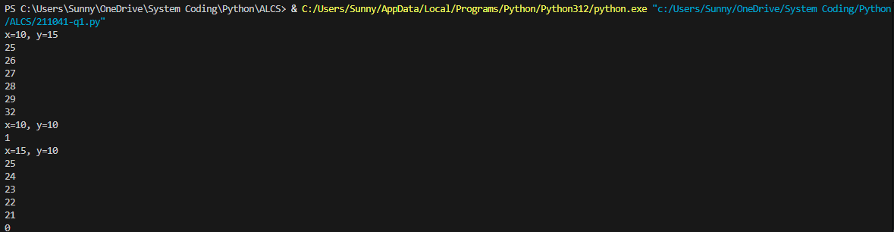
Part 1(c)
def IterativeUnknown(x, y):
cnt = 1
while x < y:
print(x + y)
x += 1
cnt *= 2
while x > y:
print(x + y)
x -= 1
cnt //= 2
return cnt

Part 1(d)(i)
def main():
print("Call of unknown:")
print("x=10, y=15")
print(Unknown(10, 15))
print("x=10, y=10")
print(Unknown(10, 10))
print("x=15, y=10")
print(Unknown(15, 10))
print("Call of iterative unknown:")
print("x=10, y=15")
print(IterativeUnknown(10, 15))
print("x=10, y=10")
print(IterativeUnknown(10, 10))
print("x=15, y=10")
print(IterativeUnknown(15, 10))

if __name__ == "__main__":
main()

Part 1(d)(ii)
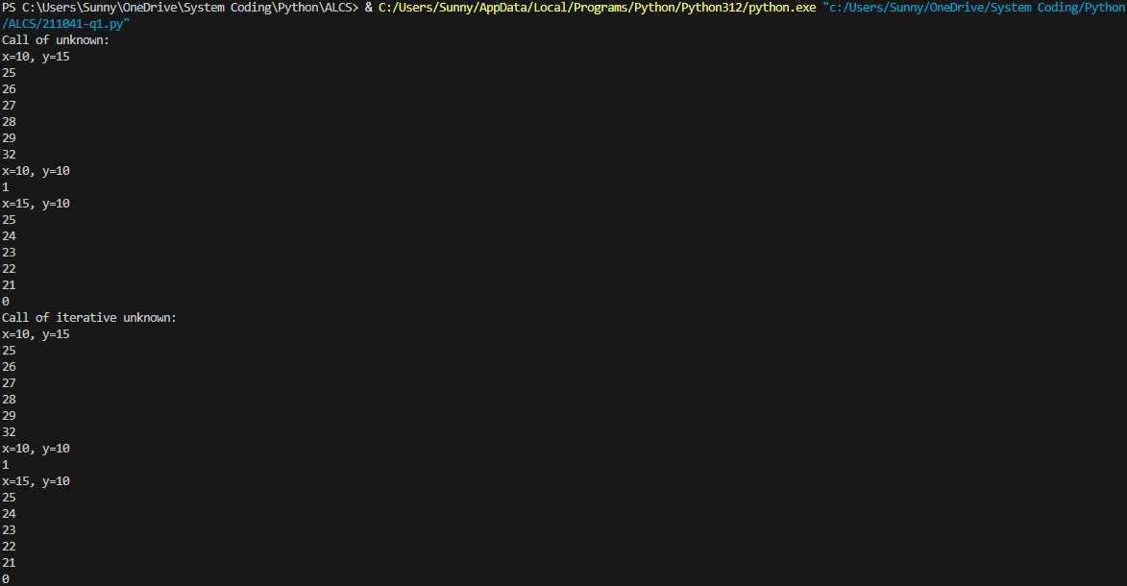
Question 2
Part 2(a)
class Picture:
def __init__(self, description, weight, height, framecolor):
self.__descriptiopn = description #string
self.__weight = weight #integer
self.__height = height #integer
self.__framecolor = framecolor #string

Part 2(b)
def getDescription(self):
return self.__descriptiopn
def getWeight(self):
return self.__weight
def getHeight(self):
return self.__height
def getFrameColor(self):
return self.__framecolor

Part 2(c)
def SetDescription(self, x):
self.__descriptiopn = x

Part 2(d)
arr = [None] * 100

Part 2(e)
def ReadData():
global arr
cnt = 0
try:
with open("Pictures.txt", encoding='utf-8') as f:
while True:
try:
arr[cnt] = Picture(f.readline().strip(), int(f.readline().strip()), int(f.readline().strip()), f.readline().strip())
except ValueError:
break
cnt += 1
return cnt
except FileNotFoundError:
print("File is not found.")

Part 2(f)
def main():
global arr
ReadData()

if __name__ == "__main__":
main()

Part 2(g)
def main():
global arr
ReadData()
c = input("Enter color of frame: ")
mw = int(input("Enter max width: "))
mh = int(input("Enter max height: "))
found = False
for i in range(len(arr)):
if arr[i] != None and arr[i].getWidth() == mw and arr[i].getHeight() == mh and arr[i].getFramesilColor().casefold() == c.casefold():
found = True
print(arr[i].getDescription())
if not found: print("Picture not found.")

if __name__ == "__main__":
main()

Part 2(h)
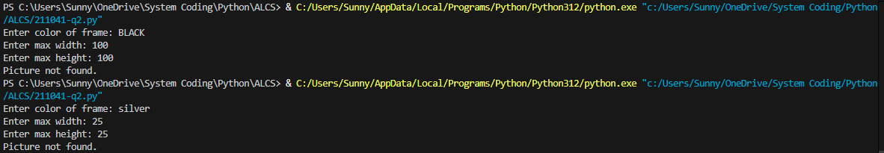
Question 3
Part 3(a)
def main():
ArrayNodes = [[0 for _ in range(3)] for _ in range(20)]
RootPointer = -1
FreeNode = 0

if __name__ == "__main__":
main()

Part 3(b)
def AddNode(arr, root, free):
if free == -1:
print("The binary tree array is full.")
return
inp = int(input("Enter the number to add: "))
if root == -1:
root = free
arr[root][1] = inp
free += 1
return arr, root, free
current = root
while True:
if inp > arr[current][1]:
if arr[current][2] == 0:
arr[current][2] = free
arr[free][1] = inp
break
else:
current = arr[current][2]
elif inp < arr[current][1]:
if arr[current][0] == 0:
arr[current][0] = free
arr[free][1] = inp
break
else:
current = arr[current][0]
free += 1
if free == 20: free = -1
return arr, root, free

Part 3(c)
def PrintAll(arr):
for i in range(len(arr)):
print(str(arr[i][0]) + " " + str(arr[i][1]) + " " + str(arr[i][2]))

Part 3(d)(i)
def main():
ArrayNodes = [[0 for _ in range(3)] for _ in range(20)] #2D array of integers
RootPointer = -1 #integer
FreeNode = 0 #integer
for i in range(10):
ArrayNodes, RootPointer, FreeNode = AddNode(ArrayNodes, RootPointer, FreeNode)
PrintAll(ArrayNodes)

if __name__ == "__main__":
main()

Part 3(d)(ii)
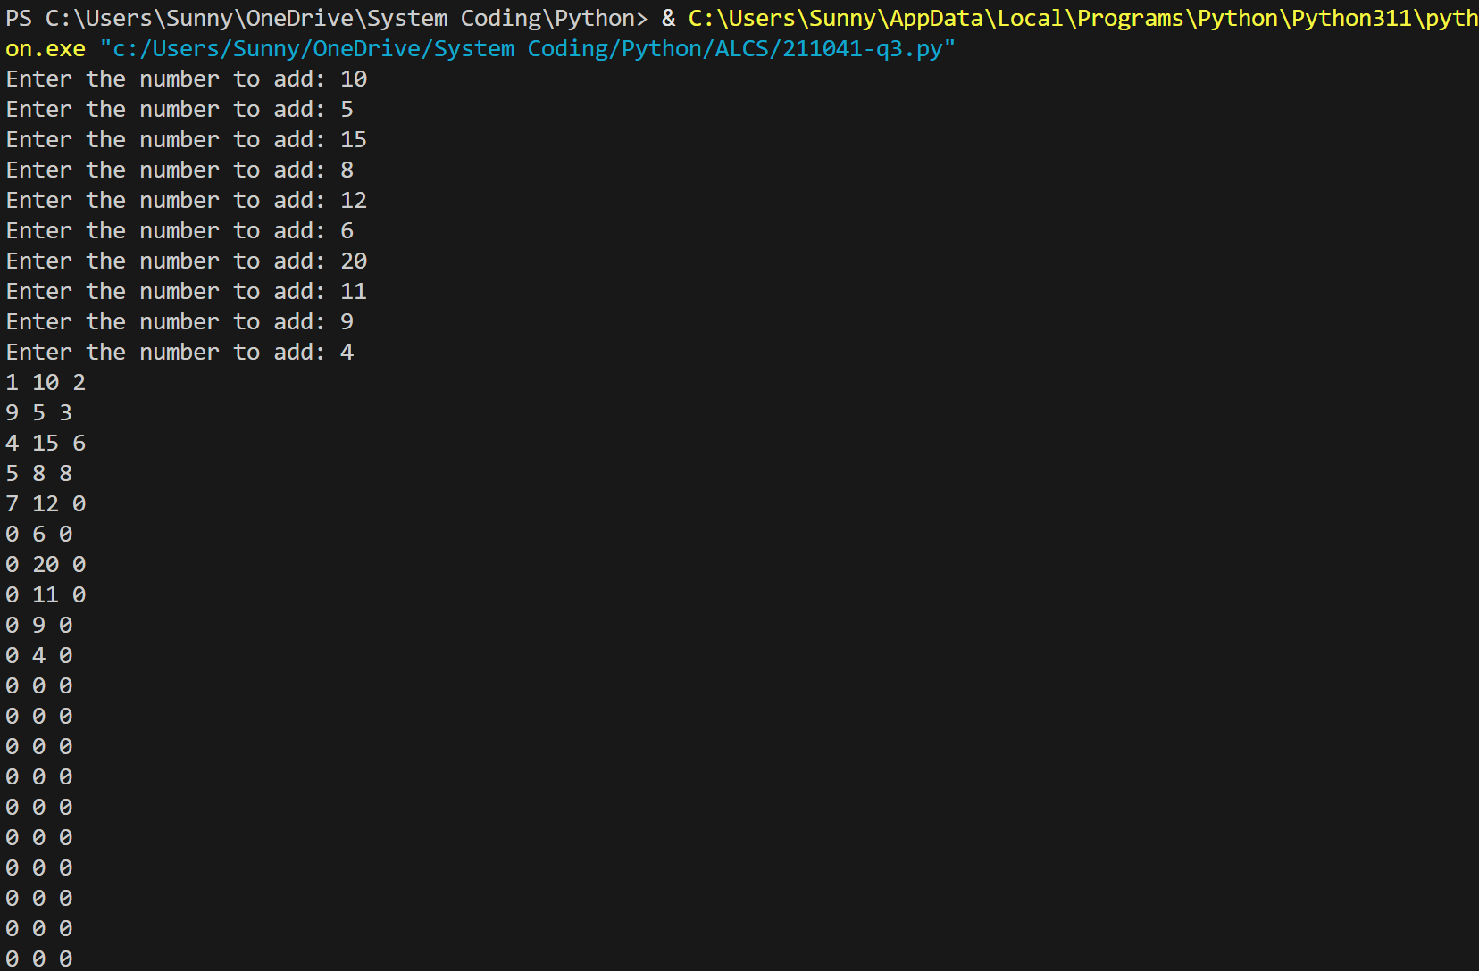
Part 3(e)(i)
def InOrder(arr, pointer):
if arr[pointer][0] != 0:
InOrder(arr, arr[pointer][0])
print(arr[pointer][1])
if arr[pointer][2] != 0:
InOrder(arr, arr[pointer][2])

Part 3(e)(ii)
