Insert your centre number, name and candidate number into the header above.
Save this evidence document as evidence_ followed by your centre number_ candidate number. For example: evidence_ zz999_9999
Screenshots or program listings must be copied into appropriate cells in the following table.
Examiners must be able to read the contents including any screenshots without the use of a magnifying glass. Answers that are not readable or missing will not be awarded any marks.
Save this evidence document at regular intervals, for example every 10 minutes.
Question 1
Part 1(a)
StackData = [0] * 10
pointer = 0

Part 1(b)
def iterate():
global StackData, StackPointer
for i in range(10):
print(StackData[i])
print("Stack Pointer:", StackPointer)

Part 1(c)
def push(value):
global StackData, StackPointer
if StackPointer < 10:
StackData[StackPointer] = value
StackPointer += 1
return True
else:
return False

Part 1(d)(i)
def main():
global StackData, StackPointer
for i in range(11):
inp = int(input("Enter a number to push onto the stack: "))
if not push(inp):
print("Stack Overflow")
else:
print("Item Added")
iterate()

Part 1(d)(ii)
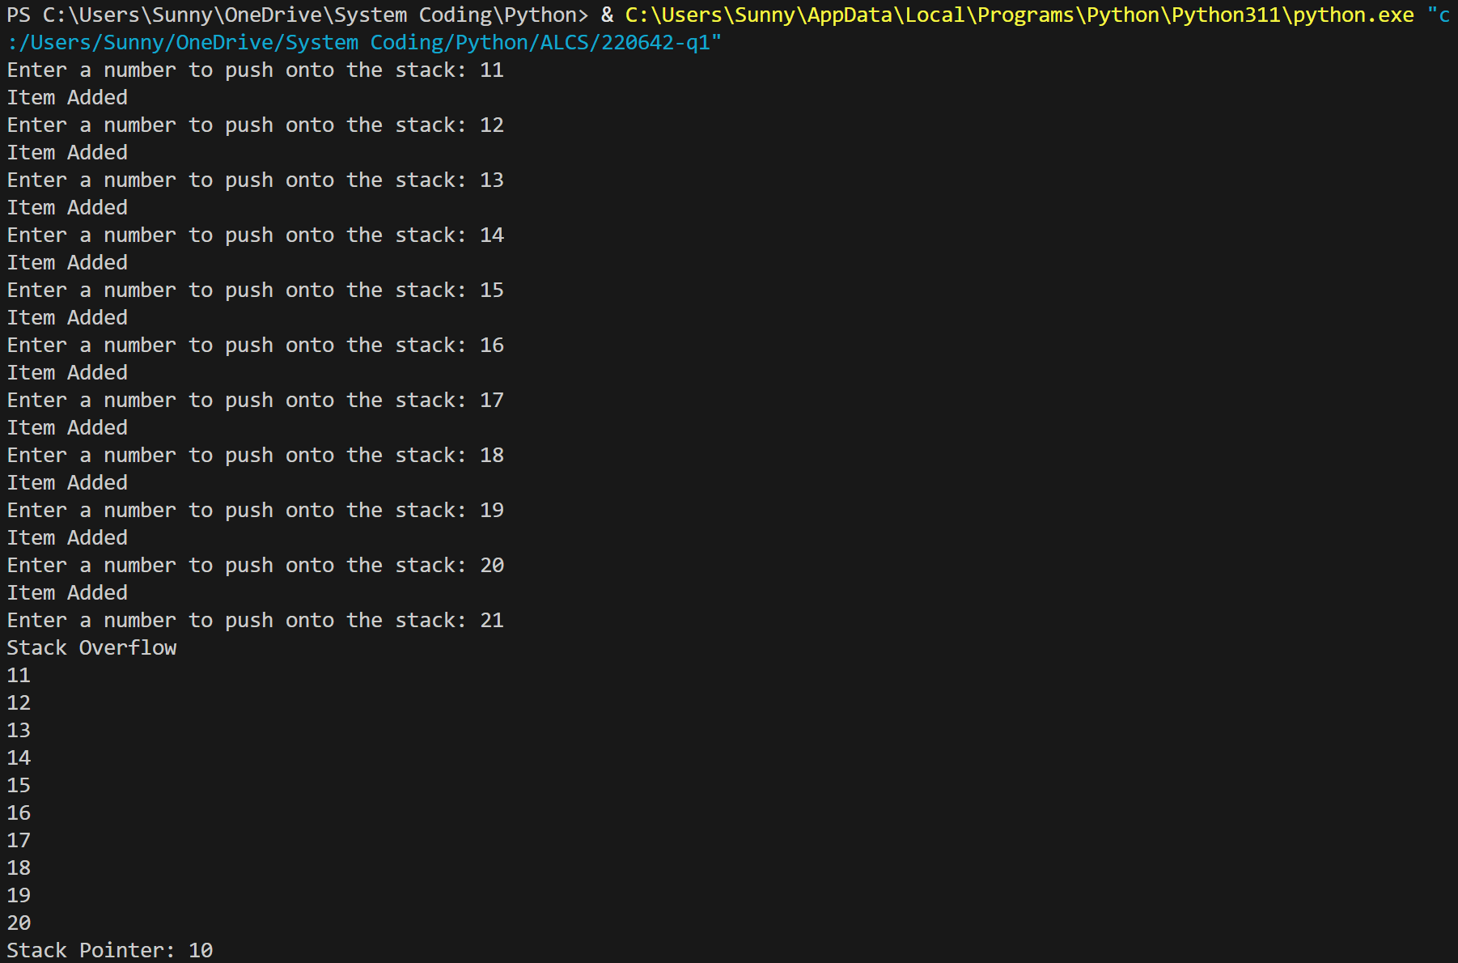

Part 1(e)(i)
def pop():
global StackData, StackPointer
if StackPointer == 0:
return -1
else:
StackPointer -= 1
return StackData[StackPointer]

Part 1(e)(ii)
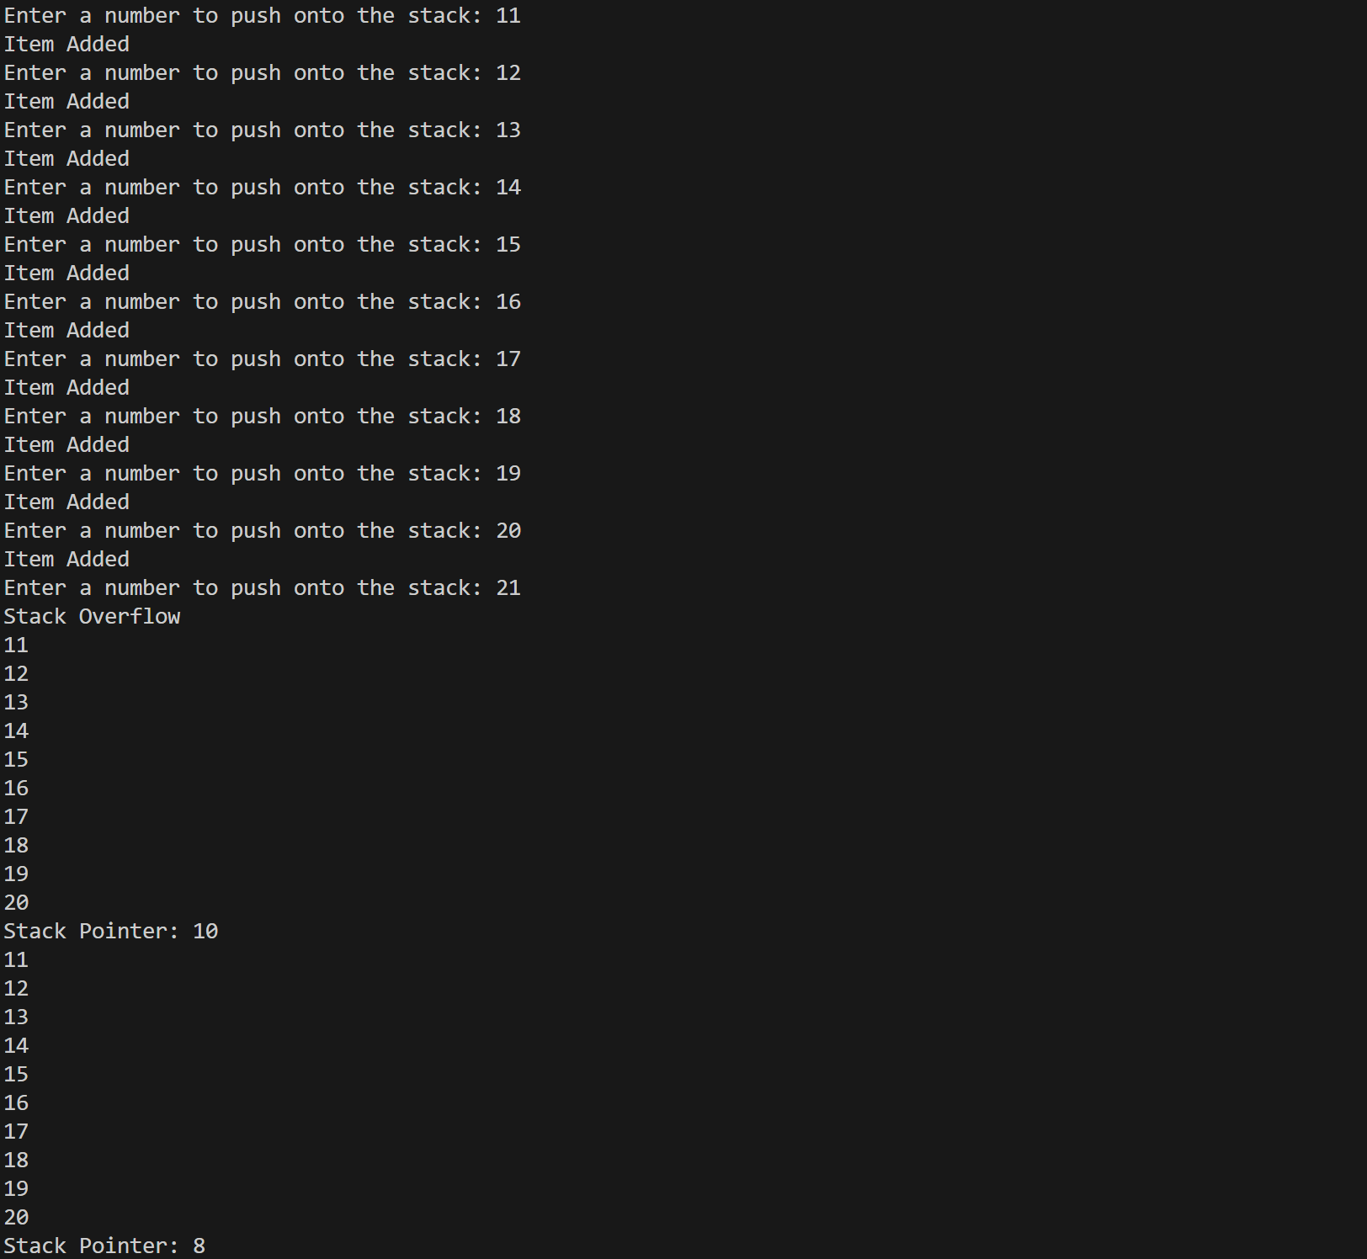
Question 2
Part 2(a)
import random
def main():
rows = 10
cols = 10
arr = [[0 for _ in range(cols)] for _ in range(rows)]
for i in range(10):
for j in range(10):
arr[i][j] = random.randint(1, 100)

Part 2(b)(i)
def main():
rows = 10
cols = 10
for i in range(10):
for j in range(10):
arr[i][j] = random.randint(1, 100)
arr = [[0 for _ in range(cols)] for _ in range(rows)]
arraylength = 10
for x in range(arraylength):
for y in range(arraylength - 1):
for z in range(arraylength - y - 1):
if (arr[x][z] > arr[x][z + 1]):
tmp = arr[x][z]
arr[x][z] = arr[x][z + 1]
arr[x][z + 1] = tmp

Part 2(b)(ii)
def iterate(arr):
for i in range(10):
for j in range(10):
print(arr[i][j], end=' ')
print()

Part 2(b)(iii)
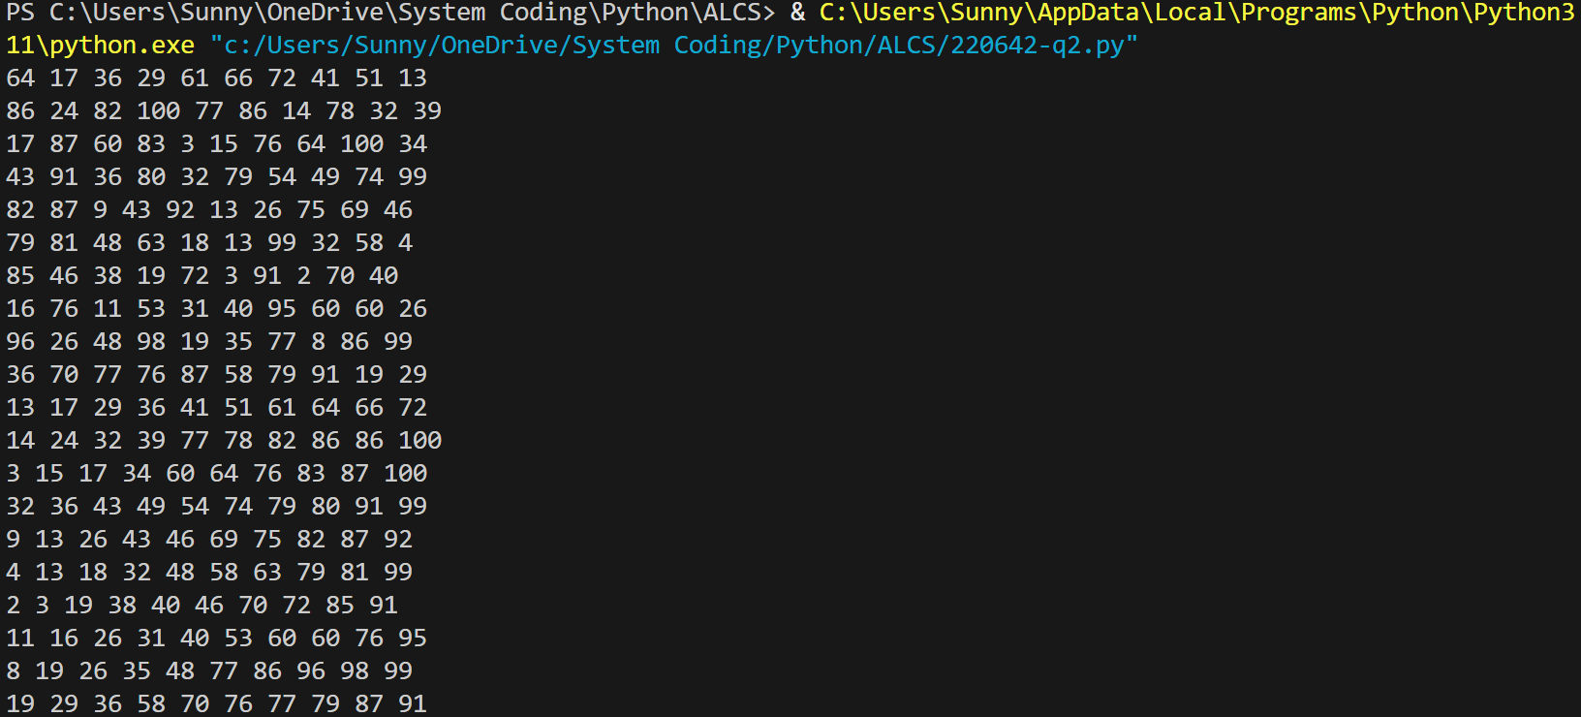

Part 2(c)(i)
def binarysearch(arr, lower, upper, value):
if upper > lower:
mid = (lower + upper - 1) // 2
if arr[0][mid] == value:
return mid
elif arr[0][mid] > value:
return binarysearch(arr, lower, mid - 1, value)
else:
return binarysearch(arr, mid + 1, upper, value)
return -1

Part 2(c)(ii)
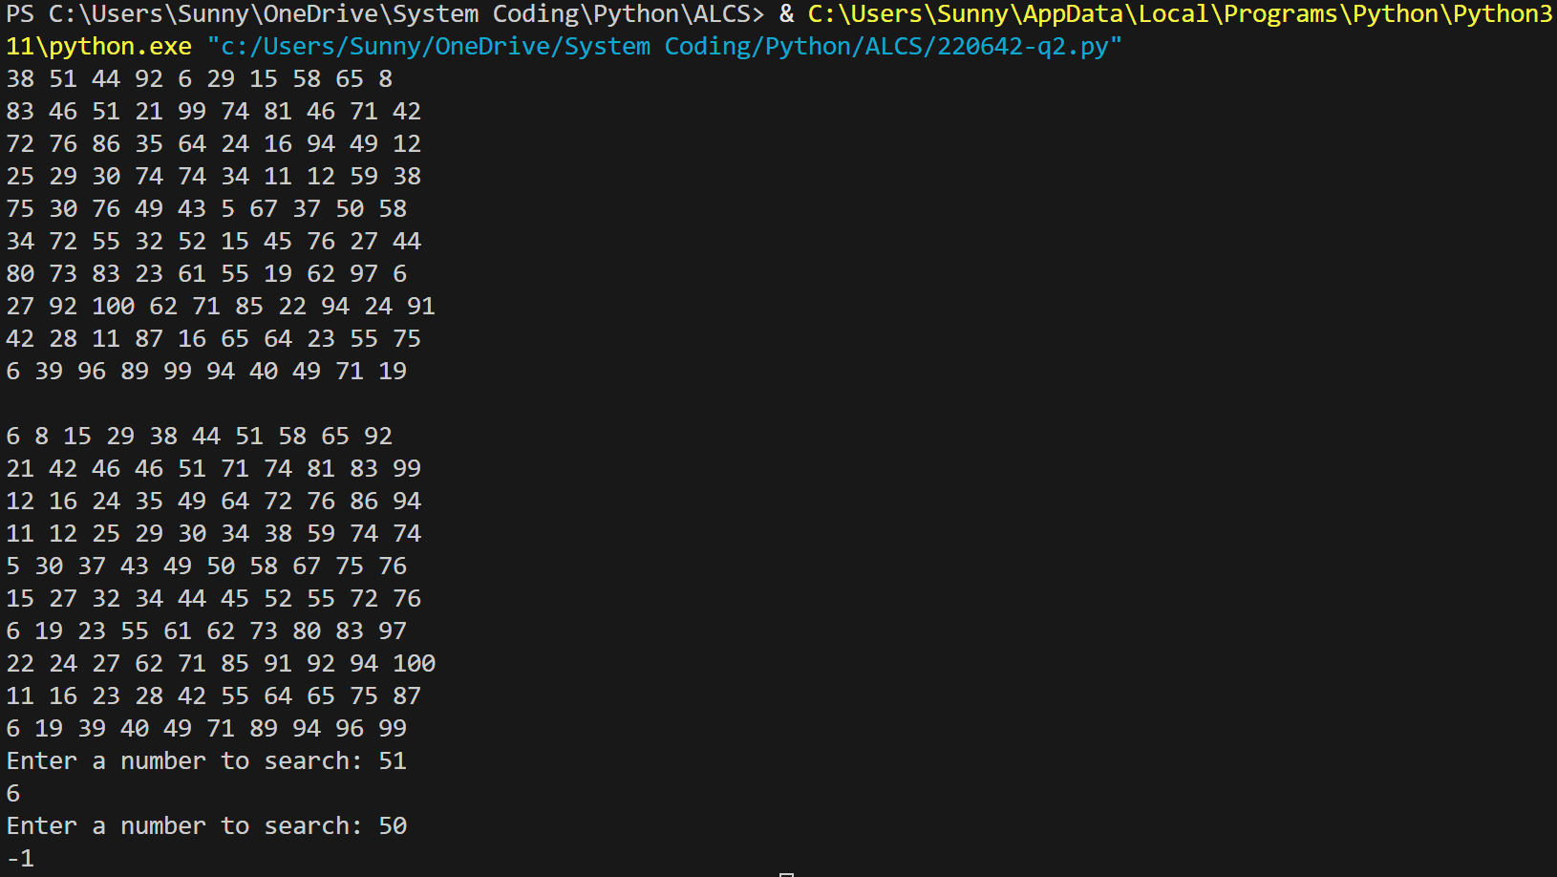

Question 3
Part 3(a)
class Card:
def __init__(self, Number, Colour):
self.__Number = Number
self.__Colour = Colour

Part 3(b)
def getNumber(self):
return self.__Number
def getColour(self):
return self.__Colour

Part 3(c)
card = [None] * 30
with open("CardValues.txt", "r", encoding = 'utf-8') as f:
for i in range(30):
num = f.readline().strip()
name = f.readline().strip()
card[i] = Card(int(num), name)

Part 3(d)
def ChooseCard(idx):
if idx <= 0 or idx > 30:
return -1
elif card[idx - 1].selected:
return -1
else:
card[idx - 1].selected = True
return idx - 1

Part 3(e)(i)
def main():
global card
Player1 = [None] * 4
with open("CardValues.txt", "r", encoding = 'utf-8') as f:
for i in range(30):
num = f.readline().strip()
name = f.readline().strip()
card[i] = Card(int(num), name)
for i in range(4):
idx = int(input("Player 1, choose your card (1-30): "))
chosen = ChooseCard(idx)
while chosen == -1:
print("Invalid choice or card already selected. Please choose again.")
idx = int(input("Player 1, choose your card (1-30): "))
chosen = ChooseCard(idx)
Player1[i] = card[chosen]
for i in range(4):
print("Card number:", Player1[i].getNumber(), "Card Colour:", Player1[i].getColour())

Part 3(e)(ii)
