Insert your centre number, name and candidate number into the header above.
Save this evidence document as evidence_ followed by your centre number_ candidate number. For example: evidence_ zz999_9999
Screenshots or program listings must be copied into appropriate cells in the following table.
Examiners must be able to read the contents including any screenshots without the use of a magnifying glass. Answers that are not readable or missing will not be awarded any marks.
Save this evidence document at regular intervals, for example every 10 minutes.
Question 1
Part 1(a)
name = []
score = []
newname = []
newscore = []

Part 1(b)
def ReadHighScores():
i = 0
with open(r"C:\Users\Sunny\Downloads\HighScore.txt", "r", encoding="utf-8") as f:
for line in f:
if (i % 2 == 0):
name.append(line)
else:
score.append(line)
i += 1

Part 1(c)
def OutputHighScores():
for i in range(0, 10):
print(name[i].strip() + " " + score[i].strip())

Part 1(d)(i)
def main():
ReadHighScores()
OutputHighScores()

Part 1(d)(ii)
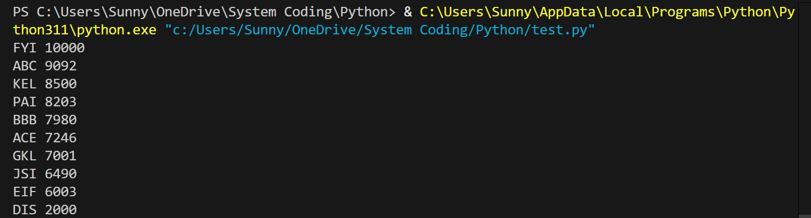
Part 1(e)(i)
def main():
n = input("Enter a 3-character player name: ")
s = int(input("Enter score between 1 and 100000 inclusive: "))
ReadHighScores()
OutputHighScores()

Part 1(e)(ii)
def updateScore(n, s):
j = 0
while(j < 9):
if (s < int(score[j])):
j += 1
else:
break
if (s > int(score[j])):
for k in range(0, 9):
if (k == j):
newname.append(n)
newscore.append(str(s))
newname.append(name[k].strip())
newscore.append(score[k].strip())
else:
for i in range(0, 10):
newname.append(name[i].strip())
newscore.append(score[i].strip())
for i in range(0, 10):
print(newname[i] + " " + newscore[i])

Part 1(e)(iii)
def main():
n = input("Enter a 3-character player name: ")
s = int(input("Enter score between 1 and 100000 inclusive: "))
ReadHighScores()
OutputHighScores()
print()
updateScore(n, s)

Part 1(e)(iv)
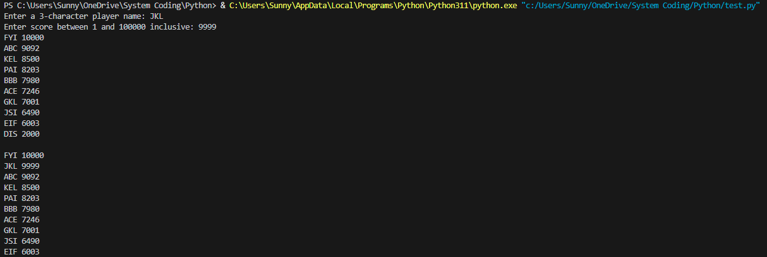
Part 1(f)
def WriteTopTen():
with open(r"C:\Users\Sunny\Downloads\output.txt", "w", encoding="utf-8") as f:
for i in range(0, 10):
f.write(newname[i] + "\n")
f.write(newscore[i] + "\n")

Question 2
Part 2(a)
class Balloon:
def __init__(self, color, defence):
self.__health = 100 #integer
self.__colour = color #string
self.__defence = defence #string

Part 2(b)
def GetDefenceItem(self):
return self.__defence

Part 2(c)
def ChangeHealth(self, change):
self.__health += change

Part 2(d)
def CheckHealth(self):
return self.__health <= 0

Part 2(e)
def main():
d = input("Enter defence item: ")
c = input("Enter colour: ")
Balloon1 = Balloon(c, d)

Part 2(f)
def Defend(balloon):
s = int(input("Enter strength of opponent: "))
balloon.ChangeHealth(-s)
print(balloon.GetDefenceItem())
if (balloon.CheckHealth()):
print("It has no health remaining")
else:
print("It has health remaining")
return balloon

Part 2(g)(i)
def main():
d = input("Enter defence item: ")
c = input("Enter colour: ")
Balloon1 = Balloon(c, d)
Defend(Balloon1)

Part 2(g)(ii)
Question 3
Part 3(a)
head = 0 #integer
tail = 0 #integer
size = 0 #integer
arr = [“”] * 10 #array

Part 3(b)
def Enqueue(QueueArray, DataToAdd):
global tail, size
if size == 10:
return False
QueueArray[tail] = DataToAdd
if tail >= 9:
tail = 0
else:
tail += 1
size += 1
return True

Part 3(c)
def Dequeue():
global head, size
if size == 0:
return False
result = arr[head]
arr[head] = None
if head >= 9:
head = 0
else:
head += 1
size -= 1
return result

Part 3(d)(i)
def main():
for i in range(11):
a = input("Enter item to add: ")
if (Enqueue(arr, a)):
print("Item added")
else:
print("Queue full")
print(Dequeue())
print(Dequeue())

Part 3(d)(ii)
