Erika Valle-Baird

CIS 285

Software Engineering Tools

1/26/2023

Lab 1 & 2

Project Statistics for Split Smart:

**Resource Sheet:**

The Resource Sheet View shows us the different resources along with their costs. If the Resource name is colored red, then that resource is overallocated within the project and needs to be adjusted.

Task Usage of a specific task

Overview of Task Usage view-

**Now on a selected task:**

This view allows us to see workers time scheduled work that is allocated over the task time period.

**Calendar of each month**

January View:

February View:

March View:

April View:

These views display important project dates in our project.

**Network Diagram :**

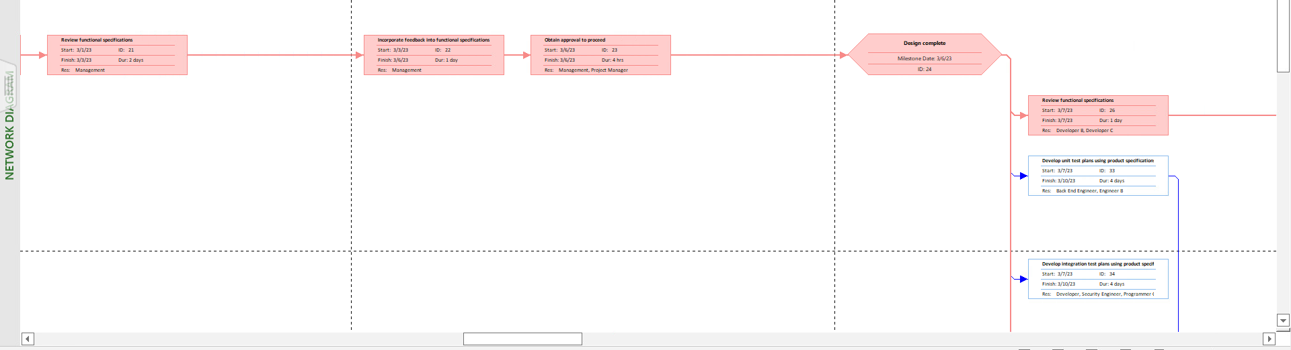

The Network Diagram View displays the project dependencies and key information about the task contained within each node. We can see the nodes that line up vertically or near vertically take place within the same time period, or for the later case close to each other time wise.

**4-5 Reports:**

Report containing Total Cost:

This report contains all information dealing with costs pertaining to the project. The cost distribution is a breakdown of the total project cost, adding up to $1 million.

Report 2, Resource Overview:

This report displays all information pertaining to allocation of resources, resources pertaining to human labor. This report also displays all work that is still left to be done.

Report 3, Critical Tasks:

This report displays all tasks that would be detrimental to the project should they fail to remain on the timeline target.

Report 4, Work Overview:

This report displays all work that has been done, remaining, by whom, total work hours of the project, remaining availability, and resource statistics.

