Real-Time Operating System for a Traffic Light that Prioritizes Emergency Vehicles and Pedestrian

Jacob Wald | Erika Valle-Baird
Department of Computer & Information Science | Department of Computer & Information Science
University of Michigan – Dearborn | University of Michigan – Dearborn
Dearborn, MI, USA | Dearborn, MI, USA

Abstract— Modern traffic management systems increasingly rely on artificial intelligence, computer vision, and large-scale infrastructure to optimize traffic flow. However, these approaches often introduce high costs, complexity, and reliance on advanced computational resources, making them impractical for smaller or resource-constrained environments. This project presents the design and simulation of a Real-Time Operating System (RTOS)-based traffic light controller that prioritizes emergency vehicles and pedestrian safety while maintaining low cost and system simplicity. The proposed system leverages deterministic scheduling, preemptive priority-based task execution, and a finite state machine to coordinate traffic signals in a predictable and safety-critical manner. A simulated intersection environment was developed to model real-time events, including pedestrian requests and emergency vehicle preemption, ensuring safe and conflict-free signal transitions. The system employs a fixed time-step clock to emulate RTOS behavior, enabling periodic task execution and guaranteed response times. Results demonstrate that the controller successfully enforces safety constraints, including immediate emergency response, minimum pedestrian crossing times, and the prevention of conflicting signal states. This work highlights the viability of embedded, RTOS-driven traffic control as a practical and reliable alternative to more complex smart-city solutions.

Keywords—Real-Time Operating System (RTOS), Traffic Light Control, Embedded Systems, Deterministic Scheduling, Preemptive Priority Scheduling, Finite State Machine, Emergency Vehicle Preemption, Pedestrian Safety, Smart Traffic Systems, Low-Cost Traffic Control

Introduction
This project proposes the design and simulation of a Real-Time Operating System (RTOS)-based traffic light controller that prioritizes emergency vehicles and pedestrian safety while remaining significantly lower in cost and complexity than modern AI-driven smart city infrastructure. The primary motivation is to address a growing disparity between cities that can afford advanced, data-driven traffic systems and those that cannot, yet still face the same safety-critical traffic management challenges. Rather than attempting to compete with state-of-the-art optimization-focused systems, this project targets a complementary design space centered on affordability, predictability, and reliability.
Instead of relying on cloud connectivity, machine learning models, or large-scale sensing infrastructure, the proposed system adopts a microcontroller-oriented embedded design philosophy. By leveraging deterministic scheduling, bounded response times, and well-defined task priorities within an RTOS framework, the system demonstrates that meaningful traffic safety improvements can be achieved using modest computational resources. This approach emphasizes predictable and verifiable system behavior, which is critical in safety-sensitive environments where timing guarantees are essential.
The system models a real-world intersection controller using simulated inputs that represent pedestrian button presses and emergency vehicle signals. RTOS tasks manage traffic signal sequencing, pedestrian crossing phases, emergency overrides, and fault handling. Priority-based scheduling ensures that emergency vehicle requests are handled immediately without introducing conflicting traffic signals, while pedestrian requests are serviced in a safe and predictable manner. In the event of system failure, the controller defaults to a safe flashing-red state to prevent hazardous conditions.
Finally, this project follows the waterfall software development life cycle, progressing through clearly defined phases: requirements analysis, system design, implementation, testing, and documentation. This structured approach is well-suited for safety-critical embedded systems, where upfront specification of timing constraints, task interactions, and fault-handling behavior is essential. Each phase produces well-documented artifacts that guide subsequent development, reducing ambiguity and minimizing the risk of unsafe system behavior.

Literature Survey

Early Adaptive Traffic Control Approaches
Adaptive traffic control is not a new concept, and in fact dates back far before the emergence of artificial intelligence. Shortly after the introduction of signalized intersections, it became clear that fixed-time traffic light control, while simple to implement, was inefficient under dynamically changing traffic conditions. Intersections that operated efficiently at one point in the day with predefined timing schedules often struggled during periods of congestion, when those timings no longer reflected real-world traffic demand. To address this limitation, early adaptive systems were developed to improve responsiveness through locally informed decision-making. One such approach utilized fuzzy logic, which enabled a distributed, fault-tolerant control strategy based on real-time conditions without relying on modern machine learning techniques [2]. Similarly, early embedded intelligent traffic controllers introduced sensor-driven phase adjustments and basic emergency-awareness mechanisms, demonstrating measurable improvements over fixed-time systems while still remaining constrained in flexibility and scalability [1].

Embedded & Low-Cost Traffic Control Systems
In modern traffic control research, the focus remains on reducing congestion and improving intersection efficiency; however, many contemporary solutions—particularly those driven by artificial intelligence—introduce significant computational and infrastructural overhead. As a result, embedded systems continue to serve as an attractive alternative due to their lower cost and ability to operate locally without reliance on large-scale infrastructure. Research into embedded traffic systems has demonstrated that integrating energy-efficient technologies, such as LED-based traffic lighting, can further reduce operational costs while improving system performance and reliability [3]. In addition, recent work leveraging widely used microcontrollers such as the STM32 has shown that modern embedded platforms are capable of supporting dynamic signal timing, pedestrian countdown systems, real-time sensor input, and stable field deployment [4]. Despite these advancements, most embedded solutions are framed as intelligent or adaptive controllers rather than explicitly designed real-time systems, and they typically lack formal scheduling models or deterministic guarantees required for safety-critical applications.

Connected & IoT-Based Traffic Systems
Building upon these earlier developments, more recent research has shifted toward connected infrastructure solutions that leverage communication technologies, edge computing, and Internet of Things (IoT) devices to further enhance traffic responsiveness. For example, Visible Light Communication (VLC)-based systems propose using traffic lights themselves as communication nodes, enabling infrastructure-to-vehicle data exchange in a low-cost and energy-efficient manner [5]. In parallel, IoT-based traffic management systems integrate sensors, microcontrollers, and wireless communication modules to dynamically adjust signal timing based on real-time traffic volume, while also enabling features such as emergency vehicle prioritization [6]. Extending this concept further, edge computing approaches treat traffic lights as distributed edge nodes capable of validating and processing traffic data locally, reducing reliance on centralized cloud systems and improving response latency [7]. While these approaches significantly enhance situational awareness and system responsiveness, they also introduce increased dependence on communication reliability, network infrastructure, and sensor integration, which can raise both system complexity and deployment cost.

Vision-Based Traffic Sensing & Prediction
As technology progressed, traffic sensing became increasingly rich, but also more computationally demanding. This evolution led to the adoption of image-processing systems that utilize cameras to estimate vehicle queues and dynamically adjust signal timing based on observed traffic conditions [8]. Subsequent work expanded on this approach by integrating computer vision with contextual event data to predict traffic density several minutes into the future, improving the system’s ability to respond proactively rather than reactively [9]. More recently, modern edge vision systems have advanced this paradigm further through the use of You Only Look Once (YOLO)-based real-time detection, enabling accurate vehicle classification and enhanced traffic modeling. These systems often incorporate richer representations such as Passenger Car Equivalent (PCE)-aware density, which accounts for the varying impact of different vehicle types on overall traffic flow [14]. While these approaches are powerful and effective in optimizing traffic behavior, they rely heavily on camera infrastructure, large datasets, and computationally capable hardware. As a result, they are often impractical for smaller cities or municipalities seeking affordable, low-complexity solutions to intersection congestion.

Reinforcement Learning & AI-Based Traffic Control
In contrast to vision-based systems, the current dominant research direction in intelligent traffic control focuses on reinforcement learning (RL)-based signal optimization. RL-based approaches have gained significant attention due to their ability to learn adaptive signal timing policies directly from traffic data, allowing systems to dynamically respond to changing traffic conditions. For instance, IntelliLight demonstrates the effectiveness of deep reinforcement learning in single-intersection scenarios using real traffic data [10]. This approach has been extended to larger-scale environments through multi-agent deep reinforcement learning (DRL), where individual intersections are modeled as cooperative agents, enabling scalable coordination across complex traffic networks [11]. More recent AI-driven traffic management systems also attempt to balance competing objectives, such as minimizing vehicle delay while maintaining reasonable pedestrian wait times [12]. Despite these advantages, RL-based systems primarily focus on optimizing efficiency and throughput, often at the expense of deterministic behavior and predictability. Furthermore, they typically require extensive training, simulation environments, and complex deployment pipelines, which can limit their practicality in real-world, resource-constrained settings.

Edge & Edge-Cloud Traffic Architectures
Edge-cloud architectures have emerged as a major response to the latency, bandwidth, and scalability limitations of fully centralized smart-city traffic systems. In these approaches, perception and initial data processing are performed at the edge—directly at or near the intersection—while higher-level optimization and coordination are handled in the cloud [7], [13]. This separation of responsibilities enables intersections to operate in a truly dynamic and real-time manner, while still benefiting from global optimization strategies across the broader traffic network. Recent work in edge-deployed adaptive traffic control demonstrates that modern systems are capable of running real-time computer vision (CV)-based detection alongside adaptive signal scheduling on embedded hardware platforms [14]. As a result, these systems represent one of the closest approximations to the current state of the art, as they integrate advanced sensing, adaptive control, and practical deployment considerations into a unified framework [13], [14]. However, despite these advantages, such systems still rely on camera infrastructure, specialized edge computing devices, and robust networking support, making them significantly more complex and costly than lightweight, deterministic RTOS-based controllers.

Research Gap & Project Positioning
Across the literature, there is a clear trend toward greater adaptivity, richer sensing, and more intelligent optimization. However, these improvements often come at a cost, as many modern systems introduce increased expense, architectural complexity, and computational dependence. Much of the recent work focuses on optimizing congestion reduction, queue length, or overall throughput [12], [14], while comparatively fewer approaches emphasize deterministic timing, bounded response, and safety-first local control. In contrast, this project targets a different design space, presenting a low-cost, RTOS-inspired, safety-critical traffic controller that prioritizes emergency vehicles and pedestrians without relying on AI, computer vision, cloud infrastructure, or large-scale smart-city deployments. Rather than attempting to outperform the state of the art in traffic optimization, this system addresses scenarios where such solutions are impractical, offering a predictable, reliable, and accessible alternative for resource-constrained environments.

State of the Art
The current state of the art in traffic signal control is characterized by the integration of artificial intelligence, computer vision, and edge-enabled architectures to enable highly adaptive and data-driven intersection management. Modern systems leverage deep learning models and reinforcement learning techniques to dynamically optimize signal timing based on real-time traffic conditions, often using camera-based sensing and edge computing devices to perform low-latency detection and decision-making [12], [14]. These approaches have demonstrated significant improvements in reducing congestion, minimizing vehicle delay, and increasing overall traffic throughput. However, they typically assume the availability of advanced sensing infrastructure, reliable communication networks, and substantial computational resources, which can limit their feasibility in smaller or resource-constrained environments. In contrast, this project does not aim to compete with such systems in terms of global optimization or intelligence, but instead addresses a complementary need: providing a low-cost, deterministic, and safety-oriented traffic control solution that can operate reliably without dependence on complex infrastructure or data-driven training pipelines.

Functional Requirements

Timing & Sequencing Functionality

- The controller shall enforce minimum (Green/Red - 5s; Yellow - 1s) and maximum (Green/Red - 45s; Yellow - 5s) phase durations for each light state to prevent unsafe rapid switching.
- The controller shall include an all-red clearance interval (2s) between opposing green phases to allow intersections to clear.
- The controller shall support configurable timing parameters that can be updated without recompiling firmware.
- The controller must execute light colors in a specific order. Green → Yellow → Red; Red → Green

Pedestrian-Specific Functional Requirements
- The controller shall provide a pedestrian “WALK” phase when a crosswalk request is registered.
- The controller shall enforce a minimum pedestrian crossing time (20s) based on crosswalk length.
- The controller shall ignore repeated pedestrian button presses during an active crossing phase.
- The controller shall provide visual countdown or status indicators for pedestrian crossings.

Emergency Vehicle Handling
- The controller shall prioritize emergency vehicle requests over normal traffic and pedestrian requests.
- The controller shall restore normal operation after emergency mode terminates.
- The controller shall prevent emergency overrides from creating conflicting green signals.

Normal Vehicle Handling
- The controller shall enforce normal vehicles stop at the stop line when encountering a red light.
- The controller shall prevent normal vehicles from stop inside of the intersection when emergency vehicles are present.
- The controller shall enforce normal vehicles stay in motion once light is green.
- The controller shall prevent cars from driving over one another by enforcing queue spacing.

Display & Feedback
- The system will produce a simulation of an intersection within the CLI in order to see a reflection of the current state of the RTOS.
- The system will respond to key presses and broadcast alerts to simulate the approach of emergency vehicles and/or pedestrian button presses.

Non-Functional Requirements
- The system will be coded in python
- The system will function on MacOS, Windows, & Linux operating systems
- The system shall guarantee deterministic response timing for all simulated inputs
- The system must process input from simulated sensors with a latency of 20ms
- Signals typically received by hardware will be simulated in our system
- Simulated data should provide accurate information comparable to real-time traffic data
- The system shall be modular to allow new signal types without the need for refactoring core logic
- The system shall follow consistent coding styles and naming conventions
- The system shall be documented sufficiently to allow another developer to modify timing parameters or input sources.

Design

Use-Case Diagram
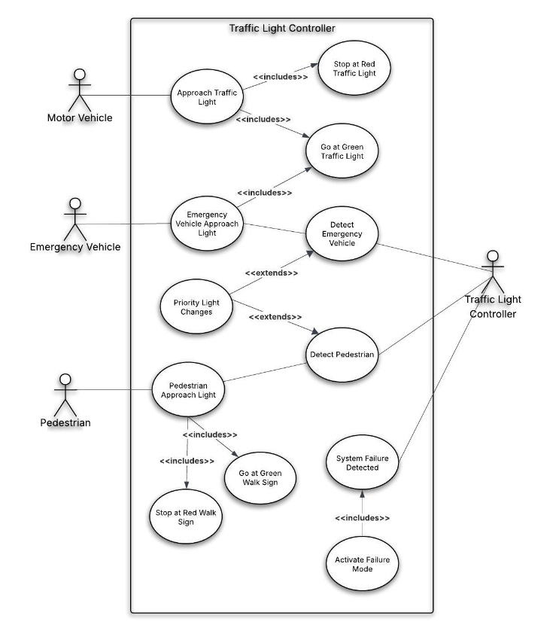
Figure 1: Use-Case Diagram

Entity Relationship Diagram
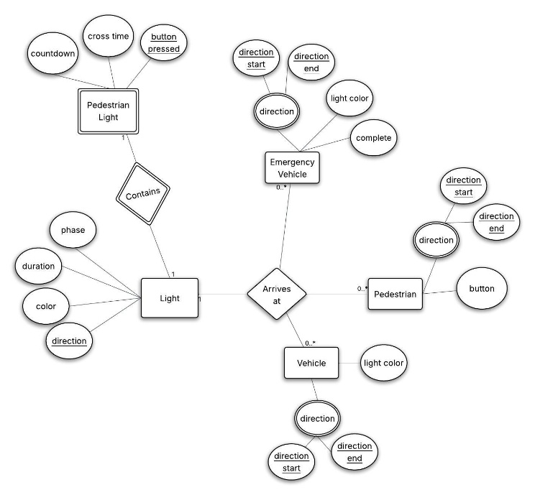
Figure 2: Entity Relationship Diagram (ERD)

Testing
To ensure complete testing coverage, Black-Box Testing was utilized to cover each functional and non-functional requirement. Black-Box Testing was centered around how the software was deployed and ran from a user’s perspective. Functional Black-Box Testing was performed to verify the system’s features and requirements. To guarantee the system satisfies the business requirements and operates as intended, a series of test cases were designed around each of the requirements. Internal logic and code structure was tested using White-Box Testing. Testing was conducted on each of the conditions, branches, and paths to establish comprehensive code coverage.

- Test Number | Name | Description
1 | Timing & Sequence | Test and confirm correct order of light phases, durations, and sequences.
2 | Pedestrian-Specific | Test and confirm pedestrian button press triggers correct controller WALK phase.
3 | Emergency Vehicle | Test and confirm light changes in response to sensed emergency vehicle.
4 | Normal Vehicle | Test and confirm intersection clearance and stop rules.
5 | Display & Feedback | Test and confirm user interface visuals occur when simulation begins running.
6 | Reliability | Test simulated traffic produces a consistent and deterministic result.
7 | Usability | Test that system functions in Windows and/or Linux operating environment.
8 | Modularity | Test that system has clearly separated components.
9 | Performance | Test traffic light changes occur within specified time parameters.
- Test Cases

Test Case 1: Timing & Sequence
- Description: Each light state of each traffic light occurs in specific orders, phases, durations, and sequences.
- Steps:
  - As changes in light color, phases, durations of the lights, and sequences are dependent on regular traffic, pedestrian traffic, or emergency vehicle traffic, allow 2 minutes to pass while documenting normal traffic flow, light durations, and sequence.
  - Select the ‘P’ key to begin the pedestrian phase. Confirm switching and duration light phases are correct.
  - Select the ‘E’ key to being the emergency vehicle phase. Confirm switching and duration light phases are correct.
- Outcome: The system successfully completed the light orders in the correct phase as well as for the correct duration of each phase and light.

Test Case 2: Pedestrian-Specific
- Description: Test and confirm pedestrian button press triggers correct controller WALK phase.
- Steps:
  - While the simulation is running, select the ‘P’ button to trigger the pedestrian phase.
  - The “WAIT” indicator remains active until all vehicles have stopped at the stop line.
  - The “WALK” indicator becomes active and the pedestrian walks across the crosswalk.
  - A visual countdown of 20 seconds is displayed and timing enforced.
  - During the crossing phase, ‘P’ button presses are ignored.
- Outcome: The system successfully completed the pedestrian phase.

Test Case 3: Emergency Vehicle
- Description: Test and confirm light changes in response to sensed emergency vehicle.
- Steps:
  - While the simulation is running, select the ‘E’ button to trigger an emergency vehicle.
  - Normal cars inside the intersection cleared the intersection to prevent blockages.
  - Visual indication that emergency vehicle mode has begun is displayed to screen.
  - Traffic light signal switching occurs to provide the emergency vehicle with clearance to pass through the light.
  - Normal operations were restored after the emergency vehicle completed its phase.
- Outcome: The system successfully completed the emergency vehicle phase, utilizing the emergency preemptive logic.

Test Case 4: Normal Vehicle
- Description: Test and confirm intersection clearance and stop rules.
- Steps:
  - Using the user interface, either:
    - Allow 1 minute to pass to ensure enough normal vehicles have populated the simulation
    - Spawn normal vehicles using the ‘R’ key
  - The system enforces, for each light, the stop line for the head of the normal vehicle queue.
  - The system enforces queue spacing for stopped vehicles.
  - Using the user interface, the ‘E’ button is selected while normal vehicles are within the intersection.
- Outcome: Normal vehicles stopped at their required locations and intersections were not blocked during emergency vehicle operations were verified successfully.

Test Case 5: Display & Feedback
- Description: Test and confirm user interface visuals occur when simulation begins running.
- Steps:
  - While the simulation is running, the current state of the RTOS is displayed to screen to provide the user with current state information.
  - The system responds to the emergency vehicle key press and begins the emergency vehicle phase.
    - There are clear indicators displayed to screen that the state of the RTOS has begun the emergency vehicle phase.
    - A visualization of the emergency vehicle passing through the traffic light is displayed to the screen.
  - The system responds to the pedestrian key press and beings the pedestrian phase.
    - There are clear indicators displayed to screen that the state of the RTOS has begun the pedestrian phase.
    - The ‘WAIT’ sign changes to ‘WALK’
    - A visualization of the pedestrian walking across the crosswalk is displayed to the screen.
- Outcome: The system successfully displays the necessary visualizations to the user.

Test Case 6: Reliability
- Description: Validate there are no indeterministic results when numerous vehicles and pedestrians are spawned.
- Steps:
  - Light sequence and durations are checked and recorded over 10 separate 20-minute periods.
- Outcome: Simulated traffic produces a consistent and deterministic result.

Test Case 7: Usability
- Description: Test that system functions in Windows and/or Linux operating environment.
- Steps:
  - Run the simulation in a Windows operating environment.
  - Run the simulation in a Linux operating environment.
- Outcome: The simulation successfully ran in separate tests for both operating environments.

Test Case 8: Modularity
- Description: Ensure system has loosely coupled components, enabling independent maintenance, testing, and updates.
- Steps:
  - After the simulation has been activated, cycle through triggering the different possible events and controls to ensure triggering a phase does not impact another element or control.
- Outcome: Triggering the emergency vehicle phase caused normal vehicles in the intersection to freeze. Code was updated, then test carried out again without issue. Test provided verification of separated components.

Test Case 9: Performance
- Description: Test traffic light changes occur within specified time parameters.
- Steps:
  - After the simulation has begun, activate the pedestrian walk phase.
  - Activate the emergency vehicle phase.
  - Cycle through different activations to ensure specified time parameters remain deterministic.
- Outcome: Phases occurred within the allocated timers successfully for every instance that was run.

Implermentation
A demonstration of our RTOS traffic light system that prioritizes pedestrians and emergency vehicles can be found at: https://youtu.be/w7sQMiFTz9Q

Function Name | Inputs | Outputs | Written By You | Short Description
SignalState | Enum | None | Yes – custom helper | Creates the red, yellow, and green states of each traffic light.
Phase | Enum | None | Yes – custom helper | Creates the different phases possible, including all red, emergency, and pedestrian walk.
Direction | Enum | None | Yes – custom helper | Creates each direction.
Helper Functions
clamp | v, lo, hi | Floating point – value between lo & hi | Yes – custom helper | Restricts a value between a minimum and maximum specified range.
draw_text | surface, text, font, color, pos, center | None | Yes – custom helper for displaying text | Draws text onto the screen at specified points.
lerp | a, b, t | Floating point – interpolated value between a & b | Yes – custom helper | Linearly interpolates between 2 values. Used to smooth movement of animations.
Vehicle Class Functions
init | self, direction, emergency | None | Yes – initialization | Creates a vehicle, sets its direction, size, speed, color, and starting position.
first_position | self | Floating point - front of vehicle | Yes – custom helper | Used to tell whether a vehicle has reached the stop line.
stop_line_position | self | Int -stop-line coordinate | Yes – custom helper | Returns the stop line coordinate the vehicle must obey.
signal_group | self | String – NS or EW | Yes – custom helper | Tells whether the vehicle belongs to the North-South group or the East-West group.
is_inside_intersection | self | Boolean – Vehicle inside of intersection or not | Yes – custom helper | Checks whether the vehicle is currently inside the intersection box.
passed_intersection | self | Boolean – Vehicle passed intersection or not | Yes – custom helper | Checks whether the vehicle has moved completely off the screen and can be removed.
rect | self | Rect Object - rectangle for drawing & collision | Yes – custom helper for building visualizations | Builds the Pygame rectangle used for collision checks and drawing.
has_crossed_stop_line | self | Boolean – vehicle has passed intersection stop line | Yes – custom helper | Determines if the vehicle has already crossed the stop line/intersection and is moving away from it.
is_approaching_stop_line | self | Boolean – Approaching or not approaching stop line. | Yes – custom helper | Determines if the vehicle is approaching the stop line. Defines the only situation where a car is allowed to stop.
distance_to_lead_vehicle | self, other | Floating point – distance value. | Yes – custom helper | Measures how far the current vehicle is from the lead vehicle in that queue to ensure safe spacing and queue behavior.
blocked_by_lead_vehicle | self, vehicles, controller | Boolean – vehicle is blocked by a car ahead of them or not. | Yes – custom helper | Prevents emergency vehicles from getting stuck in the queue behind normal vehicle traffic.
can_move | self, controller, vehicles | Boolean – Vehicle moves or stops. | Yes – project function | Main movement decision function. Determines if a car should move or stop.
update | self, controller, vehicles | None | Yes – project function | Updates the vehicle’s position and state in each frame.
draw | self, controller, vehicles | None | Yes – custom helper for displaying vehicles | Draws the vehicle on the screen.
Pedestrian Class Functions
init | self, start_pos, end_pos, duration | None | Yes – initialization | Creates a pedestrian with a start point, end point, and crossing duration.
update | self, dt | None | Yes – project function | Advances the pedestrian’s crossing progress over time.
draw | self, surface | None | Yes – custom helper for displaying pedestrian | Draws the pedestrian as a simple stick figure at its current interpolated position.
RTOS Related Functions
init | self, name, period, priority, callback | None | Yes – initialization | Creates a scheduled task. Includes name, run period, priority, and callback function to execute.
tick | self, dt | None | Yes – custom helper for RTOS clock functions | Accumulates elapsed time for the task. The internal timer is updated.
ready | self | Boolean – if tasks should run or not. | Yes – custom helper for RTOS functions | Checks if enough time has passed for the task to run again.
run | self | None | Yes – project function | Runs/executes the task callback and subtracts one period from the timer.
RTOS Functions
init | self | None | Yes – initialization | Creates the RTOS scheduler and an empty task list.
add_task | self, task | None | Yes – project function | Adds a task to the scheduler.
update | self, dt | None | Yes – project function | Simulates the RTOS scheduler by updating all task timers, finding ready tasks, sorting tasks by priority, and running tasks in priority order. i.e. it runs the scheduled tasks.
Traffic Controller Class Functions
init | self | None | Yes – initialization | Initializes the intersection controller state's current phase, timers, light colors, pedestrian request state, and emergency request state.
request_pedestrian | self | None | Yes – project function | Triggers the pedestrian phase by registering a pedestrian crossing request unless one is already active.
request_emergency | self, direction | None | Yes – project function | Triggers the emergency phase by requesting an emergency vehicle request and stores its direction.
set_ns | self, state | None | Yes – project function | Sets the North-South signal color.
set_ew | self, state | None | Yes – project function | Sets the East-West signal color.
set_all_red | self | None | Yes – project function | Turns both light directions red for safe transition.
start_ped_walk | self | None | Yes – project function | The pedestrian crossing phase begins by switching all lights to red, starts 20-second countdown, clears pending pedestrian requests, and created animated pedestrians to cross the road.
start_emergency_phase | self | None | Yes – project function | Beings the emergency vehicle phase by stopping normal traffic, turning the emergency vehicle's direction green, prevents conflicting green lights, and cancels pedestrian movement during the emergency.
end_emergency_phase | self | None | Yes – project function | Ends the emergency phase and transitions safely back to normal operation through all-red.
update | self, dt, vehicles | None | Yes – project function | Central traffic logic function that controls normal light color cycling, all-red transitions, pedestrian walk phase timing, emergency preemption mode, and ends emergency mode when the emergency vehicle has cleared. This is our brain and controller for the traffic lights.
draw status | self, surface | None | Yes – custom helper for displaying text | Draws status text on the screen of current phase, pedestrian status, controls, and if an emergency is active.
Vehicle System Class Functions
init | self, controller | None | Yes – initialization | Creates the vehicle manager and stores a reference to the controller.
spawn_normal | self | None | Yes – project function | Creates a normal vehicle in a random direction.
spawn_emergency | self | None | Yes – project function | Creates an emergency vehicle in a random direction and notifies the controller.
update | self, dt | None | Yes – project function | Updates all vehicles by spawning new vehicles at random intervals, updates movements, and removed off-screen vehicles.
draw | self, surface | None | Yes – custom helper for displaying all vehicles | Draws all vehicles.
Drawing Functions
draw_dashed_center_line | surface, start, end, vertical | None | Yes – custom helper for displaying dashed center lines | Draws dashed yellow center lines on the roads.
draw_crosswalk | surface, rect, vertical | None | Yes – custom helper for displaying crosswalks | Draws zebra-style crosswalk stripes.
draw_signal | surface, x, y, state, label | None | Yes – custom helper for displaying signals | Draws a traffic signal box with red, yellow, and green lights.
draw_ped_signal | surface, x, y, active, countdown_text | None | Yes – custom helper for displaying pedestrian signals | Draws the pedestrian signal box showing WALK or WAIT and the countdown.
draw_scene | surface, controller, vehicle_system | None | Yes – custom helper for displaying the scene | Draws the full scene that includes the grass, roads, lane markings, stop lines, crosswalks, traffic lights, pedestrian signals, pedestrians, vehicles, and status text.
Main Program Function
main | None | None | Yes – project function | Main program entry point that creates the controller, vehicles manager and RTOS scheduler. It also adds RTOS tasks, runs the main Pygame loop, processes keyboard input, advances the simulation in fixed timer intervals/steps, redraws the screen each frame, and exists when the user selects the esc button.

- Call Table Implementation Displaying Function Call Information

Documentation
A collaborative, multi-stage review process was used throughout the development of this project. Each team member was assigned primary responsibility for specific sections, while the other member performed secondary review and validation. This approach ensured that all work was cross-checked, reducing the likelihood of overlooked errors and improving overall quality. Given the small team size, this peer-review process was critical in maintaining accuracy and consistency across all components of the project. The following tasks were completed by each member:
Jacob Wald | Erika Valle-Baird
- Concept  - Literature Survey  - State of the Art  - Functional & Non-functional Requirements  - Project Design  - Conclusion  - References | - PyGame RTOS Implementation  - Test Cases  - Diagrams  - Gantt Chart  - Call Table  - Project Design  - User Manual  - Results
Figure 3: Project Schedule
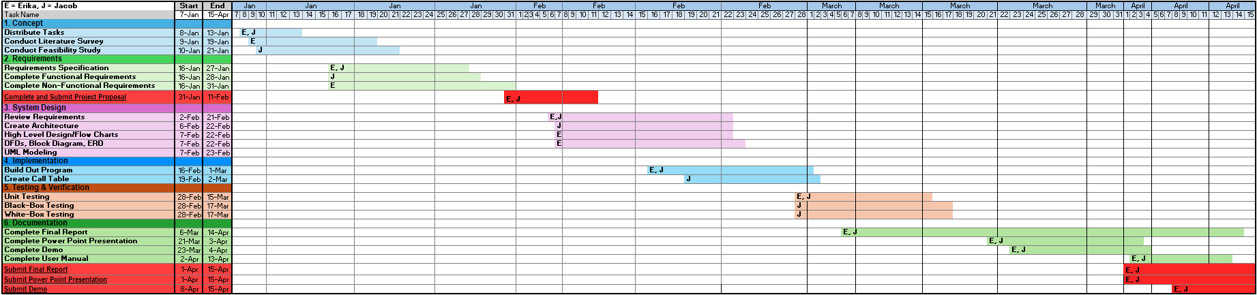

User Manual
GitHub was utilized to store our repository and make it accessible. Navigate to the following link: https://github.com/Airikuh/TrafficLightController
To run the application on your device:
- Clone the repository on your personal machine via git clone {https://github.com/Airikuh/TrafficLightController}
- If your device does not have the required Python library Pygame:
  - Open the command prompt on your personal machine.
  - Type and run the command: ‘pip install pygame’.
- Navigate to the folder location using the cd command.
  - If not specified, cloned repositories are typically stored within the GitHub folder located inside your Documents folder.
- Run the simulation via ‘python main.py’

This simulation allows the user to control spawning of normal vehicles, emergency vehicles, and pedestrians.
To control the simulation, use the following keys:
- ‘R’: Generates a normal vehicle from a random direction.
  - Vehicles will be spawned randomly without the use of the ‘R’ key. However, this allows the user to add additional vehicles at their liking.
- ‘P’: Generates a pedestrian walk request.
- ‘E’: Generates an emergency vehicle.
- ‘esc’: Stops the simulation and exits the user interface window.

Results
Due to paywall constraints when attempting to gather real-time traffic data, the decision to pivot to a fully simulated traffic system was made.
To ensure the simulated traffic behaved using RTOS:
- Tasks were periodic and priority-based
- The traffic controller behaved like a real-time state machine
- Vehicle behavior was reactive to the shared state.

The implemented real-time scheduled traffic system safely coordinated vehicles, pedestrians, and emergency vehicles using priority-driven task execution and state-machine control. The RTOS system used periodic tasks, deterministic timing, and different priority levels.
In an effort to remain true to Real-Time Operating Systems and Embedded Systems, the following was employed:
- RTOS Scheduler that runs periodic tasks based on priority and timing
- Preemptive Priority Scheduling
  - Guaranteed Safety: Priority Enforcement
- Finite State Machine: Simulated as a Traffic Controller
- System Clock: Fixed Time-Step Simulation

An RTOS kernel was implemented using a task scheduler. The following variables and tasks were implemented to perform and ensure the system simulated real RTOS tasks:
- Imitates an RTOS Task Table: task_list
- Preemptive Priority Scheduling Enforced: priority
- Clock Tick acts as the system timer interrupt: tick()
- A Task must become Ready before it can run: ready( )
- Task Execution: run( )

RTOS Schedule Model
The RTOS Scheduling Model was developed around:
- Normal traffic light cycles
- Pedestrian crossings (with safety timing)
- Emergency vehicle priority
Task | Priority | Period | Description
Traffic Control | High | 0.05s | Updates Signal States
Vehicle System | Medium | 0.02s | Moves & Spawns Vehicles
Background | Low | 0.10s | Idle
- RTOS Scheduling Model - Tasks

RTOS Scheduling Model Behavior Included:
- Tasks accumulate time → run when ready
- Scheduler runs highest priority first
- Simulates preemptive embedded system behavior

Finite State Machine
To manage the different signal phases and system states, a simulated finite state machine in the form of the traffic controller was implemented. This allowed us to control functions, as well as employ synchronous and asynchronous communication methods.
The Finite State Machine Traffic Controller:
- Managed Signal Phase & System State
  - Phase transitions
  - Timing logic
  - Interrupt-like requests (emergency/pedestrian)

System Clock
In order to avoid deadlocked tasks, confirm interrupts were active, and the scheduler was functioning, we utilized a fixed time-step simulation to represent the system clock. A periodic signal that was generated by a task and timer, providing a simulated system clock tick. Additionally, like an embedded microcontroller and real RTOS tick, deterministic timing was ensured, pedestrians were provided with 20 seconds or more to cross the intersection, and emergency vehicles are always immediately handled.

Simulated Embedded System Tasks
With the aim of representing tasks similar to real embedded systems, subsystem control tasks were simulated and represented by traffic control tasks, vehicle tasks, and background tasks.

Traffic Control Tasks
Acting as our traffic control and firmware task, the traffic controller management included the traffic lights, pedestrian phase, and emergency overrides. The central traffic logic controls normal light color cycling, all-red transitions, pedestrian walk phase timing, emergency preemption, and ending emergency mode after the emergency vehicle has cleared the intersection. Additionally, when evoking the emergency phase, this control stopped normal traffic, changed the lights to green for only the emergency vehicle’s direction, prevented conflicting green lights, controlled entry and exit during special phases, and canceled pedestrian movement during the emergency to safeguard a pedestrian from being stuck by an oncoming emergency vehicle.

Vehicle System Control Tasks
Vehicle system tasks were simulated sensor and actuator update loops. Here, a continued and iterative process simulated sensors monitoring the simulated environment with actuators manipulating that environment. Vehicle positions, movement rules, periodically spawned new vehicles, removal of off-screen vehicles, and collision spacing were updated frequently to represent real conditions.

Background Control Tasks
To manage and control background idle tasks found in real-time operating systems, a background tasks manager was employed. This manager provides the system with information on what can be run when nothing else needs the CPU.

Preemptive Priority Scheduling
Preemptive Embedded System behavior was simulated using preemptive priority scheduling. When handling multiple tasks that are ready at the same time or if a new task arrives, preemptive RTOS behavior chooses the highest priority tasks to preempt the currently running task. In the same manner, we chose priority-based task execution with the highest priority going to traffic control, medium priority to vehicle systems, and the lowest priority of background tasks. By utilizing this priority enforcement, safety was guaranteed in both the RTOS resource protection and real-time constraint handling for emergency vehicles and pedestrians. Priority-based task execution prioritized safety by preventing pedestrians from crossing during the emergency phase, as well providing emergency vehicles with the highest priority, pedestrian crossing the second highest priority, and normal traffic the lowest priority.

Safety Mechanisms
Safety mechanisms were employed for emergency vehicles, pedestrians, and phase changes. Real-time constraint handling for emergency vehicles included forcing the system into a safe state during emergencies, and immediately overriding all other tasks. RTOS resource protection was developed for pedestrians by utilizing deterministic timing and preventing reentrancy bugs. Finally, safety was ensured through controlled entry and exit during the emergency vehicle and pedestrian special phases, and guaranteeing the absence of conflicting green lights.

Conclusion
This project demonstrated that a deterministic, RTOS-based traffic light controller can effectively manage intersection safety while operating within the constraints of low-cost, resource-limited environments. By leveraging priority-based scheduling, bounded response times, and a finite state machine design, the system successfully coordinated normal traffic flow, pedestrian crossings, and emergency vehicle preemption without introducing unsafe conditions or conflicting signals. Unlike modern AI- and vision-driven traffic systems, which prioritize optimization and require significant computational and infrastructural investment, the proposed approach emphasizes predictability, reliability, and accessibility. The results show that meaningful improvements in traffic safety and control can be achieved using modest embedded system principles, making this solution particularly suitable for smaller municipalities or scenarios where advanced smart-city infrastructure is impractical. Overall, this work reinforces the value of real-time systems design in safety-critical applications and highlights a viable alternative to increasingly complex traffic management solutions.

references
- [1] S. S. Chavan, R. S. Deshpande and J. G. Rana, "Design of Intelligent Traffic Light Controller Using Embedded System," 2009 Second International Conference on Emerging Trends in Engineering & Technology, Nagpur, India, 2009, pp. 1086-1091, doi: 10.1109/ICETET.2009.76.
- [2] S. Chiu and S. Chand, "Adaptive Traffic Signal Control Using Fuzzy Logic," 1993 IEEE International Conference on Fuzzy Systems, San Francisco, CA, USA, 1993, pp. 1371-1376.
- [3] Z. Bundalo, M. Veljko, D. Bundalo, G. Kuzmić, M. Sajić, and A. Ramakić, "Energy Efficient Embedded Systems for LED Lighting Control in Traffic," 8th Mediterranean Conference on Embedded Computing (MECO), Budva, Montenegro, 2019, pp. 1-4, doi: 10.1109/MECO.2019.8760048.
- [4] L. Cai, Z. Li, Y. Zhong, P. Lin and F. Zhang, "Design and Optimization of Intelligent Traffic Light Based on STM32 Microcontroller," in Proceedings of the 2024 International Symposium on Integrated Circuit Design and Integrated Systems (ICDIS 2024), Xiamen, China, Nov. 22-24, 2024, ACM, New York, NY, USA, 6 pages.
- [5] H. Kulhandjian, W. Greives, and M. Kulhandjian, "Smart Traffic Light Controller using Visible Light Communications," IEEE Vehicle Power and Propulsion Conference (VPPC), Merced, CA, USA, 2022, pp. 1-6, doi: 10.1109/VPPC55846.2022.10003305.
- [6] D. Baskar, S. Pragadeswaran, N. Ragupathi, U. S. Praveen, S. Preethi, and S. R. Vishnu Kumar, "IoT-based Smart Traffic Management System," in 2025 7th International Conference on Inventive Material Science and Applications (ICIMA), Namakkal, India, May 2025, doi: 10.1109/ICIMA64861.2025.11074196.
- [7] L. Wu, R. Zhang, R. Zhou and D. Wu, "An edge computing based data detection scheme for traffic light at intersections," Computer Communications, vol. 176, pp. 91-98, 2021.
- [8] M. M. Elkhatib, A. I. Adwan, A. S. Alsamna and A. M. Abu-Hudrouss, "Smart Traffic Lights using Image Processing Algorithms," 2019 IEEE 7th Palestinian International Conference on Electrical and Computer Engineering (PICECE), Gaza, Palestine, 2019, pp. 1-6, doi: 10.1109/PICECE.2019.8747225.
- [9] I. Gokasar and A. Timurogullari, "Real-Time Prediction of Traffic Density with Deep Learning Using Computer Vision and Traffic Event Information," in 2021 International Conference on Innovations in Intelligent Systems and Applications (INISTA), Kocaeli, Turkey, Aug. 2021, doi: 10.1109/INISTA52262.2021.9548434.
- [10] H. Wei, G. Zheng, H. Yao and Z. Li, "IntelliLight: A Reinforcement Learning Approach for Intelligent Traffic Light Control," in Proceedings of the 24th ACM SIGKDD International Conference on Knowledge Discovery & Data Mining (KDD '18), London, United Kingdom, Aug. 19-23, 2018, ACM, New York, NY, USA, 10 pages.
- [11] T. Chu, J. Wang, L. Codecà and Z. Li, "Multi-Agent Deep Reinforcement Learning for Large-scale Traffic Signal Control," arXiv preprint arXiv:1903.04527, 2019.
- [12] B. Muyombo, H. Vadapalli, "Enhancing Urban Traffic Flow: An AI-Driven Traffic Light Management System", Procedia Computer Science, Volume 270, June 2025, Pages 3848-3859, ISSN 1877-0509, https://doi.org/10.1016/j.procs.2025.09.510.
- [13] R. M. Khaleefah, "An Intelligent Traffic Control System using Edge-Cloud Computing and Deep Learning for Smart Cities," International Journal of Engineering Research & Technology (IJERT), vol. 14, no. 07, July 2025, doi: 10.17577/IJERTV14IS070169.
- [14] M. Raza, M. Kazmi, H. M. Kidwai, H. R. Khan, S. A. Qazi, K. Arshad and K. Assaleh, "An Edge-Deployed Real-Time Adaptive Traffic Light Control System Using YOLO-Based Vehicle Detection and PCE-Aware Density Estimation," IEEE Access, vol. 13, 2025.

