Erika Valle-Baird

CIS 285: Software Engineering Tools

University of Michigan Dearborn

Lab 3 Git

February 2, 2023

**

Add local repository:

Add file:

Added code to duck file:

When attempting git diff nothing happens:

**Task 2**- creating tom branch:

Can see in Tom branch now

Add swim method:

Ensuring the changes were made by opening up the doc in git

Switch back to master branch:

**Task 3**: under Bob branch

Check log and check file was changed with git opening up the file

Switch back to master

Ensuring back in master branch:

Task 4 Merging:

(accidentally wrote Ton instead of Tom the first time)

Making sure it merged correctly before continuing:

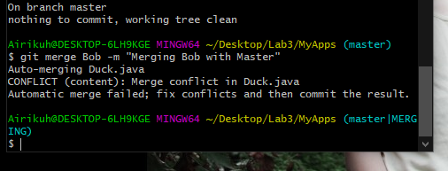

Merging Bob:

**Didn’t fix the file correctly, redid and reran-

**Gitk**:

Ensured the hidden items were made available before zipping:

