
Submitted by-
Airin Afroj Aishi
ID:0242320012091064
Batch: 18 (A)
Semester: Fall-2024
Department of Computing and Information System

Submitted to-
MD. Faruk Hosen Sir
Lecturer
Department of Computing and Information System
Semester Project On -
Operating System
CIS232L
Semester Fall-2024

Lab Part

a. Introduction
The Vehicle Rental System is created to automate the process of vehicle management for Daffodil International University (DIU). The system will allow Transport Managers to manage the vehicles by adding, updating, and removing vehicles. It also provides an interface for staff and students to view available vehicles, rent vehicles, and return them. The system keeps track of rental logs, calculates rental costs, and applies late fees when its necessary.

b. Objective
The main objective is to make an automated user-friendly system that is useful for both the management and students in Daffodil International University.

c. Methodology
I have used following methodology:
- Main Menu: A main menu is displayed to users, offering the options for Transport Managers or Staff/Students. User can select an option to exit the program.
- Manager Functions: The manager can add, update, or remove vehicles using a simple menu and communicates with the vehicles.csv and rental_log.csv files. The manager must input a password to access these functionalities.
- Student Functions:
Students/staff can view available vehicles, rent a vehicle (by entering the registration number, rental days, and university ID), and return a vehicle.
The rental fee is calculated based on the duration of the rental, and late fees (10) are applied if the vehicle is returned after the specified rental period.
- File Handling: The system stores vehicle information (vehicles.csv) and rental logs (rental_log.csv). The sed command is used to update vehicle availability and prices in the vehicles.csv file. Rental records are logged into the rental_log.csv file for future reference.

d. Tools and Technology
Programming Language: Bash (Shell scripting)
File Handling: CSV files (vehicles.csv and rental_log.csv)
Tools/commands: grep, sed, cut, echo, read for processing user input and manipulating files.
Text Editors: Visual Studio Code and notepad++ to write the script and git bash to run in terminal.

e. Expected Outcome/ Screen Dumps:

output 1:
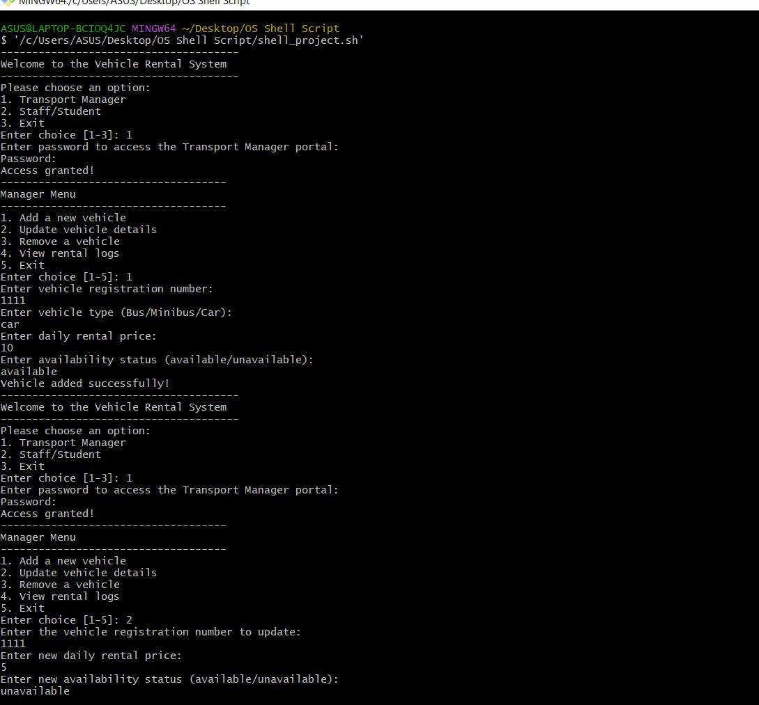

Output 2:
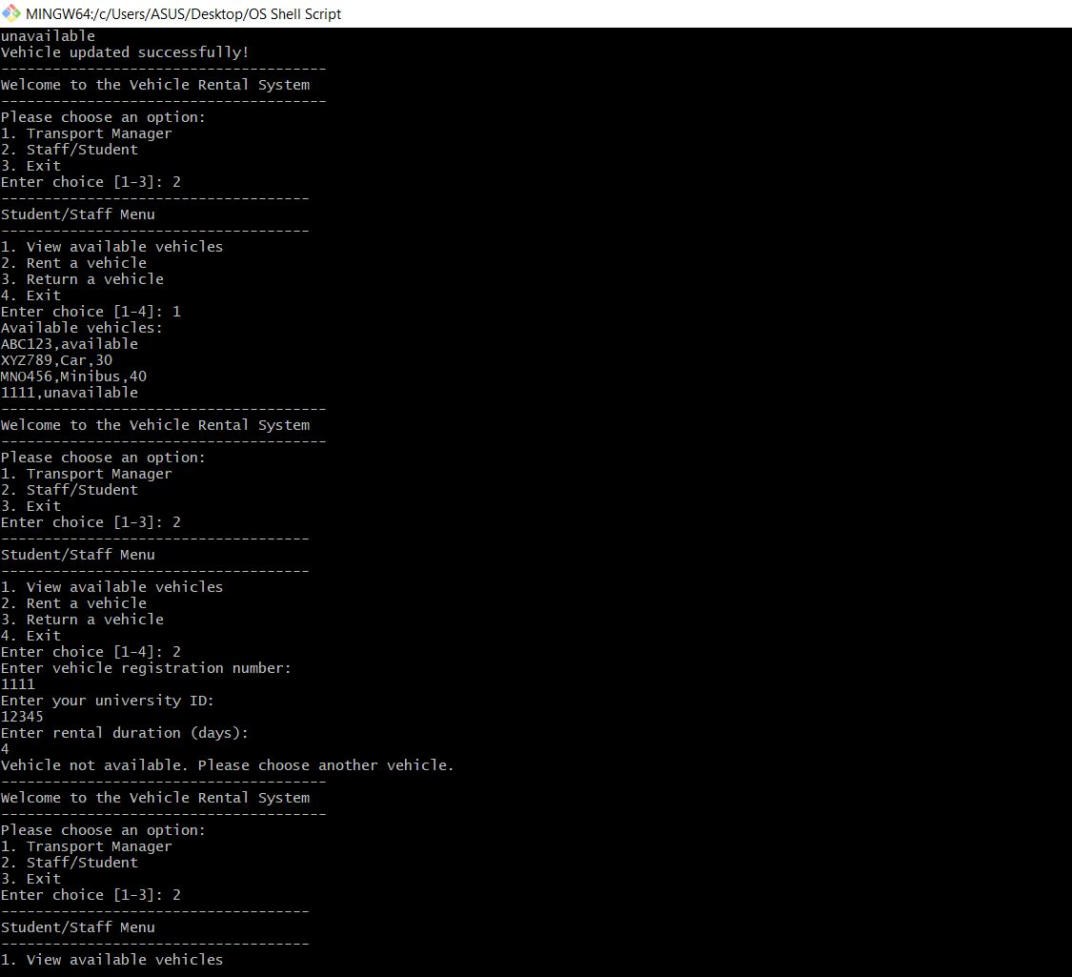

Output 3:

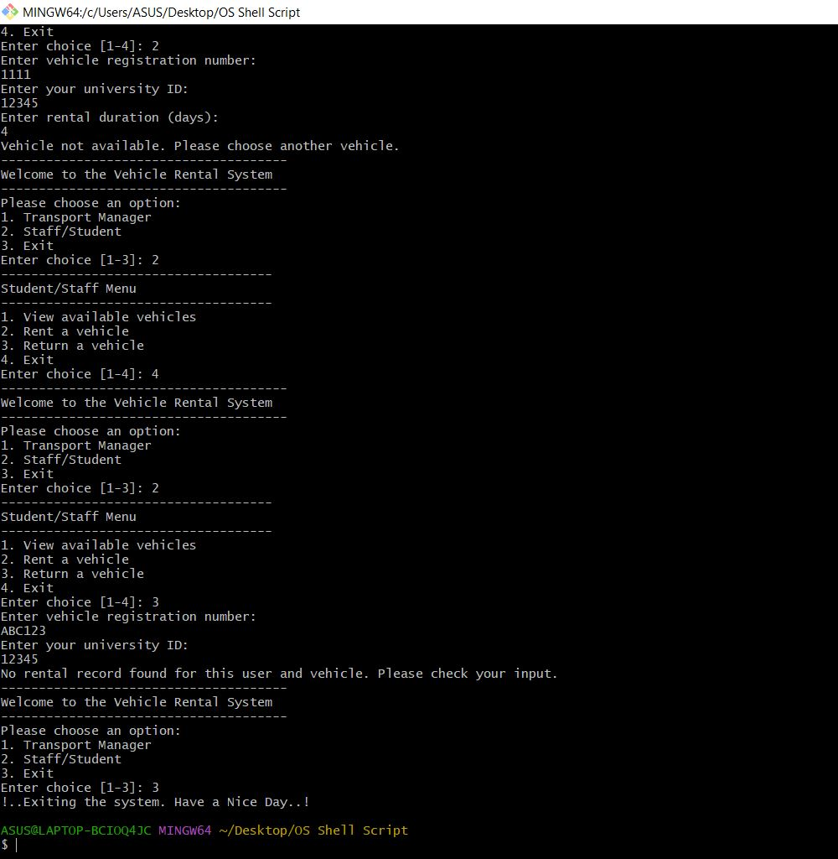

g. Codes:

#!/bin/bash
vehicle_file="vehicles.csv"
rental_log="rental_log.csv"
Main_menu=("Transport Manager" "Staff/Student" "Exit")
show_main_menu() {
echo "--------------------------------------"
echo "Welcome to the Vehicle Rental System"
echo "--------------------------------------"
echo "Please choose an option:"
for i in "${!Main_menu[@]}"; do
echo "$((i+1)). ${Main_menu[$i]}"
done
read -p "Enter choice [1-3]: " choice
}
manager_menu() {
echo "Enter password to access the Transport Manager portal:"
read -sp "Password: " password
echo

if [ "$password" == "1234" ]; then
echo "Access granted!"
echo "------------------------------------"
echo "Manager Menu"
echo "------------------------------------"
echo "1. Add a new vehicle"
echo "2. Update vehicle details"
echo "3. Remove a vehicle"
echo "4. View rental logs"
echo "5. Exit"
read -p "Enter choice [1-5]: " manager_choice

case $manager_choice in
1) add_vehicle ;;
2) update_vehicle ;;
3) remove_vehicle ;;
4) view_rental_logs ;;
5) return ;;
*) echo "Invalid option!" ;;
esac
else
echo "Incorrect password!"
fi
}
student_menu() {
echo "------------------------------------"
echo "Student/Staff Menu"
echo "------------------------------------"
echo "1. View available vehicles"
echo "2. Rent a vehicle"
echo "3. Return a vehicle"
echo "4. Exit"
read -p "Enter choice [1-4]: " student_choice

case $student_choice in
1) view_available_vehicles ;;
2) rent_vehicle ;;
3) return_vehicle ;;
4) return ;;
*) echo "Invalid option!" ;;
esac
}

add_vehicle() {
echo "Enter vehicle registration number:"
read reg_no
echo "Enter vehicle type (Bus/Minibus/Car):"
read type
echo "Enter daily rental price:"
read price
echo "Enter availability status (available/unavailable):"
read availability

# Append new vehicle details to the file we won't overwrite
echo "$reg_no,$type,$availability,$price" >> $vehicle_file
echo "Vehicle added successfully!"
}
update_vehicle() {
echo "Enter the vehicle registration number to update:"
read reg_no

# Check if vehicle exists
if ! grep -q "$reg_no" "$vehicle_file"; then
echo "Vehicle not found!"
return
fi
echo "Enter new daily rental price:"
read new_price
echo "Enter new availability status (available/unavailable):"
read new_availability

# Update the record means (replacing line which have 1st in reg_no)
sed -i "/^$reg_no,/s/\(.*\)/$reg_no,$new_availability,$new_price/" $vehicle_file

echo "Vehicle updated successfully!"
}

# Function to remove a vehicle
remove_vehicle() {
echo "Enter the vehicle registration number to remove:"
read reg_no

# Remove the vehicle from the file
sed -i "/^$reg_no,/d" $vehicle_file
echo "Vehicle removed successfully!"
}

# Function to view rental logs (manager)
view_rental_logs() {
echo "Rental Logs:"
cat $rental_log
}

# Function to view available vehicles (student)
view_available_vehicles() {
echo "Available vehicles: "
grep "available" $vehicle_file | cut -d',' -f1,2,4
}

# Function to rent a vehicle (staff/student)
rent_vehicle() {
echo "Enter vehicle registration number:"
read reg_no
echo "Enter your university ID:"
read uni_id
echo "Enter rental duration (days):"
read rental_days

# Check if vehicle is available
availability=$(grep "^$reg_no," $vehicle_file | cut -d',' -f3)
if [ "$availability" != "available" ]; then
echo "Vehicle not available. Please choose another vehicle."
return
fi

# Calculate rental cost
price=$(grep "^$reg_no," $vehicle_file | cut -d',' -f4)
total_cost=$(( price * rental_days ))

# Mark the vehicle as unavailable
sed -i "s/^$reg_no,.*/$reg_no,,$availability,$total_cost/" $vehicle_file

# Log the rental info
echo "$uni_id,$reg_no,$rental_days,$total_cost" >> $rental_log

echo "Vehicle rented successfully. Total rental cost: $total_cost"
}

# Function to return a vehicle (staff/student)
return_vehicle() {
echo "Enter vehicle registration number:"
read reg_no
echo "Enter your university ID:"
read uni_id

# Check rental log for matching rental
rental_info=$(grep "$uni_id,$reg_no" $rental_log)
if [ -z "$rental_info" ]; then
echo "No rental record found for this user and vehicle. Please check your input."
return
fi

# Extract rental details
rental_days=$(echo $rental_info | cut -d',' -f3)
total_cost=$(echo $rental_info | cut -d',' -f4)

# Calculate late fee if any
echo "Enter actual return date (in days):"
read actual_return_date
if [ "$actual_return_date" -gt "$rental_days" ]; then
late_fee=$(( (actual_return_date - rental_days) * 10 )) # Example late fee rate
total_cost=$((total_cost + late_fee))
echo "Late fee applied: $late_fee"
fi

# Mark the vehicle as available
sed -i "s/^$reg_no,.*/$reg_no,available,$total_cost/" $vehicle_file

# Remove rental record
sed -i "/$uni_id,$reg_no/d" $rental_log

echo "Vehicle returned successfully. Total fee: $total_cost"
}

# Main Program Execution
while true; do
show_main_menu
case $choice in
1) manager_menu ;;
2) student_menu ;;
3) echo "!..Exiting the system. Have a Nice Day..!"
exit 0 ;;
*) echo "Invalid choice. Please try again." ;;
esac
done

Vehicle_file.csv:

reg_no,type,availability,price_per_day
ABC123,available,250 12345
XYZ789,Car,unavailable,30
MNO456,Minibus,available,40

1111,unavailable,5
2222,bus,available,9

Rental_log.csv:

uni_id,reg_no,rental_days,total_cost
67890,XYZ789,3,90

note: I have attached the drive file link herewith

https://drive.google.com/drive/folders/1MDCD9MaYJE3OY7ctTWF4zk0g_v89hBhr?usp=sharing

