Name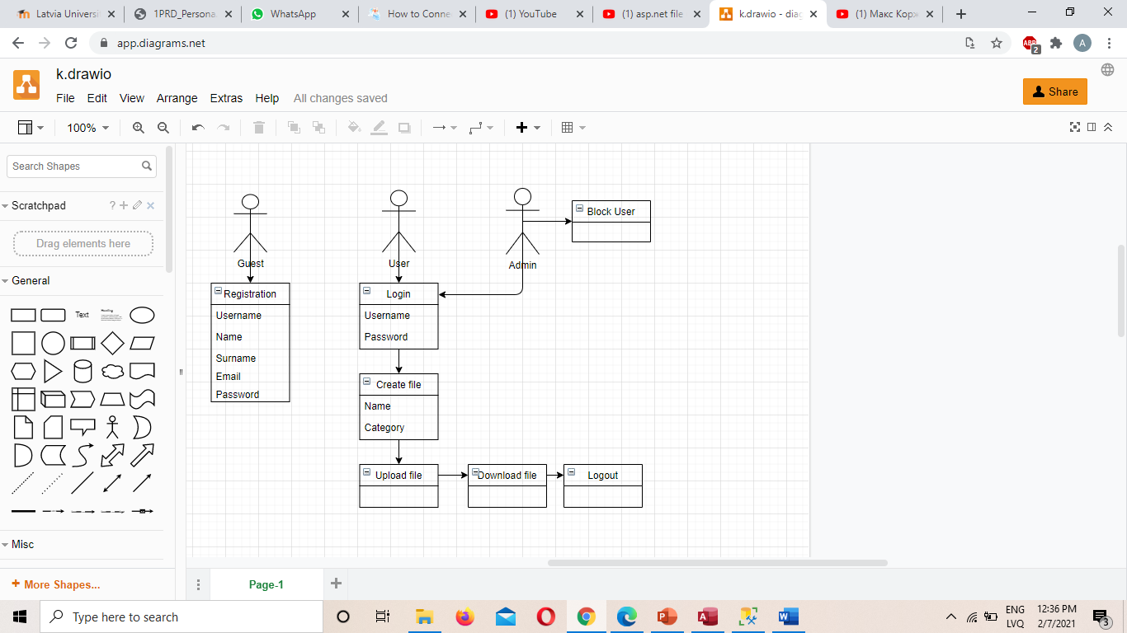

Username

Password

Register

Files

Login

Create

Surname

Confirm Password