目 录
1 作品简介 1
2 作品展示（图） 2
3 源代码 3

1 作品简介
2020的春天，一场疫情突袭中华大地。新型冠状病毒从爆发至今，围绕疫情的各种数据和信息成为大众了解事态的窗口。春节以来，关注各家新闻媒体关于疫情的报道已经成为了人们每天的必修课，而其中最为直观的说明方式莫过于疫情地图。可以说，这场疫情让大家充分感受到了大数据和数据可视化的魅力。人类是感官动物，人的大脑对视觉信息的处理优于对文本和数据的处理。所以，同样的信息内容，使用图像方式来呈现的话，可以帮助信息接受者快速了解，这正是数据可视化的作用所在。​
作品来源：本作品的数据集来源于b站的讨论群，群友爬取了外网上的“截止2020.5.11日的确诊人数、死亡人数、男女比、国籍等”信息。根据数据集内容和实际分析需求，实现各个功能，完成各项任务。从界面设计，到简单node.js、d3.js搭建，均由我一个人完成。因为现在Github中有很多地图的jason，所以我也整合了第三方开源地图包实现。
功能用途：本作品通过各国家颜色的不同，可以清晰地看出疫情在当前国家的严重程度，也能通过切换comfirm cases（确诊）、deaths（死亡）、cases/population（确诊人口比例）来查看不同的可视化地图数据。
技术特点：本作品目前主要集合了可视化地图、柱状图、折线图的可视化图表，用node.js起一个服务（即运行 http-server .）D3.js除了用强大来形容，就不知道怎么去来表达它的厉害之处了。里面的组件和实现效果真的眼花缭乱，只有你想不到，没有它办不到，这个也被视为js 可视化框架的鼻祖楷模。
2 作品展示
地图可视化图表
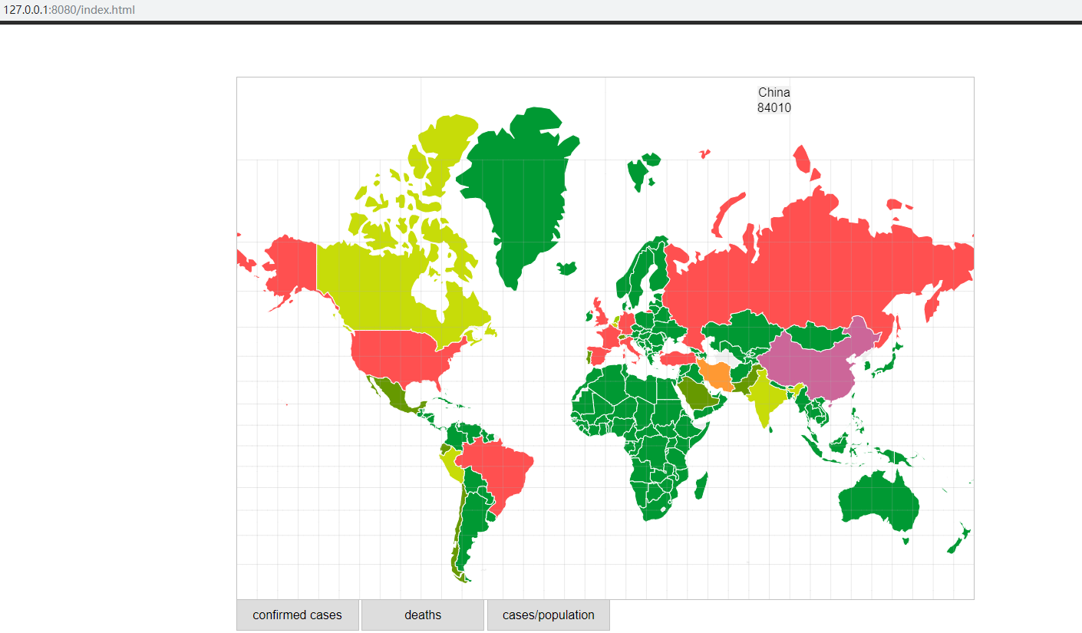
图2-1 comfirmed cases
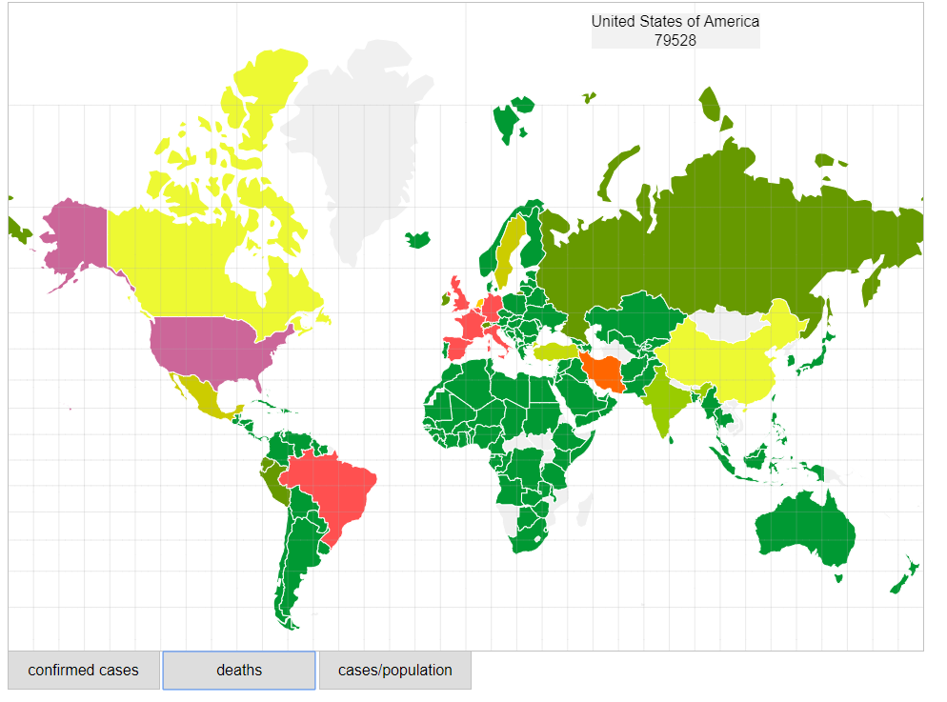
图2-2 deaths
地图可视化图表：下面有三个按钮，可以切换comfirm cases（确诊）、deaths（死亡）、cases/population（确诊人口比例）来查看不同的可视化地图数据。，也有交互式的设计，鼠标移到该国家上时，此国家会变紫色。鼠标悬停时，左上角出现对应数据。

柱状图
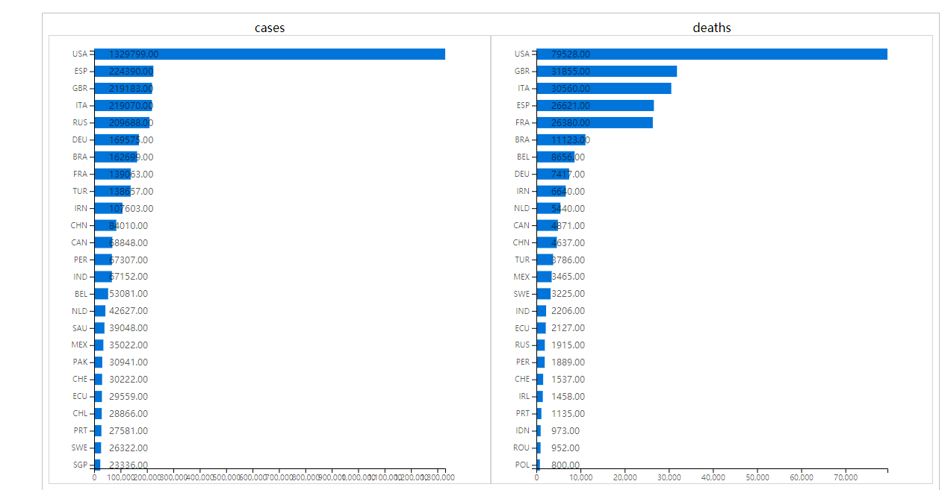
图2-3 cases\deaths 柱状图
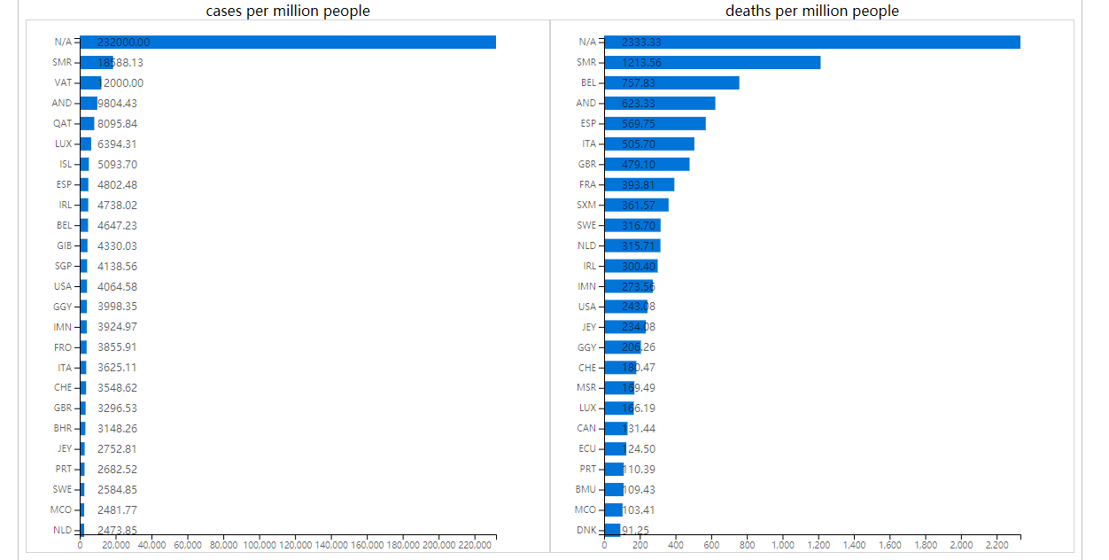
图2-4 cases\deaths per million people 柱状图

柱状图图表：按数据自动生成比例尺，在矩形上显示数据，以降序排列各国家，能清晰明了的看出疫情在各个国家发展的严重程度，及形成对比。

折线图
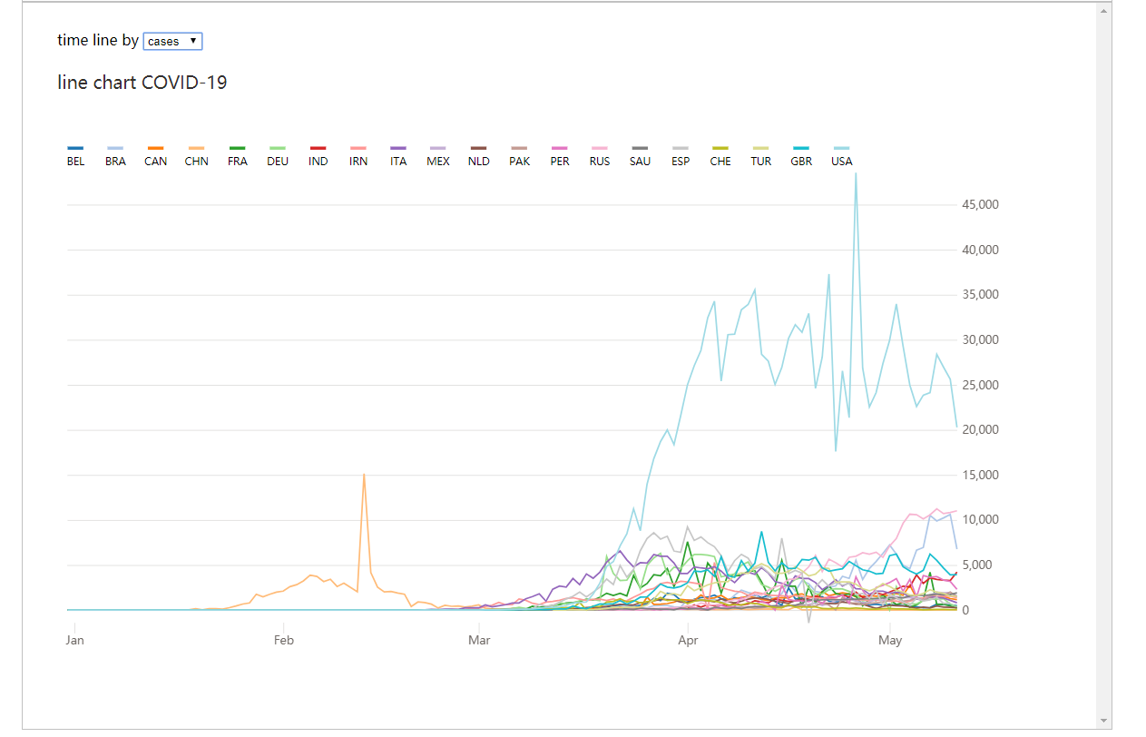
图2-5折线图
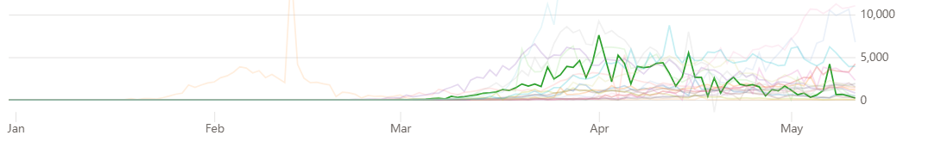
图2-6-1鼠标悬停在折线上
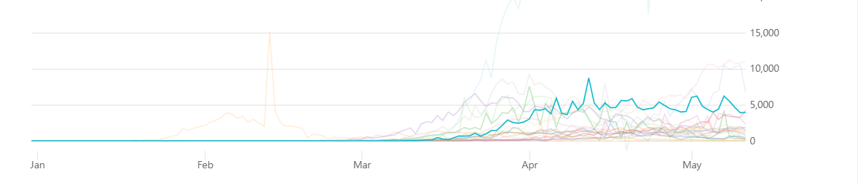
图2-6-2鼠标悬停在折线上
折线图图表：很容易就能看出该国家的疫情发展趋势，多条折线在同一图上，还能在不同国家之间进行对比，鼠标悬停在某一条折线上则其他折线会改变透明度，强调突出选中折线变换趋势。横坐标为月份。

男女比例图

图2-7 男女比例图
柱状图表：通过对男女死亡患者的比例来更直观的发现男性更容易在新冠状病毒中（COVID-19）死亡。

3 源代码
代码文件目录清单
 三个html页面，一个data.csv数据集，一个
图3-1 代码目录 world.json地图包。

关键代码：
1.地图可视化
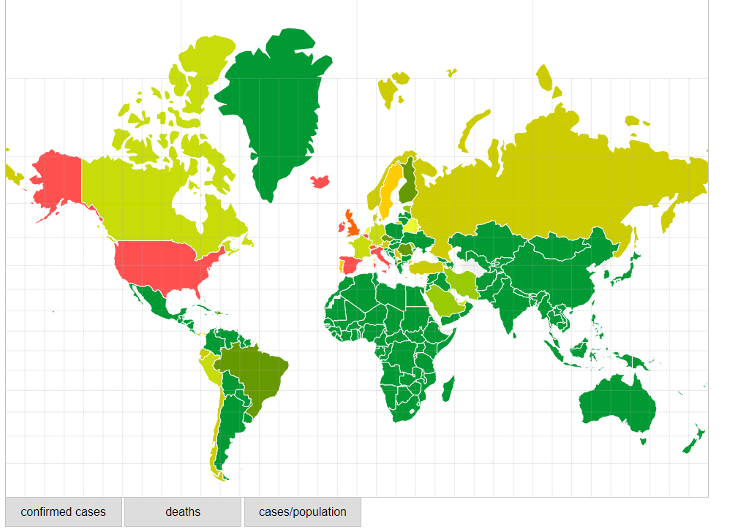
图3-2 接收报警示意图
部分代码：
<!DOCTYPE html>
<html>
<head>
<meta charset="utf-8" />
<style>
/* CSS goes here. */
body {
padding: 60px 0;
}
.map {
width: 960px;
height: 680px;
margin: 0 auto;
border: 1px solid #c1c1c1;
overflow: hidden;
}
.slider {
width: 960px;
margin: 0 auto;
height: 60px;
}
.slider > button {
margin-left: -1px;
width: 160px;
height: 40px;
border: 1px solid #c1c1c1;
border-top: none;
cursor: pointer;
font-size: 16px;
}
.subunit {
fill: none;
stroke: #fff;
stroke-width: 1px;
}
text.subunit-label {
font-family: 'Helvetica Neue', Helvetica, Arial, sans-serif;
font-size: 16px;
font-weight: 300;
text-anchor: middle;
fill: #000;
transform: translate(700px, 20px);
}
.subunit-label {
display: none;
}
.graticule {
fill: none;
stroke: #aaa;
stroke-opacity: 0.5;
stroke-width: 0.5px;
}
.bar {
margin-top: 20px;
width: 1200px;
height: 1400px;
min-height: 960px;
margin: 0 auto;
border: 1px solid #c1c1c1;
}
.line {
margin-top: 20px;
width: 1200px;
height: 800px;
margin: 0 auto;
border: 1px solid #c1c1c1;
}
.footer {
color: #fff;
margin: 100px auto;
width: 100vw;
padding: 20px 0;
}
.footer-title {
color: #333;
width: 1200px;
margin: 0 auto;
text-align: center;
}
.footer-conent {
width: 1200px;
margin: 0 auto;
display: flex;
justify-content: space-between;
}
.women {
height: 100px;
line-height: 100px;
font-size: 16px;
width: 37%;
text-align: center;
background-color: rgb(50, 145, 223);
}
.men {
height: 100px;
line-height: 100px;
font-size: 16px;
width: 63%;
text-align: center;
background-color: rgb(223, 99, 16);
}
</style>
</head>
<body onload="load()">
<!-- <script src="//d3js.org/d3.v3.min.js" charset="utf-8"></script> -->
<script src="https://cdn.bootcdn.net/ajax/libs/d3/3.5.17/d3.min.js"></script>
<script src="https://cdn.bootcdn.net/ajax/libs/topojson/1.6.20/topojson.min.js"></script>

<div class="map"></div>
<div class="slider">
<button name="cases" class="select-btn">confirmed cases</button>
<button name="deaths" class="select-btn">deaths</button>
<button name="cases/population" class="select-btn">cases/population</button>
</div>
<div class="bar">
<iframe id="iframe" width="100%" height="1400px" src="./bar.html" frameborder="0"></iframe>
</div>
<div class="line">
<iframe id="iframe" width="100%" height="800px" src="./line.html" frameborder="0"></iframe>
</div>

<div class="footer">
<div class="footer-title">
<h2 class="title-h1">Biological Sex is also a RISK-FACTOR</h1>
<h3 class="title-h2">% of COVID-19 deaths</h3>
</div>
<div class="footer-conent">
<div class="women">
37% WOMEN
</div>
<div class="men">
63% MEN
</div>
</div>
</div>
<!-- <script src="//d3js.org/d3.v3.min.js" charset="utf-8"></script>
<script src="//d3js.org/topojson.v1.min.js"></script> -->
<script>
/* JavaScript goes here. */
// globals used in graph
const btnList = document.getElementsByClassName('select-btn');
const list = Array.prototype.slice.call(btnList);
list.forEach((element) => {
element.onclick = function () {
d3.selectAll('body .map svg').remove(); // 移除svg节点
load(element.name);
};
});

function load(name = 'cases') {
var mapdata = {};
var palette = [
'#009933',
'#669900',
'#99cc00',
'#cccc00',
'#c7dc09',
'#edf933',
'#ffcc00',
'#ff9933',
'#ff6600',
'#ff5050',
];
var width = 960,
height = 960;
var minDocCount = 0,
quantiles = {};
// projection definitions
var projection = d3.geo
.mercator()
.scale((width + 1) / 2 / Math.PI)
.translate([width / 2, height / 2])
.precision(0.1);
var path = d3.geo.path().projection(projection);
var graticule = d3.geo.graticule();
// SVG related definitions
var svg = d3
.select('body .map')
.append('svg')
.attr({ width: width, height: height })
.append('g');
var filter = svg
.append('defs')
.append('filter')
.attr({ x: 0, y: 0, width: 1, height: 1, id: 'gray-background' });
filter.append('feFlood').attr('flood-color', '#f2f2f2').attr('result', 'COLOR');
filter
.append('feMorphology')
.attr('operator', 'dilate')
.attr('radius', '.9')
.attr('in', 'SourceAlpha')
.attr('result', 'MORPHED');
filter
.append('feComposite')
.attr('in', 'SourceGraphic')
.attr('in2', 'MORPHED')
.attr('result', 'COMP1');
filter.append('feComposite').attr('in', 'COMP1').attr('in2', 'COLOR');

svg.append('path').datum(graticule).attr('class', 'graticule').attr('d', path);

function keyPlusValue(arr) {
var obj = {};
arr.forEach(function (value) {
const { countryterritoryCode, cases, deaths, popData2018 } = value;
if (obj.hasOwnProperty(countryterritoryCode)) {
obj[countryterritoryCode].cases += parseInt(cases);
obj[countryterritoryCode].deaths += parseInt(deaths);
} else {
obj[countryterritoryCode] = {
countryterritoryCode: countryterritoryCode,
cases: parseInt(cases),
deaths: parseInt(deaths),
popData2018: parseInt(popData2018),
};
}
});
return Object.values(obj);
}

d3.csv('./data/data.csv', function (error, mockdata) {
const data1 = keyPlusValue(mockdata);

data1.forEach((item) => {
if (name === 'cases/population') {
item.key = item.countryterritoryCode;
item.doc_count = (item.cases / item.popData2018).toFixed(10);
} else {
item.key = item.countryterritoryCode;
item.doc_count = item[name];
}
});
const result = {
aggregations: {
world_map: {
buckets: data1,
},
},
};
mapdata = result;
draw(result);
});

function draw(data) {
d3.json('./data/world.json', function (error, world) {
// if (error) return console.error(error);
// console.log('world', world);
processWorldD(world, data);
});
}
function processWorldD(world, data) {
for (var idx = 0; idx < data.aggregations.world_map.buckets.length; idx++) {
var cCode = data.aggregations.world_map.buckets[idx].key.toUpperCase();
var doc_count = data.aggregations.world_map.buckets[idx].doc_count;
for (var wdx = 0; wdx < world.objects.subunits.geometries.length; wdx++) {
var cName = world.objects.subunits.geometries[wdx].id.toUpperCase();
if (cCode === cName) {
world.objects.subunits.geometries[wdx].properties.doc_count = doc_count;
}
}
}
var subunits = topojson.feature(world, world.objects.subunits);
subunits.features = subunits.features.filter(function (d) {
return d.id !== 'ATA';
});
// console.log('subunits', subunits);
minDocCount = d3.min(subunits.features, function (d) {
return d.properties.doc_count;
});
// console.log('minDocCount', minDocCount);
var doc_counts = subunits.features.map(function (d) {
return d.properties.doc_count;
});
doc_counts = doc_counts
.filter(function (d) {
return d;
})
.sort(d3.ascending);
//console.log('doc_counts',doc_counts);
quantiles['0.95'] = d3.quantile(doc_counts, '0.95');
var countries = svg.selectAll('path.subunit').data(subunits.features).enter();
countries
.insert('path', '.graticule')
.attr('class', function (d) {
return 'subunit ca' + d.id;
})
.style('fill', heatColor)
.attr('d', path)
.on('mouseover', mouseoverLegend)
.on('mouseout', mouseoutLegend)
.on('click', coutryclicked);

countries
.append('svg:text')
.attr('class', function (d) {
return 'subunit-label la' + d.id + d.properties.name.replace(/[ \.#']+/g, '');
})
//.attr('transform', function(d) { return 'translate('+ path.centroid(d) +')'; })
.attr('transform', function (d) {
return 'translate(' + (width - 5 * d.properties.name.length) + ',' + 15 + ')';
})
.attr('dy', '.35em')
.attr('filter', 'url(#gray-background)')
.append('svg:tspan')
.attr('x', 0)
.attr('dy', 5)
.text(function (d) {
return d.properties.name;
})
.append('svg:tspan')
.attr('x', 0)
.attr('dy', 20)
.text(function (d) {
return d.properties.doc_count ? d.properties.doc_count : '';
});
}

function mouseoverLegend(datum, index) {
d3.selectAll(
'.subunit-label.la' + datum.id + datum.properties.name.replace(/[ \.#']+/g, ''),
).style('display', 'inline-block');
d3.selectAll('.subunit.ca' + datum.id).style('fill', '#cc6699');
}

function mouseoutLegend(datum, index) {
d3.selectAll(
'.subunit-label.la' + datum.id + datum.properties.name.replace(/[ \.#']+/g, ''),
).style('display', 'none');
d3.selectAll('.subunit.ca' + datum.id).style('fill', heatColor(datum));
}

function coutryclicked(datum, index) {
//filter event for this country should be applied here
// console.log('coutryclicked datum', datum);
}
function heatColor(d) {
if (quantiles['0.95'] === 0 && minDocCount === 0) return '#F0F0F0';
if (!d.properties.doc_count) return '#F0F0F0';
if (d.properties.doc_count > quantiles['0.95']) return palette[palette.length - 1];
if (quantiles['0.95'] == minDocCount) return palette[palette.length - 1];
var diffDocCount = quantiles['0.95'] - minDocCount;
var paletteInterval = diffDocCount / palette.length;
var diffDocCountDatum = quantiles['0.95'] - d.properties.doc_count;
var diffDatumDiffDoc = diffDocCount - diffDocCountDatum;
var approxIdx = diffDatumDiffDoc / paletteInterval;
if (!approxIdx || Math.floor(approxIdx) === 0) approxIdx = 0;
else approxIdx = Math.floor(approxIdx) - 1;
return palette[approxIdx];
}
}
</script>
</body>
</html>

2.柱状图
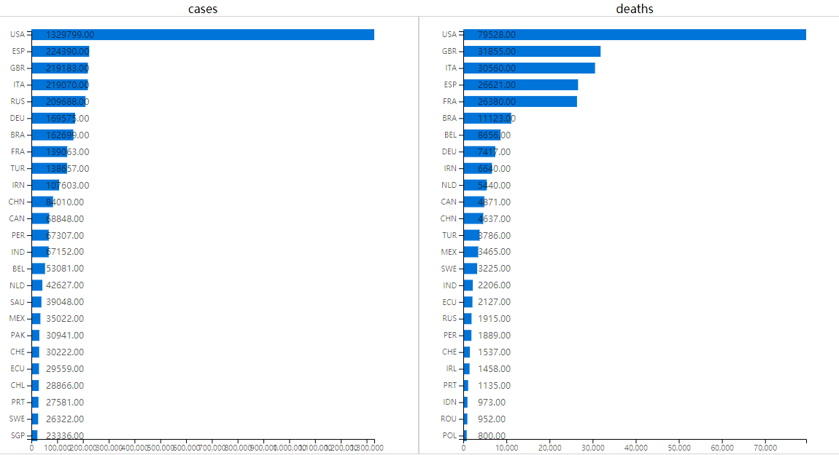
图3-3柱状图

部分代码：
<!DOCTYPE html>
<html>
<body>
<style>
svg {
border: 1px solid lightgrey;
}
.box {
display: flex;
flex-wrap: wrap;
}
.title {
text-align: center;
}
.text {
color: #c1c1c1;
font-size: 12px;
/* transform: translate(460px, 12px); */
}
</style>
<div class="box">
<div>
<div class="title">cases</div>
<div class="car1"></div>
</div>
<div>
<div class="title">deaths</div>
<div class="car2"></div>
</div>
<div>
<div class="title">cases per million people</div>
<div class="car3"></div>
</div>
<div>
<div class="title">deaths per million people</div>
<div class="car4"></div>
</div>
</div>
<script src="http://d3js.org/d3.v5.min.js"></script>
<script type="text/javascript">
const maxHeight = 600;
const maxWidth = 590;
const margin = {
top: 20,
right: 60,
bottom: 20,
left: 60,
};
const colorArray = ['#0074D9'];
function keyPlusValue(arr) {
var obj = {};
arr.forEach(function (value) {
const {
countriesAndTerritories,
cases,
deaths,
popData2018,
countryterritoryCode,
} = value;
if (obj.hasOwnProperty(countriesAndTerritories)) {
obj[countriesAndTerritories].cases += parseInt(cases);
obj[countriesAndTerritories].deaths += parseInt(deaths);
} else {
obj[countriesAndTerritories] = {
countriesAndTerritories: countriesAndTerritories,
countryterritoryCode,
cases: parseInt(cases),
deaths: parseInt(deaths),
popData2018: parseInt(popData2018),
};
}
});
return Object.values(obj);
}

function drawBar(type, data1, name) {
if (type === 'cases/million') {
data1.forEach((item) => {
item.label = item.countryterritoryCode;
item.value = item.cases * (1000000 / item.popData2018);
});
} else if (type === 'deaths/million') {
data1.forEach((item) => {
item.label = item.countryterritoryCode;
item.value = item.deaths * (1000000 / item.popData2018);
});
} else {
data1.forEach((item) => {
item.label = item.countryterritoryCode;
item.value = item[type];
});
}
const data2 = data1.sort((a, b) => b.value - a.value);
const data3 = data2.slice(0, 25);
console.log(data3);
renderHorizontalBars(data3, name);
}

d3.csv('./data/data.csv').then(function (data) {
const data1 = keyPlusValue(data);
console.log(data1);
drawBar('cases', data1, '.car1');
drawBar('deaths', data1, '.car2');
drawBar('cases/million', data1, '.car3');
drawBar('deaths/million', data1, '.car4');
});

function renderHorizontalBars(data, name) {
const barHeight = 15;
const yTicks = new Array(data.length + 1);
for (let i = 0; i <= data.length; i++) {
yTicks[i] = i;
}
const getX = (d) => d.value;
const getY = (d) => d.label;
const scaleY = d3
.scalePoint()
.domain(data.map(getY))
.range([0, maxHeight - margin.top - margin.bottom])
.padding(0.2);
const scaleX = d3
.scaleLinear()
.domain([0, d3.max(data, getX)])
.range([0, maxWidth - margin.left - margin.right]);
const svg = d3
.select(`body .box ${name}`)
.append('svg')
.attr('width', maxWidth)
.attr('height', maxHeight);
const bar = svg.selectAll('rect');

bar
.data(data)
.enter()
.append('rect')
.attr('x', margin.left)
.attr('y', (d) => scaleY(getY(d)) + margin.top - barHeight / 2)
.attr('width', (d) => scaleX(getX(d)))
.attr('height', barHeight)
.attr('fill', (d, i) => colorArray[i % colorArray.length])
.on('mousemove', moved)
.on('mouseover', entered)
.on('mouseout', left);

bar
.data(data)
.enter()
.append('text')
.attr('class', 'text')
.attr('x', margin.left + 20)
.attr('y', (d) => scaleY(getY(d)) + margin.top + 12 - barHeight / 2)
.text(function (d) {
return Number(d.value).toFixed(2);
});

const axisLeft = d3.axisLeft(scaleY);
svg
.append('g')
.attr('transform', `translate(${margin.left}, ${margin.top})`)
.call(axisLeft);
const axisBottom = d3.axisBottom(scaleX);
svg
.append('g')
.attr('transform', `translate(${margin.left}, ${maxHeight - margin.bottom})`)
.call(axisBottom);

function moved() {
d3.selectAll('rect').style('opacity', '0.65');
d3.selectAll('text').style('opacity', '0.65');
d3.select(this).style('opacity', '1');
d3.select(this).style('opacity', '1');
}
function entered() {
d3.selectAll('rect').style('opacity', '0.65');
d3.select(this).style('opacity', '1');
}

function left() {
d3.selectAll('rect').style('opacity', '1');
}
}
</script>
</body>
</html>

3.折线图
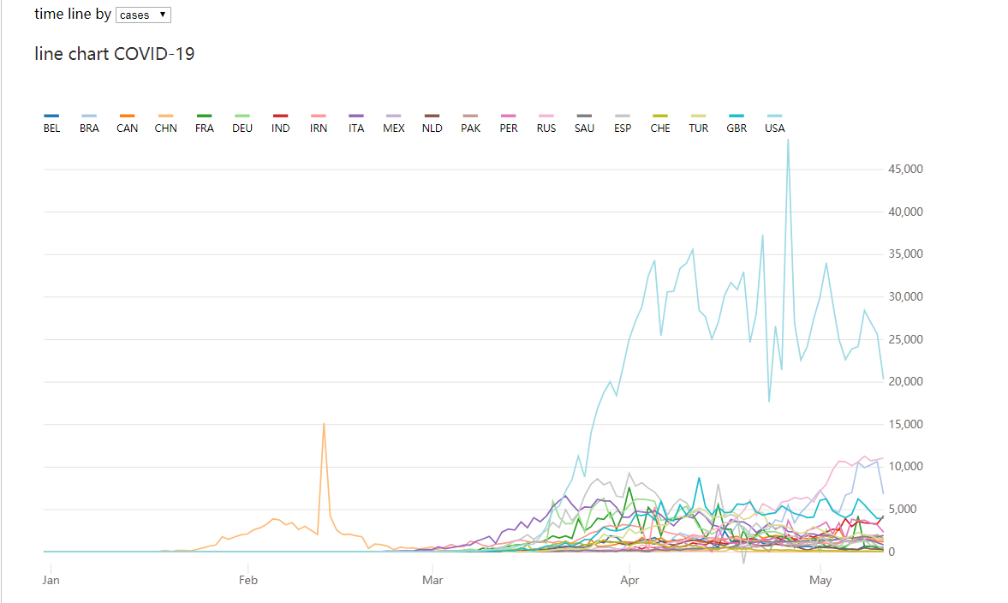
图3-3折线图

部分代码：
<!DOCTYPE html>
<html>
<meta charset="utf-8" />
<script src="https://cdn.bootcdn.net/ajax/libs/d3/4.13.0/d3.min.js"></script>
<script src="https://cdn.bootcdn.net/ajax/libs/lodash.js/4.17.11/lodash.min.js"></script>
<script src="https://cdn.bootcdn.net/ajax/libs/d3-legend/2.25.6/d3-legend.min.js"></script>
<meta name="viewport" content="width=device-width, initial-scale=1.0" />
<style>
html {
background-color: hsl(0, 0%, 100%);
overflow-y: scroll;
font-family: MetricWeb, sans-serif;
}

.bounding {
margin-left: 30px;
margin-right: 30px;
margin-top: 30px;
}

#chart {
width: 100%;
max-width: 1200px;
height: 600px;
margin: 0 auto;
}

.main {
fill: #33302e;
font-size: 17px;
}

.sub {
fill: #66605c;
display: inline-block;
font-size: 13px;
opacity: 0.9;
}

.y-axis path,
.x-axis path {
stroke: #757575;
shape-rendering: crispEdges;
stroke-width: 1px;
}

.x-axis text,
.y-axis text {
font-size: 11px;
fill: #66605c;
opacity: 0.95;
}

.x-axis .tick line {
stroke: #66605c;
stroke-width: 0.8px;
opacity: 0.2;
}

.y-axis .tick line {
stroke: #66605c;
stroke-width: 0.8px;
opacity: 0.2;
}

.footnote text {
font-size: 9px;
opacity: 0.85;
fill: #66605c;
}
.title {
margin-bottom: 20px;
}
</style>

<body>
<div class="bounding">
<div id="chart">
<div class="title">
<span>time line by</span>
<select onchange="selectStages()" id="select">
<option value="cases">cases</option>
<option value="deaths">deaths</option>
</select>
</div>
</div>
</div>
</body>
<script>
var dataset;
function keyPlusValue(arr) {
var obj = {};
arr.forEach(function (value) {
const { countryterritoryCode, cases, deaths, popData2018 } = value;
if (obj.hasOwnProperty(countryterritoryCode)) {
obj[countryterritoryCode].cases += parseInt(cases);
obj[countryterritoryCode].deaths += parseInt(deaths);
} else {
obj[countryterritoryCode] = {
countryterritoryCode: countryterritoryCode,
cases: parseInt(cases),
deaths: parseInt(deaths),
popData2018: parseInt(popData2018),
};
}
});
return Object.values(obj);
}

function selectStages() {
var selectNodesObj = document.getElementById('select');
var selIndex = selectNodesObj.selectedIndex; //获取当前选择的选项的index值
var selValue = selectNodesObj.options[selIndex].value;
load(selValue);
}
function load(type = 'cases') {
d3.selectAll('body #chart svg').remove(); // 移除svg节点
d3.csv('./data/data.csv', function (err, data) {
const data1 = keyPlusValue(data);
const data2 = data1.sort((a, b) => b[type] - a[type]);
const data3 = data2.slice(0, 20);
const data4 = [];
data.forEach((v) => {
if (data3.some((v1) => v1.countryterritoryCode === v.countryterritoryCode)) {
data4.push(v);
}
});

data4.forEach((item) => {
item.ticker = item.countryterritoryCode;
item.date = `${item.month}-${item.day}-${item.year}`;
item.rebased = parseInt(item[type]);
});
dataset = data4;
var parseTime = d3.timeParse('%m-%d-%Y');

dataset.forEach(function (d) {
d.date = parseTime(d.date);
d.price = +d.price;
d.rebased = +d.rebased;
});

draw(dataset);
});
}

load();
function draw(data) {
'use strict';

var margin = {
top: 100,
right: 100,
bottom: 70,
left: 10,
},
container_width = 960,
container_height = 600,
width = container_width - margin.left - margin.right,
height = container_height - margin.top - margin.bottom;

var svg = d3
.select('#chart')
.append('svg')
.attr('id', 'svg_container')
.attr('viewBox', `0 0 ${container_width} ${container_height}`)
.attr('preserveAspectRatio', 'xMidYMid')
.append('g')
.attr('id', 'container')
.attr('transform', 'translate(' + margin.left + ',' + margin.top + ')');

var main_padding = 20;
var sub_padding = 45;

var chart = d3.select('#svg_container').append('g').attr('id', 'text-label');

chart
.append('text')
.attr('class', 'main')
.text('line chart COVID-19')
.attr('transform', 'translate(' + 0 + ',' + main_padding + ')');

var footer_data = [];
svg
.append('g')
.attr('class', 'footnote')
.selectAll('text')
.data(footer_data)
.enter()
.append('text')
.text(function (d) {
return d;
})
.attr('transform', function (d, i) {
return 'translate(' + -margin.left + ',' + (height + margin.bottom / 1.3 + i * 14) + ')';
});

var tickers = _.uniqBy(data, 'ticker');
tickers = _.map(tickers, function (el) {
return el.ticker;
});

var y_extent = d3.extent(data, function (d) {
return d.rebased;
});

var y_floor = Math.floor(y_extent[0] / 10) * 10;

var x_extent = d3.extent(data, function (d) {
return d.date;
});

var ticker_scale = d3
.scaleOrdinal()
.domain(tickers)
.range(['Devon Energy', 'Cimarex Energy', 'Newfield Exploration', 'Continental Resources']);

var color_scale = d3
.scaleOrdinal()
.domain(d3.range(tickers.length))
.range(['#93e0e6', '#ff75a6', '#1c568b', '#b3315f']);

var color_scale_plus = d3.scaleOrdinal(d3.schemeCategory20);

var x_scale = d3.scaleTime().range([0, width]).domain(x_extent);
var y_scale = d3.scaleLinear().range([height, 0]).domain([y_floor, y_extent[1]]);

var yAxis = svg.append('g').attr('class', 'y-axis');

yAxis
.attr('transform', `translate(${0},0 )`)
.call(d3.axisRight(y_scale).tickSizeInner(width).tickSizeOuter(0).tickPadding(5))
.call((g) => g.select('.domain').remove());

var xAxis = svg.append('g').attr('class', 'x-axis');

var calendar = d3.timeMonth.every(2).range(new Date('1/1/2018'), new Date('12/1/2018'));

xAxis
.attr('transform', 'translate(0,' + height + ')')
.call(
d3
.axisBottom(x_scale)
.ticks(4)
// .tickValues(calendar)
.tickSizeInner(10)
.tickFormat(d3.timeFormat('%b')),
)
.call((g) => g.select('.domain').remove());

var line = d3
.line()
.x(function (d) {
return x_scale(d.date);
})
.y(function (d) {
return y_scale(d.rebased);
});

data = _.groupBy(data, function (d) {
return d.ticker;
});

var data = Object.keys(data).map(function (key) {
return data[key];
});

var g = svg
.selectAll('g.start')
.data(data)
.enter()
.append('g')
.attr('class', 'path')
.append('path')
// .attr('stroke', function (d, i) {
// return color_scale(i);
// })
.attr('stroke', function (d, i) {
return color_scale_plus(i);
})
.style('fill', 'none')
.style('stroke-width', 1.5)
.attr('d', line)
.on('mousemove', moved)
.on('mouseover', entered)
.on('mouseout', left);

var label_scale_ordinal = d3.scaleOrdinal().domain(tickers);

var svg = d3.select('svg');

svg.append('g').attr('class', 'legendOrdinal').attr('transform', 'translate(10,70)');

var legendOrdinal = d3
.legendColor()
.orient('horizontal')
.shape('rect', d3.symbol().type(d3.symbolTriangle).size(50)())
.shapePadding(20)
.scale(label_scale_ordinal);

svg
.append('g')
.attr('class', 'legendOrdinal')
.attr('transform', 'translate(10,60)')
.style('font-size', '10px')
.call(legendOrdinal);

d3.selectAll('.swatch')
.style('height', 3)
.attr('transform', 'translate(0,15)')
.attr('fill', function (d, i) {
return color_scale_plus(i);
});

var cells = d3.selectAll('.cell');
var cellGap = legendOrdinal.shapeWidth() + legendOrdinal.shapePadding() / 4;

var offset = 0;
cells.each(function (d, i) {
var d3sel = d3.select(this);

var textWidth = d3sel.select('text').node().getComputedTextLength();

var offsetInc = textWidth / 5.5 + legendOrdinal.shapeWidth() + legendOrdinal.shapePadding();
d3sel.attr('transform', 'translate(' + offset + ' 0)');
offset += offsetInc;
});

function moved() {
d3.selectAll('path').style('opacity', '0.25');
d3.select(this).style('opacity', '1');
}
function entered() {
d3.selectAll('path').style('opacity', '0.25');
d3.select(this).style('opacity', '1');
}

function left() {
d3.selectAll('path').style('opacity', '1');
}
}
</script>
</html>

