**TUGAS MOBILE TECHNOLOGY**

**“KAMUS NAMA FAUNA INDONESIA-LATIN”**

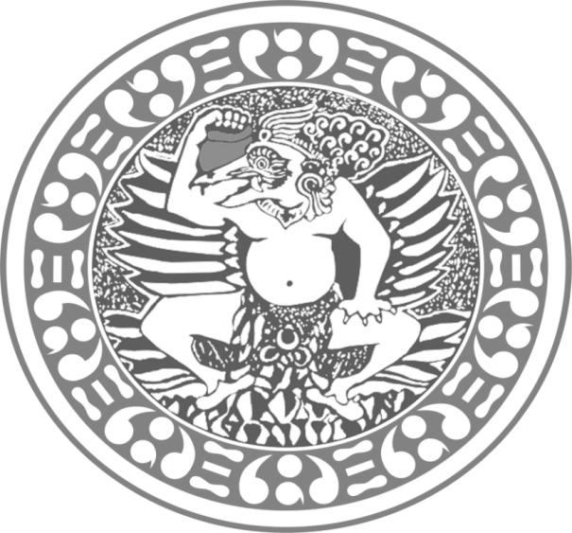

**Disusun Oleh :**

**Almira Hani 081411631003**

**Windra Rasyad 081411631020**

**Shof Rijal Ahlan Robbani 081411631038**

**S1 SISTEM INFORMASI**

**FAKULTAS SAINS DAN TEKNOLOGI**

**UNIVERSITAS AIRLANGGA**

**2016**

**Screenshot Aplikasi**

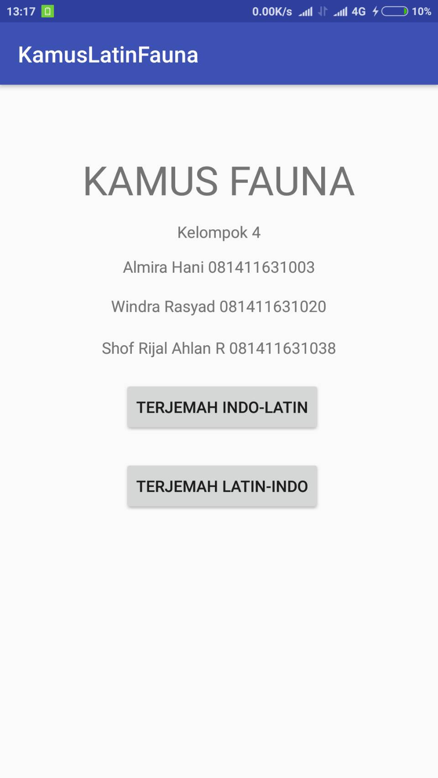

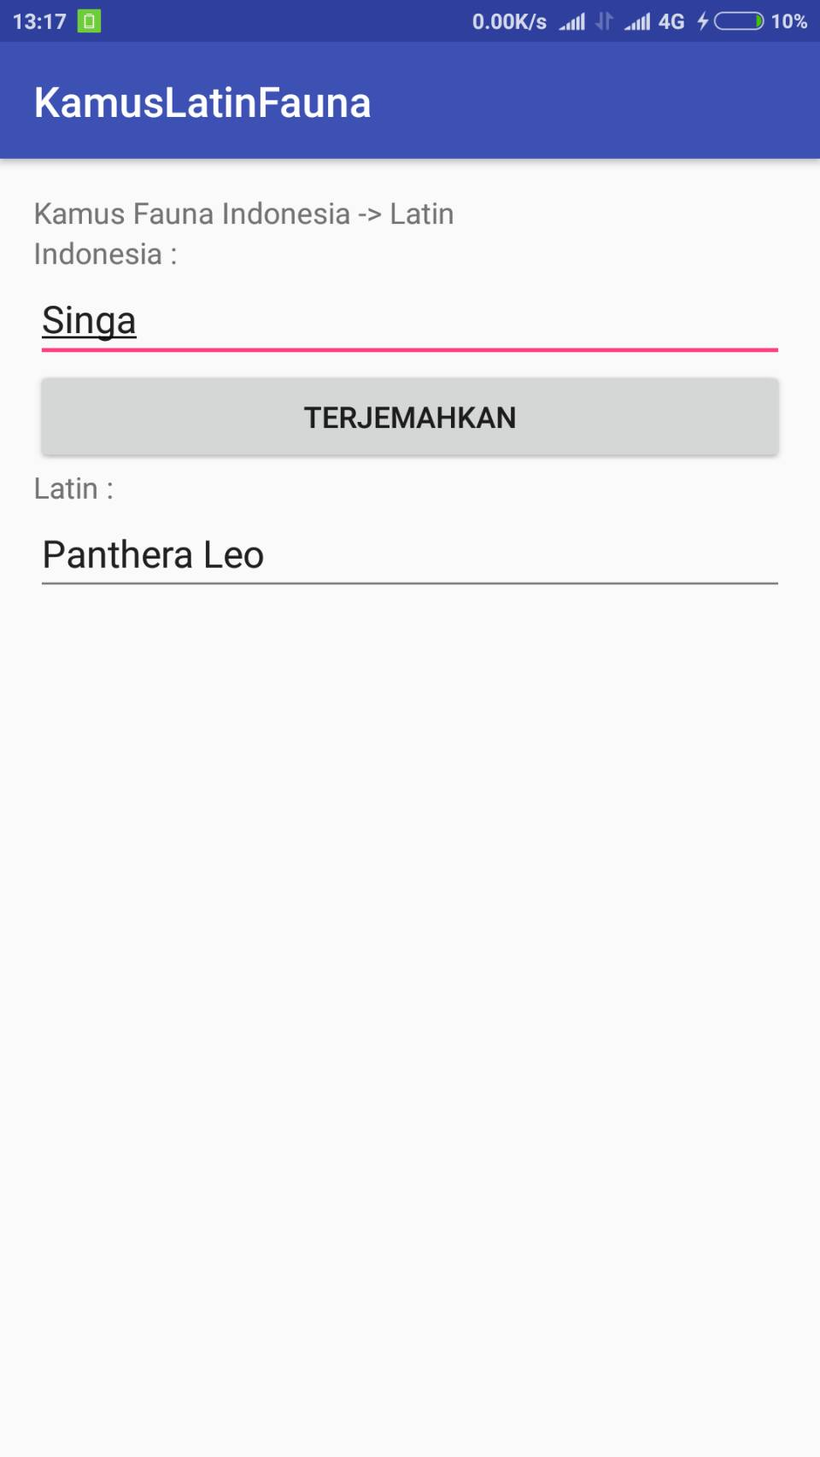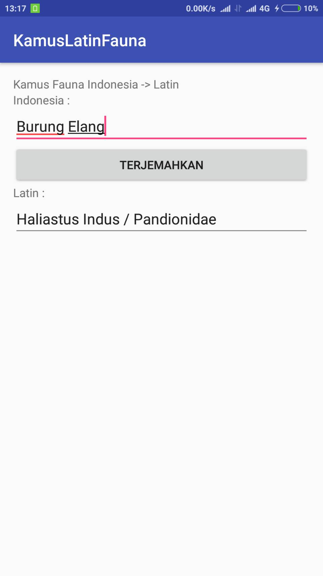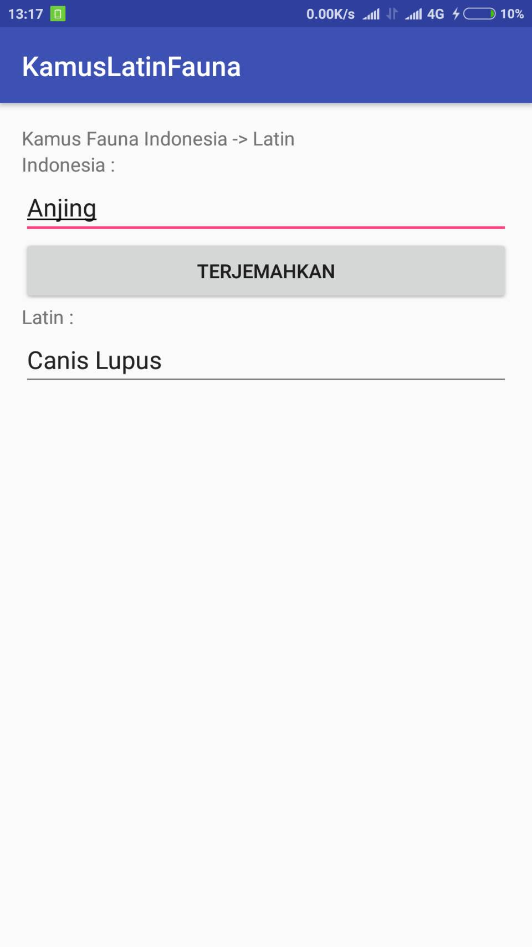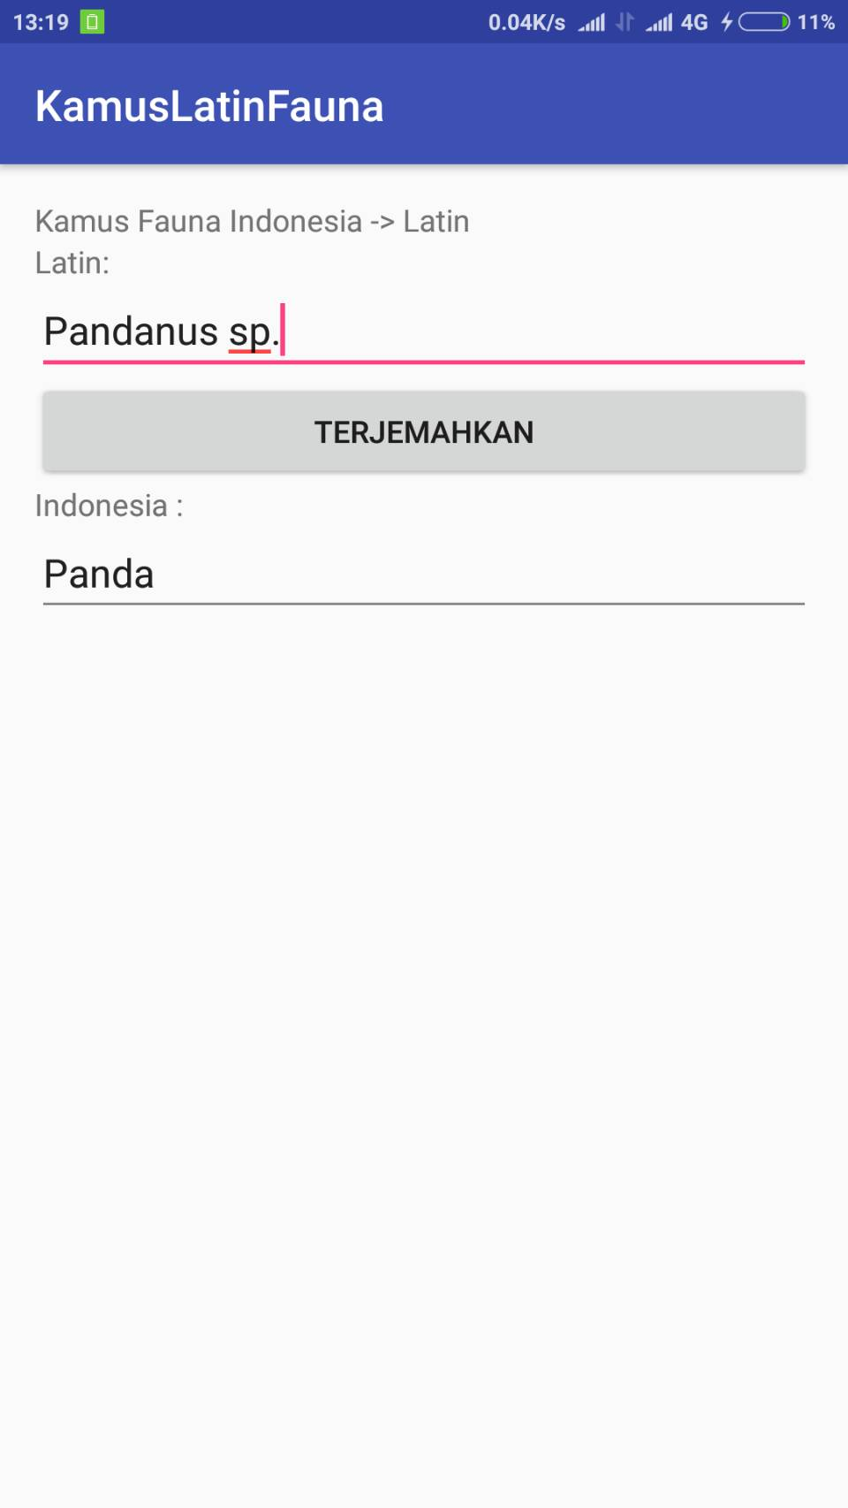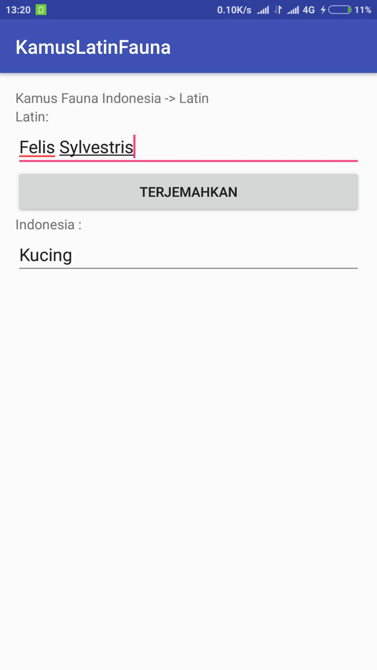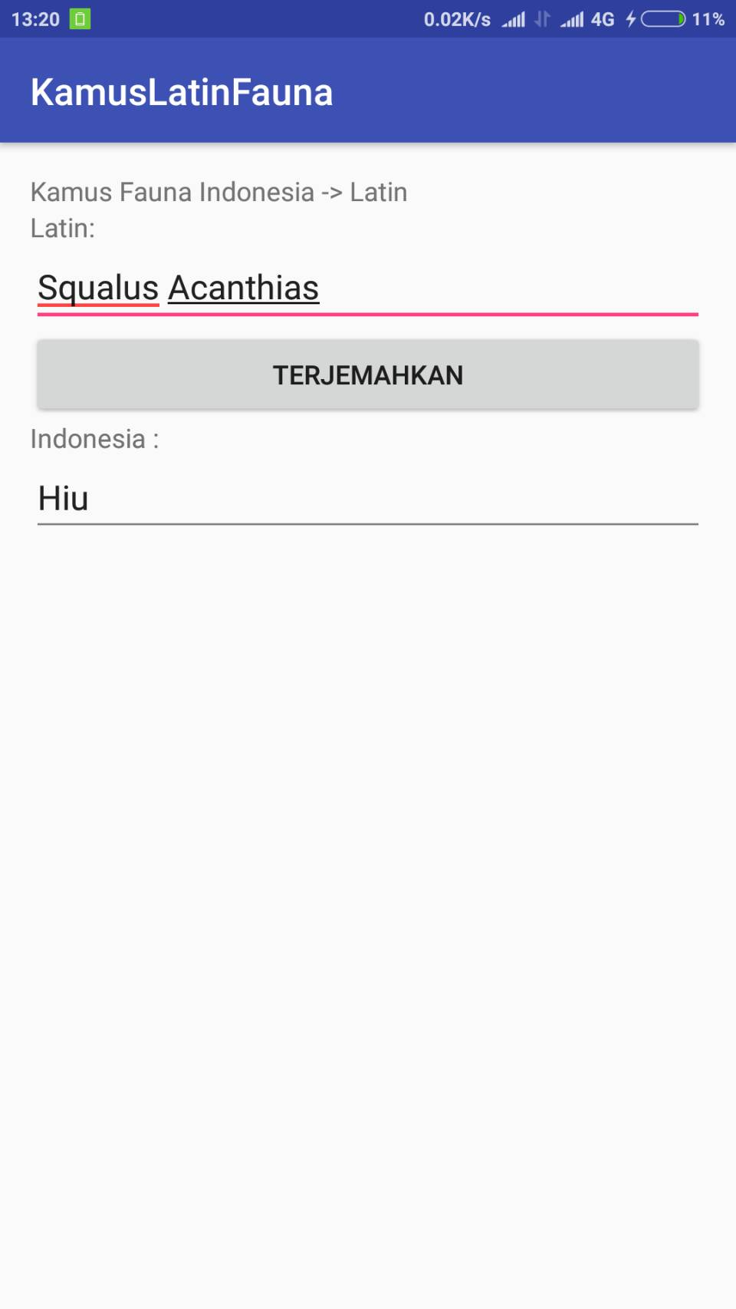

**Kosa Kata Kamus**

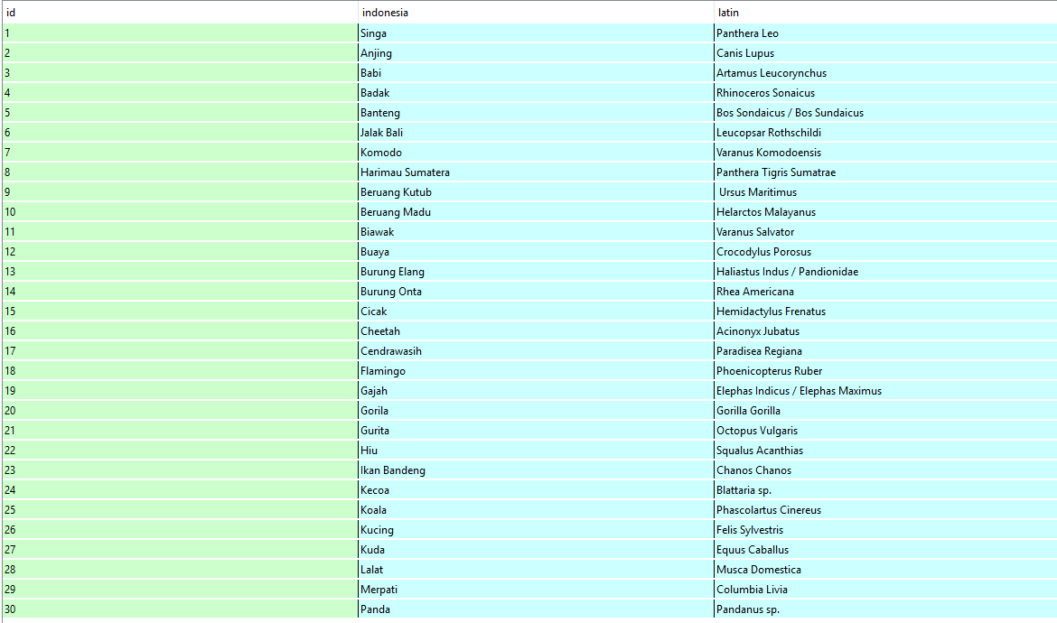

**Source Code**

**MenuAwal.java**

**package com.example.robbani.kamuslatinfauna;**

**import android.content.Intent;**

**import android.support.v7.app.AppCompatActivity;**

**import android.os.Bundle;**

**import android.view.View;**

**import android.widget.Button;**

**/\*\***

**\* Created by ROBBANI on 11/28/2016.**

**\*/**

**public class MenuAwal extends AppCompatActivity {**

**Button Find, Find2;**

**@Override**

**protected void onCreate(Bundle savedInstanceState) {**

**super.onCreate(savedInstanceState);**

**setContentView(R.layout.activity_menu_awal);**

**Find = (Button)findViewById(R.id.FindKata);**

**Find2 = (Button)findViewById(R.id.FindKata2);**

**//listener;**

**Find.setOnClickListener(new View.OnClickListener() {**

**@Override**

**public void onClick(View v) {**

**Intent i = new Intent(getApplicationContext(),Main2Activity.class);**

**startActivity(i);**

**}**

**});**

**Find2.setOnClickListener(new View.OnClickListener() {**

**@Override**

**public void onClick(View v) {**

**Intent i = new Intent(getApplicationContext(),Main3Activity.class);**

**startActivity(i);**

**}**

**});**

**}**

**}**

**Activity_menu_awal.xml**

**<?xml version="1.0" encoding="utf-8"?>**

**<RelativeLayout xmlns:android="http://schemas.android.com/apk/res/android"**

**xmlns:tools="http://schemas.android.com/tools"**

**android:id="@+id/activity_menu_awal"**

**android:layout_width="match_parent"**

**android:layout_height="match_parent"**

**android:paddingBottom="@dimen/activity_vertical_margin"**

**android:paddingLeft="@dimen/activity_horizontal_margin"**

**android:paddingRight="@dimen/activity_horizontal_margin"**

**android:paddingTop="@dimen/activity_vertical_margin"**

**tools:context="com.example.robbani.kamuslatinfauna.MenuAwal">**

**<TextView**

**android:text="KAMUS FAUNA"**

**android:layout_width="wrap_content"**

**android:layout_height="wrap_content"**

**android:layout_alignParentTop="true"**

**android:layout_centerHorizontal="true"**

**android:layout_marginTop="45dp"**

**android:id="@+id/textView"**

**android:textSize="36sp" />**

**<Button**

**android:text="TERJEMAH LATIN-INDO"**

**android:layout_width="wrap_content"**

**android:layout_height="wrap_content"**

**android:id="@+id/FindKata2"**

**android:layout_below="@+id/FindKata"**

**android:layout_alignLeft="@+id/FindKata"**

**android:layout_alignStart="@+id/FindKata"**

**android:layout_marginTop="23dp" />**

**<TextView**

**android:text="Kelompok 4"**

**android:layout_width="wrap_content"**

**android:layout_height="wrap_content"**

**android:layout_below="@+id/textView"**

**android:layout_centerHorizontal="true"**

**android:layout_marginTop="13dp"**

**android:id="@+id/textView2" />**

**<TextView**

**android:text="Almira Hani 081411631003"**

**android:layout_width="wrap_content"**

**android:layout_height="wrap_content"**

**android:layout_below="@+id/textView2"**

**android:layout_centerHorizontal="true"**

**android:layout_marginTop="12dp"**

**android:id="@+id/textView3" />**

**<TextView**

**android:text="Windra Rasyad 081411631020"**

**android:layout_width="wrap_content"**

**android:layout_height="wrap_content"**

**android:layout_below="@+id/textView3"**

**android:layout_centerHorizontal="true"**

**android:layout_marginTop="16dp"**

**android:id="@+id/textView4" />**

**<Button**

**android:text="TERJEMAH INDO-LATIN"**

**android:layout_width="wrap_content"**

**android:layout_height="wrap_content"**

**android:id="@+id/FindKata"**

**android:layout_marginTop="57dp"**

**android:layout_below="@+id/textView4"**

**android:layout_alignLeft="@+id/textView3"**

**android:layout_alignStart="@+id/textView3" />**

**<TextView**

**android:text="Shof Rijal Ahlan R 081411631038"**

**android:layout_width="wrap_content"**

**android:layout_height="wrap_content"**

**android:id="@+id/textView5"**

**android:layout_below="@+id/textView4"**

**android:layout_centerHorizontal="true"**

**android:layout_marginTop="18dp" />**

**</RelativeLayout>**

**Main2Activity.java**

**package com.example.robbani.kamuslatinfauna;**

**import android.database.Cursor;**

**import android.database.sqlite.SQLiteDatabase;**

**import android.support.v7.app.AppCompatActivity;**

**import android.os.Bundle;**

**import android.view.View;**

**import android.widget.EditText;**

**/\*\***

**\* Created by ROBBANI on 11/28/2016.**

**\*/**

**public class Main2Activity extends AppCompatActivity {**

**private SQLiteDatabase db = null;**

**private Cursor kamusCursor = null;**

**private EditText txtLatin;**

**private EditText txtIndonesia;**

**private DatabaseHelper datakamus = null;**

**public static final String INDONESIA = "indonesia";**

**public static final String LATIN = "latin";**

**@Override**

**protected void onCreate(Bundle savedInstanceState) {**

**super.onCreate(savedInstanceState);**

**datakamus = new DatabaseHelper(this);**

**db = datakamus.getWritableDatabase();**

**datakamus.createTable(db);**

**datakamus.generateData(db);**

**setContentView(R.layout.activity_main2);**

**txtLatin = (EditText) findViewById(R.id.textLatin);**

**txtIndonesia = (EditText) findViewById(R.id.textIndonesia);**

**}**

**public void getTerjemahanLatin(View view) {**

**String result = "";**

**String indoword = txtIndonesia.getText().toString();**

**kamusCursor = db.rawQuery("SELECT ID, INDONESIA, LATIN "**

**+ "FROM kamusfauna where INDONESIA='" + indoword**

**+ "' ORDER BY INDONESIA", null);**

**if (kamusCursor.moveToFirst()) {**

**result = kamusCursor.getString(2);**

**for (; !kamusCursor.isAfterLast(); kamusCursor.moveToNext()) {**

**result = kamusCursor.getString(2);**

**}**

**}**

**if (result.equals("")) {**

**result = "Terjemahan Not Found";**

**}**

**txtLatin.setText(result);**

**}**

**@Override**

**public void onDestroy() {**

**super.onDestroy();**

**kamusCursor.close();**

**db.close();**

**}**

**}**

**Activity_main2.xml**

**package com.example.robbani.kamuslatinfauna;**

**import android.database.Cursor;**

**import android.database.sqlite.SQLiteDatabase;**

**import android.support.v7.app.AppCompatActivity;**

**import android.os.Bundle;**

**import android.view.View;**

**import android.widget.EditText;**

**/\*\***

**\* Created by ROBBANI on 11/28/2016.**

**\*/**

**public class Main2Activity extends AppCompatActivity {**

**private SQLiteDatabase db = null;**

**private Cursor kamusCursor = null;**

**private EditText txtLatin;**

**private EditText txtIndonesia;**

**private DatabaseHelper datakamus = null;**

**public static final String INDONESIA = "indonesia";**

**public static final String LATIN = "latin";**

**@Override**

**protected void onCreate(Bundle savedInstanceState) {**

**super.onCreate(savedInstanceState);**

**datakamus = new DatabaseHelper(this);**

**db = datakamus.getWritableDatabase();**

**datakamus.createTable(db);**

**datakamus.generateData(db);**

**setContentView(R.layout.activity_main2);**

**txtLatin = (EditText) findViewById(R.id.textLatin);**

**txtIndonesia = (EditText) findViewById(R.id.textIndonesia);**

**}**

**public void getTerjemahanLatin(View view) {**

**String result = "";**

**String indoword = txtIndonesia.getText().toString();**

**kamusCursor = db.rawQuery("SELECT ID, INDONESIA, LATIN "**

**+ "FROM kamusfauna where INDONESIA='" + indoword**

**+ "' ORDER BY INDONESIA", null);**

**if (kamusCursor.moveToFirst()) {**

**result = kamusCursor.getString(2);**

**for (; !kamusCursor.isAfterLast(); kamusCursor.moveToNext()) {**

**result = kamusCursor.getString(2);**

**}**

**}**

**if (result.equals("")) {**

**result = "Terjemahan Not Found";**

**}**

**txtLatin.setText(result);**

**}**

**@Override**

**public void onDestroy() {**

**super.onDestroy();**

**kamusCursor.close();**

**db.close();**

**}**

**}**

**Main3Activity.java**

**package com.example.robbani.kamuslatinfauna;**

**import android.database.Cursor;**

**import android.database.sqlite.SQLiteDatabase;**

**import android.support.v7.app.AppCompatActivity;**

**import android.os.Bundle;**

**import android.view.View;**

**import android.widget.EditText;**

**/\*\***

**\* Created by ROBBANI on 11/28/2016.**

**\*/**

**public class Main3Activity extends AppCompatActivity {**

**private SQLiteDatabase db = null;**

**private Cursor kamusCursor = null;**

**private EditText txtLatin;**

**private EditText txtIndonesia;**

**private DatabaseHelper datakamus = null;**

**public static final String INDONESIA = "indonesia";**

**public static final String LATIN = "latin";**

**@Override**

**protected void onCreate(Bundle savedInstanceState) {**

**super.onCreate(savedInstanceState);**

**datakamus = new DatabaseHelper(this);**

**db = datakamus.getWritableDatabase();**

**datakamus.createTable(db);**

**datakamus.generateData2(db);**

**setContentView(R.layout.activity_main3);**

**txtLatin = (EditText) findViewById(R.id.textLatin);**

**txtIndonesia = (EditText) findViewById(R.id.textIndonesia);**

**}**

**public void getTerjemahanIndo(View view) {**

**String result = "";**

**String latinword = txtLatin.getText().toString();**

**kamusCursor = db.rawQuery("SELECT ID, INDONESIA, LATIN "**

**+ "FROM kamusfauna where LATIN='" + latinword**

**+ "' ORDER BY LATIN", null);**

**if (kamusCursor.moveToFirst()) {**

**result = kamusCursor.getString(1);**

**for (; !kamusCursor.isAfterLast(); kamusCursor.moveToNext()) {**

**result = kamusCursor.getString(1);**

**}**

**}**

**if (result.equals("")) {**

**result = "Terjemahan Not Found";**

**}**

**txtIndonesia.setText(result);**

**}**

**@Override**

**public void onDestroy() {**

**super.onDestroy();**

**kamusCursor.close();**

**db.close();**

**}**

**}**

**Activity_main3.xml**

**<?xml version="1.0" encoding="utf-8"?>**

**<LinearLayout xmlns:android="http://schemas.android.com/apk/res/android"**

**xmlns:tools="http://schemas.android.com/tools"**

**android:id="@+id/activity_main3"**

**android:layout_width="match_parent"**

**android:layout_height="match_parent"**

**android:paddingBottom="@dimen/activity_vertical_margin"**

**android:paddingLeft="@dimen/activity_horizontal_margin"**

**android:paddingRight="@dimen/activity_horizontal_margin"**

**android:paddingTop="@dimen/activity_vertical_margin"**

**android:orientation="vertical"**

**tools:context="com.example.robbani.kamuslatinfauna.Main3Activity">**

**<TextView android:layout_width="fill_parent"**

**android:layout_height="wrap_content" android:text="Kamus Fauna Latin -> Indonesia" />**

**<TextView android:text="Latin:" android:id="@+id/TextView03"**

**android:layout_width="wrap_content" android:layout_height="wrap_content"></TextView>**

**<EditText android:text="" android:id="@+id/textLatin"**

**android:layout_width="fill_parent" android:layout_height="wrap_content"**

**></EditText>**

**<Button android:text="Terjemahkan" android:id="@+id/btnTerjemah"**

**android:layout_width="fill_parent" android:layout_height="wrap_content"**

**android:onClick="getTerjemahanIndo"></Button>**

**<TextView android:text="Indonesia :" android:id="@+id/TextView01"**

**android:layout_width="wrap_content" android:layout_height="wrap_content"></TextView>**

**<EditText android:text="" android:id="@+id/textIndonesia"**

**android:layout_width="fill_parent" android:layout_height="wrap_content"**

**android:editable="false"></EditText>**

**</LinearLayout>**