Automated Intelligent Data Analysis Pipeline
Project Documentation

1. Problem Statement
Data analysis is a critical but time-consuming process. When a data analyst receives a raw CSV file, they must manually:
- Understand the data structure and schema
- Clean and preprocess the data
- Explore distributions and relationships
- Detect patterns and anomalies
- Choose appropriate visualizations
- Generate charts and graphs
- Write a comprehensive summary report
This manual process typically takes 2–4 hours of skilled human work per dataset. For organizations handling multiple datasets daily, this represents a significant bottleneck in decision-making workflows.

2. Solution Overview
Our Automated Intelligent Data Analysis Pipeline transforms a raw CSV file into a complete, professional HTML report in under 60 seconds with zero human intervention.
The solution chains two different AI tools via API:
- Gemini API (Google) – Acts as the data analyst and report narrator
- Groq API (Llama 3.3) – Generates executable Python analysis code
A single command (python pipeline.py dataset.csv) orchestrates all 6 stages, from data profiling to final report generation.

3. Tools Used
Tool | Provider | UX Type | Role in Pipeline | Cost
Gemini API (gemini-2.5-flash) | Google | Chat AI | Data Analyst (Stage 1) + Report Narrator (Stage 4) | Free tier
Groq API (llama-3.3-70b-versatile) | Groq | Code Gen AI | Python Code Generator (Stage 2) | Free tier
Cerebras API (llama-3.3-70b) | Cerebras | Code Gen AI | Fallback for Stage 2 | Free tier
OpenRouter (deepseek-chat-v3-0324) | OpenRouter | Chat AI | Fallback for Stages 1 & 4 | Free tier
Python | – | CLI + Streamlit | Profiling, Execution, Compilation (Stages 0, 3, 5) | Free

4. Workflow Diagram
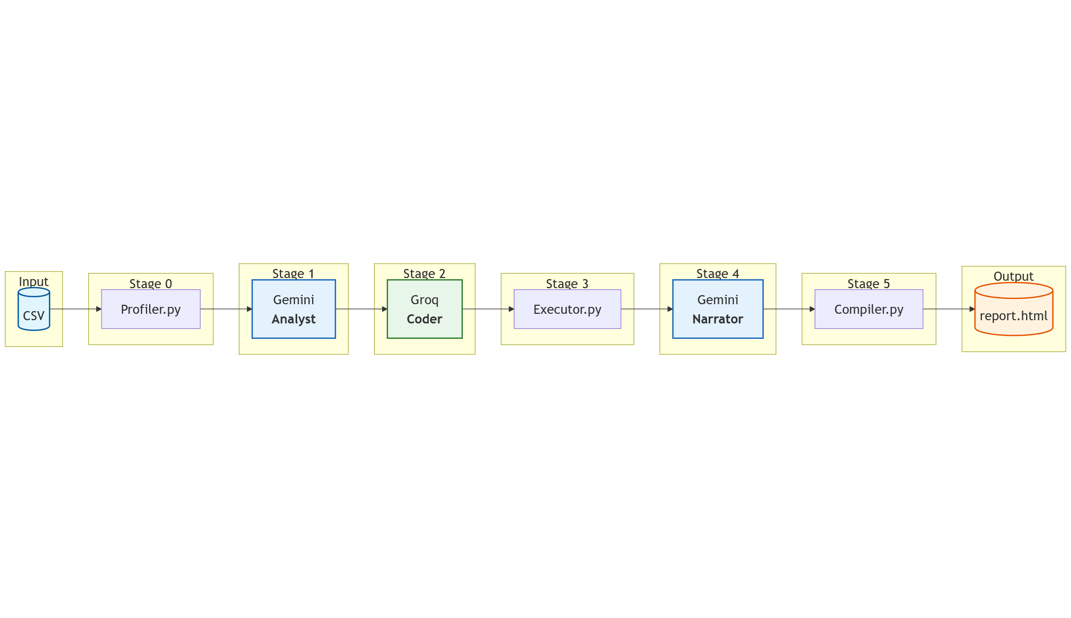
Figure 1: Pipeline Workflow Diagram

5. Step-by-Step Workflow Instructions

Stage 0: Data Profiling (Python – profiler.py)
- Reads the CSV file with pandas.
- For large datasets (over 2,000 rows), statistics are computed on a random sample of 2,000 rows; the full dataset is still used in Stage 3.
- Extracts schema: column names, data types, row count.
- Calculates statistics: mean, median, min, max, std, skewness, kurtosis, percentiles for numeric columns.
- Counts missing values per column and top value counts for categorical columns.
- Samples 3 representative rows.
- Output: data_profile (JSON).

Stage 1: AI Analysis Planning (Gemini API)
- Receives the data profile.
- Identifies what the dataset represents.
- Generates 4–5 analytical questions to answer.
- Specifies columns, analysis types, and chart types for each.
- Suggests data cleaning steps.
- Output: analysis_plan (JSON).

Stage 2: Code Generation (Groq API)
- Receives data profile and analysis plan.
- Generates a complete, runnable Python script.
- Script handles: data loading, cleaning, analysis, chart generation.
- Output: analysis_script.py (Python code string).

Stage 3: Auto-Execution (Python – executor.py)
- Clears old charts from previous runs to avoid stale results.
- Writes generated code to a file and executes via subprocess with 120-second timeout.
- Captures stdout (analysis results) and stderr (errors).
- Collects generated PNG charts.
- If the script crashes partway through but some charts were saved, the pipeline treats it as a partial success.
- Output: charts (PNG files) + raw_insights (JSON).

Stage 4: Narrative Generation (Gemini API)
- Receives raw analysis results and chart descriptions.
- Writes an executive summary (3–4 sentences).
- Generates key findings (bullet points).
- Provides actionable recommendations.
- Output: narrative (JSON).

Stage 5: Report Compilation (Python – compiler.py)
- Loads Jinja2 HTML template.
- Embeds charts as base64 data URIs.
- Injects narrative, findings, recommendations.
- Adds metadata (dataset name, timestamp, tools used).
- Output: report.html (self-contained HTML file).

6. Final Prompts Used at Each Stage

Prompt 1: The Analyst (Stage 1 – Gemini API)
You are a senior data analyst. I will give you a data profile (schema, statistics, sample rows) of a CSV dataset.
Your job:
1. Identify what this dataset represents (domain, purpose)
2. List the 4-5 most interesting analytical questions this data can answer
3. For each question, specify:
- The exact columns to use
- The type of analysis (correlation, distribution, comparison, trend, anomaly detection)
- The best chart type (bar, scatter, histogram, box, heatmap, line, violin, pie)
- A short description of what insight to look for
4. Identify data cleaning steps needed with SPECIFIC handling for null values and edge cases:
- For each column with null values, specify: "Drop rows with null in [column_name]" OR "Fill null in [column_name] with [value/mode/median/mean]"
- For numeric columns: use mean, median, or a specific value
- For categorical columns: use mode or "Unknown"
- For columns with string patterns (like duration "2h 30m", "30m", "5h" or stops "2 stops"), handle ALL edge cases
- ALWAYS specify a robust parsing function that handles all formats
- NEVER use operations that assume non-null values (like .split()) without first handling nulls and edge cases
- Add a check: if converting strings to numeric, handle parsing errors with try-except or pd.to_numeric with errors='coerce'
IMPORTANT: If any column has null values, you MUST include explicit null-handling steps in cleaning_steps before any other operations.
Return your response as ONLY valid JSON with this structure:
{
"dataset_description": "string",
"cleaning_steps": ["step1", "step2"],
"analyses": [
{
"question": "string",
"columns": ["col1", "col2"],
"analysis_type": "string",
"chart_type": "string",
"insight_hint": "string"
}
]
}
Here is the data profile:
{profile_json}

Prompt 2: The Coder (Stage 2 – Groq API)
You are an expert Python data analyst. Generate a COMPLETE, RUNNABLE Python script that performs the following analysis on a CSV file.
RULES:
- The CSV file path will be passed as the first command-line argument (sys.argv[1])
- Use only: pandas, matplotlib, seaborn, sys, os, re
- Save each chart as a PNG file in an "output/charts/" directory (create if needed)
- Name chart files using simple numbered names ONLY, like "chart_1.png", "chart_2.png"
- Print a JSON object to stdout with the key results of each analysis
- Do NOT use plt.show() — only plt.savefig()
- Wrap EACH individual analysis in its own try/except block
- Close each figure after saving with plt.close()
CRITICAL DATA TYPE HANDLING – USE EXACT SYNTAX:
1. For null handling: df.loc[:, 'col'] = df['col'].fillna(value)
2. For converting categorical string columns to numeric:
- Create mapping dict, apply mapping, pd.to_numeric, fillna, astype(int)
3. For datetime conversion: df['col'] = pd.to_datetime(df['col'], format='mixed', dayfirst=True)
4. For string operations like .split(), ALWAYS handle NaN first using fillna
5. For Duration parsing: use a robust function handling "Xh Ym", "Ym", "Xh", and empty values
6. Always verify column types after conversion using df.dtypes
DATA SCHEMA:
{data_profile}
ANALYSIS PLAN:
{analysis_plan}
Return ONLY the Python code, no markdown fences, no explanation.

Prompt 3: The Narrator (Stage 4 – Gemini API)
You are a senior data analyst writing a report for stakeholders.
I will give you the raw results of a data analysis (statistical findings, chart descriptions, detected patterns).
Write:
1. An executive summary (3-4 sentences, the most important takeaway)
2. Key findings (bullet points, one per analysis performed)
3. Recommendations (2-3 actionable next steps based on the data)
Return your response as ONLY valid JSON:
{
"executive_summary": "string",
"key_findings": ["finding1", "finding2"],
"recommendations": ["rec1", "rec2"]
}
Here are the analysis results:
{analysis_results}

7. Results
The pipeline successfully:
- Processes any CSV dataset in under 60 seconds
- Generates professional visualizations automatically
- Produces coherent, stakeholder-ready narratives
- Creates self-contained HTML reports (no external dependencies)
Time saved: 2–4 hours per dataset reduced to 45–60 seconds.

