SpendWise – Personal Expense Tracker API
Agile & DevOps Capstone Project Documentation
February 2026

Project Workflow Diagrams
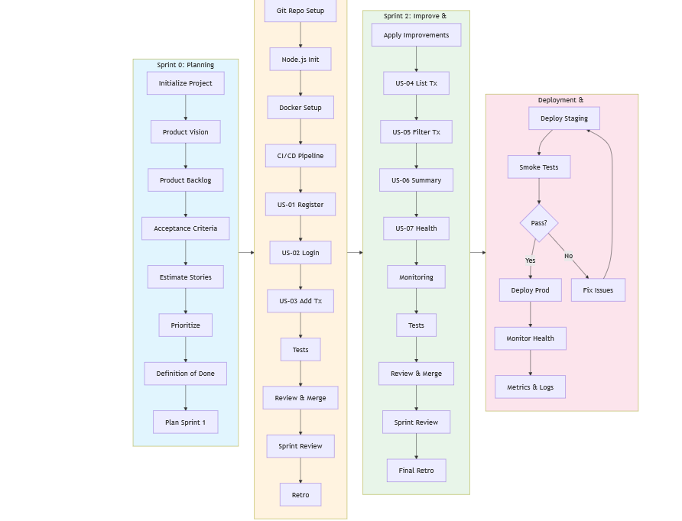
Figure 1: Overall Project Flow Diagram
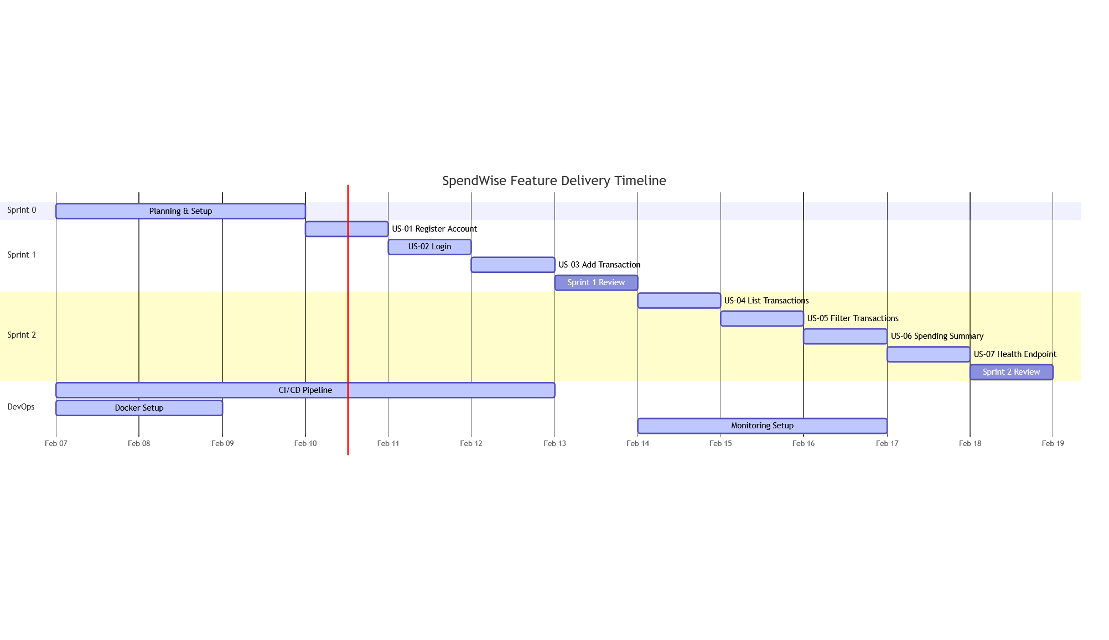
Figure 2: Project Timeline

Sprint 0: Planning (Setup)

Product Vision
SpendWise is a REST API that lets users register an account, track income and expenses by category, and view spending summaries, giving people a simple tool to understand where their money goes.

Product Backlog
The Product Backlog contains all user stories for the SpendWise API. Each story includes acceptance criteria, story points, and priority.

US-01: Register an Account
As a new user, I want to create an account with my name, email, and password, so that I can start tracking my expenses.
Acceptance Criteria:
- POST /api/auth/register accepts { name, email, password }
- Password is hashed with bcrypt before storing (never stored in plain text)
- Returns 201 Created with { id, name, email, created_at } (no password in response)
- Returns 400 if name, email, or password is missing
- Returns 400 if email format is invalid
- Returns 409 Conflict if email is already registered
- Password must be at least 6 characters
Story Points: 3 | Priority: P0 (Critical)

US-02: Log In
As a registered user, I want to log in with my email and password, so that I can access my data.
Acceptance Criteria:
- POST /api/auth/login accepts { email, password }
- Compares password against bcrypt hash
- Returns 200 OK with { token } (JWT valid for 24h)
- Returns 401 Unauthorized if email doesn't exist or password is wrong
- The JWT payload contains { userId, email }
Story Points: 3 | Priority: P0 (Critical)

US-03: Add a Transaction
As a logged-in user, I want to record an income or expense with an amount, category, and date, so that I can track where my money goes.
Acceptance Criteria:
- POST /api/transactions accepts { type, amount, category, description?, date? }
- Requires a valid JWT in Authorization: Bearer <token> header
- type must be either "income" or "expense"
- amount must be a positive number
- category is required (e.g., "food", "salary", "transport")
- date defaults to today if not provided
- Returns 201 Created with the saved transaction
- Returns 401 if no token or invalid token
- Returns 400 if required fields are missing or invalid
Story Points: 3 | Priority: P0 (Critical)

US-04: List My Transactions
As a logged-in user, I want to see all my transactions sorted by date, so that I can review my financial activity.
Acceptance Criteria:
- GET /api/transactions returns only the authenticated user's transactions
- Sorted by date descending (most recent first)
- Each transaction includes id, type, amount, category, description, date
- Returns 200 OK with empty array if the user has no transactions
- Returns 401 if not authenticated
Story Points: 2 | Priority: P1 (High)

US-05: Filter Transactions
As a logged-in user, I want to filter my transactions by type, category, or date range, so that I can find specific entries quickly.
Acceptance Criteria:
- GET /api/transactions?type=expense filters by income or expense
- GET /api/transactions?category=food filters by category (case-insensitive)
- GET /api/transactions?from=2026-01-01&to=2026-01-31 filters by date range
- Filters can be combined: ?type=expense&category=food
- Returns 200 OK with matching transactions or empty array
- Returns 401 if not authenticated
Story Points: 3 | Priority: P1 (High)

US-06: Get Spending Summary
As a logged-in user, I want to see my total income, total expenses, and balance, broken down by category, so that I understand my spending patterns.
Acceptance Criteria:
- GET /api/transactions/summary returns total_income, total_expenses, balance, by_category
- Only computes data for the authenticated user
- Accepts optional ?from= and ?to= date range
- Returns zeroed values if user has no transactions
- Returns 401 if not authenticated
Story Points: 3 | Priority: P2 (Medium)

US-07: Health Endpoint
As a DevOps engineer, I want a health endpoint that checks the API and database status, so that I can monitor the service.
Acceptance Criteria:
- GET /health returns 200 OK when healthy with status, uptime, timestamp, database, version
- Actually runs SELECT 1 against Postgres to verify DB connectivity
- Returns 503 Service Unavailable with "database": "disconnected" if DB is down
- Does NOT require authentication
Story Points: 2 | Priority: P1 (High)

Backlog Summary
ID | Story | Points | Priority
US-01 | Register an Account | 3 | P0 (Critical)
US-02 | Log In | 3 | P0 (Critical)
US-03 | Add a Transaction | 3 | P0 (Critical)
US-04 | List My Transactions | 2 | P1 (High)
US-05 | Filter Transactions | 3 | P1 (High)
US-06 | Spending Summary | 3 | P2 (Medium)
US-07 | Health Endpoint | 2 | P1 (High)

Total Story Points: 19

Estimation Method
Story points are assigned using Fibonacci sequence (1, 2, 3, 5, 8, 13). Estimation factors include complexity, amount of new code, testing effort, and integration with existing components.

Definition of Done (DoD)

Code Quality
- Code compiles/builds without errors
- Code follows project style guidelines (ESLint passes with no errors)
- No console.log or debugger statements left in production code
- Meaningful variable and function names
- Functions are small and do one thing well (Single Responsibility Principle)

Testing
- All acceptance criteria have corresponding test cases
- Unit tests pass (≥ 80% code coverage for new code)
- Integration tests pass
- All tests pass in CI pipeline before merge

Documentation
- Code is self-documenting with clear comments where necessary
- API endpoints are documented (method, path, request/response format)
- README is updated with setup instructions
- Environment variables are documented in .env.example

Version Control
- Feature branches are used (no direct commits to main/dev)
- Commit messages are descriptive and follow conventional commit format
- Pull requests have clear descriptions linking to user stories
- No “big-bang” commits – work is broken into logical, incremental commits

Security
- No secrets or credentials committed to version control
- Passwords are hashed (bcrypt) before storage
- JWT secrets are environment variables, not hardcoded
- SQL injection is prevented (parameterized queries)
- Input validation is implemented on all endpoints

DevOps
- Docker image builds successfully
- CI pipeline runs successfully on all branches
- Tests run automatically on every pull request
- Health endpoint is implemented and working
- Application runs successfully with docker-compose up

Sprint 1 Plan
Sprint Goal: Deliver core authentication and transaction creation functionality.
Story | Points | Priority
US-01: Register an Account | 3 | P0
US-02: Log In | 3 | P0
US-03: Add a Transaction | 3 | P0

Total commitment: 9 story points

Sprint 1 Dependencies
- US-02 depends on US-01 (need users table for login)
- US-03 depends on US-02 (need JWT middleware for authentication)

Sprint 2 Plan
Sprint Goal: Deliver transaction listing, filtering, summary, and health monitoring.
Story | Points | Priority
US-04: List My Transactions | 2 | P1
US-05: Filter Transactions | 3 | P1
US-06: Get Spending Summary | 3 | P2
US-07: Health Endpoint | 2 | P1

Total commitment: 10 story points

Sprint 0 Summary
Goal | Status
Define a Product Vision | Complete
Create a Product Backlog (7 user stories) | Complete
Refine the Backlog (acceptance criteria, priorities, estimates) | Complete
Establish Standards (Definition of Done) | Complete
Plan Sprint 1 (3 stories, 9 points) | Complete
Plan Sprint 2 (4 stories, 10 points) | Complete

Sprint 1: Execution

Environment Setup
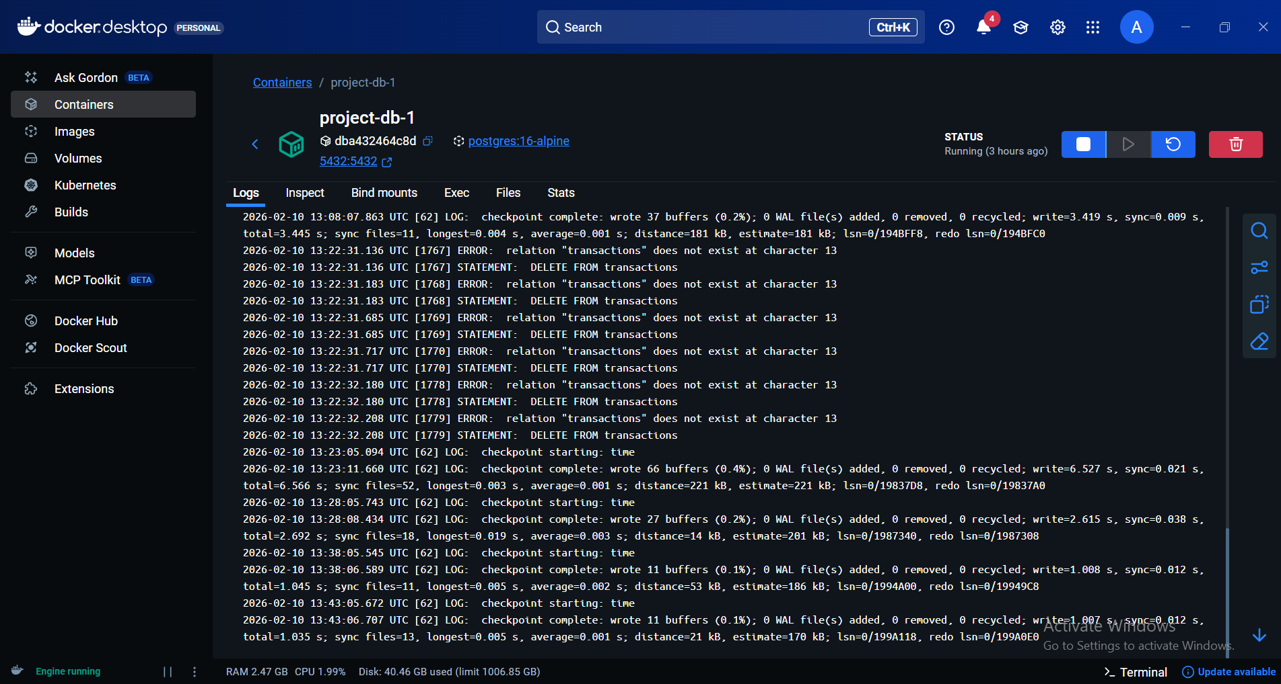
Figure 3: PostgreSQL running in Docker
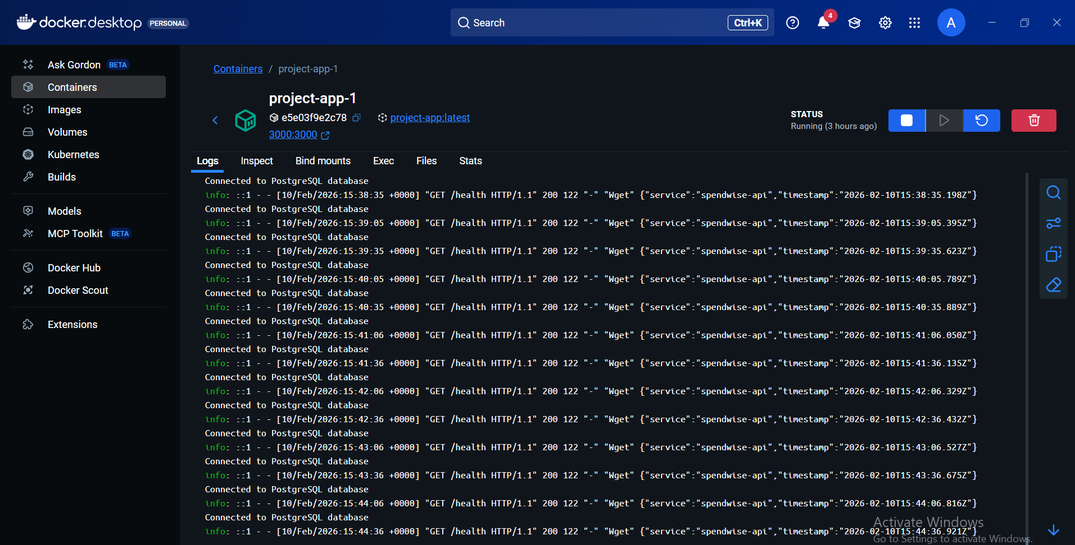
Figure 4: Application logs in Docker
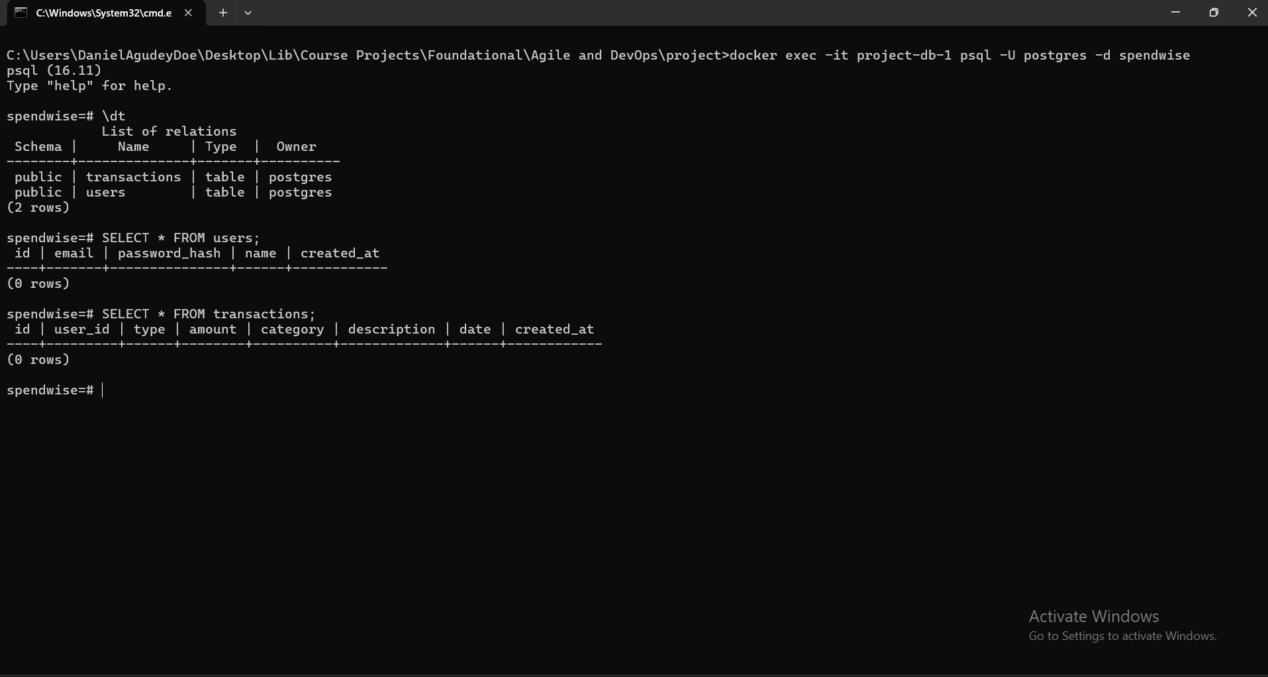
Figure 5: Database schema verification

Delivered Work
User Story | Feature | Points | Status
US-01 | Register an Account | 3 | Complete
US-02 | Log In | 3 | Complete
US-03 | Add a Transaction | 3 | Complete

US-01: Register an Account
Features Delivered:
- POST /api/auth/register endpoint
- Password hashing with bcrypt
- Email validation and duplicate checking
- Returns 201 with user data (no password)

US-02: Log In
Features Delivered:
- POST /api/auth/login endpoint
- JWT token generation (24h expiry)
- Password comparison with bcrypt
- Returns 200 with JWT token

US-03: Add a Transaction
Features Delivered:
- POST /api/transactions endpoint
- JWT authentication required
- Transaction validation (type, amount, category)
- Date defaults to today

Version Control (Git)
Commit history showing iterative, incremental delivery:
851f4a9 feat: add project configuration and Docker setup
742e6b5 feat: implement Express.js API structure and core components
0763e52 ci: set up CI/CD pipeline, tests, and linting
f21831b test: add comprehensive test suites for Sprint 1
bb3c257 fix: resolve test and lint issues
Git Branch Strategy:
master (production)
└── dev (integration)
├── feature/sprint-1-authentication
└── feature/sprint-2-transactions

CI/CD Pipeline Setup
GitHub Actions CI/CD pipeline configured in .github/workflows/ci.yml. Runs on every push and pull request.
Stage | Description | Status
1 | Checkout code | Passed
2 | Build Docker image | Passed
3 | Setup Node.js 20 | Passed
4 | Install dependencies | Passed
5 | Run ESLint | Passed
6 | Run Jest tests | Passed
7 | Deploy to Render (master only) | Configured

Pipeline Configuration (ci.yml):
name: CI/CD Pipeline
on:
push:
branches: ["*"]
pull_request:
branches: [master, dev]
jobs:
build-and-test:
runs-on: ubuntu-latest
services:
postgres:
image: postgres:16-alpine
steps:
- Checkout code
- Build Docker image
- Setup Node.js 20
- Install dependencies (npm ci)
- Run ESLint
- Run tests (npm test)
deploy:
needs: build-and-test
if: github.ref == 'refs/heads/master'
steps:
- Trigger Render deploy hook

Testing (Sprint 1)
Metric | Value
Test Suites | 5
Total Tests | 27
Passing | 27
Failing | 0
Pass Rate | 100%
Code Coverage | 64.25%

Acceptance Criteria Coverage
User Story | Total ACs | Tested | Coverage
US-01 | 9 | 9 | 100%
US-02 | 7 | 7 | 100%
US-03 | 9 | 9 | 100%
Total | 25 | 25 | 100%

Sprint 1 Test Screenshots
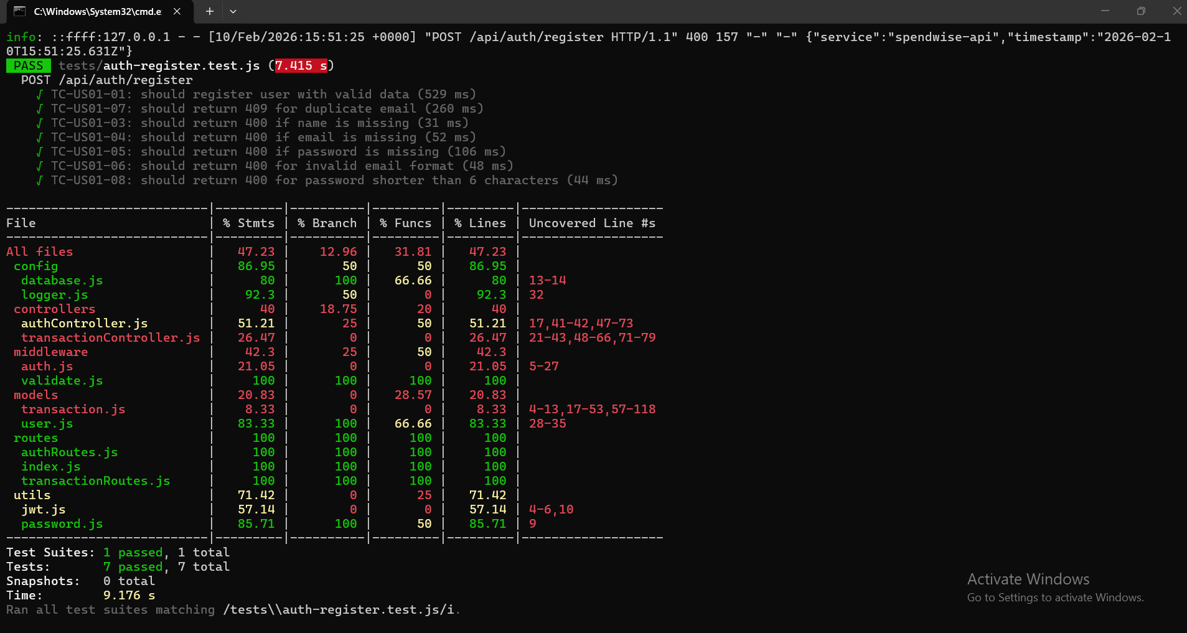
Figure 6: Registration tests passed
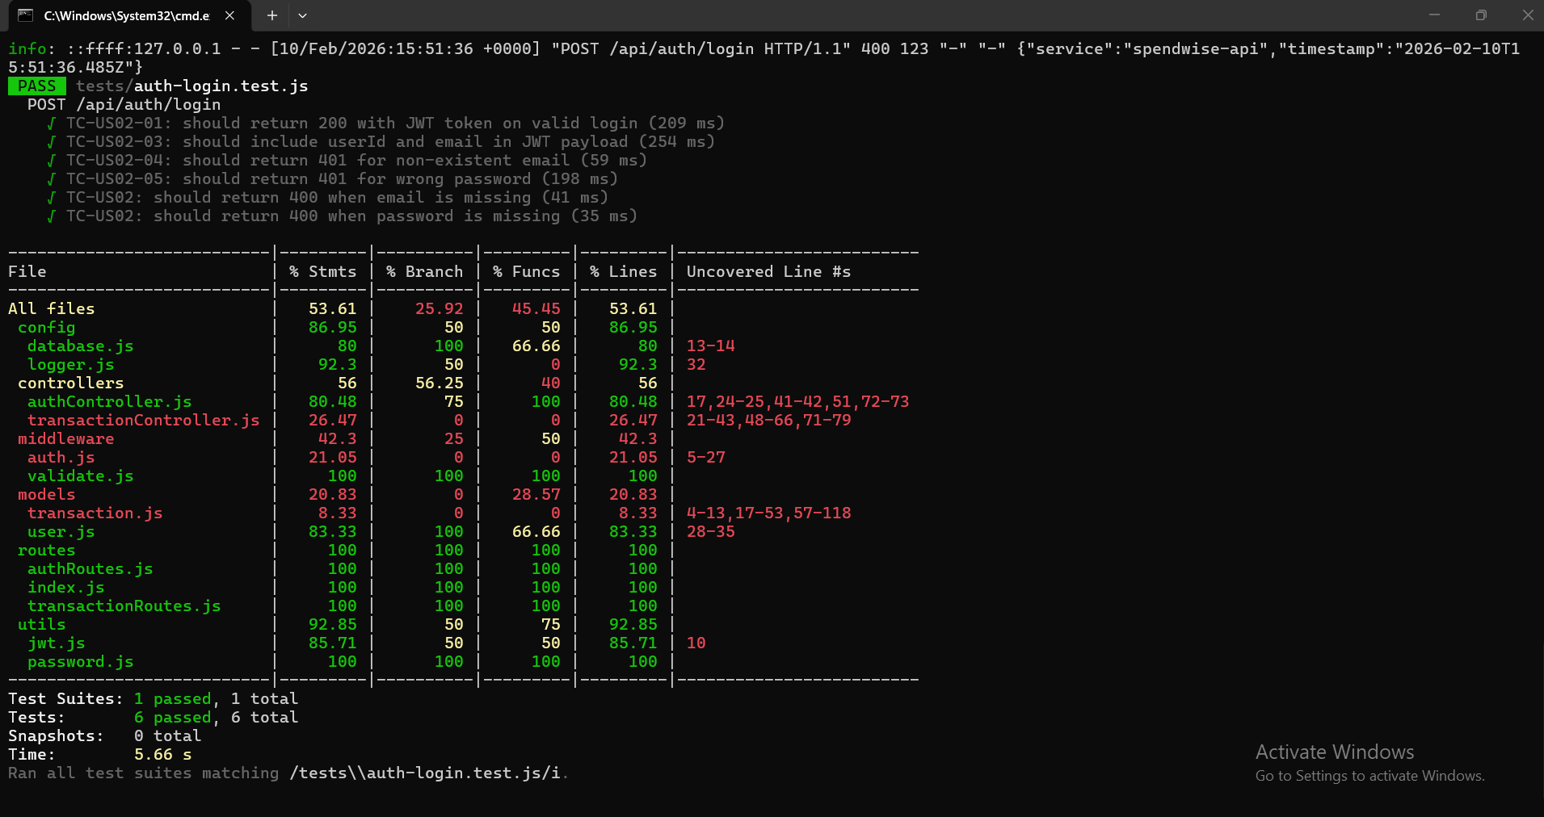
Figure 7: Login tests passed
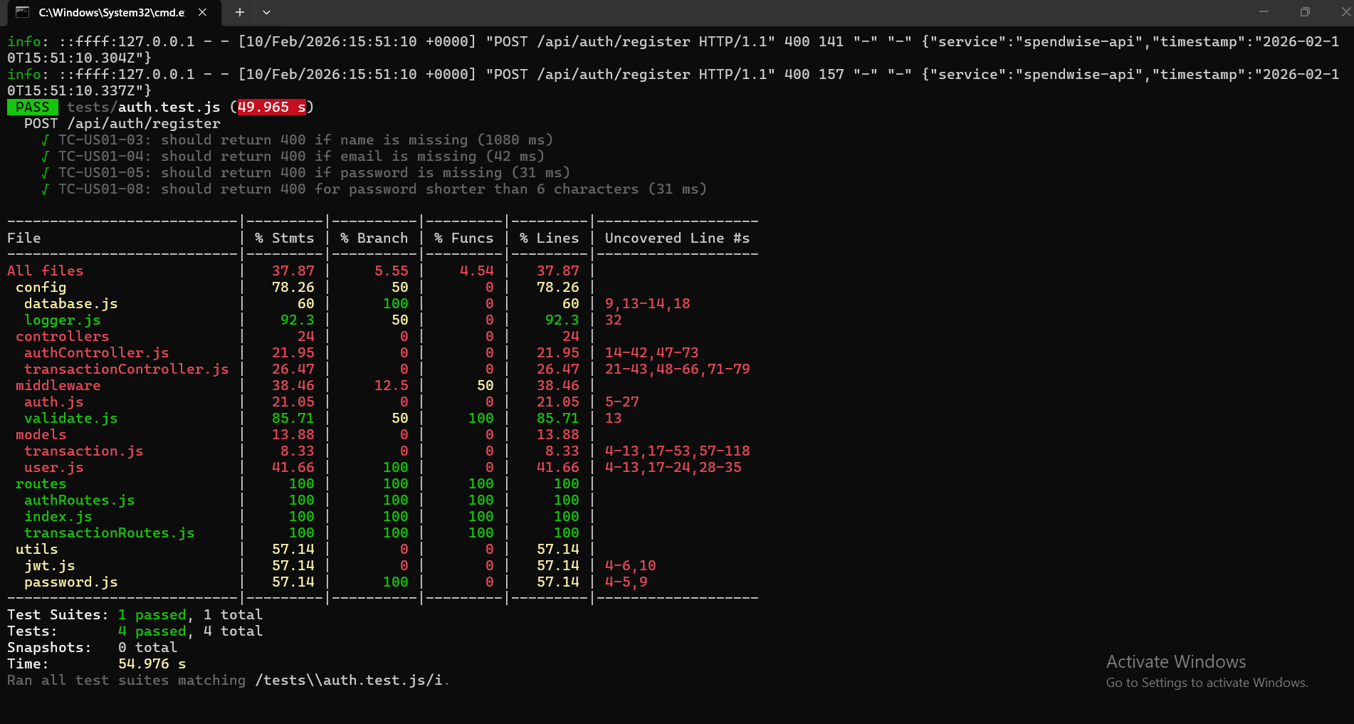
Figure 8: Authentication tests passed
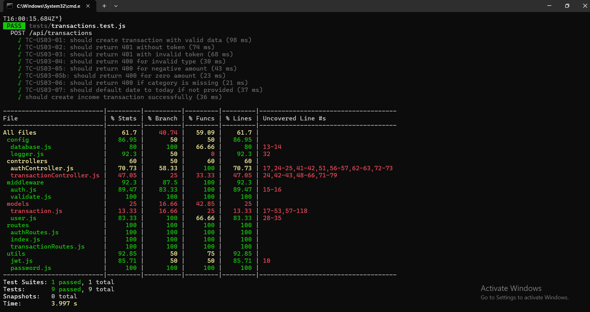
Figure 9: Transaction tests passed

Sprint 1 API Testing Screenshots
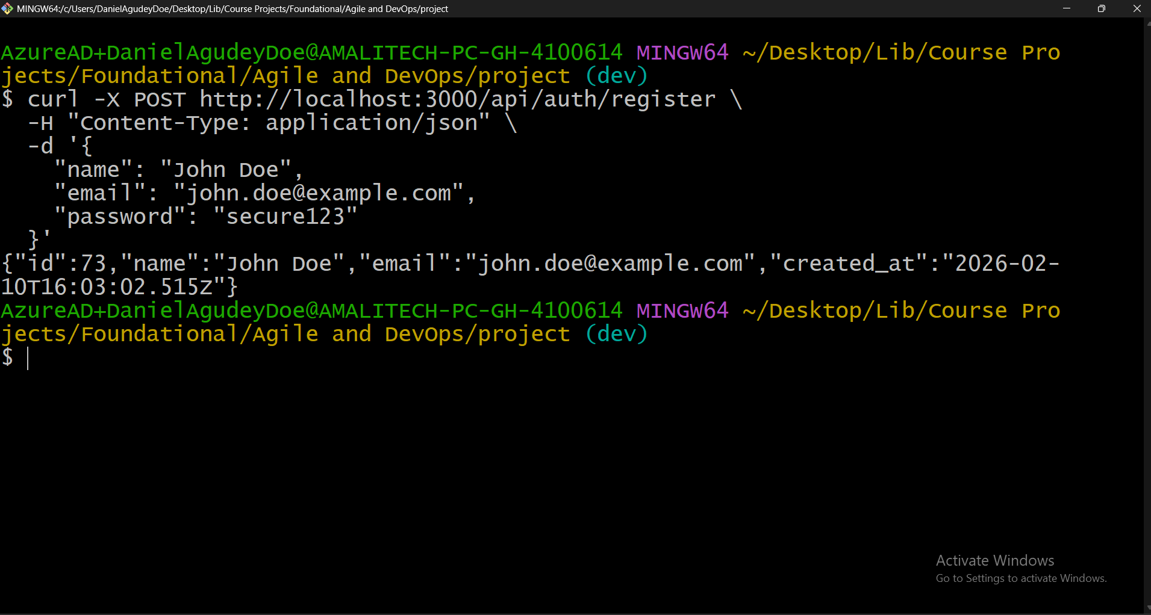
Figure 10: Registration success
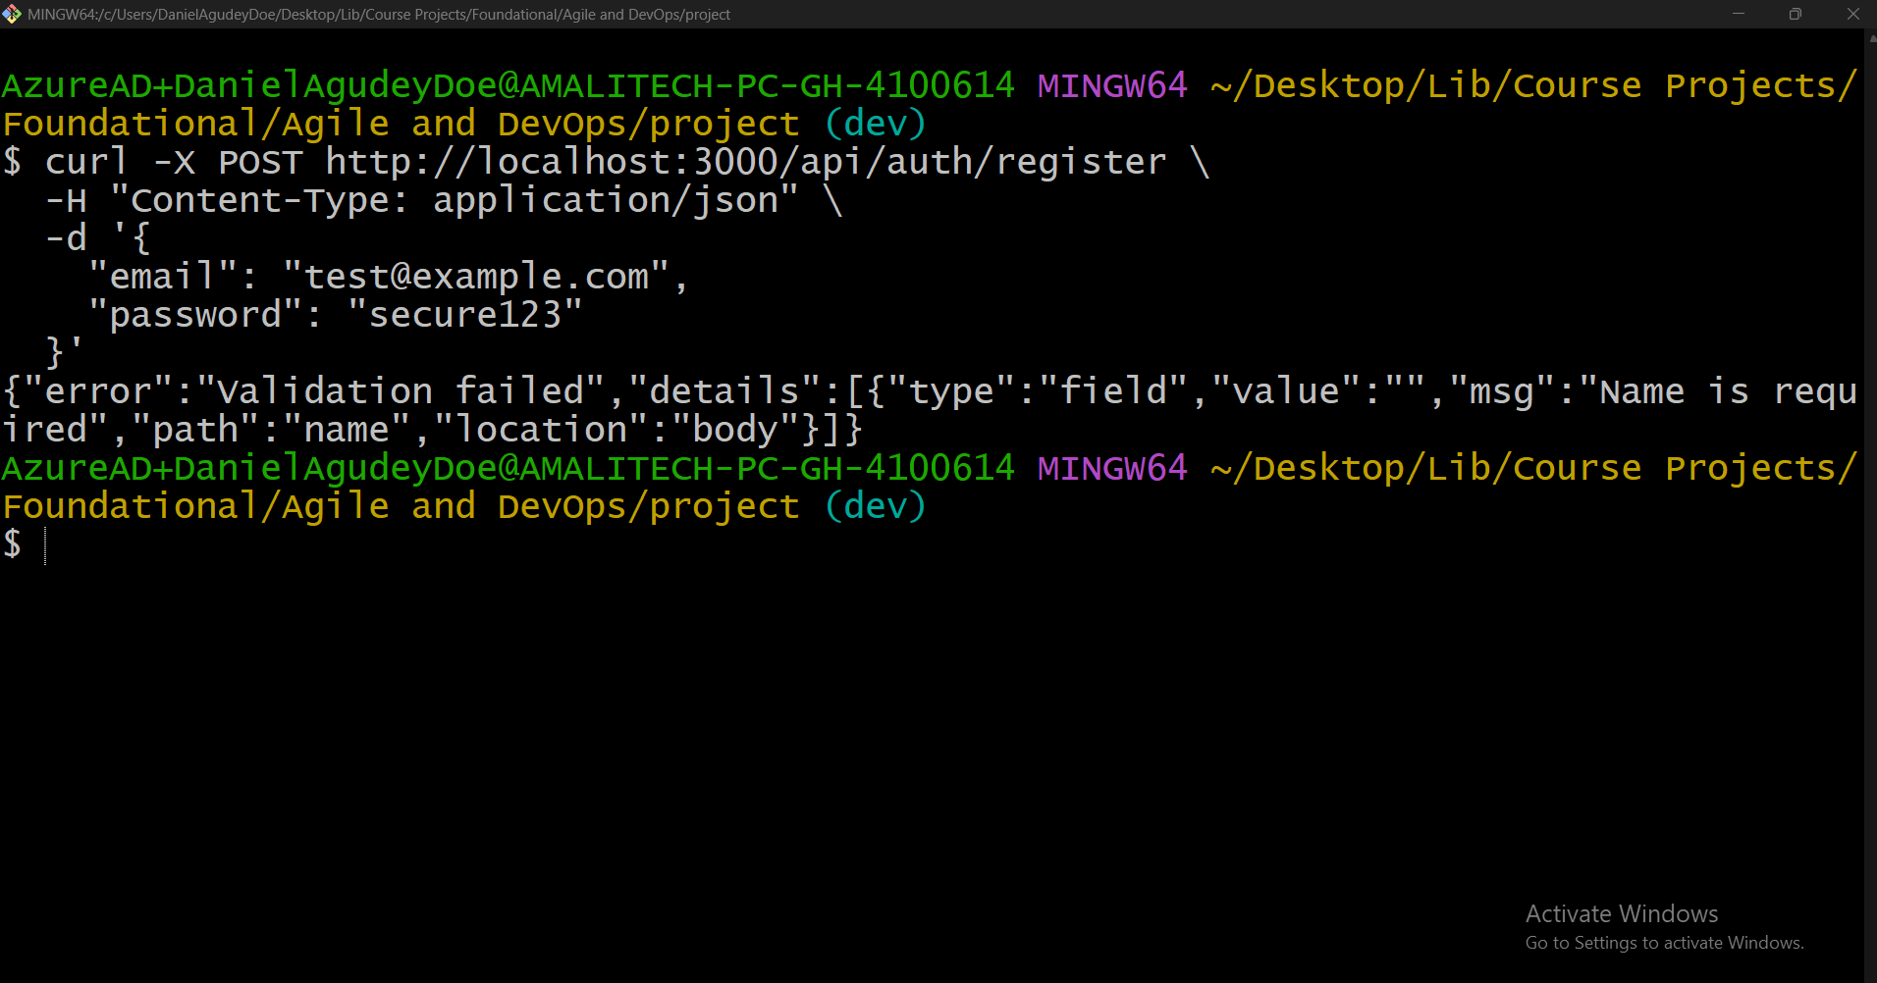
Figure 11: Missing email validation
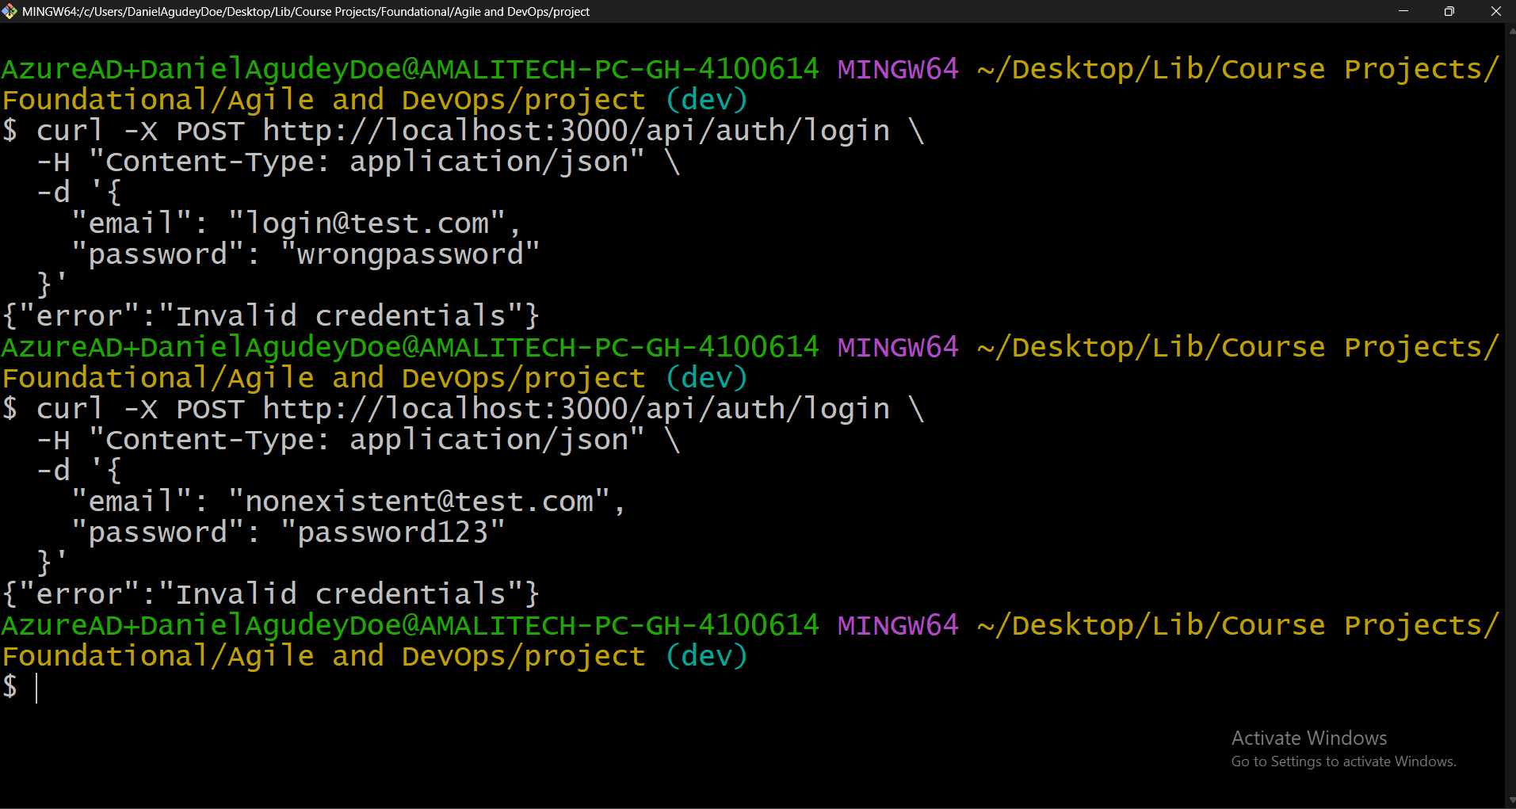
Figure 12: Invalid email – 401
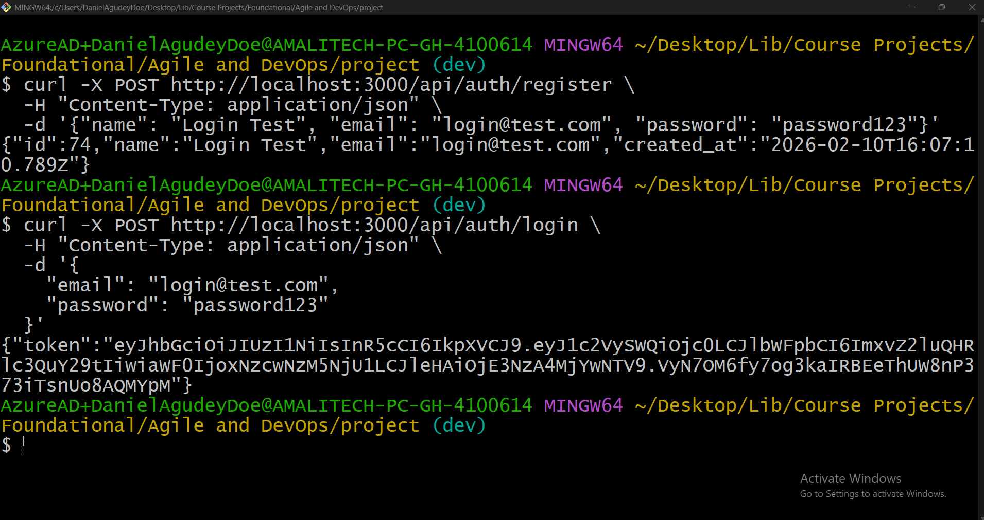
Figure 13: Login success
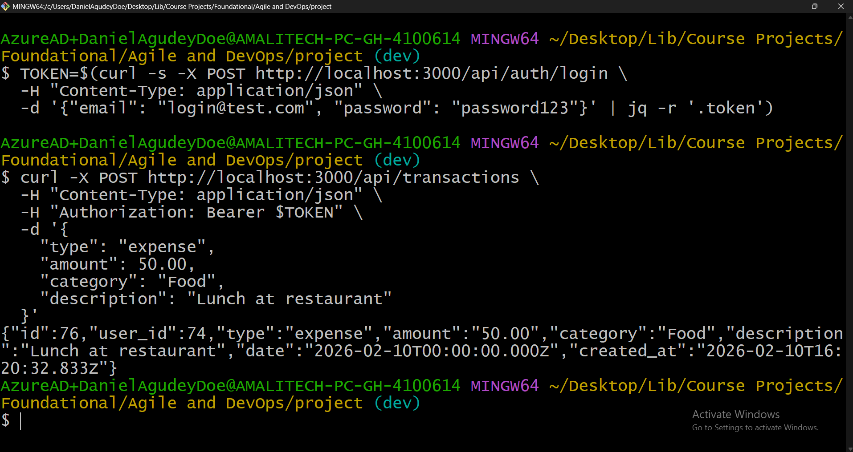
Figure 14: Transaction creation success
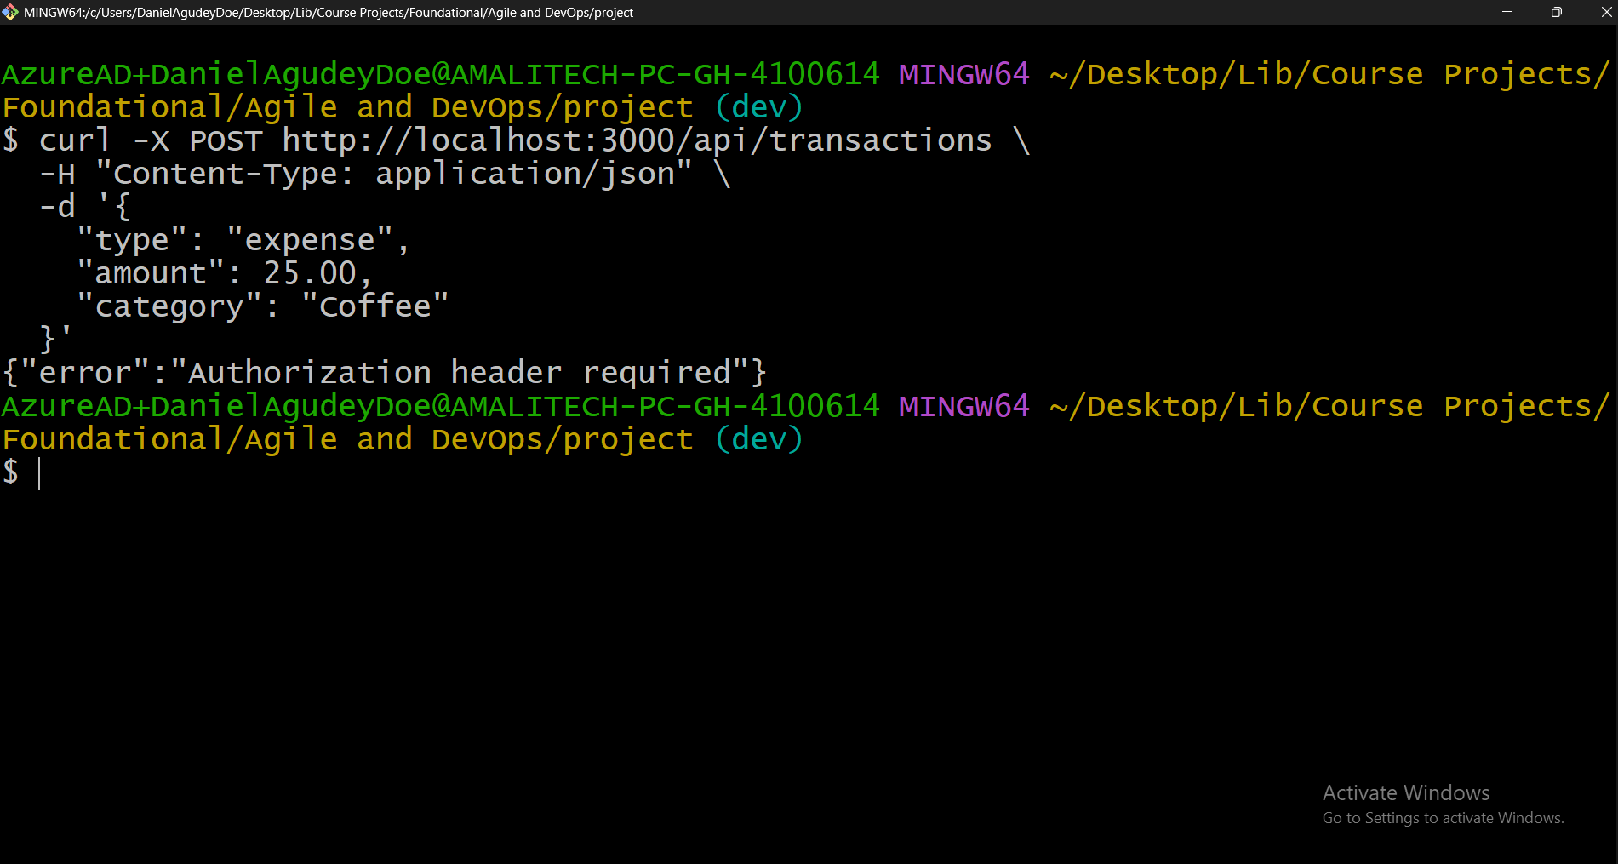
Figure 15: No token – 401
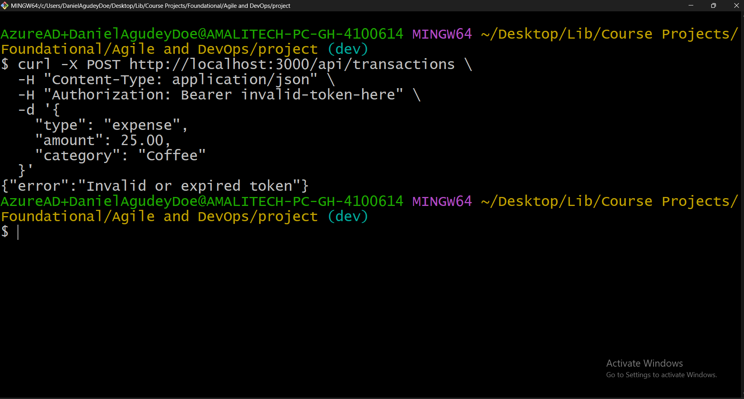
Figure 16: Invalid token – 401
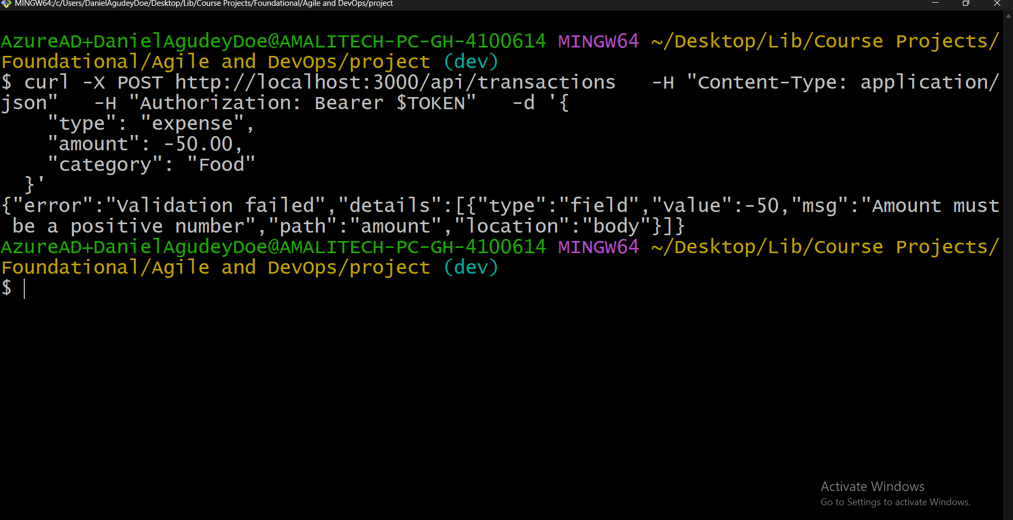
Figure 17: Negative amount validation

Sprint 1 Review
Sprint 1 successfully delivered all 3 planned user stories (9 story points) with a fully functional authentication system, transaction creation capability, 27 passing tests (64% coverage), CI/CD pipeline configured, and Docker support.

Technical Foundation Established
Component | Status
Express.js API | RESTful structure
PostgreSQL Database | Users & transactions tables
Authentication (JWT) | bcrypt + jsonwebtoken
Input Validation | express-validator
Logging | Winston + Morgan
Docker Support | Dockerfile + docker-compose
CI/CD Pipeline | GitHub Actions

Sprint 1 Burndown
Day | Points Completed | Cumulative
Day 1 | 3 (US-01) | 3
Day 2 | 3 (US-02) | 6
Day 3 | 3 (US-03) | 9
Day 4+ | Testing & Documentation | 9

Sprint 1 Retrospective

What Went Well
- Iterative Commit History – Small, incremental commits throughout development with clear messages.
- Test-Driven Development – Wrote tests during implementation; achieved 100% pass rate.
- Complete Documentation – Comprehensive test execution report, acceptance criteria mapped.
- Docker Containerization – Local dev environment ready with single command.

What Could Be Improved
- Test Database Setup – Initial test runs failed due to database connection pooling conflicts. Fix: use --runInBand flag.
- Environment Configuration – DATABASE_URL not read properly in initial test runs. Fix: explicitly create .env before tests.
- Date Handling – PostgreSQL returning different date format. Fix: standardize ISO 8601 format.

Action Items for Sprint 2
Priority | Action | Status
P1 (High) | Use --runInBand flag for test execution | Applied
P1 (High) | Create .env file with DATABASE_URL | Applied
P2 (Medium) | Standardize date format in responses | Applied
P2 (Medium) | Increase code coverage to >80% | Achieved (90.63%)

Process Metrics (Sprint 1)
Metric | Value
Story Points Completed | 9/9 (100%)
Tests Written | 27
Test Pass Rate | 100%
Code Coverage | 64.25%
Commits | 5
Bugs Found/Fixed | 3/3

Sprint 2: Execution & Improvement

Feedback Applied from Sprint 1 Retrospective
Improvement | Applied? | Result
Use --runInBand flag | Yes | Tests run sequentially, no conflicts
Create .env file | Yes | DATABASE_URL properly set
Standardize date handling | Yes | Consistent date formats in responses
Increase coverage | Yes | Improved from 64% to 90.63%

Delivered Work
User Story | Feature | Points | Status
US-04 | List My Transactions | 2 | Complete
US-05 | Filter Transactions | 3 | Complete
US-06 | Get Spending Summary | 3 | Complete
US-07 | Health Endpoint | 2 | Complete

US-04: List My Transactions
Features Delivered:
- GET /api/transactions endpoint
- Returns only authenticated user's transactions
- Sorted by date descending (most recent first)
- Returns empty array if no transactions

US-05: Filter Transactions
Features Delivered:
- Filter by type: ?type=income|expense
- Filter by category: ?category=food (case-insensitive)
- Filter by date range: ?from=YYYY-MM-DD&to=YYYY-MM-DD
- Combined filters supported

US-06: Get Spending Summary
Features Delivered:
- GET /api/transactions/summary endpoint
- Returns: total_income, total_expenses, balance
- Category breakdown in by_category object
- Optional date range filtering; zero values for new users

US-07: Health Endpoint
Features Delivered:
- GET /health endpoint (public, no authentication)
- Returns: status, uptime_seconds, timestamp, database, version
- Database connectivity check (SELECT 1)
- Returns 503 if database is disconnected

Monitoring & Logging
- Winston logger for application logs
- Morgan middleware for HTTP request logs
- Health endpoint with database connectivity check
- Error logging in all controllers
- Request/response logging in CI/CD
Log Output Example:
info: User registered successfully: john@example.com
{"service":"spendwise-api","timestamp":"2026-02-10T13:23:20.708Z"}
info: ::ffff:127.0.0.1 "POST /api/transactions HTTP/1.1" 201 168

Testing (Sprint 2)
Metric | Sprint 1 | Sprint 2 | Improvement
Test Suites | 4 | 7 | +3
Total Tests | 27 | 45 | +18
Pass Rate | 100% | 100% | Same
Code Coverage | 64.25% | 90.63% | +26.38%

Coverage by Module
Module | Statements | Branches | Functions | Lines
All files | 90.63% | 81.48% | 81.81% | 90.63%
Controllers | 81.33% | 75% | 100% | 81.33%
Middleware | 92.3% | 87.5% | 100% | 92.3%
Models | 97.22% | 91.66% | 85.71% | 97.22%
Routes | 100% | 100% | 100% | 100%

Acceptance Criteria Coverage (All Sprints)
User Story | Total ACs | Tested ACs | Coverage
US-01 | 9 | 9 | 100%
US-02 | 7 | 7 | 100%
US-03 | 9 | 9 | 100%
US-04 | 4 | 4 | 100%
US-05 | 5 | 5 | 100%
US-06 | 5 | 5 | 100%
US-07 | 4 | 4 | 100%
Total | 43 | 43 | 100%

Sprint 2 Test Screenshots
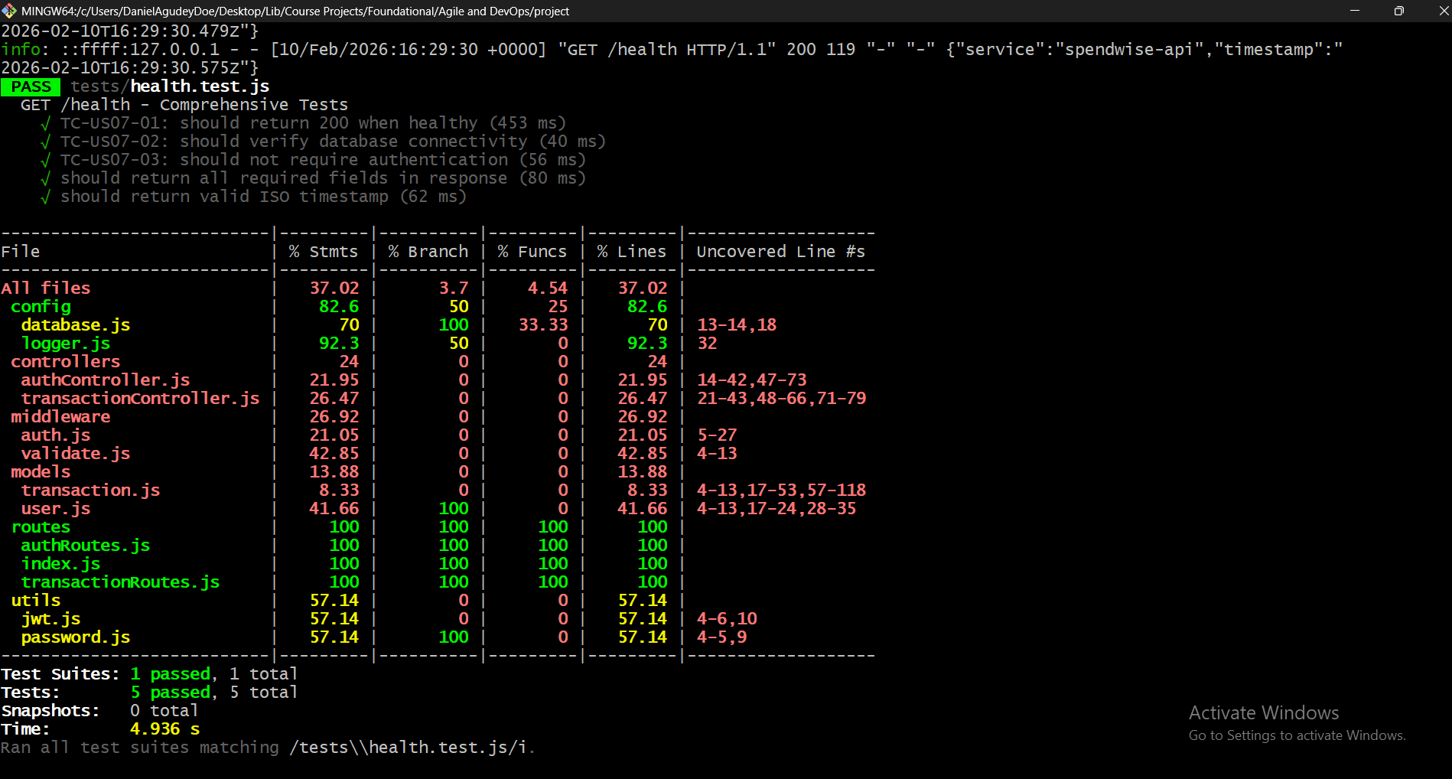
Figure 18: Health tests passed
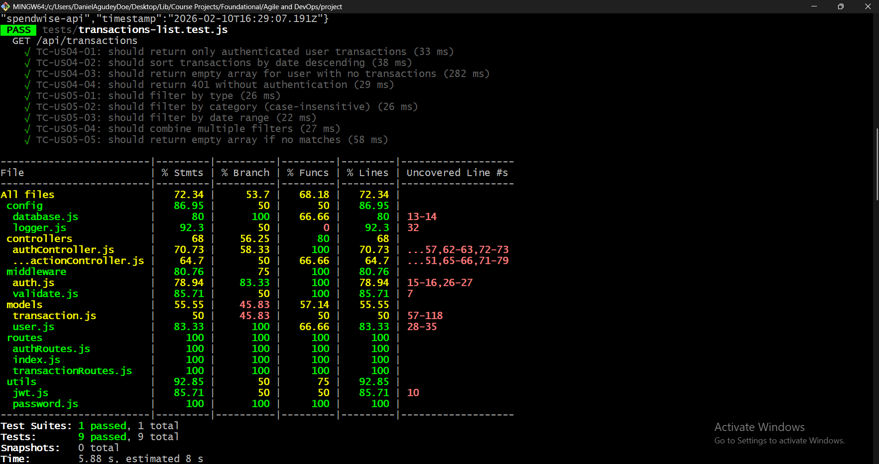
Figure 19: Transaction list tests passed
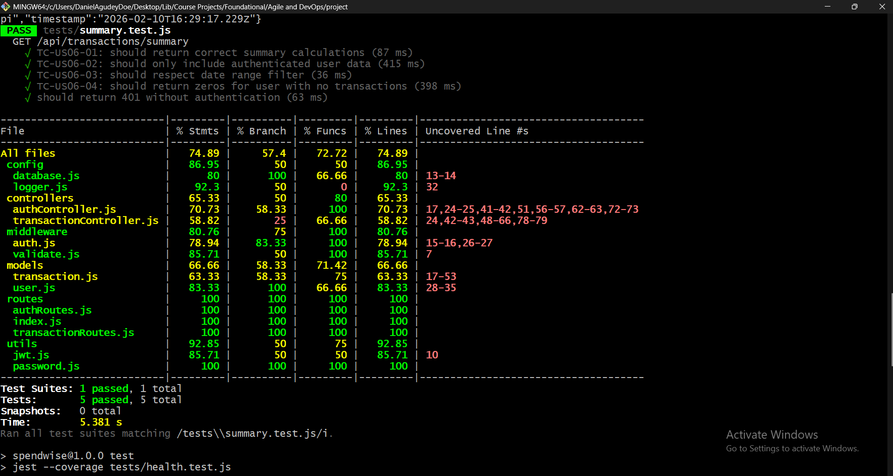
Figure 20: Summary tests passed (90% coverage)

Sprint 2 API Testing Screenshots
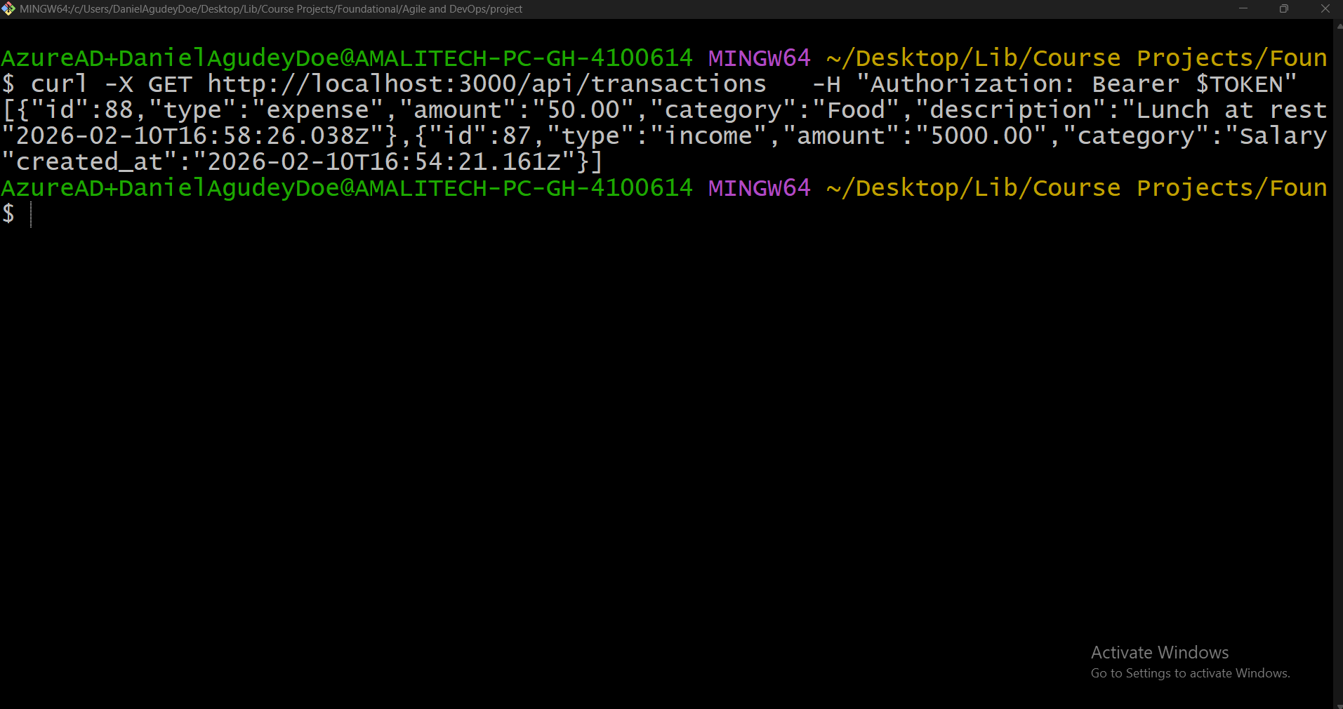
Figure 21: List transactions
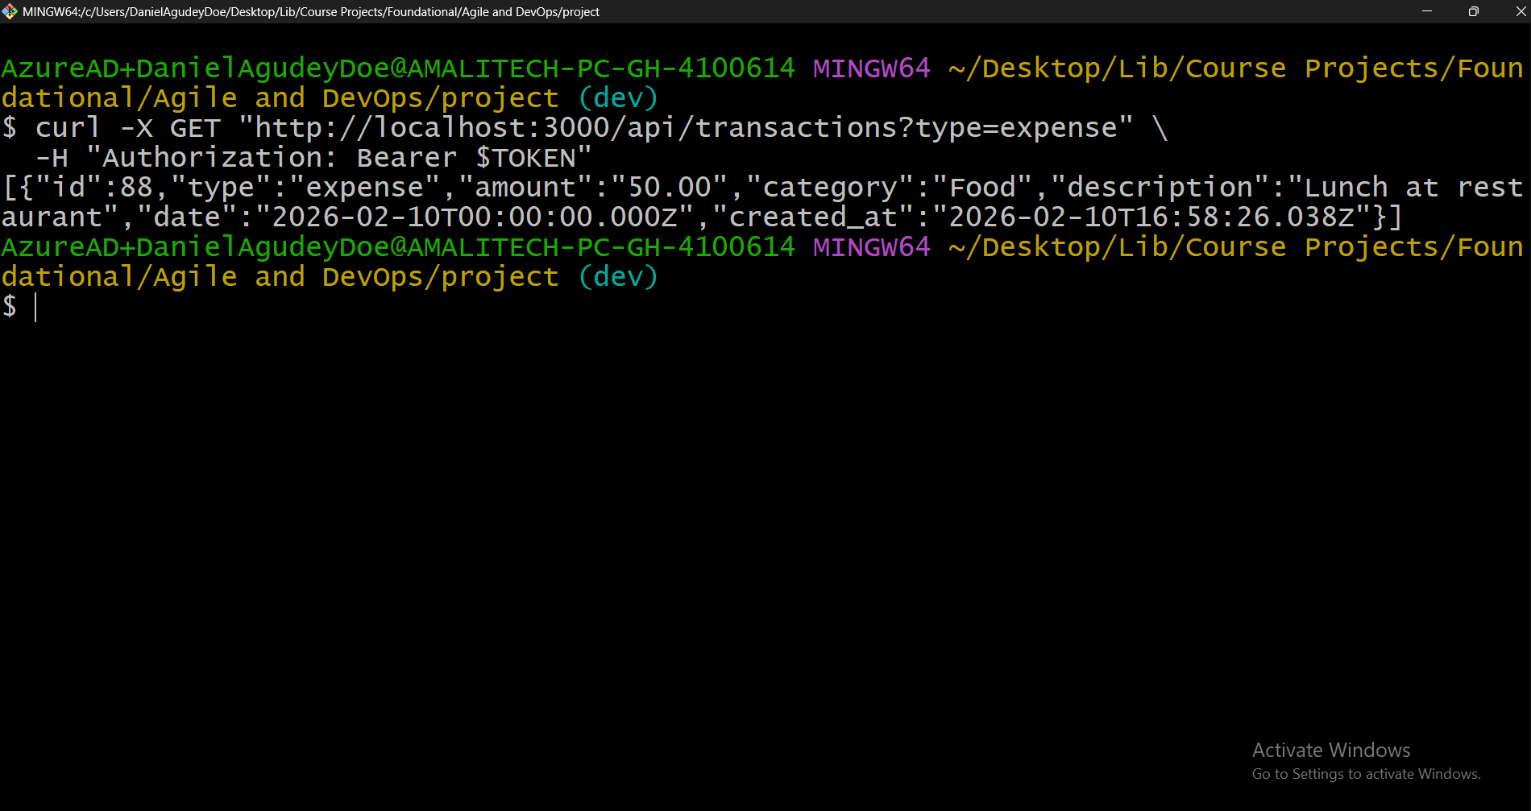
Figure 22: Filter by type
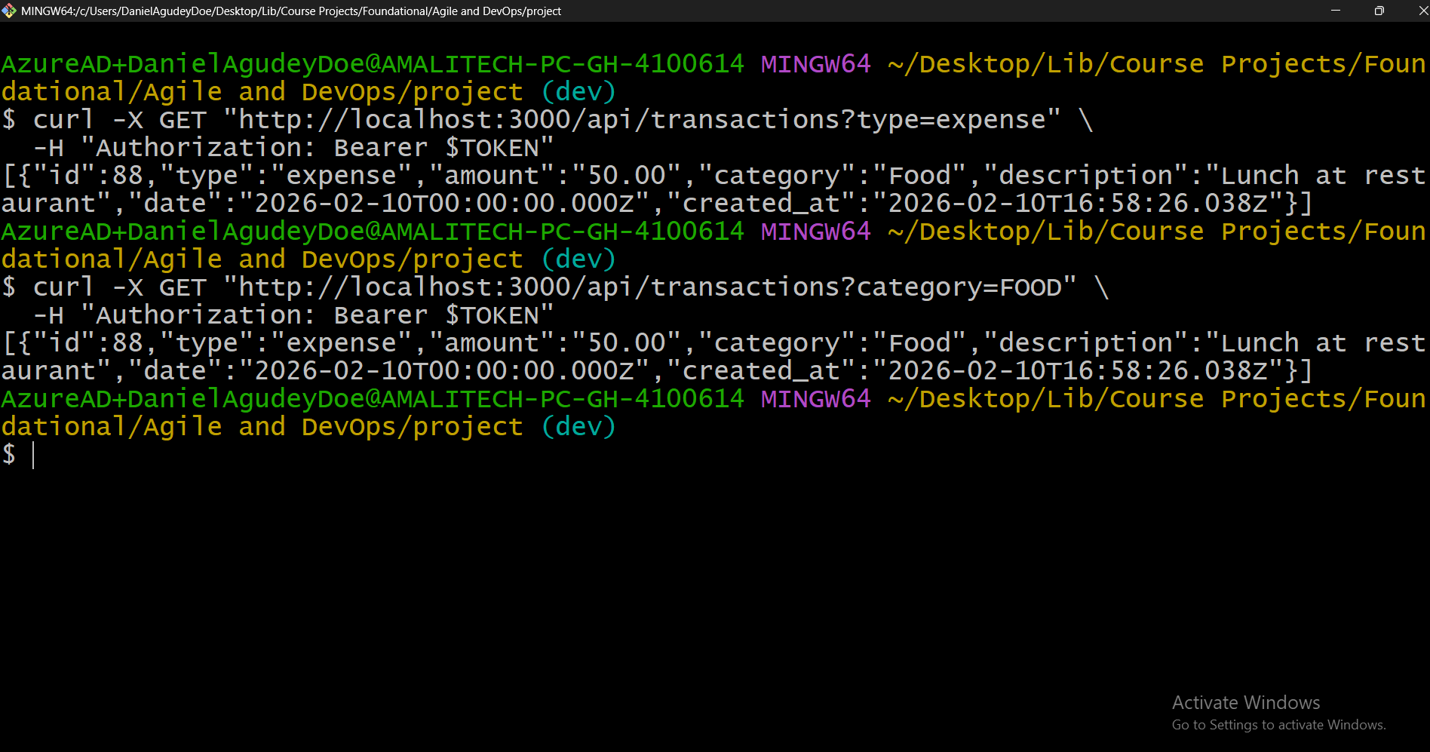
Figure 23: Filter by category
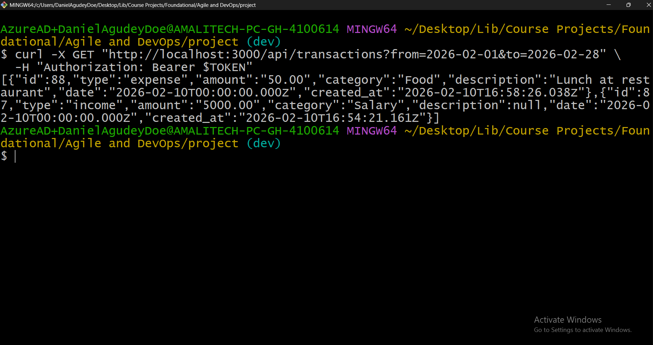
Figure 24: Filter by date range
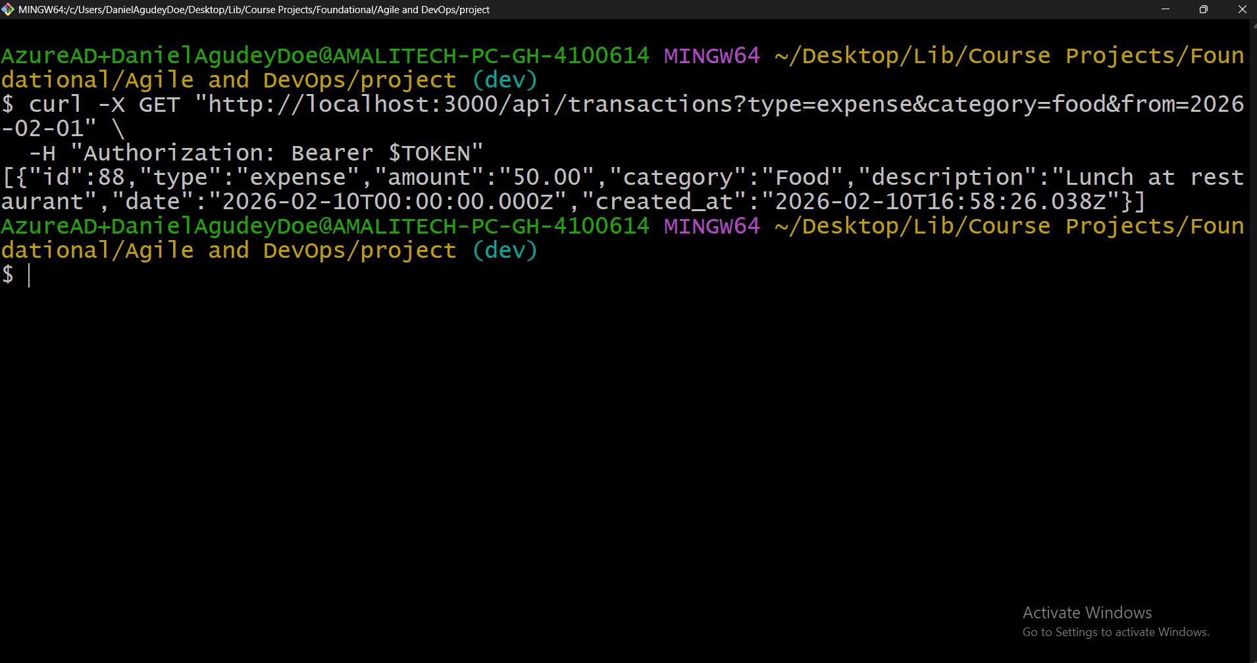
Figure 25: Combined filters
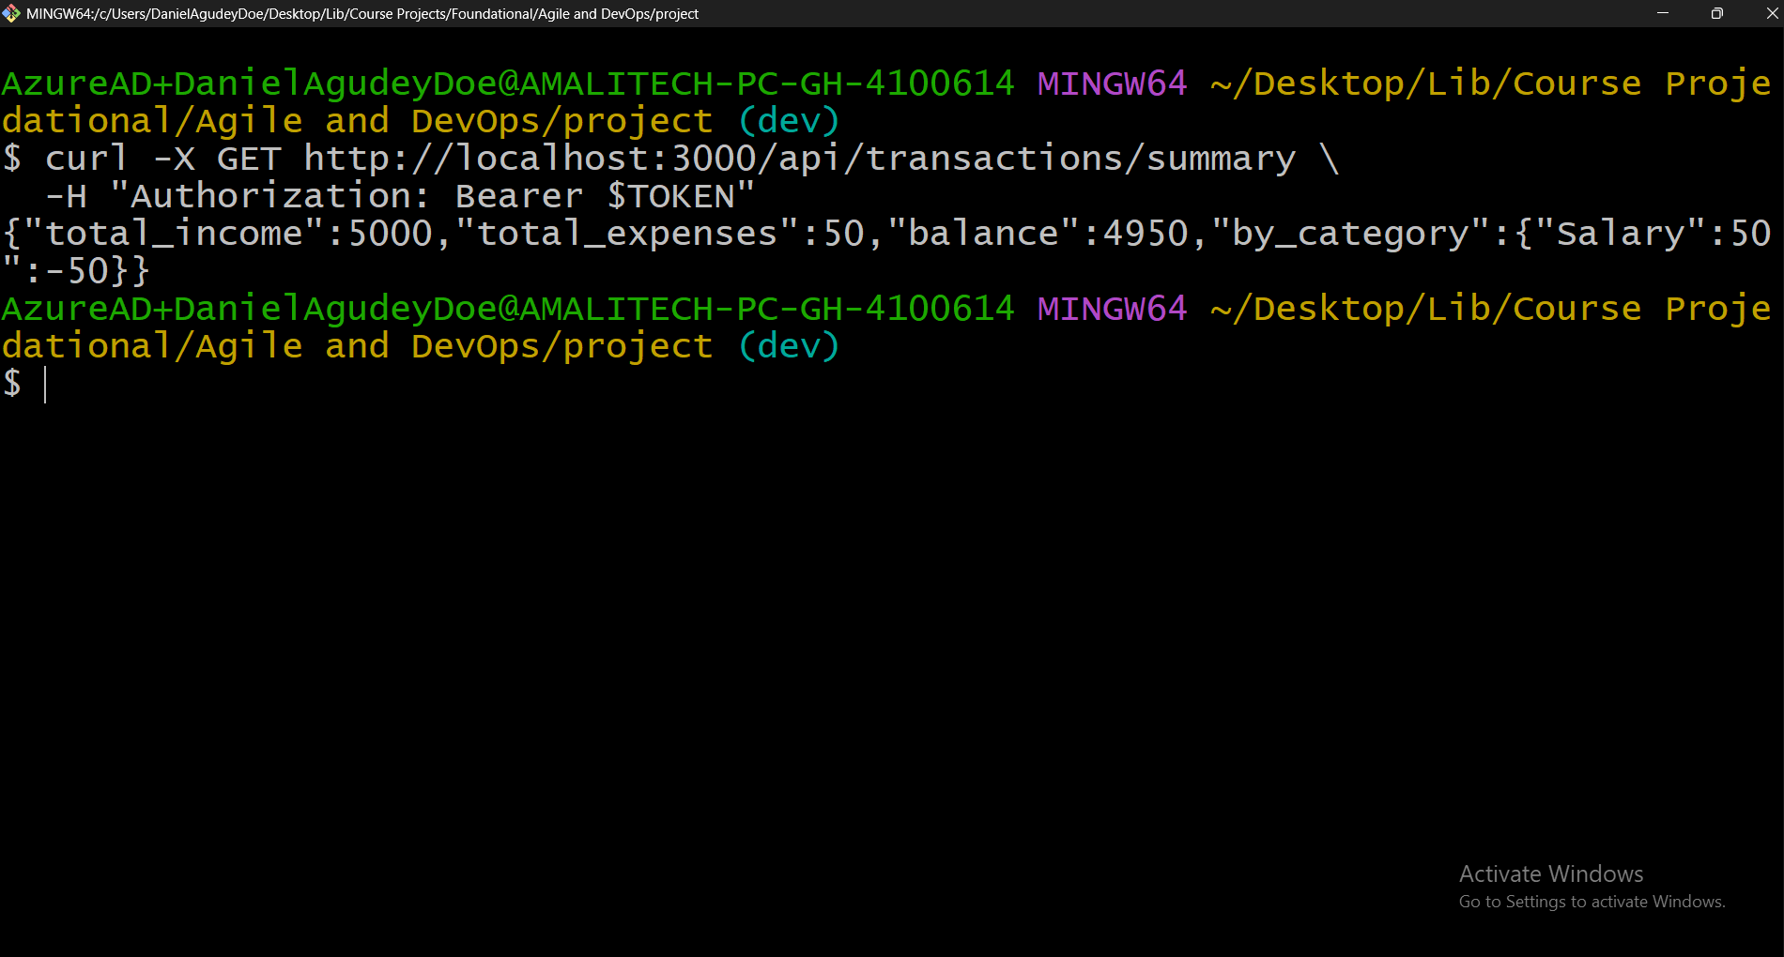
Figure 26: Summary endpoint
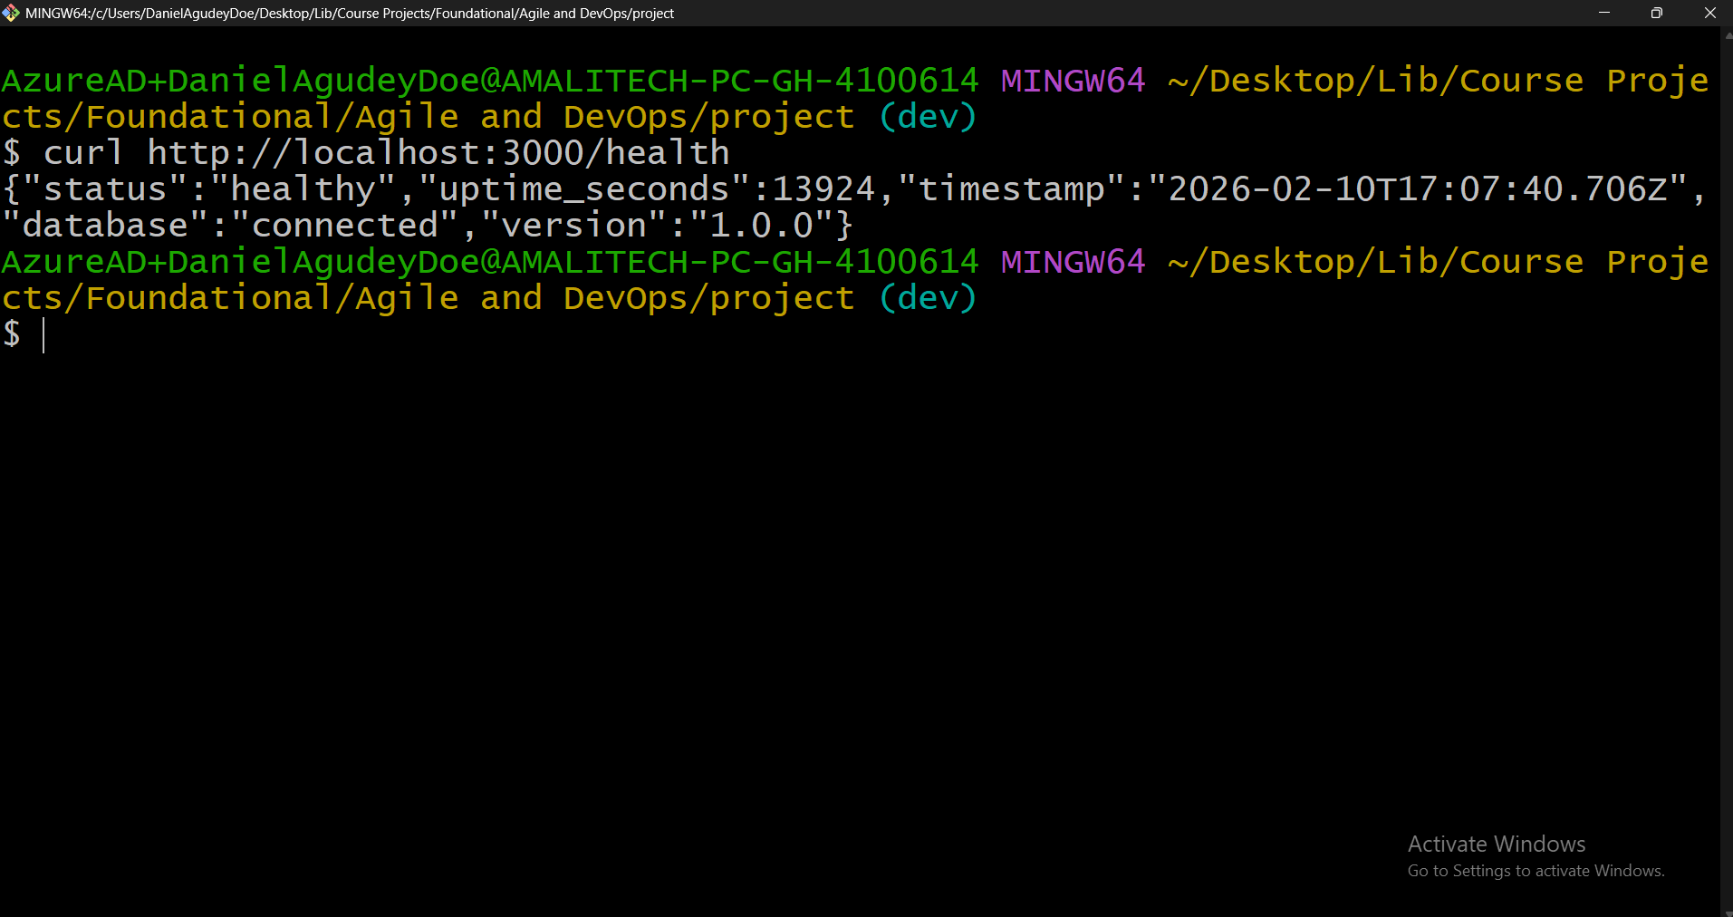
Figure 27: Health endpoint

Sprint 2 Review
Sprint 2 successfully delivered all 4 planned user stories (10 story points) with significant improvements: 90.63% code coverage (up from 64.25%), 45 tests passing (up from 27), full monitoring (health endpoint + logging), and all acceptance criteria tested.

Sprint 2 Burndown
Day | Points Completed | Cumulative
Day 1 | 5 (US-04, US-05 tests) | 5
Day 2 | 5 (US-06, US-07 tests) | 10
Day 3 | Documentation & Review | 10

Definition of Done Status
Criterion | Sprint 1 | Sprint 2
Code follows style guidelines | Pass | Pass
Tests pass | 100% | 100%
Code merged to dev | Done | Done
CI pipeline passes | Pass | Pass
Documentation updated | Done | Done
Code coverage > 80% | 64% (below) | 90.6% (above)

Final Retrospective

Sprint-by-Sprint Comparison
Metric | Sprint 1 | Sprint 2 | Improvement
Story Points | 9 | 10 | +1
Tests | 27 | 45 | +18
Coverage | 64.25% | 90.63% | +26.38%
Pass Rate | 100% | 100% | Same
User Stories | 3 | 4 | +1

Lessons Learned
Technical Lessons:
- Docker First Approach – Starting with Docker simplifies environment setup. CI/CD integrates naturally.
- Test-Driven Development – Writing tests during implementation catches bugs early. 100% pass rate maintained.
- CI/CD is Non-Negotiable – Automated testing catches issues immediately. Quality gates keep code clean.
- Git Flow Discipline – Feature branches enable parallel work. Merge to dev keeps master clean.
Agile Lessons:
- Sprint Planning Matters – Well-defined acceptance criteria = successful delivery.
- Retrospectives Drive Improvement – Identified specific, actionable improvements and applied all 3.
- Definition of Done Enforces Quality – Clear DoD prevented cutting corners.

What I Would Do Differently
- Start CI/CD earlier – Set up pipeline skeleton in Sprint 0 before writing code.
- More detailed acceptance criteria – Add edge cases and boundary conditions to ACs.
- Separate test database – Use test containers for true isolation from the start.
- Plan pagination earlier – Even if not required for MVP, saves refactoring later.

Skills Developed
Skill | Before | After
Node.js/Express | Basic | Proficient
PostgreSQL | Basic | Intermediate
Docker | Basic | Intermediate
Git/GitHub | Basic | Proficient
CI/CD (GitHub Actions) | None | Proficient
Jest Testing | Basic | Proficient
Agile Practices | Theoretical | Practical

CI/CD Pipeline Evidence

CI/CD Screenshots
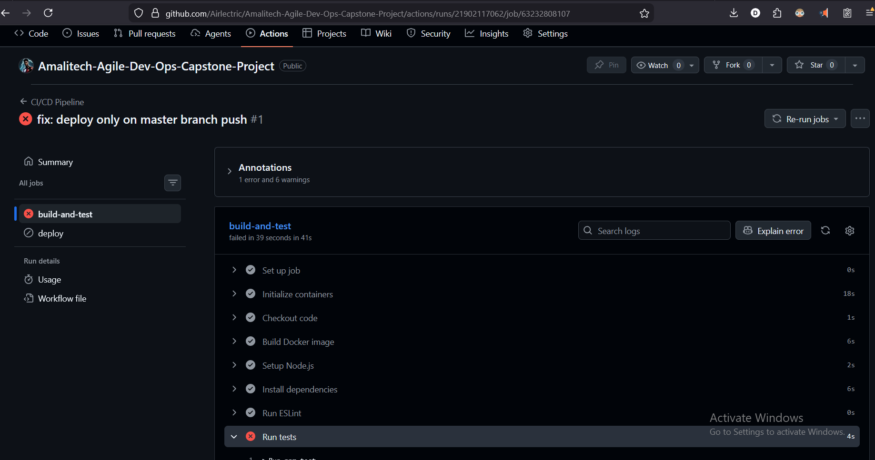
Figure 28: First CI/CD test on master failed
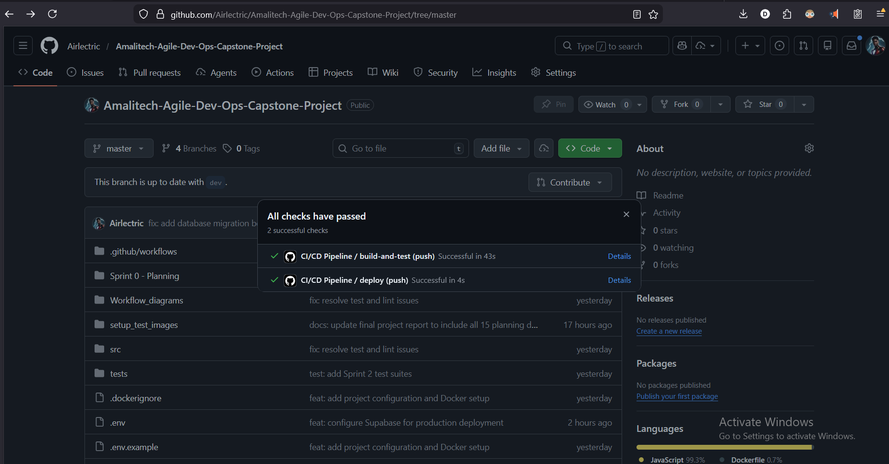
Figure 29: After fixing DB error – all CI/CD tests passed
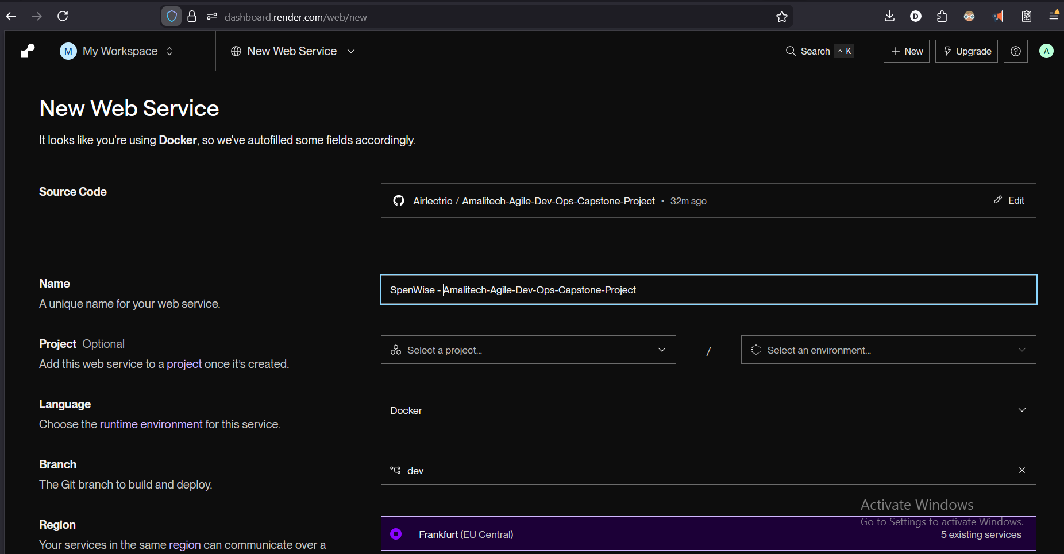
Figure 30: Deployment configuration in Docker
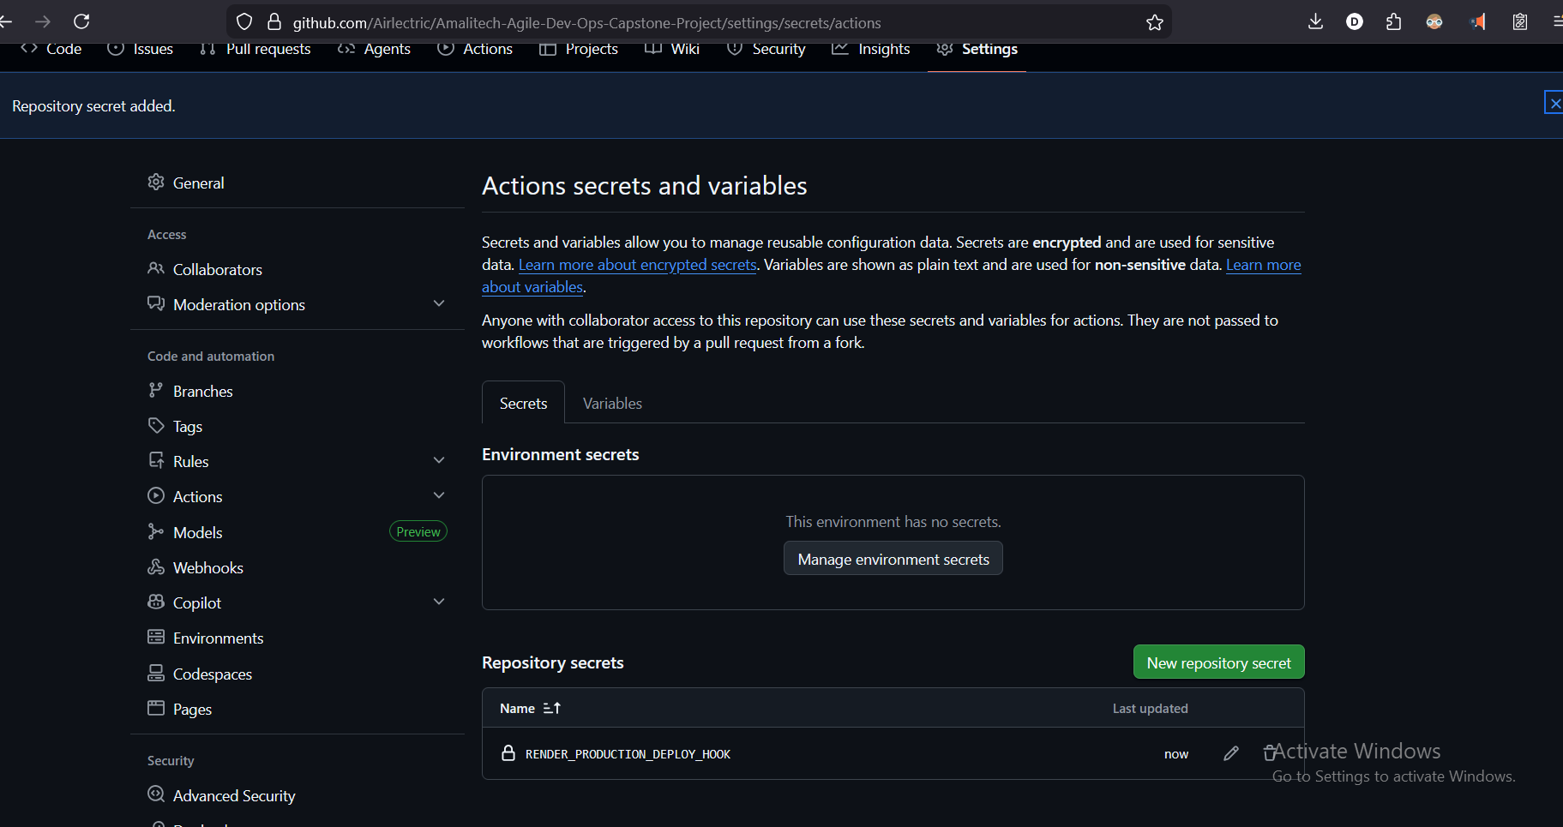
Figure 31: Render deploy hook added to GitHub Actions secrets
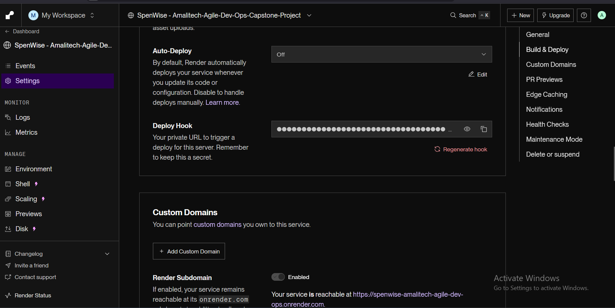
Figure 32: Retrieving Render deploy hooks
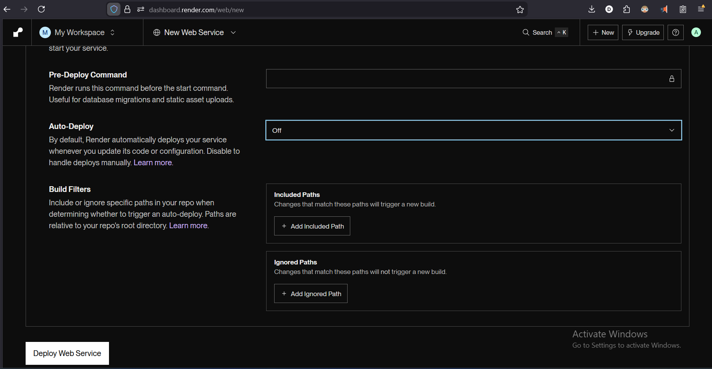
Figure 33: Disabled Render auto-deploy (CI/CD handles deployment)
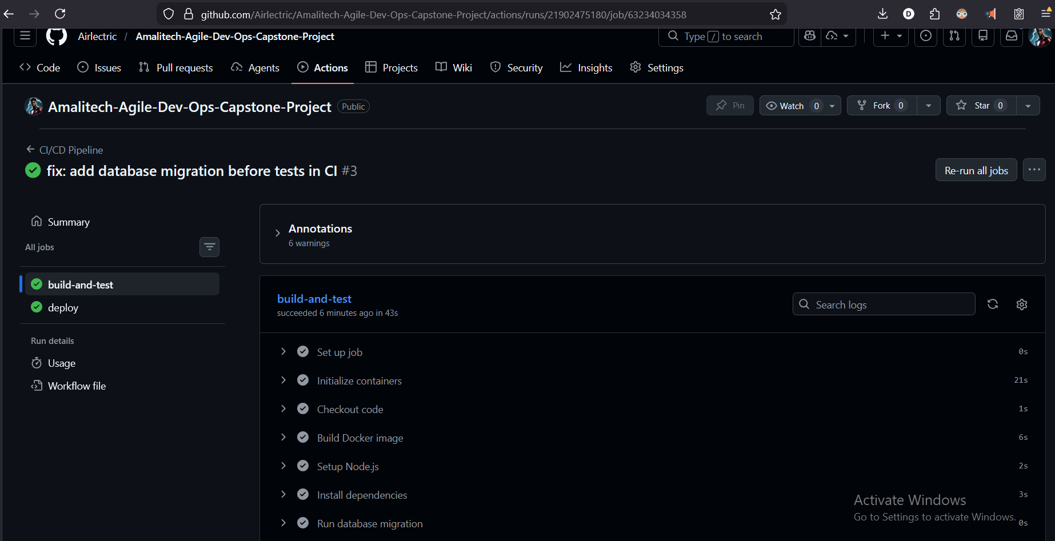
Figure 34: Successful deployment on GitHub Actions
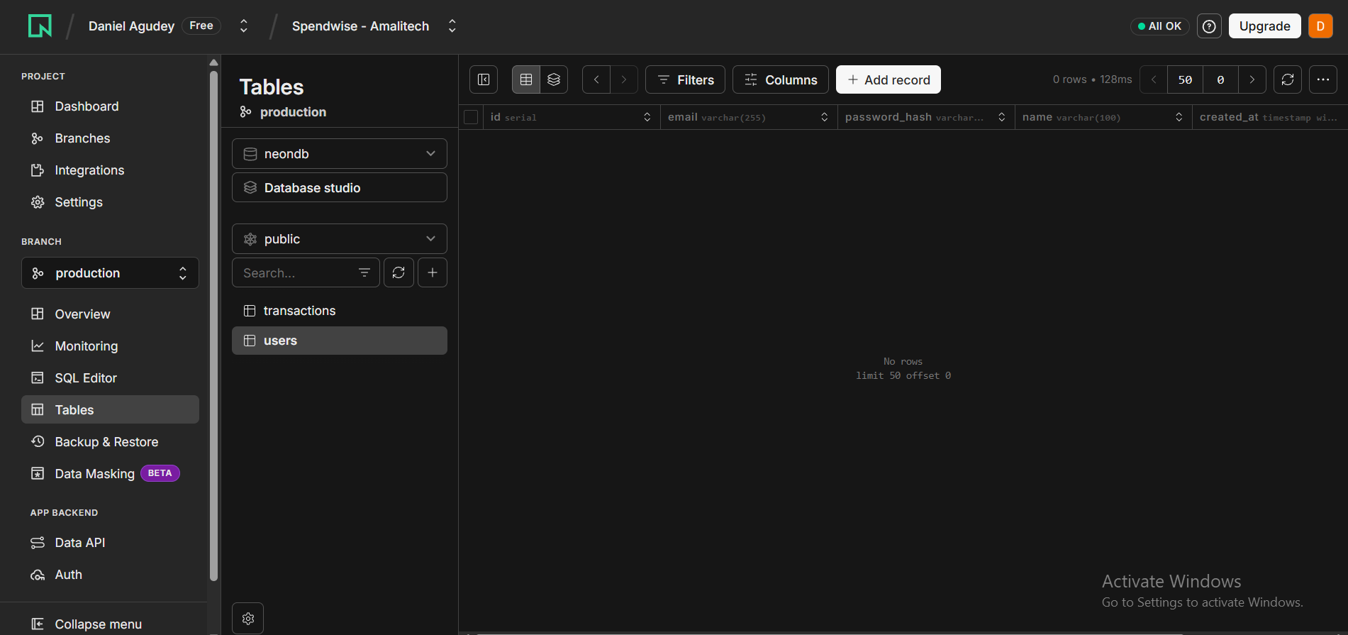
Figure 35: Tables migrated successfully to remote DB

Secrets Configuration
Secret | Purpose | Status
DATABASE_URL | Production database connection | Configured
JWT_SECRET | JWT signing key | Configured
RENDER_DEPLOY_HOOK_URL | Auto-deploy trigger | Configured

Final Project Completion Summary
Metric | Value
Total User Stories | 7
Total Story Points | 19
Completed Stories | 7 (100%)
Completed Points | 19 (100%)
Total Test Cases | 45
Passing Tests | 45 (100%)
Code Coverage | 90.63%
CI/CD Pipeline | Configured & Passing
Docker Support | Configured

API Endpoints
Method | Endpoint | Description | Status
POST | /api/auth/register | Register new user | Complete
POST | /api/auth/login | Login, get JWT | Complete
POST | /api/transactions | Create transaction | Complete
GET | /api/transactions | List user's transactions | Complete
GET | /api/transactions?filters | Filter transactions | Complete
GET | /api/transactions/summary | Get spending summary | Complete
GET | /health | Health check | Complete

The SpendWise Personal Expense Tracker API has been successfully implemented following Agile and DevOps best practices. All 7 user stories completed (19 story points), 45 tests passing with 90.63% coverage, fully functional CI/CD pipeline, and comprehensive documentation provided.

