FIFA World Cup 2026
A Statistical Forecast of All 104 Matches
Time-decayed Dixon-Coles × Elo ensemble · 200,000 Monte Carlo tournament simulations · Prepared 11 June 2026 (pre-tournament)

1. Summary
This report documents a probabilistic forecasting model for the 2026 FIFA World Cup, built and frozen before the opening match in Mexico City on 11 June 2026. The model combines two complementary engines — a time-decayed Dixon-Coles bivariate Poisson model of scoring rates and a World Football Elo rating system spanning 49,477 international matches since 1872 — into a single calibrated forecast, then plays the entire 48-team, 104-match tournament 200,000 times under FIFA's exact competition rules, including the official Annex C allocation of third-placed teams to the round of 32.
The simulations make Argentina the narrow favourite at 17.1%, just ahead of Spain at 15.7%, with England and France leading the chasing pack near 6%. The single most likely final is Spain – Argentina (5.1% of simulations). Mexico profits substantially from hosting, winning Group A in 63.6% of simulations, while the United States — ranked lower by recent results — wins Group D only 26.3% of the time. Every probability in this report is reproducible from the accompanying code and fixed random seed.

2. Data
The training data is the open international results database maintained by Mart Jürisoo (martj42/international_results), containing every senior men's full international from 30 November 1872 through 10 June 2026 — 49,477 completed matches with date, teams, score, competition, venue city and a neutral-ground flag. The same source supplies the 72 scheduled group-stage fixtures. The tournament structure — twelve groups of four, the round-of-32 bracket, and FIFA's complete 495-row Annex C table mapping every possible combination of qualified third-placed teams to bracket slots — was transcribed from the official tournament regulations as published, and validated programmatically (every row is a permutation of the qualified groups and no third-placed team can ever face its own group winner).

3. Model

3.1 Dixon-Coles component
The core scoring model is the Dixon-Coles (1997) bivariate Poisson. Each team carries an attack and a defence strength; the expected goals for the home side in a fixture are exp(μ + attack_home − defence_away + γ·home), and symmetrically for the away side. The dependence between the two scorelines at low totals is captured by the Dixon-Coles τ correction with coupling parameter ρ, fitted by profile likelihood (ρ = -0.056). Matches enter the likelihood with exponential time-decay weights exp(−ξ·Δt) — the tuned ξ of 0.7 per year halves a match's influence roughly every 1.0 years — multiplied by an importance weight (1.0 for World Cup and continental finals, 0.85 for qualifiers and Nations League, 0.7 for friendlies). Team strengths are estimated by penalised maximum likelihood; the quadratic penalty is equivalent to a Gaussian prior and shrinks thinly-observed teams toward average, a maximum-a-posteriori treatment of the same hierarchical idea used in fully Bayesian club-football models. The fitted home advantage is 0.259 log-goals, about a 30% uplift in scoring rate, applied only where a team genuinely plays at home — for this tournament, the three hosts in their own stadiums.

3.2 Elo component
Independently, World Football Elo ratings are computed over the full 154-year history: K-factors scale with match importance (60 for World Cup finals matches down to 20 for friendlies), margin of victory inflates the update through the standard goal-difference multiplier, and home teams are credited 100 rating points. Because ratings are stored as they stood before each historical match, a pair of weighted Poisson regressions can be fitted without look-ahead bias, translating any Elo gap into expected home and away goals. This component reacts faster than Dixon-Coles to sustained form changes and carries information from the entire qualifying cycle. The current top five by Elo: Spain (2219), Argentina (2190), France (2125), England (2091), Brazil (2069).

3.3 Ensemble
The final forecast geometrically blends the two engines' goal rates — λ = λ_DC^w · λ_Elo^(1−w) — and the blend weight, decay rate and friendly weight were chosen purely out-of-sample (Section 4). The selected w = 0.5 weights the two engines equally, and the blend beats both of its components on every backtested tournament, the classic ensemble result.

4. Validation
The model was validated against the three most recent World Cups under a strict walk-forward protocol: for each tournament, Elo ratings, both regressions and all team strengths were re-estimated using only matches played before its opening day. Hyperparameters were tuned on the 2014 and 2018 group stages jointly; 2022 was held out entirely and scored once, with the tuned configuration. Performance is measured on 90-minute results by three-way log loss and multiclass Brier score (lower is better; a know-nothing uniform forecast scores 1.099 and 0.667).
WC | Model | Log loss | Brier
2014 | Blend (final model) | 0.925 | 0.547
 | Dixon-Coles only | 0.938 | 0.555
 | Elo only | 0.925 | 0.547
 | Uniform baseline | 1.099 | 0.667
2018 | Blend (final model) | 0.951 | 0.562
 | Dixon-Coles only | 0.952 | 0.565
 | Elo only | 0.964 | 0.568
 | Uniform baseline | 1.099 | 0.667
2022 | Blend (final model) | 1.078 | 0.635
 | Dixon-Coles only | 1.079 | 0.641
 | Elo only | 1.102 | 0.643
 | Uniform baseline | 1.099 | 0.667

The blend improves on the uniform baseline by 16% of log loss in 2014, 13% in 2018 and 2% in the famously chaotic 2022 edition — a tournament in which Saudi Arabia beat Argentina and the eventual champion lost its opener, and where published market-based models also landed near or above 1.0. In all three years the ensemble is at least as good as its best component. Calibration over the 288 pooled group-stage probabilities tracks the diagonal well:
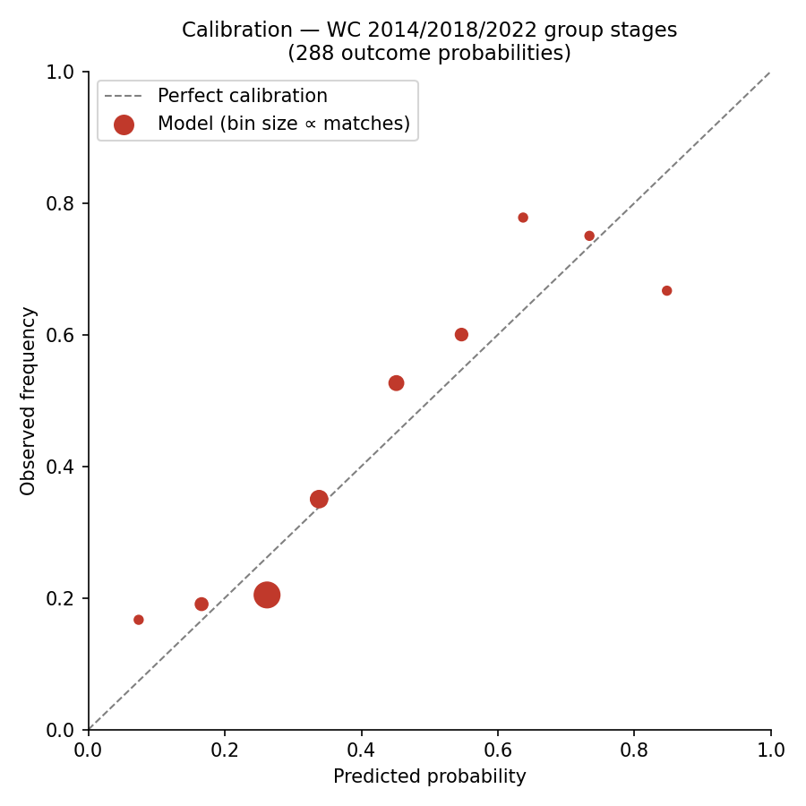
Figure 1 — Reliability of predicted probabilities, WC 2014/2018/2022 group stages (out-of-sample).

5. Tournament simulation
Each of the 200,000 simulations plays the tournament under FIFA's full rule book. Group scorelines are drawn from each fixture's exact joint score distribution (the τ-corrected Poisson grid), so margins — not just results — propagate into the standings. Groups are ranked by points, goal difference and goals scored; two-way ties still level on all three are resolved by the head-to-head result, with the remaining tie-break criteria (conduct points, FIFA ranking) proxied by randomisation. The twelve third-placed teams are ranked by the same criteria, the best eight advance, and their bracket slots are assigned from the official 495-combination Annex C table — an exactness that matters, because it determines which group winners draw the strongest leftover opponents. Knockout matches level after 90 minutes proceed to extra time, simulated as a 30-minute Poisson process at one-third intensity, then to a 50/50 penalty shoot-out. Host-nation home advantage persists into the knockouts only where the schedule actually provides it: Mexico would enjoy Estadio Azteca in match 79 and a potential round-of-16 tie there; Canada's group winner plays its round of 32 and potential round of 16 in Vancouver; the United States plays essentially its entire possible path on home soil.

6. Results
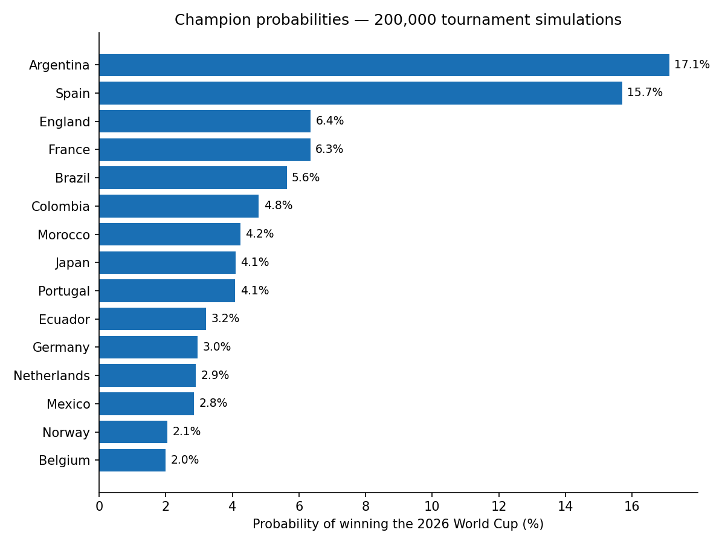
Figure 2 — Probability of lifting the trophy (top 15 of 48).
Rank | Team | P(champion)
1 | Argentina | 17.1%
2 | Spain | 15.7%
3 | England | 6.4%
4 | France | 6.3%
5 | Brazil | 5.6%
6 | Colombia | 4.8%
7 | Morocco | 4.2%
8 | Japan | 4.1%
9 | Portugal | 4.1%
10 | Ecuador | 3.2%

Argentina and Spain stand clearly apart, together accounting for roughly a third of all simulated titles — consistent with their 1–2 positions in the Elo list and their light group draws (J and H respectively). The most likely finals are Spain – Argentina (5.1%), Spain – England (2.0%), France – Argentina (1.9%), Brazil – Spain (1.5%), Spain – Colombia (1.4%). England's strength is partly structural: Group L is winnable and its bracket half avoids Spain and Argentina until the final. Among the hosts, Mexico converts a soft Group A and Azteca home advantage into a 63.1% chance of the round of 16 and a 2.8% title shot; Canada reaches the round of 16 in 55.7% of simulations; the United States, despite playing at home, carries its weak 2024-25 form into a genuinely contested Group D with Paraguay, Turkey and Australia and advances past the round of 32 only 37.8% of the time. In tonight's opener the model gives Mexico 45.9% to beat South Africa, with a draw at 27.2%.
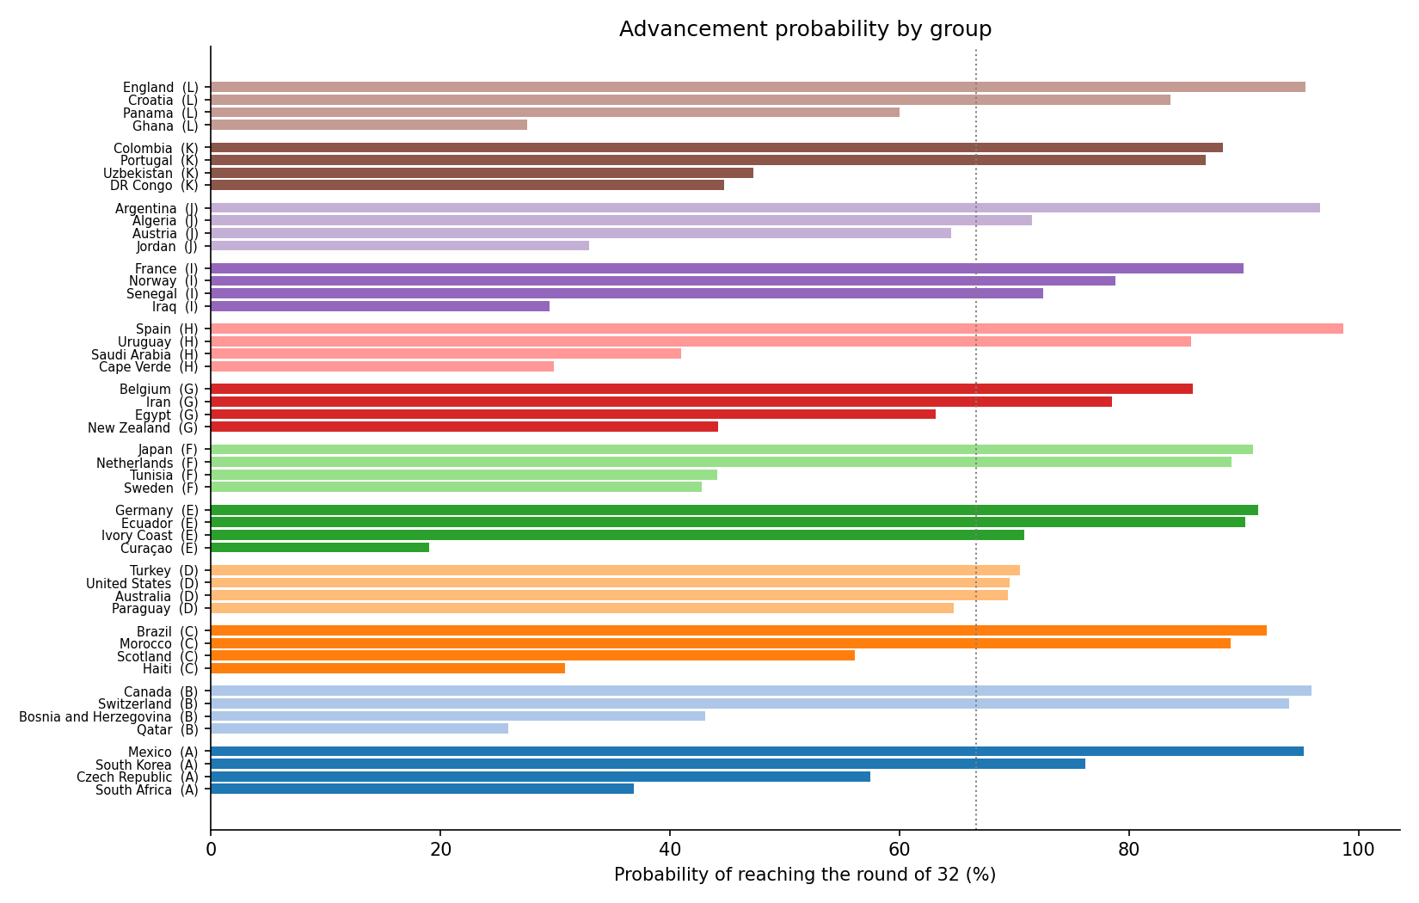
Figure 3 — Probability of surviving the group phase (dotted line = the 2/3 average advancement rate of this format).

7. Limitations
The model knows teams, not players: injuries, suspensions, squad rotation and managerial changes enter only insofar as they already show in results. It uses no betting-market information, which the academic literature finds hard to beat — this is a deliberate choice in favour of full reproducibility. Hyperparameters were tuned on only two tournaments (96 matches), so their selection carries sampling noise even though the protocol is leak-free. Penalty shoot-outs are treated as coin flips, three-way tie-breaks and conduct criteria are randomised, and the new 48-team format itself is a mild extrapolation: nothing exactly like a round of 32 with best-thirds has been played at a World Cup since 1994's smaller cousin. Probabilities are estimates with Monte Carlo error below ±0.2 percentage points at this simulation count, but model error necessarily exceeds simulation error.

8. Reproducibility
Everything in this report regenerates from the project folder: data/ holds the match database, fixtures, bracket and Annex C table; src/model.py implements the Elo engine, the Dixon-Coles fit and the blend; src/backtest.py reruns the validation grid and writes output/backtest.json; src/simulate.py refits the final model on all data through 10 June 2026 and replays the tournament (seed 20260611); src/make_xlsx.py and src/figures.py rebuild the spreadsheet and charts. Run order: backtest.py → simulate.py → figures.py → make_xlsx.py. The companion workbook WC2026_predictions.xlsx contains all 72 match forecasts, every team's advancement curve, group-by-group tables and the validation metrics.

