**Experiment 1: Food Preferences**

Thank you for agreeing to participate in this study on decision making. You will be compensated £25 for your time. The entire session should take approximately 2 ½ hours.

You should not have eaten for 3 hours before coming to participate in this study. This is important for the success of the study so please indicate before the study begins if for any reason you weren’t able to comply with this requirement.

If at any time you no longer wish to continue with the study, you are free to leave at any point.

**Bidding Task**

Your task in the first experiment is to indicate the price you are willing to pay to buy various snack items. You will be asked to bid on each of these items, from £0-£3. Indicate your bid by sliding the scale left or right using the arrow keys. When the cursor is in the right place, press the **down** arrow key to enter your bid.

The following screenshot provides an example of the bidding task:

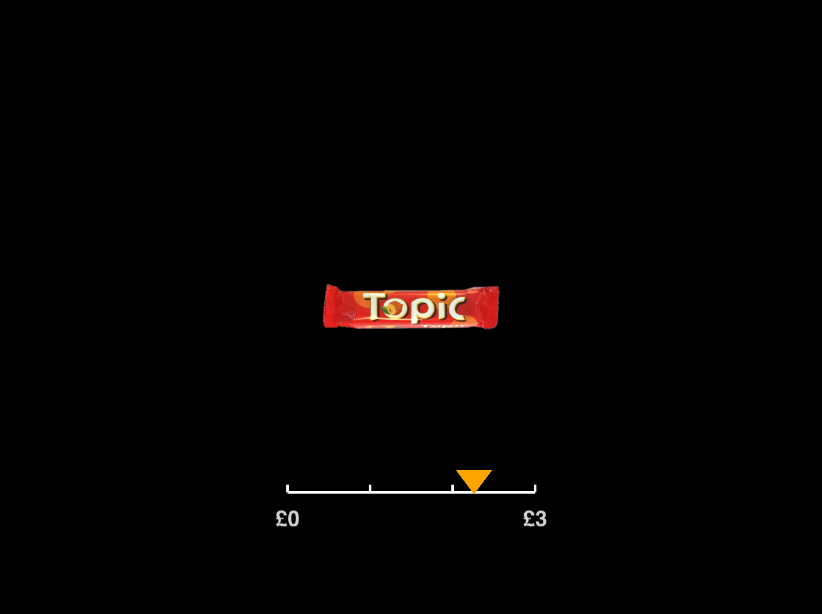

Think carefully about the price you bid. Each bid should be the maximum price you are prepared to pay to consume each of these items.

**Choice Task**

In the second task, you will be asked to choose between a series of snacks. These will be the same snacks you bid on previously, but will be presented in pairs. First you will be asked to indicate which item you prefer using the left and right arrow keys on the keyboard in front of you.

You will then be asked to rate how confident you are that you made the best choice.　To measure this, we will ask you to indicate how confident you were that you were correct on each trial. This is on a sliding scale of 1-6, with:

1 = relatively low confidence

6 = relatively high confidence

It is important that you try to use the full range of the scale from 1-6 and think hard about how confident you are after each decision. We are interested in **relative** confidence within our task. In other words, even if your confidence only fluctuates a small amount during the task, please indicate this using the whole scale.

The scale looks a bit like this:

1 6

Use the **left** and **right** arrow keys on the keyboard to slide the cursor left and right on the confidence scale. When the cursor is in the right place, press the **down** arrow key to record your answer.

The following 2 screenshots illustrate an example of the choice task:

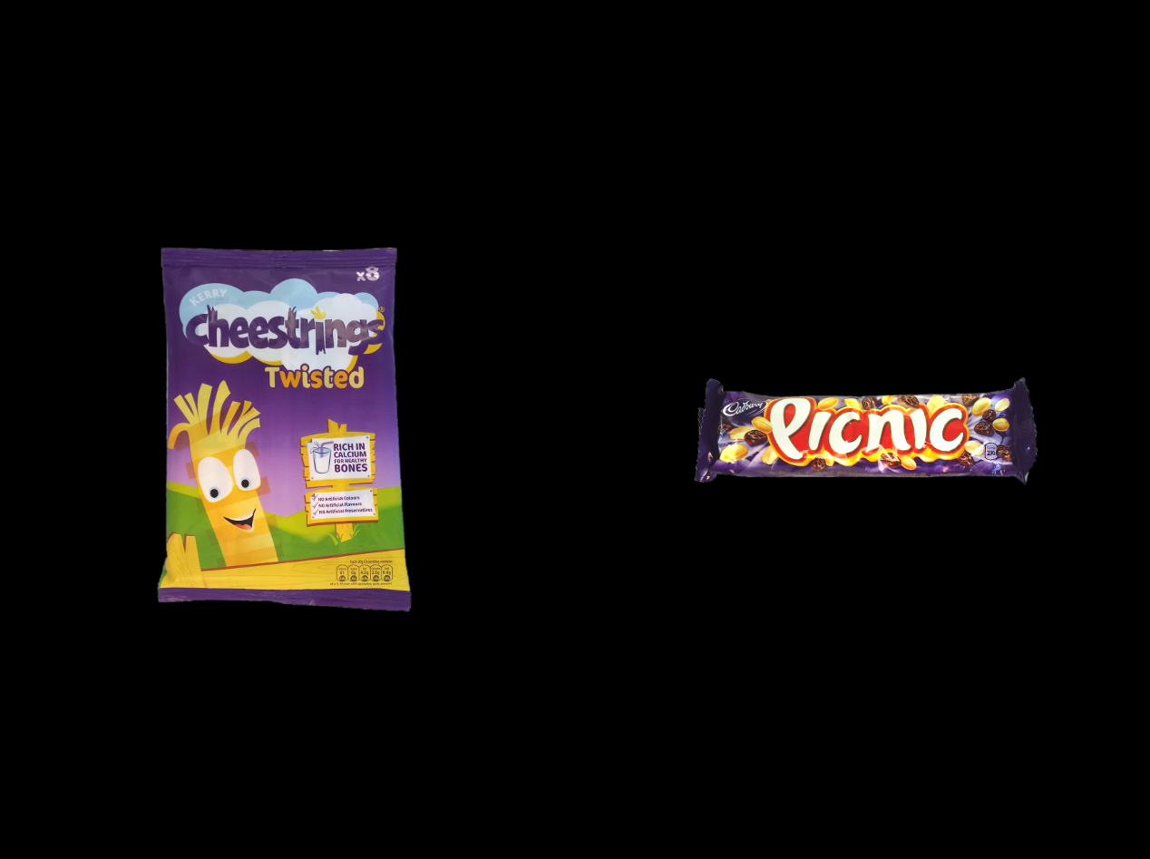 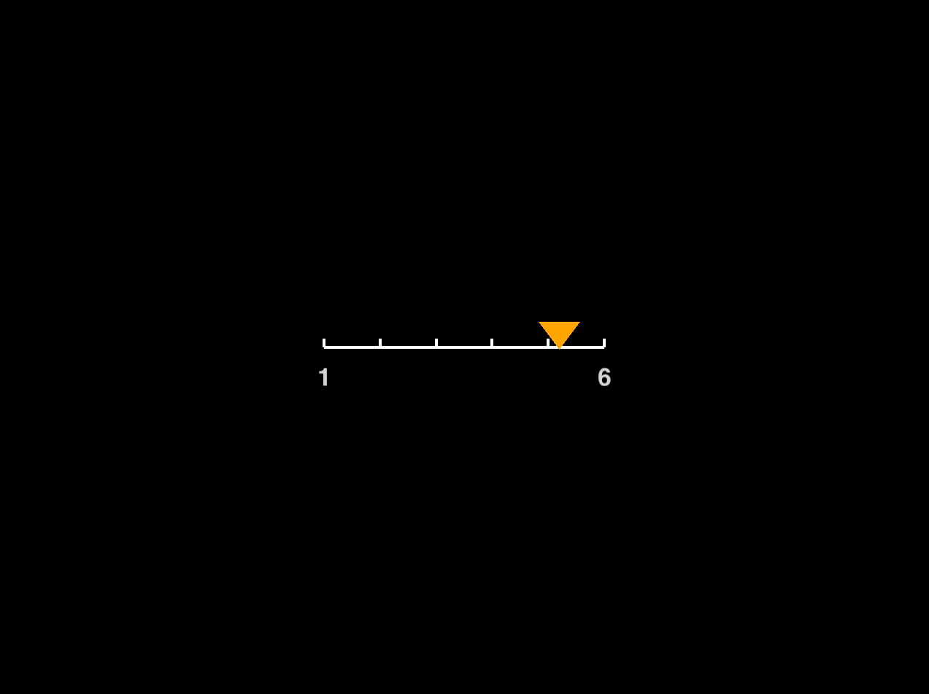

Here in the first screenshot you’re asked to indicate whether you would prefer a bag of Cheestrings to a Picnic bar. In the second, you’re asked to provide a rating of confidence. In this example, the participant was reasonably confident of their decision, so they selected a confidence rating just above 5.

**Snack Purchase**

When you finish, we will select one trial at random from the choice task. We will look at which of the two items you chose and the maximum price you stated you would be happy to pay for that item in the bidding task. In order to establish what the price of the item is and if you buy the item or not, we will run an auction. Let’s have a look at how this auction works…

**Auction Rules:**

We start by looking at your bid for the item (i.e. the maximum price you were happy to pay for it). For example, let’s say the item is a Snickers bar and your bid for it in the experiment was £1.64. The “retail” price of the snack (e.g. the Snickers bar) will be randomly generated by computer using a random number generator that can generate a price between £0.01 and £3.00. Let’s say for example that the cost of the Snickers bar generated randomly is established to be £1.13. Since the maximum price you bid (£1.64) is higher than the cost of the item (£1.13), you will buy the item in this instance. However, it is important to realise that you won’t pay £1.64 for it—rather, you would pay the randomly generated cost of the Snickers (£1.13). This might seem strange, but think of each price that you bid as the maximum price you are happy to pay, not the price that you would actually pay, which will be randomly generated. If the randomly generated price were instead established to be £2.17, since this price is higher than your bid of £1.64, you won’t purchase the Snickers bar. It’s therefore in your interest to state the truthful price you are willing to pay for each item, since this won’t affect the cost of the item to you, but it does affect the probability that you buy the item.

Please be aware that you will be required to stay 1 more hour with us after the experiment and the ONLY FOOD you will be allowed to consume during this time will be any item bought during the experiment – we will be very strict about this. So when you are deciding how much to bid for an item, ask yourself how much YOU want that item and how much you are ready to pay for consuming that snack at this time (disregarding how much you would usually expect to pay for each of these items in a grocery store).

This is not such an unusual situation and a real-life example might help to clarify the point. Imagine you go to the cinema and want to buy some popcorn to eat during the film; here it has probably occurred to you at one time or another that the cost of popcorn would be a lot less outside of the cinema (e.g. in a supermarket or at your home) than the prices being demanded by the cinema snack counter. However, if you want to consume popcorn during the film, you have to pay the prices they’re proposing and it’s up to you to decide if this is a price you are happy paying or not.

At the end of the experiment, we will total your final payment in this way:

£25 base payment  
− cost of item purchased at auction (if an item is purchased)  
+ total reward for correct responses in Experiment 2 (explained later)  
_______________  
= FINAL PAYMENT

You will receive a cheque in the mail for your final payment amount.