**Experiment 2: Learning Task**

In the second experiment, you will be asked to learn a random set of snack items. This set includes one item from each of the pairs you saw in the first experiment.

You will be shown several pairs of snacks – the same pairs you saw during the first experiment – and then asked to indicate which item you think is the item included in the set.

Imagine there are several buckets each filled with 10 snacks. **You can’t see** inside the buckets, but on the outside of each one there is a picture of a different pair of snacks. Each bucket contains 8 of one of these snack and 2 of the other, but you don’t know which is which. Your goal is to figure out which of the two items the bucket has 8 of.

First, you indicate which item you think is the correct answer. (In this task, you will use the left and right arrow keys to make your selection; a red star will appear on the item you selected, as shown in the screen shot on the bottom left, below.)

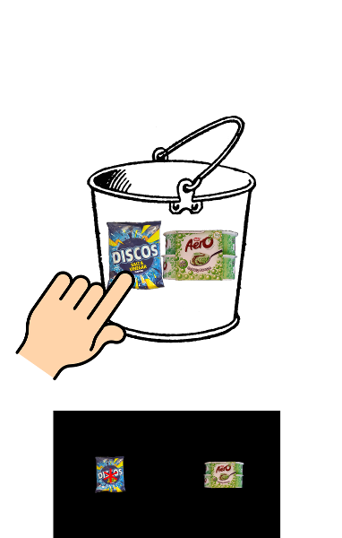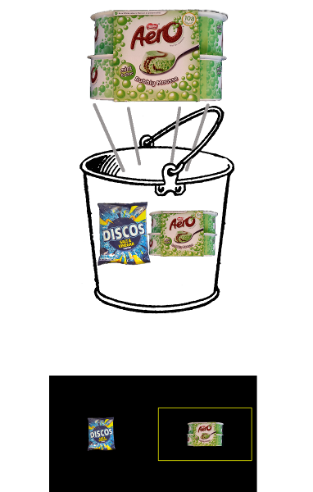

After you indicate your answer, one item will be drawn at random from the bucket and then put back for the next trial. In the actual task, a yellow box will appear around **the item that was drawn from the bucket**.

Eventually, based on which item is drawn more often, you’ll learn the correct answer. It is important to understand that the correct answer never changes, but sometimes the yellow box will appear around different items (because, in this analogy, each bucket has 2 of the wrong item).

You will be shown several different pairs of items many times, in random order. Sometimes the items will appear on different sides of the screen. Although you will see each pair of items several times—and sometimes the items will be flipped on the screen—it’s important to understand that each pair only has one correct answer.

To help illustrate, the screen shots below show you what you might see—several presentations of the same items (sometimes flipped on the screen), with yellow boxes appearing around the correct item (Cheestrings) about 80% of the time, and around the wrong item (Picnic bar) about 20% of the time. But remember, each of these presentations result from one single correct answer (the Cheestrings).

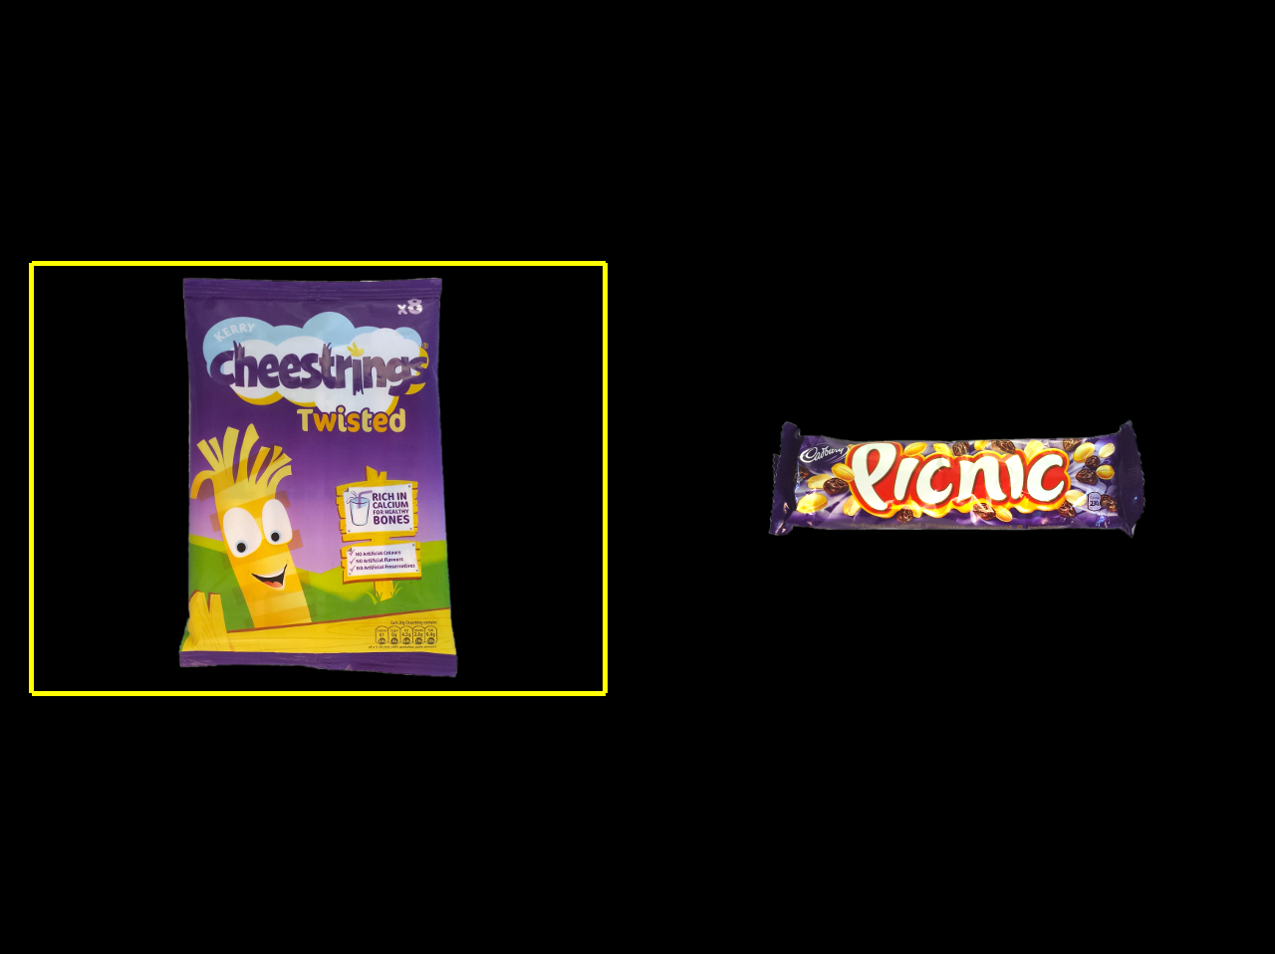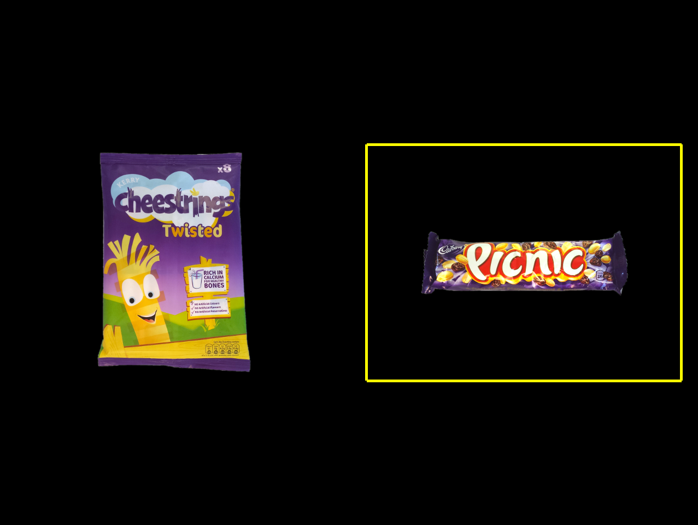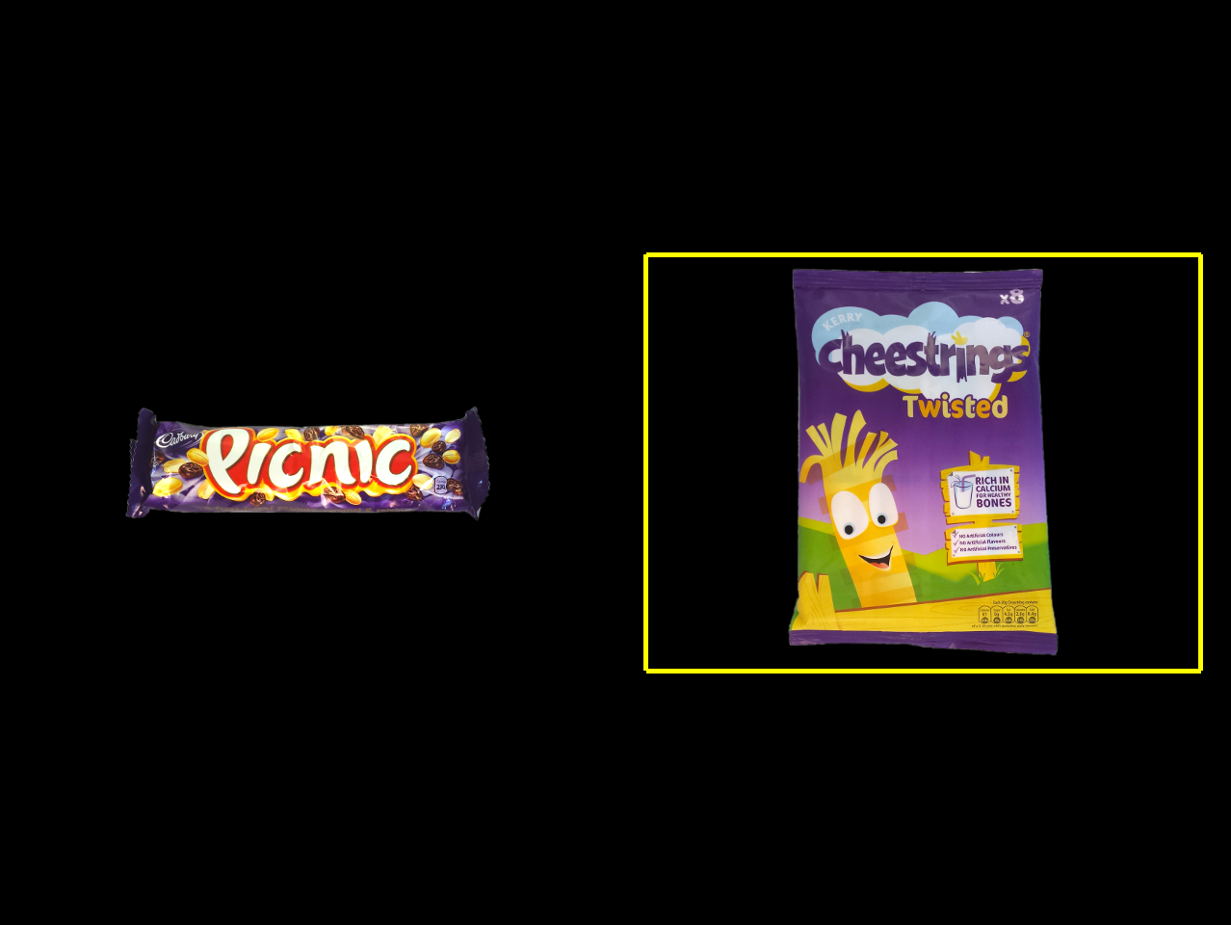



**What you would see if Cheestrings were the correct answer**

Pay close attention and try to remember each clue that the yellow box gives you – it will help you the next time you see that pair of items. You will earn **1 penny** for each correct response, which will be totalled at the end of the experiment.

Before you start, we will run some practice trials to make sure you are comfortable with the task and everything is clear. If you have any further questions before the real experiment begins, however, please feel free to ask. It’s important that you’re clear about these instructions before we start.