**Food Experiment Instructions: Part 2**

**Inferring Another Person’s Choices**

In the second part of the experiment, you will be asked to figure out which snack choices were made by one other participant in an earlier phase of this study. This person completed the same choice task you just finished, and was asked to choose between the same pairs of items that you were. Your job is to figure out which items he or she chose.

You will be shown several pairs of snacks – the same pairs you saw during the first part of the experiment – and then asked to indicate which item you think the other person chose. Use the left and right arrow keys to make your selection. A red star will appear on the item you selected, as shown in the screen shot below.

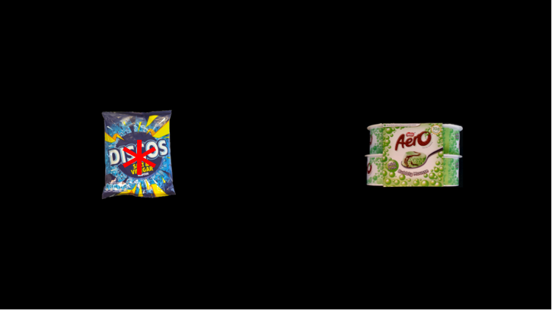

After making your selection, a yellow box will appear around one of the two items. This is a clue. About 80% of the time, the yellow box will appear around the item that the other person chose. The other 20% of the time, however, it will appear around the item that the person did NOT choose.

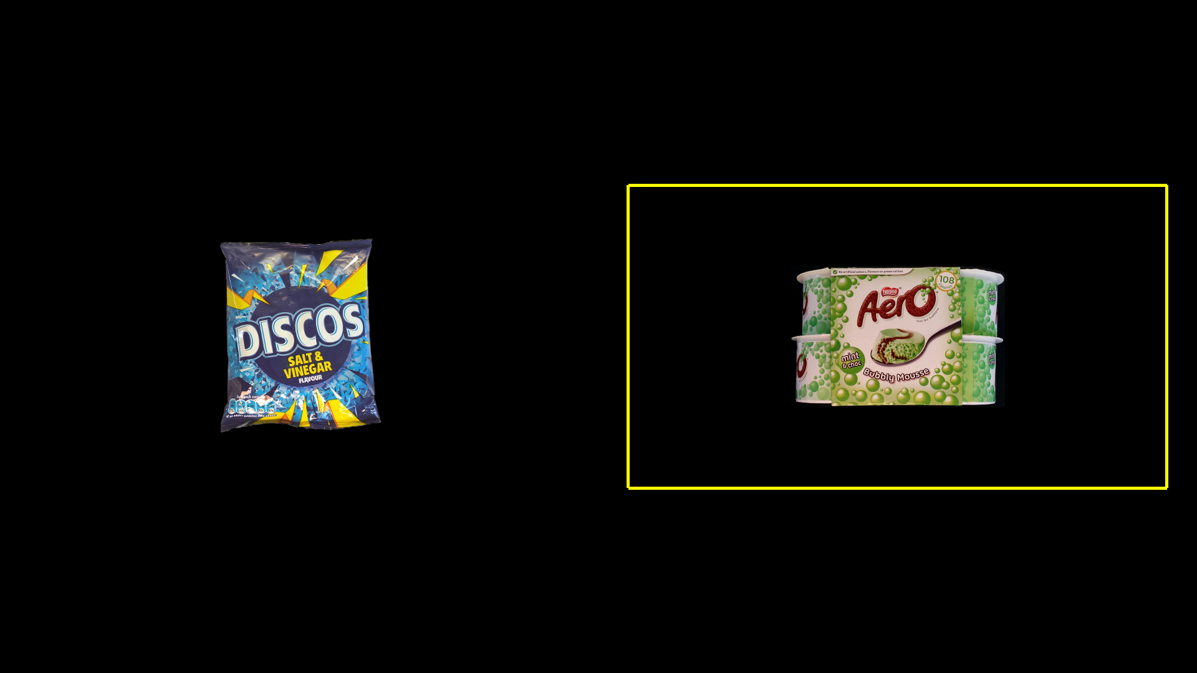

An analogy might help illustrate how this works. Imagine that the person is planning a party and needs to buy 30 bags of discos out of a snack machine that sells only Discos and Aero mousse cups. The snack machine is broken, so although the person chooses Discos each time, the machine dispenses (displays a yellow box around) discos only about 80% of the time and Aero mousse cups the other 20% of the time. It is important to understand that the person’s choice never changes, but sometimes the yellow box will appear around different items (because the machine is broken).

You will be shown several different pairs of items many times, in random order. Sometimes the items will appear on different sides of the screen. Although you will see each pair of items several times—and sometimes the items will be flipped on the screen—it’s important to understand that the person only made one choice between each pair of items.

To help illustrate, the screen shot on the left, below, shows you the screen that the other person saw when making one of the choices that you will try to figure out. (In this example, the other person chose the Cheestrings.) The screen shots on the right show you what you will see—several presentations of the same choice (sometimes flipped on the screen), with yellow boxes appearing around the other person’s choice (Cheestrings) about 80% of the time, and around the other item (Picnic bar) about 20% of the time. But remember, each of the presentations on the right result from the one single choice shown on the left.

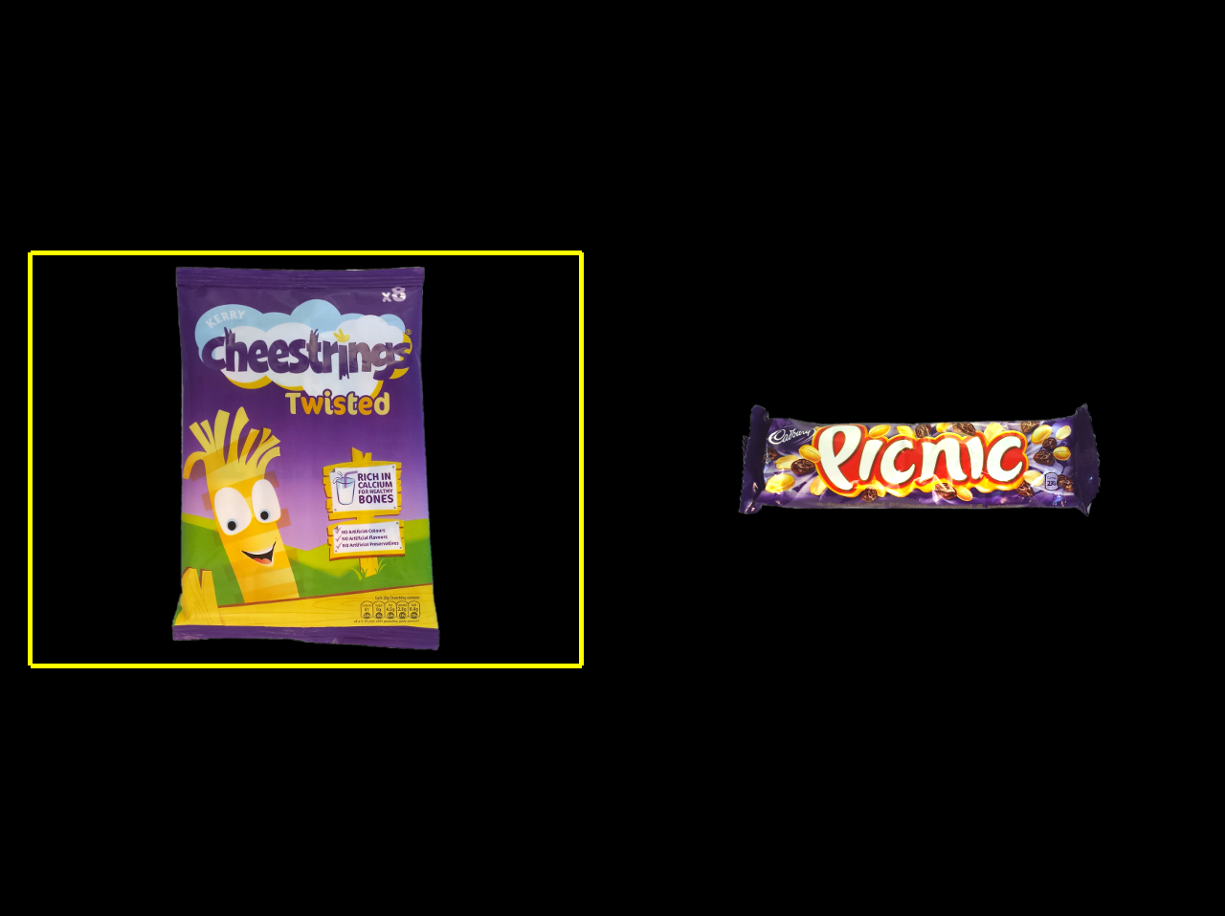

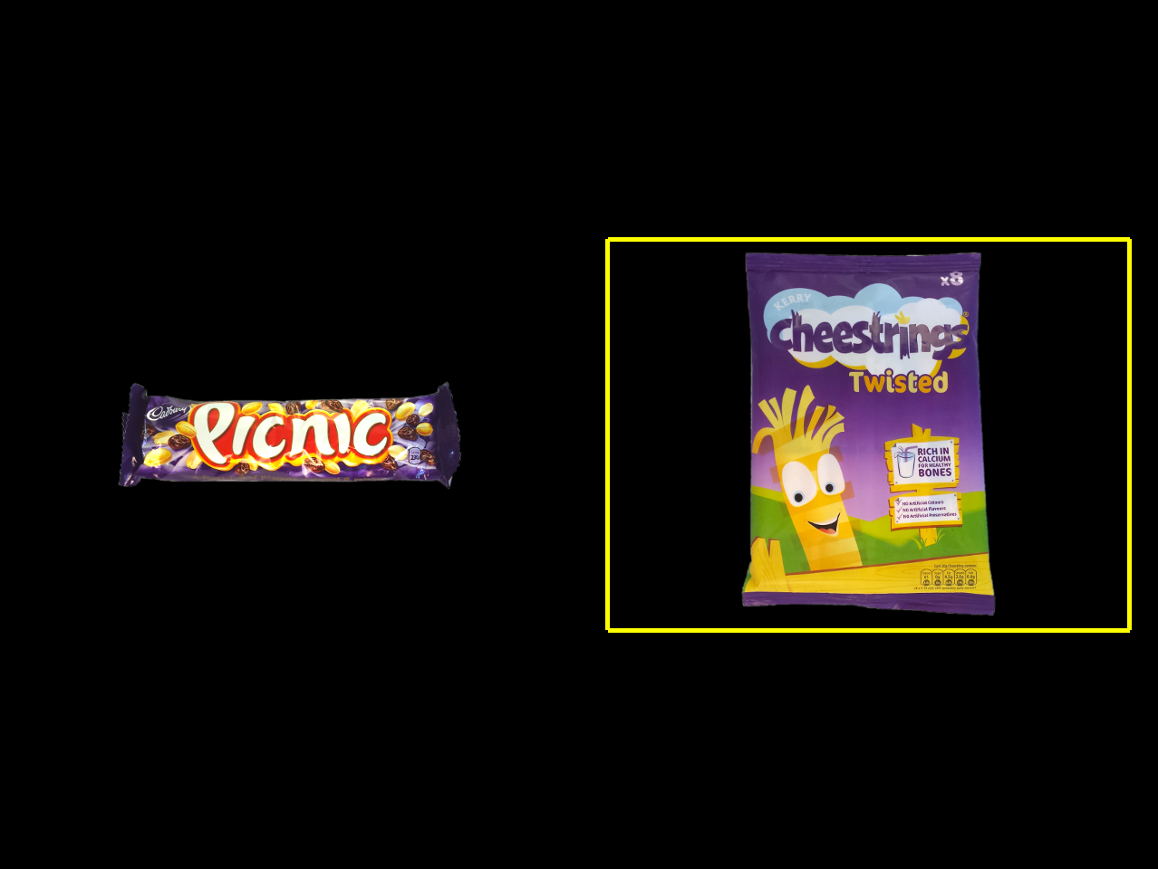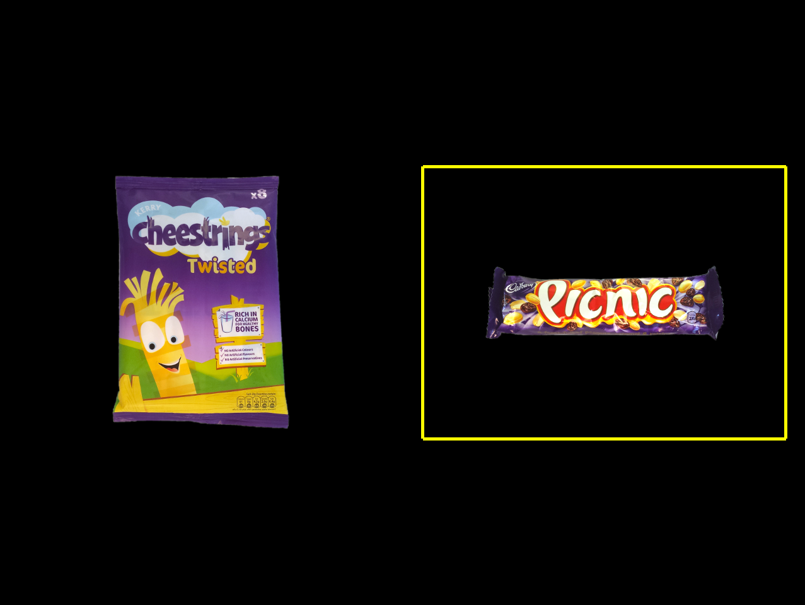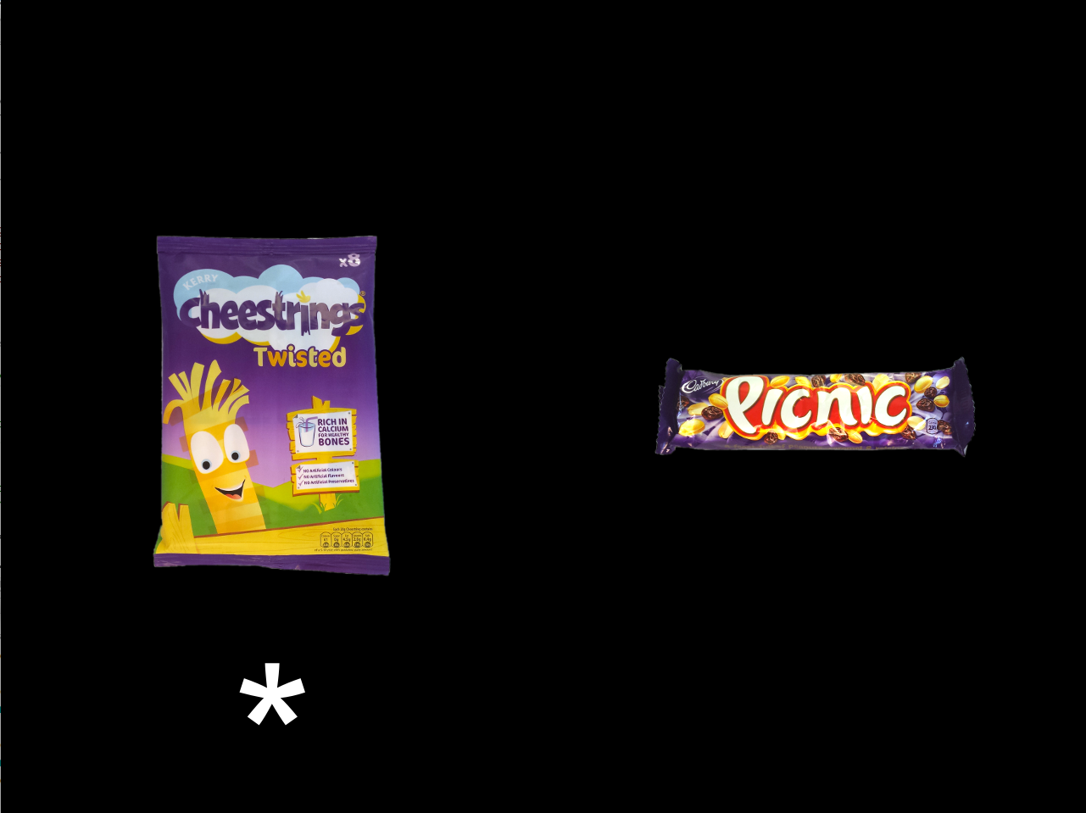

**What the other person saw What you would see**

Pay close attention and try to remember each clue that the yellow box gives you – it will help you the next time you see that pair of items. You will earn **1 penny** for each correct response, which will be totalled at the end of the experiment.

Before you start this part of the experiment, we will run some practice trials to make sure you are comfortable with the task and everything is clear. If you have any further questions before the real experiment begins, however, please feel free to ask. It’s important that you’re clear about these instructions before we start.