Gergely Daróczi

Minimal example for Pandoc.brew

# Introduction

We have two meta-information above:

* author
* title

A third field could be there too: date. For details, please check out [Pandoc's homepage](http://johnmacfarlane.net/pandoc/README.html#title-block) or just use pandoc.title function of this package.

As you can see writing and formatting paragraphs cannot be easier :)

But what about [R](http://www.r-project.org/)? Let us return pi: *3.14159265358979*

# R objects

Pander.brew would transform any returned R object to Pandoc's markdown in each code block.

For example mtcars's first 5 cases look like:

|  |  |  |  |  |  |  |
| --- | --- | --- | --- | --- | --- | --- |
|  | mpg | cyl | disp | hp | drat | wt |
| Mazda RX4 | 21 | 6 | 160 | 110 | 3.9 | 2.6 |
| Mazda RX4 Wag | 21 | 6 | 160 | 110 | 3.9 | 2.9 |
| Datsun 710 | 23 | 4 | 108 | 93 | 3.9 | 2.3 |
| Hornet 4 Drive | 21 | 6 | 258 | 110 | 3.1 | 3.2 |
| Hornet Sportabout | 19 | 8 | 360 | 175 | 3.1 | 3.4 |

|  |  |  |  |  |  |
| --- | --- | --- | --- | --- | --- |
|  | qsec | vs | am | gear | carb |
| Mazda RX4 | 16 | 0 | 1 | 4 | 4 |
| Mazda RX4 Wag | 17 | 0 | 1 | 4 | 4 |
| Datsun 710 | 19 | 1 | 1 | 4 | 1 |
| Hornet 4 Drive | 19 | 1 | 0 | 3 | 1 |
| Hornet Sportabout | 17 | 0 | 0 | 3 | 2 |

As you can see some formatting was added to the returned table and was also split up as the original table would have been too wide.

We could try other R objects too, for example prcomp on iris:

|  |  |  |  |  |
| --- | --- | --- | --- | --- |
|  | PC1 | PC2 | PC3 | PC4 |
| Sepal.Length | 0.361 | -0.657 | 0.582 | 0.315 |
| Sepal.Width | -0.085 | -0.730 | -0.598 | -0.320 |
| Petal.Length | 0.857 | 0.173 | -0.076 | -0.480 |
| Petal.Width | 0.358 | 0.075 | -0.546 | 0.754 |

Principal Components Analysis

|  |  |  |  |  |
| --- | --- | --- | --- | --- |
|  | PC1 | PC2 | PC3 | PC4 |
| Standard deviation | 2.0563 | 0.4926 | 0.2797 | 0.1544 |
| Proportion of Variance | 0.9246 | 0.0531 | 0.0171 | 0.0052 |
| Cumulative Proportion | 0.9246 | 0.9777 | 0.9948 | 1.0000 |

## Returning plot

Plots are automatically grabbed between brew tags:

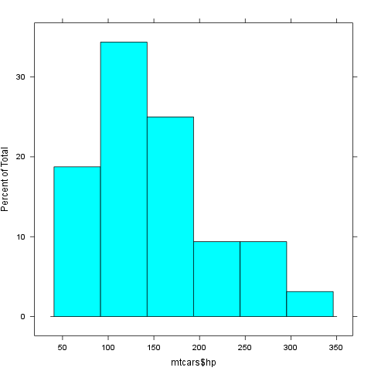

This report was generated with [R](http://www.r-project.org/) (2.15.0) and [pander](https://github.com/daroczig/pander) (0.1) in 1.577 sec on x86_64-unknown-linux-gnu platform.