Gergely Daróczi

Looong report

Sat Jun 2 12:46:37 2012

I have written the below report in 10 mins :)

# Dataset

Here I will do a pretty fast report on mtcars which is:

|  |  |  |  |  |  |  |
| --- | --- | --- | --- | --- | --- | --- |
|  | mpg | cyl | disp | hp | drat | wt |
| Mazda RX4 | 21 | 6 | 160 | 110 | 3.9 | 2.6 |
| Mazda RX4 Wag | 21 | 6 | 160 | 110 | 3.9 | 2.9 |
| Datsun 710 | 23 | 4 | 108 | 93 | 3.9 | 2.3 |
| Hornet 4 Drive | 21 | 6 | 258 | 110 | 3.1 | 3.2 |
| Hornet Sportabout | 19 | 8 | 360 | 175 | 3.1 | 3.4 |
| Valiant | 18 | 6 | 225 | 105 | 2.8 | 3.5 |
| Duster 360 | 14 | 8 | 360 | 245 | 3.2 | 3.6 |
| Merc 240D | 24 | 4 | 147 | 62 | 3.7 | 3.2 |
| Merc 230 | 23 | 4 | 141 | 95 | 3.9 | 3.1 |
| Merc 280 | 19 | 6 | 168 | 123 | 3.9 | 3.4 |
| Merc 280C | 18 | 6 | 168 | 123 | 3.9 | 3.4 |
| Merc 450SE | 16 | 8 | 276 | 180 | 3.1 | 4.1 |
| Merc 450SL | 17 | 8 | 276 | 180 | 3.1 | 3.7 |
| Merc 450SLC | 15 | 8 | 276 | 180 | 3.1 | 3.8 |
| Cadillac Fleetwood | 10 | 8 | 472 | 205 | 2.9 | 5.2 |
| Lincoln Continental | 10 | 8 | 460 | 215 | 3.0 | 5.4 |
| Chrysler Imperial | 15 | 8 | 440 | 230 | 3.2 | 5.3 |
| Fiat 128 | 32 | 4 | 79 | 66 | 4.1 | 2.2 |
| Honda Civic | 30 | 4 | 76 | 52 | 4.9 | 1.6 |
| Toyota Corolla | 34 | 4 | 71 | 65 | 4.2 | 1.8 |
| Toyota Corona | 22 | 4 | 120 | 97 | 3.7 | 2.5 |
| Dodge Challenger | 16 | 8 | 318 | 150 | 2.8 | 3.5 |
| AMC Javelin | 15 | 8 | 304 | 150 | 3.1 | 3.4 |
| Camaro Z28 | 13 | 8 | 350 | 245 | 3.7 | 3.8 |
| Pontiac Firebird | 19 | 8 | 400 | 175 | 3.1 | 3.8 |
| Fiat X1-9 | 27 | 4 | 79 | 66 | 4.1 | 1.9 |
| Porsche 914-2 | 26 | 4 | 120 | 91 | 4.4 | 2.1 |
| Lotus Europa | 30 | 4 | 95 | 113 | 3.8 | 1.5 |
| Ford Pantera L | 16 | 8 | 351 | 264 | 4.2 | 3.2 |
| Ferrari Dino | 20 | 6 | 145 | 175 | 3.6 | 2.8 |
| Maserati Bora | 15 | 8 | 301 | 335 | 3.5 | 3.6 |
| Volvo 142E | 21 | 4 | 121 | 109 | 4.1 | 2.8 |

|  |  |  |  |  |  |
| --- | --- | --- | --- | --- | --- |
|  | qsec | vs | am | gear | carb |
| Mazda RX4 | 16 | 0 | 1 | 4 | 4 |
| Mazda RX4 Wag | 17 | 0 | 1 | 4 | 4 |
| Datsun 710 | 19 | 1 | 1 | 4 | 1 |
| Hornet 4 Drive | 19 | 1 | 0 | 3 | 1 |
| Hornet Sportabout | 17 | 0 | 0 | 3 | 2 |
| Valiant | 20 | 1 | 0 | 3 | 1 |
| Duster 360 | 16 | 0 | 0 | 3 | 4 |
| Merc 240D | 20 | 1 | 0 | 4 | 2 |
| Merc 230 | 23 | 1 | 0 | 4 | 2 |
| Merc 280 | 18 | 1 | 0 | 4 | 4 |
| Merc 280C | 19 | 1 | 0 | 4 | 4 |
| Merc 450SE | 17 | 0 | 0 | 3 | 3 |
| Merc 450SL | 18 | 0 | 0 | 3 | 3 |
| Merc 450SLC | 18 | 0 | 0 | 3 | 3 |
| Cadillac Fleetwood | 18 | 0 | 0 | 3 | 4 |
| Lincoln Continental | 18 | 0 | 0 | 3 | 4 |
| Chrysler Imperial | 17 | 0 | 0 | 3 | 4 |
| Fiat 128 | 19 | 1 | 1 | 4 | 1 |
| Honda Civic | 19 | 1 | 1 | 4 | 2 |
| Toyota Corolla | 20 | 1 | 1 | 4 | 1 |
| Toyota Corona | 20 | 1 | 0 | 3 | 1 |
| Dodge Challenger | 17 | 0 | 0 | 3 | 2 |
| AMC Javelin | 17 | 0 | 0 | 3 | 2 |
| Camaro Z28 | 15 | 0 | 0 | 3 | 4 |
| Pontiac Firebird | 17 | 0 | 0 | 3 | 2 |
| Fiat X1-9 | 19 | 1 | 1 | 4 | 1 |
| Porsche 914-2 | 17 | 0 | 1 | 5 | 2 |
| Lotus Europa | 17 | 1 | 1 | 5 | 2 |
| Ford Pantera L | 14 | 0 | 1 | 5 | 4 |
| Ferrari Dino | 16 | 0 | 1 | 5 | 6 |
| Maserati Bora | 15 | 0 | 1 | 5 | 8 |
| Volvo 142E | 19 | 1 | 1 | 4 | 2 |

# Descriptives

|  |  |  |  |  |
| --- | --- | --- | --- | --- |
| Variable | Average | Median | Standard deviation | Variance |
| mpg | 20.09 | 19.2 | 6.03 | 3.6e+01 |
| cyl | 6.19 | 6.0 | 1.79 | 3.2e+00 |
| disp | 230.72 | 196.3 | 123.94 | 1.5e+04 |
| hp | 146.69 | 123.0 | 68.56 | 4.7e+03 |
| drat | 3.60 | 3.7 | 0.53 | 2.9e-01 |
| wt | 3.22 | 3.3 | 0.98 | 9.6e-01 |
| qsec | 17.85 | 17.7 | 1.79 | 3.2e+00 |
| vs | 0.44 | 0.0 | 0.50 | 2.5e-01 |
| am | 0.41 | 0.0 | 0.50 | 2.5e-01 |
| gear | 3.69 | 4.0 | 0.74 | 5.4e-01 |
| carb | 2.81 | 2.0 | 1.62 | 2.6e+00 |

## In details

### mpg

We found the folloing values here:

*21*, *21*, *22.8*, *21.4*, *18.7*, *18.1*, *14.3*, *24.4*, *22.8*, *19.2*, *17.8*, *16.4*, *17.3*, *15.2*, *10.4*, *10.4*, *14.7*, *32.4*, *30.4*, *33.9*, *21.5*, *15.5*, *15.2*, *13.3*, *19.2*, *27.3*, *26*, *30.4*, *15.8*, *19.7*, *15* and *21.4*

The mean of mpg is *20.090625* while the standard deviation is: *6.0269480520891*. The most frequent value in mpg is 10.4, but let us check out the frequency table too:

|  |  |  |  |  |  |  |  |
| --- | --- | --- | --- | --- | --- | --- | --- |
| 10.4 | 13.3 | 14.3 | 14.7 | 15 | 15.2 | 15.5 | 15.8 |
| 2 | 1 | 1 | 1 | 1 | 2 | 1 | 1 |

|  |  |  |  |  |  |  |  |
| --- | --- | --- | --- | --- | --- | --- | --- |
| 16.4 | 17.3 | 17.8 | 18.1 | 18.7 | 19.2 | 19.7 | 21 |
| 1 | 1 | 1 | 1 | 1 | 2 | 1 | 2 |

|  |  |  |  |  |  |  |
| --- | --- | --- | --- | --- | --- | --- |
| 21.4 | 21.5 | 22.8 | 24.4 | 26 | 27.3 | 30.4 |
| 2 | 1 | 2 | 1 | 1 | 1 | 2 |

|  |  |
| --- | --- |
| 32.4 | 33.9 |
| 1 | 1 |

Tables are boring, let us show the same with a histogram:

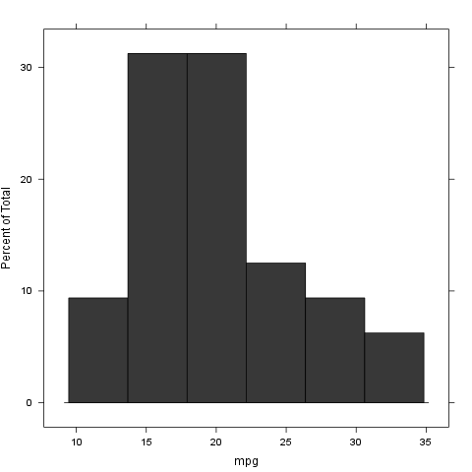

### cyl

We found the folloing values here:

*6*, *6*, *4*, *6*, *8*, *6*, *8*, *4*, *4*, *6*, *6*, *8*, *8*, *8*, *8*, *8*, *8*, *4*, *4*, *4*, *4*, *8*, *8*, *8*, *8*, *4*, *4*, *4*, *8*, *6*, *8* and *4*

The mean of cyl is *6.1875* while the standard deviation is: *1.78592164694654*. The most frequent value in cyl is 8, but let us check out the frequency table too:

|  |  |  |
| --- | --- | --- |
| 4 | 6 | 8 |
| 11 | 7 | 14 |

Tables are boring, let us show the same with a histogram:

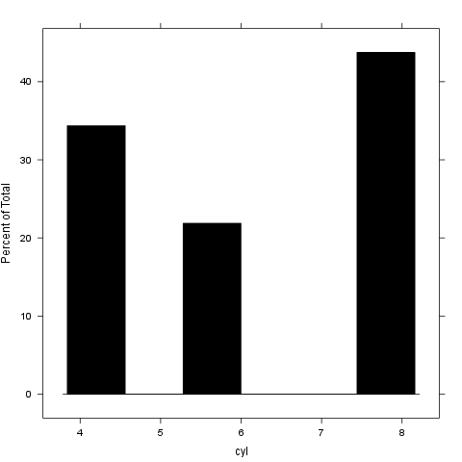

### disp

We found the folloing values here:

*160*, *160*, *108*, *258*, *360*, *225*, *360*, *146.7*, *140.8*, *167.6*, *167.6*, *275.8*, *275.8*, *275.8*, *472*, *460*, *440*, *78.7*, *75.7*, *71.1*, *120.1*, *318*, *304*, *350*, *400*, *79*, *120.3*, *95.1*, *351*, *145*, *301* and *121*

The mean of disp is *230.721875* while the standard deviation is: *123.938693831382*. The most frequent value in disp is 275.8, but let us check out the frequency table too:

|  |  |  |  |  |  |  |  |
| --- | --- | --- | --- | --- | --- | --- | --- |
| 71.1 | 75.7 | 78.7 | 79 | 95.1 | 108 | 120.1 | 120.3 |
| 1 | 1 | 1 | 1 | 1 | 1 | 1 | 1 |

|  |  |  |  |  |  |  |  |
| --- | --- | --- | --- | --- | --- | --- | --- |
| 121 | 140.8 | 145 | 146.7 | 160 | 167.6 | 225 | 258 |
| 1 | 1 | 1 | 1 | 2 | 2 | 1 | 1 |

|  |  |  |  |  |  |  |  |
| --- | --- | --- | --- | --- | --- | --- | --- |
| 275.8 | 301 | 304 | 318 | 350 | 351 | 360 | 400 |
| 3 | 1 | 1 | 1 | 1 | 1 | 2 | 1 |

|  |  |  |
| --- | --- | --- |
| 440 | 460 | 472 |
| 1 | 1 | 1 |

Tables are boring, let us show the same with a histogram:

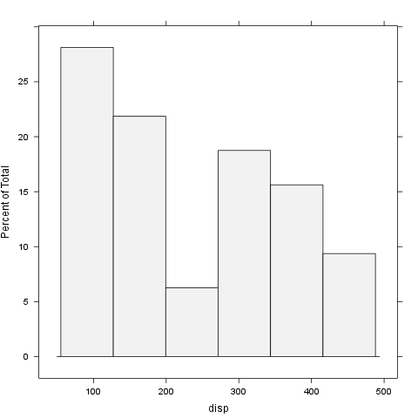

### hp

We found the folloing values here:

*110*, *110*, *93*, *110*, *175*, *105*, *245*, *62*, *95*, *123*, *123*, *180*, *180*, *180*, *205*, *215*, *230*, *66*, *52*, *65*, *97*, *150*, *150*, *245*, *175*, *66*, *91*, *113*, *264*, *175*, *335* and *109*

The mean of hp is *146.6875* while the standard deviation is: *68.5628684893206*. The most frequent value in hp is 110, but let us check out the frequency table too:

|  |  |  |  |  |  |  |  |  |
| --- | --- | --- | --- | --- | --- | --- | --- | --- |
| 52 | 62 | 65 | 66 | 91 | 93 | 95 | 97 | 105 |
| 1 | 1 | 1 | 2 | 1 | 1 | 1 | 1 | 1 |

|  |  |  |  |  |  |  |  |
| --- | --- | --- | --- | --- | --- | --- | --- |
| 109 | 110 | 113 | 123 | 150 | 175 | 180 | 205 |
| 1 | 3 | 1 | 2 | 2 | 3 | 3 | 1 |

|  |  |  |  |  |
| --- | --- | --- | --- | --- |
| 215 | 230 | 245 | 264 | 335 |
| 1 | 1 | 2 | 1 | 1 |

Tables are boring, let us show the same with a histogram:

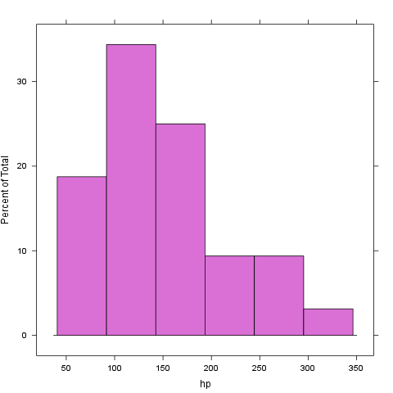

### drat

We found the folloing values here:

*3.9*, *3.9*, *3.85*, *3.08*, *3.15*, *2.76*, *3.21*, *3.69*, *3.92*, *3.92*, *3.92*, *3.07*, *3.07*, *3.07*, *2.93*, *3*, *3.23*, *4.08*, *4.93*, *4.22*, *3.7*, *2.76*, *3.15*, *3.73*, *3.08*, *4.08*, *4.43*, *3.77*, *4.22*, *3.62*, *3.54* and *4.11*

The mean of drat is *3.5965625* while the standard deviation is: *0.534678736070971*. The most frequent value in drat is 3.07, but let us check out the frequency table too:

|  |  |  |  |  |  |  |  |
| --- | --- | --- | --- | --- | --- | --- | --- |
| 2.76 | 2.93 | 3 | 3.07 | 3.08 | 3.15 | 3.21 | 3.23 |
| 2 | 1 | 1 | 3 | 2 | 2 | 1 | 1 |

|  |  |  |  |  |  |  |  |
| --- | --- | --- | --- | --- | --- | --- | --- |
| 3.54 | 3.62 | 3.69 | 3.7 | 3.73 | 3.77 | 3.85 | 3.9 |
| 1 | 1 | 1 | 1 | 1 | 1 | 1 | 2 |

|  |  |  |  |  |  |
| --- | --- | --- | --- | --- | --- |
| 3.92 | 4.08 | 4.11 | 4.22 | 4.43 | 4.93 |
| 3 | 2 | 1 | 2 | 1 | 1 |

Tables are boring, let us show the same with a histogram:

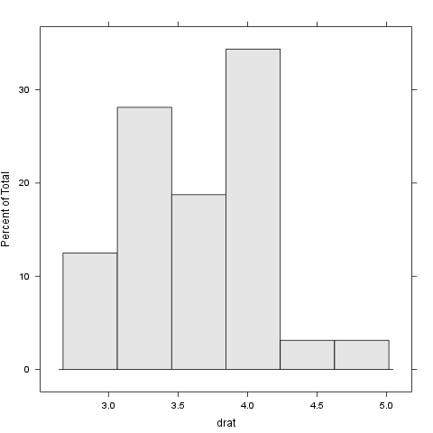

### wt

We found the folloing values here:

*2.62*, *2.875*, *2.32*, *3.215*, *3.44*, *3.46*, *3.57*, *3.19*, *3.15*, *3.44*, *3.44*, *4.07*, *3.73*, *3.78*, *5.25*, *5.424*, *5.345*, *2.2*, *1.615*, *1.835*, *2.465*, *3.52*, *3.435*, *3.84*, *3.845*, *1.935*, *2.14*, *1.513*, *3.17*, *2.77*, *3.57* and *2.78*

The mean of wt is *3.21725* while the standard deviation is: *0.978457442989697*. The most frequent value in wt is 3.44, but let us check out the frequency table too:

|  |  |  |  |  |  |  |
| --- | --- | --- | --- | --- | --- | --- |
| 1.513 | 1.615 | 1.835 | 1.935 | 2.14 | 2.2 | 2.32 |
| 1 | 1 | 1 | 1 | 1 | 1 | 1 |

|  |  |  |  |  |  |  |
| --- | --- | --- | --- | --- | --- | --- |
| 2.465 | 2.62 | 2.77 | 2.78 | 2.875 | 3.15 | 3.17 |
| 1 | 1 | 1 | 1 | 1 | 1 | 1 |

|  |  |  |  |  |  |  |
| --- | --- | --- | --- | --- | --- | --- |
| 3.19 | 3.215 | 3.435 | 3.44 | 3.46 | 3.52 | 3.57 |
| 1 | 1 | 1 | 3 | 1 | 1 | 2 |

|  |  |  |  |  |  |
| --- | --- | --- | --- | --- | --- |
| 3.73 | 3.78 | 3.84 | 3.845 | 4.07 | 5.25 |
| 1 | 1 | 1 | 1 | 1 | 1 |

|  |  |
| --- | --- |
| 5.345 | 5.424 |
| 1 | 1 |

Tables are boring, let us show the same with a histogram:

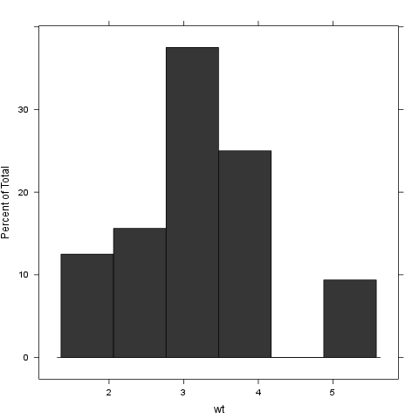

### qsec

We found the folloing values here:

*16.46*, *17.02*, *18.61*, *19.44*, *17.02*, *20.22*, *15.84*, *20*, *22.9*, *18.3*, *18.9*, *17.4*, *17.6*, *18*, *17.98*, *17.82*, *17.42*, *19.47*, *18.52*, *19.9*, *20.01*, *16.87*, *17.3*, *15.41*, *17.05*, *18.9*, *16.7*, *16.9*, *14.5*, *15.5*, *14.6* and *18.6*

The mean of qsec is *17.84875* while the standard deviation is: *1.78694323609684*. The most frequent value in qsec is 17.02, but let us check out the frequency table too:

|  |  |  |  |  |  |  |
| --- | --- | --- | --- | --- | --- | --- |
| 14.5 | 14.6 | 15.41 | 15.5 | 15.84 | 16.46 | 16.7 |
| 1 | 1 | 1 | 1 | 1 | 1 | 1 |

|  |  |  |  |  |  |  |
| --- | --- | --- | --- | --- | --- | --- |
| 16.87 | 16.9 | 17.02 | 17.05 | 17.3 | 17.4 | 17.42 |
| 1 | 1 | 2 | 1 | 1 | 1 | 1 |

|  |  |  |  |  |  |  |
| --- | --- | --- | --- | --- | --- | --- |
| 17.6 | 17.82 | 17.98 | 18 | 18.3 | 18.52 | 18.6 |
| 1 | 1 | 1 | 1 | 1 | 1 | 1 |

|  |  |  |  |  |  |  |
| --- | --- | --- | --- | --- | --- | --- |
| 18.61 | 18.9 | 19.44 | 19.47 | 19.9 | 20 | 20.01 |
| 1 | 2 | 1 | 1 | 1 | 1 | 1 |

|  |  |
| --- | --- |
| 20.22 | 22.9 |
| 1 | 1 |

Tables are boring, let us show the same with a histogram:

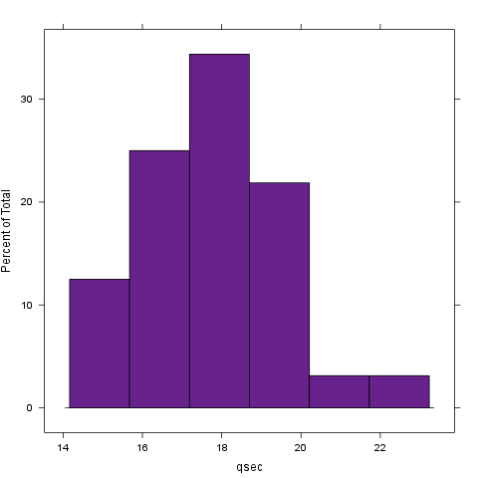

### vs

We found the folloing values here:

*0*, *0*, *1*, *1*, *0*, *1*, *0*, *1*, *1*, *1*, *1*, *0*, *0*, *0*, *0*, *0*, *0*, *1*, *1*, *1*, *1*, *0*, *0*, *0*, *0*, *1*, *0*, *1*, *0*, *0*, *0* and *1*

The mean of vs is *0.4375* while the standard deviation is: *0.504016128774185*. The most frequent value in vs is 0, but let us check out the frequency table too:

|  |  |
| --- | --- |
| 0 | 1 |
| 18 | 14 |

Tables are boring, let us show the same with a histogram:

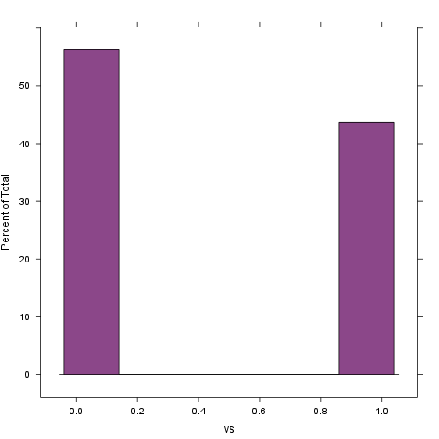

### am

We found the folloing values here:

*1*, *1*, *1*, *0*, *0*, *0*, *0*, *0*, *0*, *0*, *0*, *0*, *0*, *0*, *0*, *0*, *0*, *1*, *1*, *1*, *0*, *0*, *0*, *0*, *0*, *1*, *1*, *1*, *1*, *1*, *1* and *1*

The mean of am is *0.40625* while the standard deviation is: *0.498990917235846*. The most frequent value in am is 0, but let us check out the frequency table too:

|  |  |
| --- | --- |
| 0 | 1 |
| 19 | 13 |

Tables are boring, let us show the same with a histogram:

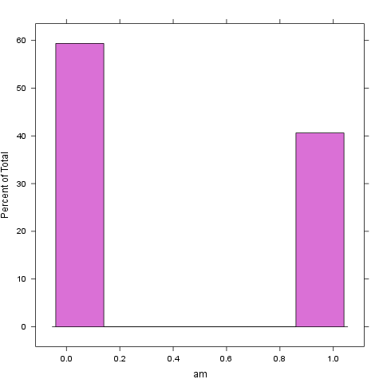

### gear

We found the folloing values here:

*4*, *4*, *4*, *3*, *3*, *3*, *3*, *4*, *4*, *4*, *4*, *3*, *3*, *3*, *3*, *3*, *3*, *4*, *4*, *4*, *3*, *3*, *3*, *3*, *3*, *4*, *5*, *5*, *5*, *5*, *5* and *4*

The mean of gear is *3.6875* while the standard deviation is: *0.737804065256947*. The most frequent value in gear is 3, but let us check out the frequency table too:

|  |  |  |
| --- | --- | --- |
| 3 | 4 | 5 |
| 15 | 12 | 5 |

Tables are boring, let us show the same with a histogram:

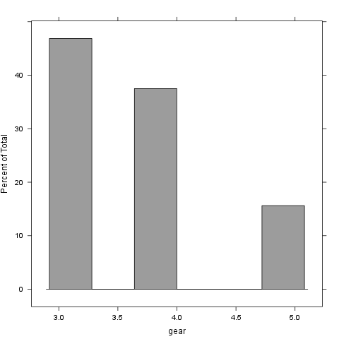

### carb

We found the folloing values here:

*4*, *4*, *1*, *1*, *2*, *1*, *4*, *2*, *2*, *4*, *4*, *3*, *3*, *3*, *4*, *4*, *4*, *1*, *2*, *1*, *1*, *2*, *2*, *4*, *2*, *1*, *2*, *2*, *4*, *6*, *8* and *2*

The mean of carb is *2.8125* while the standard deviation is: *1.61519997763185*. The most frequent value in carb is 2, but let us check out the frequency table too:

|  |  |  |  |  |  |
| --- | --- | --- | --- | --- | --- |
| 1 | 2 | 3 | 4 | 6 | 8 |
| 7 | 10 | 3 | 10 | 1 | 1 |

Tables are boring, let us show the same with a histogram:

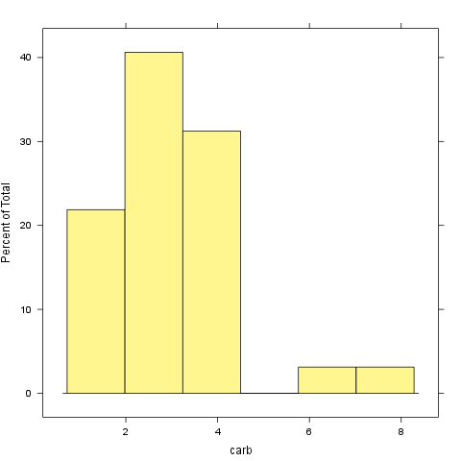

# Correlation

And here goes a correlation table:

|  |  |  |  |  |  |  |  |
| --- | --- | --- | --- | --- | --- | --- | --- |
|  | mpg | cyl | disp | hp | drat | wt | qsec |
| mpg | 1.000 | -0.852 | -0.848 | -0.776 | 0.681 | -0.868 | 0.419 |
| cyl | -0.852 | 1.000 | 0.902 | 0.832 | -0.700 | 0.782 | -0.591 |
| disp | -0.848 | 0.902 | 1.000 | 0.791 | -0.710 | 0.888 | -0.434 |
| hp | -0.776 | 0.832 | 0.791 | 1.000 | -0.449 | 0.659 | -0.708 |
| drat | 0.681 | -0.700 | -0.710 | -0.449 | 1.000 | -0.712 | 0.091 |
| wt | -0.868 | 0.782 | 0.888 | 0.659 | -0.712 | 1.000 | -0.175 |
| qsec | 0.419 | -0.591 | -0.434 | -0.708 | 0.091 | -0.175 | 1.000 |
| vs | 0.664 | -0.811 | -0.710 | -0.723 | 0.440 | -0.555 | 0.745 |
| am | 0.600 | -0.523 | -0.591 | -0.243 | 0.713 | -0.692 | -0.230 |
| gear | 0.480 | -0.493 | -0.556 | -0.126 | 0.700 | -0.583 | -0.213 |
| carb | -0.551 | 0.527 | 0.395 | 0.750 | -0.091 | 0.428 | -0.656 |

|  |  |  |  |  |
| --- | --- | --- | --- | --- |
|  | vs | am | gear | carb |
| mpg | 0.664 | 0.600 | 0.480 | -0.551 |
| cyl | -0.811 | -0.523 | -0.493 | 0.527 |
| disp | -0.710 | -0.591 | -0.556 | 0.395 |
| hp | -0.723 | -0.243 | -0.126 | 0.750 |
| drat | 0.440 | 0.713 | 0.700 | -0.091 |
| wt | -0.555 | -0.692 | -0.583 | 0.428 |
| qsec | 0.745 | -0.230 | -0.213 | -0.656 |
| vs | 1.000 | 0.168 | 0.206 | -0.570 |
| am | 0.168 | 1.000 | 0.794 | 0.058 |
| gear | 0.206 | 0.794 | 1.000 | 0.274 |
| carb | -0.570 | 0.058 | 0.274 | 1.000 |

And the same on a graph:

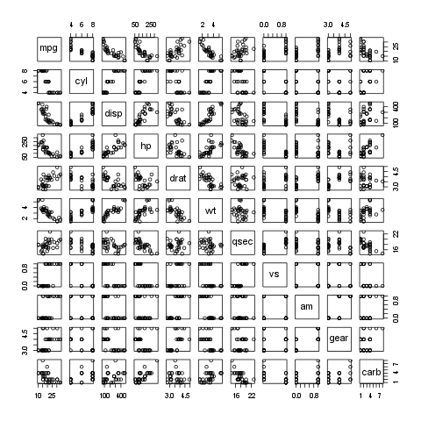

Yeah, that latter took a while to render in an image file :)

That's not a pander issue.

# Some models

Okay, let us find out how weight affects other variables:

### mpg

A simple linear model: mtcars$wt ~ mtcars$mpg

|  |  |  |  |  |
| --- | --- | --- | --- | --- |
|  | Estimate | Std. Error | t value | Pr(>|t|) |
| (Intercept) | 6.0e+00 | 3.1e-01 | 2.0e+01 | 1.2e-18 |
| Dependent | -1.4e-01 | 1.5e-02 | -9.6e+00 | 1.3e-10 |

Fitting linear model: mtcars$wt ~ Dependent

### cyl

A simple linear model: mtcars$wt ~ mtcars$cyl

|  |  |  |  |  |
| --- | --- | --- | --- | --- |
|  | Estimate | Std. Error | t value | Pr(>|t|) |
| (Intercept) | 5.6e-01 | 4.0e-01 | 1.4e+00 | 1.7e-01 |
| Dependent | 4.3e-01 | 6.2e-02 | 6.9e+00 | 1.2e-07 |

Fitting linear model: mtcars$wt ~ Dependent

### disp

A simple linear model: mtcars$wt ~ mtcars$disp

|  |  |  |  |  |
| --- | --- | --- | --- | --- |
|  | Estimate | Std. Error | t value | Pr(>|t|) |
| (Intercept) | 1.6e+00 | 1.7e-01 | 9.2e+00 | 2.7e-10 |
| Dependent | 7.0e-03 | 6.6e-04 | 1.1e+01 | 1.2e-11 |

Fitting linear model: mtcars$wt ~ Dependent

### hp

A simple linear model: mtcars$wt ~ mtcars$hp

|  |  |  |  |  |
| --- | --- | --- | --- | --- |
|  | Estimate | Std. Error | t value | Pr(>|t|) |
| (Intercept) | 1.8e+00 | 3.2e-01 | 5.8e+00 | 2.4e-06 |
| Dependent | 9.4e-03 | 2.0e-03 | 4.8e+00 | 4.1e-05 |

Fitting linear model: mtcars$wt ~ Dependent

### drat

A simple linear model: mtcars$wt ~ mtcars$drat

|  |  |  |  |  |
| --- | --- | --- | --- | --- |
|  | Estimate | Std. Error | t value | Pr(>|t|) |
| (Intercept) | 7.9e+00 | 8.5e-01 | 9.3e+00 | 2.5e-10 |
| Dependent | -1.3e+00 | 2.3e-01 | -5.6e+00 | 4.8e-06 |

Fitting linear model: mtcars$wt ~ Dependent

### qsec

A simple linear model: mtcars$wt ~ mtcars$qsec

|  |  |  |  |  |
| --- | --- | --- | --- | --- |
|  | Estimate | Std. Error | t value | Pr(>|t|) |
| (Intercept) | 4.9248 | 1.7654 | 2.7896 | 0.0091 |
| Dependent | -0.0957 | 0.0984 | -0.9719 | 0.3389 |

Fitting linear model: mtcars$wt ~ Dependent

### vs

A simple linear model: mtcars$wt ~ mtcars$vs

|  |  |  |  |  |
| --- | --- | --- | --- | --- |
|  | Estimate | Std. Error | t value | Pr(>|t|) |
| (Intercept) | 3.7e+00 | 2.0e-01 | 1.9e+01 | 3.2e-18 |
| Dependent | -1.1e+00 | 2.9e-01 | -3.7e+00 | 9.8e-04 |

Fitting linear model: mtcars$wt ~ Dependent

### am

A simple linear model: mtcars$wt ~ mtcars$am

|  |  |  |  |  |
| --- | --- | --- | --- | --- |
|  | Estimate | Std. Error | t value | Pr(>|t|) |
| (Intercept) | 3.8e+00 | 1.6e-01 | 2.3e+01 | 1.5e-20 |
| Dependent | -1.4e+00 | 2.6e-01 | -5.3e+00 | 1.1e-05 |

Fitting linear model: mtcars$wt ~ Dependent

### gear

A simple linear model: mtcars$wt ~ mtcars$gear

|  |  |  |  |  |
| --- | --- | --- | --- | --- |
|  | Estimate | Std. Error | t value | Pr(>|t|) |
| (Intercept) | 6.1e+00 | 7.4e-01 | 8.2e+00 | 3.6e-09 |
| Dependent | -7.7e-01 | 2.0e-01 | -3.9e+00 | 4.6e-04 |

Fitting linear model: mtcars$wt ~ Dependent

### carb

A simple linear model: mtcars$wt ~ mtcars$carb

|  |  |  |  |  |
| --- | --- | --- | --- | --- |
|  | Estimate | Std. Error | t value | Pr(>|t|) |
| (Intercept) | 2.5e+00 | 3.2e-01 | 7.7e+00 | 1.4e-08 |
| Dependent | 2.6e-01 | 1.0e-01 | 2.6e+00 | 1.5e-02 |

Fitting linear model: mtcars$wt ~ Dependent

This report was generated with [R](http://www.r-project.org/) (2.15.0) and [pander](https://github.com/daroczig/pander) (0.1) in 17.629 sec on x86_64-unknown-linux-gnu platform.