BEGINNER CIRCULAR-SAW CROSSCUT WORKTABLE
An original, simplified build plan — with built-in storage and a bottomless T-square crosscut guide
This plan is an original design inspired by the general concept behind The Honest Carpenter's circular-saw crosscut jig video — a flat work surface, a controlled straight path for the saw, a fence for aligning boards, a sacrificial cutting surface, and a system for repeatable square cuts. It does not reproduce that video's exact dimensions or hardware — everything below is built from scratch around your stated goals: straighter cuts, simple construction, safety, and repeatability, without a complicated adjustable miter mechanism.
Design note: your original spec listed the main top as "72 x 36" and the replaceable panel as a separate "24 x 36" piece. For this to work as one flat cutting surface (not a raised patch), the main top covers the left 48" and the replaceable panel fills the remaining 24" on the right — together forming the full 72" x 36" surface. That's what's reflected in the cut list, diagrams, and shopping list below.

Safety Requirements — read before you build
Non-negotiable safety rules
• Never mount the circular saw upside down under the table.
• Never disable or tie open the lower blade guard.
• Never permanently lock the trigger.
• Clamp both the material and the guide before every cut.
• Set blade depth only slightly deeper than the material thickness.
• Support large panels on both sides of the cut.
• Do not use this jig to rip narrow 2x4 boards lengthwise — crosscuts only.
• Keep hands clear of the blade path at all times.
• Let the blade come to a complete stop before lifting the saw off the cut.
• Wear eye and hearing protection for every cut.

1. Full Shopping List

Framing lumber
Item | Qty | Used for
2x4x8 stud | 9 | Legs, upper/lower rails, cross supports (buy extra for kerf loss, warped boards, and picking straight pieces)
1x3x8 board (straight) | 2 | One for the T-square guide board; one for the zero-clearance guide fence
1x4x8 board | 1 | Rear bench fence and stop block

Sheet goods
Item | Qty | Used for
3/4" plywood, 4x8 sheet | 1 | Main top (48" x 36") — leftover strip is enough for the jig head and brace
3/4" plywood, 4x8 sheet (or half sheet) | 1 | Replaceable cutting panel (24" x 36") — cut 2-3 spares from the same sheet while you're at it
1/2" plywood or OSB, 4x8 sheet (optional) | 1 | Lower shelf (66" x 30")
1/4" hardboard (Masonite), 4x8 sheet | 1 | Zero-clearance guide base (12" x 96" strip, with material left over)

Hardware & consumables
Item | Qty | Notes
3" construction/deck screws | 1 box (~1 lb) | Frame joints, legs, rear fence
1-1/4" wood screws | 1 box | Top, replaceable panel, shelf panel, jig assembly
Wood glue | 1 bottle | Frame, legs, shelf, jig — NOT the main top or replaceable panel
Bar or quick clamps | 4 minimum | 2 to hold material, 2 to hold the guide, minimum
Carriage bolts or corner braces (optional) | as needed | Extra reinforcement at leg-to-frame joints
Safety glasses + hearing protection | 1 set | Required for every cut

2. Cut List

Upper frame (2x4)
Piece | Qty | Length
Front/back upper rails | 2 | 72"
End rails | 2 | 33"
Upper cross supports | 3 | 33"
Legs | 4 | 34-1/4"

Lower shelf frame (2x4) — optional
Piece | Qty | Length
Lower rails | 2 | ~66"
Lower cross supports | 3 | ~30"

Plywood
Piece | Qty | Size
Main top | 1 | 48" x 36" x 3/4"
Replaceable cutting panel | 1 (+ 2-3 spares recommended) | 24" x 36" x 3/4"
Lower shelf panel (optional) | 1 | 66" x 30" x 1/2"

T-square crosscut guide
Piece | Qty | Size
Guide board | 1 | 1x3 x ~24", straightest board you have
Plywood head | 1 | 4" x 12" x 3/4"
Triangular brace | 1 | ~5" x 5" right triangle, 3/4" plywood scrap
Rear bench fence | 1 | 1x4 x 72"
Stop block | 1 (+ spares) | 1x4 x 6-8"

Zero-clearance 8-foot guide
Piece | Qty | Size
Hardboard base | 1 | 12" x 96" x 1/4"
Straight fence | 1 | 1x3 (or MDF strip) x 96"

3. Top-View Diagram
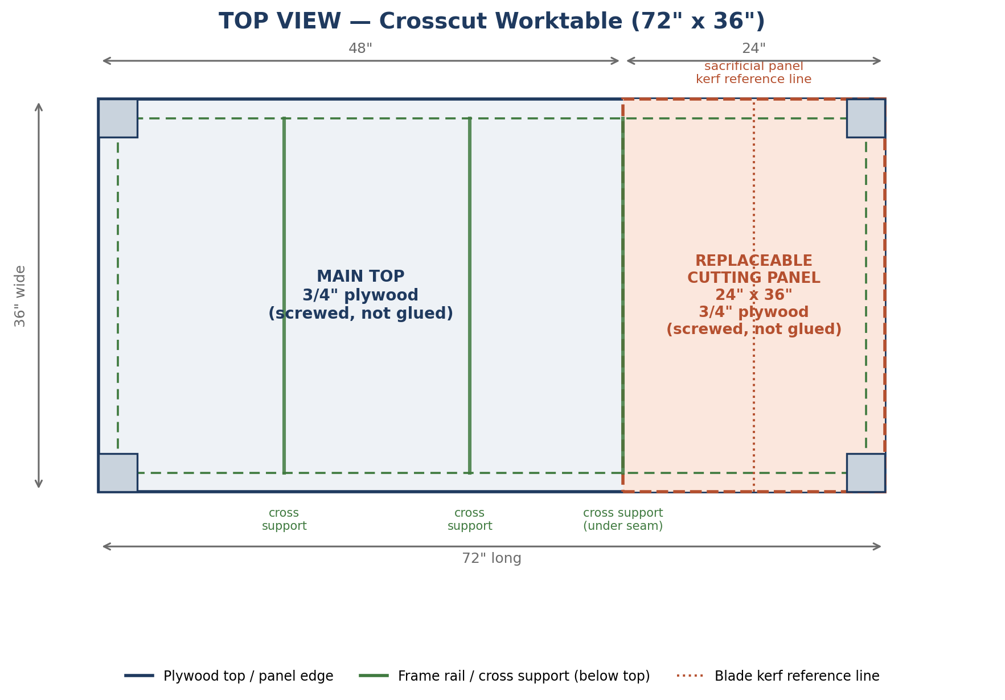
Top view — main top on the left (48"), replaceable cutting panel on the right (24"), frame and cross supports shown below the surface.
The cross support directly under the seam (at the 48" mark) is a deliberate design choice: both the main top's right edge and the panel's left edge land on it and get screwed down independently, so the seam is fully supported instead of floating between supports.

4. Side-View Diagram
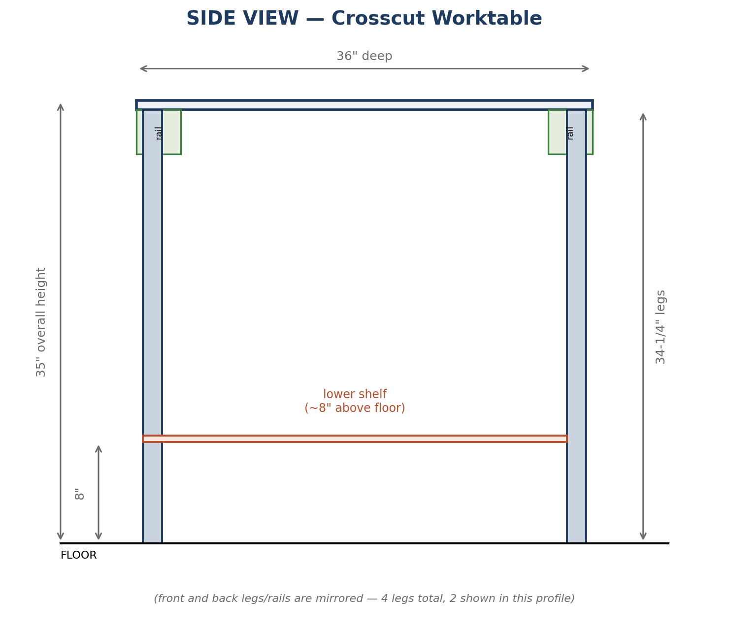
Side view — 35" overall height, 3/4" top, 34-1/4" legs, optional lower shelf mounted about 8" above the floor.

5. Step-by-Step Assembly

A. Build the upper frame
- Cut all 2x4 pieces per the cut list. Label each piece with painter's tape and a pencil so nothing gets mixed up.
- Lay the 2 front/back rails (72") and 2 end rails (33") on a flat floor. The end rails fit BETWEEN the front/back rails, so the outside dimension comes out to 72" x 36".
- Pre-drill and screw each corner with 3" construction screws (2 per corner) plus wood glue. This frame is permanent — glue is fine here.
- Check the frame for square using the diagonal method (see Section 7) before the glue sets. Adjust if needed.
- Attach the 3 upper cross supports (33") between the front and back rails: one near the 18" mark, one at the 36" mark (center), and one directly at the 48" mark, under the seam between the main top and the replaceable panel.
- Attach the 4 legs (34-1/4") inside the corners of the frame, flush with the top and with the outer corner faces. Use 3" screws plus glue, 2-3 screws per direction into each leg.
- Stand the frame up and confirm it doesn't rock. Shim a leg slightly if the floor or cuts are uneven.

B. Add the lower shelf (optional)
- Mark 8" up from the floor on the inside face of each leg.
- Cut the 2 lower rails (~66") and 3 lower cross supports (~30") — measure your actual leg-to-leg spacing first and adjust these lengths if they differ from spec.
- Screw the lower rails between the legs at the 8" marks, then attach the 3 cross supports across them, evenly spaced.
- Drop the 1/2" plywood/OSB shelf panel onto the lower frame and screw it down. Glue is fine here — the shelf isn't meant to be removable.

C. Attach the top
- Position the 48" x 36" main top on the frame, flush with the left, front, and back edges. Screw it down with 1-1/4" screws every ~8" around the perimeter and into each cross support beneath it. No glue — this keeps the top removable if the frame ever needs work.
- Position the 24" x 36" replaceable cutting panel into the remaining opening on the right, flush with the main top's surface and edges. Screw it down the same way, with extra screws into the cross support at the seam. No glue — this is the piece you'll swap out.

D. Build and attach the rear fence
- Cut the 1x4 rear fence to 72" (full bench width).
- Screw the fence along the back edge of the benchtop. Measure from the front edge of the bench to the fence at both ends before final screws go in — the two measurements must match, or the fence won't be parallel to the front edge.

6. T-Square Crosscut Guide
This is a bottomless T-square design, not a raised carriage. A raised carriage adds material thickness under the saw base and eats into your maximum cutting depth. A bottomless guide is only as thick as the 1x3 guide board itself, so it preserves nearly full blade depth — this works the same way whether you're running a 5-1/2", 6-1/2", or 7-1/4" circular saw, since the guide doesn't depend on a fixed track width.
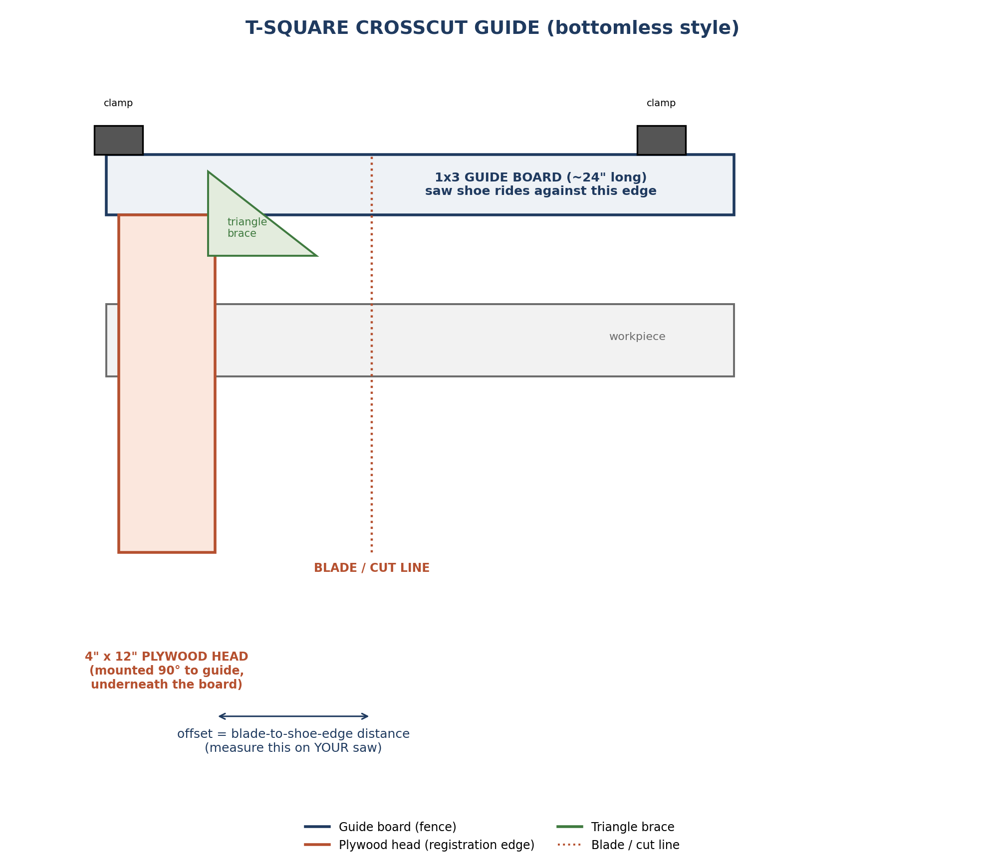
T-square crosscut guide — 1x3 guide board, 4"x12" plywood head mounted at 90°, triangular brace, and the offset you'll measure for your own saw.
- Cut the 1x3 guide board to ~24" long. Sight down its edge and pick the straightest board you own — this single piece determines how straight every future cut is.
- Cut the plywood head to 4" x 12" from 3/4" plywood scrap (the leftover strip from the main top sheet works well).
- Mark a precise 90-degree line across the guide board near one end using a speed square or combination square.
- Glue and screw the plywood head to the UNDERSIDE of the guide board, aligned exactly on your 90-degree mark. The head's edge is the registration edge — it will register against the edge of your workpiece for every cut.
- Cut the triangular brace (~5" x 5" right triangle) from plywood scrap.
- Glue and screw the brace into the inside corner where the head meets the guide board, on the same underside, to lock the 90-degree angle permanently. Let the glue fully cure before using the guide.
- Recheck square after the glue sets (Section 7) before you rely on this guide for real work.

Zero-clearance 8-foot guide (for long, straight cuts)
- Cut the 1/4" hardboard to 12" x 96".
- Attach the straight 8-foot 1x3 (or MDF strip) fence along one long edge of the hardboard, screwed every ~12". Set the fence back from the hardboard's far edge by more than your saw's base plate width, so the shoe has full support in the next step.
- Clamp the whole assembly to a sacrificial board or scrap sheet, with the wide hardboard section under the saw's travel path and the fence riding against the saw's base plate.
- Run the circular saw down the full length once, shoe riding the fence. This trims the hardboard's edge exactly on the blade's cut line.
- From now on, that trimmed edge IS your cut line — align it directly over your marked line on future boards, clamp, and cut. No offset math needed for this guide.

7. Checking That the Frame and Guide Are Square

Frame square check
- Before driving final screws, measure both diagonals of the assembled rectangle, corner to opposite corner.
- If the two measurements match exactly, the frame is square. If they differ, gently rack the frame toward the longer diagonal until both diagonals match, then brace it diagonally before driving the permanent screws.

T-square guide square check
- Draw a straight reference line across a piece of scrap using a reliable straightedge.
- Clamp the guide with the head registered against one edge of the scrap and cut along your line.
- Flip the guide over — register it against the opposite edge of the same scrap — and make a second cut a few inches away, parallel to the first.
- Measure the distance between the two cuts at both ends of the board. Matching distances at both ends means the guide is square. If they don't match, the head-to-guide angle is off: re-glue/re-screw the head at a corrected angle rather than trying to compensate while cutting.

8. Calibrating the Guide to Your Circular Saw
- Place your saw's base plate flat against the guide board's edge with the blade retracted and the saw unplugged.
- Measure the exact distance from the edge of the blade (the blade plate itself, not the guard) to the edge of the saw's shoe that registers against the guide.
- This measurement is your offset. Write it directly on the guide with a permanent marker so you never have to re-measure for this saw.
- To cut on a marked line: position the guide so its registration edge sits exactly one offset-width away from your line, on the waste side, then clamp before cutting.
- Make a test cut on scrap and check it against your mark before cutting your real workpiece. Re-measure the offset if you ever switch to a different saw — every saw's offset is different.

9. Making Repeatable Cuts With a Stop Block
- Butt your board against the rear fence for a consistent starting reference.
- Measure and mark your desired cut length from the end of the board.
- Clamp a scrap stop block to the rear fence at that mark, positioned using the same offset logic from Section 8, so the block's edge lines up with your intended cut.
- For every additional piece, push the board against the stop block instead of re-measuring, clamp the T-square guide against the board's edge, and cut. Every piece comes out identical.
- Spot-check the first two or three cuts with a tape measure before running through a full batch, to confirm the stop block is positioned correctly.

10. What's Removable or Replaceable
- Replaceable cutting panel (24" x 36", screwed only, no glue) — swap it out once it's chewed up with kerf cuts. Keep 1-2 spares cut ahead of time.
- Main benchtop (48" x 36", screwed only, no glue) — removable if you ever need to access the frame or replace a damaged top, though it won't wear out nearly as fast as the panel.
- Zero-clearance guide base (1/4" hardboard) — wears out with repeated use. Unscrew the fence and swap in a fresh strip when the trimmed edge stops giving a clean reference.
- Stop block — intentionally temporary. It's clamped, never screwed, so it can move for every new cut length.
- NOT removable — permanent, glued and screwed: frame rails, cross supports, legs, and the lower shelf frame. These are structural and should not be designed to come apart.

Build order recap: frame → legs → optional shelf → top and panel → rear fence → T-square guide → square-check everything → calibrate to your saw → go make straight cuts.

