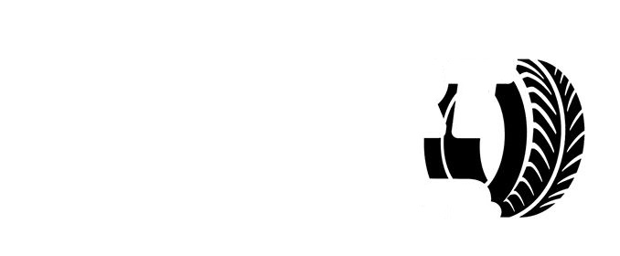

***TYRESLTD.***

***AIRPORT***