QUERY

--#1

SELECT 'Premier Customer' AS "Type", custID AS "Customer", custEmail AS "Email", custPhone AS "Phone" FROM Customer NATURAL JOIN PremierMember

UNION (SELECT 'Steady Customer' AS "Type", custID AS "Customer", custEmail AS "Email", custPhone AS "Phone" FROM Customer NATURAL JOIN SteadyMember)

UNION (SELECT 'Prospective Customer' AS "Type", custID AS "Customer", custEmail AS "Email", custPhone AS "Phone" FROM Customer NATURAL JOIN ProspectiveMember);

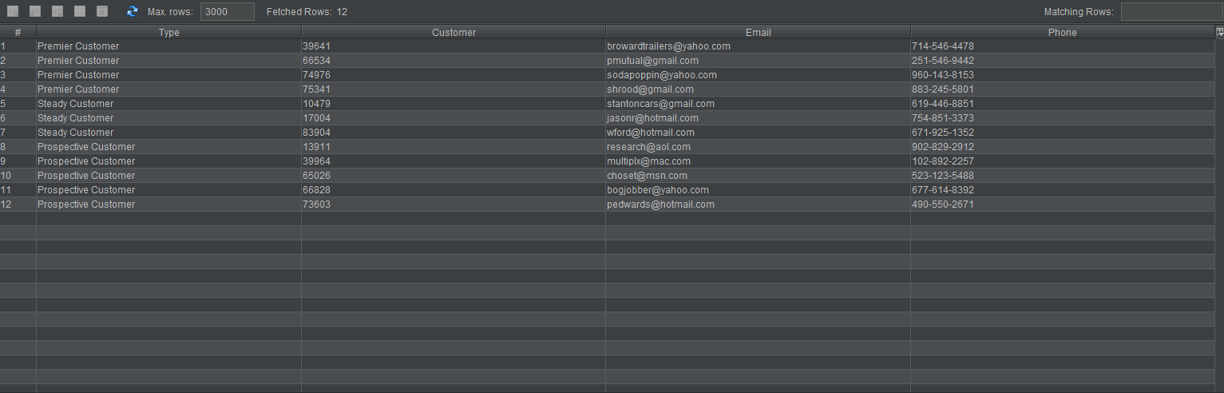

--#2)

SELECT orderDate, price FROM MaintenanceOrder

GROUP BY orderDate, price;

--#3)

SELECT

--#4)

SELECT DISTINCT mechName  
FROM SkillCertification  
WHERE mechName IN (SELECT mechName FROM (SELECT DISTINCT mechName, skillName FROM SkillCertfication) skillCount  
GROUP BY mechName  
HAVING COUNT(skillName) >= 3);

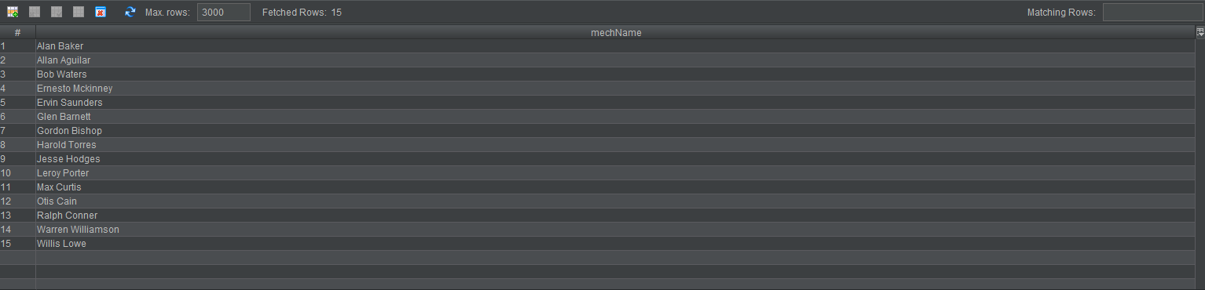

--#5)

SELECT a.mechName, b.mechName

FROM SkillCertification x NATURAL JOIN Mechanic a

INNER JOIN SkillCertification y NATURAL JOIN Mechanic b ON x.skillName = y.skillName

WHERE x.mechName < y.mechName

GROUP BY x.mechName, y.mechName

HAVING COUNT(y.mechName) >= 3;



--#6)

--#7)

--#8)

SELECT CONCAT(iLastName, ', ', iFirstName) AS "Customer", loyaltyPoints

FROM Individual NATURAL JOIN Customer NATURAL JOIN SteadyMember

UNION

SELECT corporationName, loyaltyPoints

FROM Corporation NATURAL JOIN Customer NATURAL JOIN SteadyMember

ORDER BY loyaltyPoints DESC;



--#9)

10.

11.

12.

--#13)

SELECT mentorName, COUNT(menteeName) AS "Number of Mentees Trained", CONCAT(skillLearn, ', ', skillLevel) AS "Skill Taught"

FROM Mentorship

GROUP BY mentorName

ORDER BY COUNT(menteeName) DESC

LIMIT 1;



--#14)

SELECT skillName, COUNT(skillName) AS "Amount of Mechanics w/skill" FROM SkillCertification

GROUP BY skillName

ORDER BY COUNT(skillName)

LIMIT 3;



--#15)

SELECT mechName, mechPhone

FROM Mechanic

WHERE mechName IN

(SELECT techName

FROM Technician)

AND mechPhone IN

(SELECT techPhone

FROM Technician);

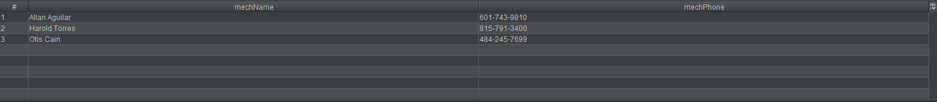

--16a) Show that a customer can not have more than 3 vehicles

SELECT custID, COUNT(custID)

FROM Customer NATURAL JOIN Vehicle

GROUP BY custID

HAVING COUNT(custID) > 3;