**View Output**

/* #1) Customer View */

CREATE VIEW Customer_v AS

SELECT CONCAT(iLastName, ', ', iFirstName) as 'Customer Name', 'Premier' as "Customer Type", (2017 - YEAR(dateJoined)) AS "Length of Membership"

FROM PremierMember NATURAL JOIN ExistingCustomer NATURAL JOIN Customer NATURAL JOIN Individual

UNION

SELECT corporationName, 'Premier', (YEAR(now()) - YEAR(dateJoined))

FROM PremierMember NATURAL JOIN ExistingCustomer NATURAL JOIN Customer NATURAL JOIN Corporation

UNION

SELECT CONCAT(iLastName, ', ', iFirstName), 'Steady', (2017 - YEAR(dateJoined))

FROM SteadyMember NATURAL JOIN ExistingCustomer NATURAL JOIN Customer NATURAL JOIN Individual

UNION

SELECT corporationName, 'Steady', (YEAR(now()) - YEAR(dateJoined))

FROM SteadyMember NATURAL JOIN ExistingCustomer NATURAL JOIN Customer NATURAL JOIN Corporation

UNION

SELECT CONCAT(iLastName, ', ', iFirstName), 'Prospective', 'N/A'

FROM ProspectiveMember NATURAL JOIN Customer NATURAL JOIN Individual

UNION

SELECT corporationName, 'Prospective', 'N/A'

FROM ProspectiveMember NATURAL JOIN Customer NATURAL JOIN Corporation;

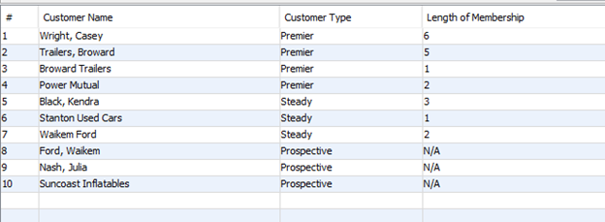

/* #2) Customer Address View */

--CREATE VIEW Customer_Addresses_v AS

SELECT CONCAT(iLastName, ',', iFirstName), 'Individual' AS "Individual or Corporation", mainAddress as "Address"

FROM Individual

UNION

SELECT corporationName, 'Corporation', Addresses.address

FROM Corporation NATURAL JOIN Addresses;

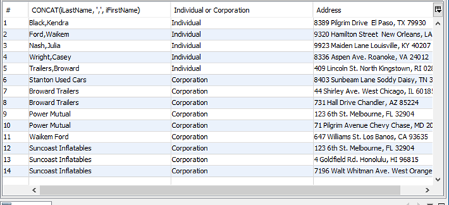

/* #3) Mechanic Mentor View */

CREATE VIEW Mechanic_mentor_v AS

SELECT mentorName as "Mentor Name", menteeName as "Mentee Name"

FROM Mentorship

ORDER BY mentorName, menteeName;

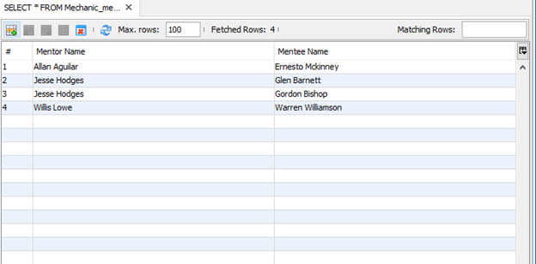

/* #4) Premier Profits View */

--CREATE VIEW Premier_profits_v

/* #5) Prospective Resurrection v */

CREATE VIEW Prospective_resurrection_v AS

SELECT ProspectiveMember.custID, numOfContacts, emailDate AS "Date of Contact"

FROM ProspectiveMember NATURAL JOIN Customer NATURAL JOIN Notification

WHERE numOfContacts > 3 AND (YEAR(now()) - YEAR(emailDate)) > 2;

