Service Type Dedicated Internet 

Order Type {{orderType}}









{{#SiteDetails}}

SITE DETAILS

| | Installation Address {{streetAddress}} | PIN Code {{sitePincode}} | | --- | --- | | Branch Code |  | | City {{siteCity}} State {{siteState}} | Country {{siteCountry}} | | SEZ Site {{SEZ}} GSTN {{GST}} |  | | Billing Address {{billingAddress}} | PIN Code {{billingPincode}} | | City {{billingCity}} State {{billingState}} | Country {{billingCountry}} | | Site Incharge {{inchargeName}} {{inchargePhone}} |  | | Name Mobile Number |  | | Company Name {{CompanyName}} | Contract Period {{contractPeriod}} | | Requested Date of Delivery {{deliveryDate}} |  |  | ₹{{arc}} + ₹{{otc}} ₹{{total}}  ARC OTC Payable Amount  *Price above excludes any taxes applicable | | --- |   {{#PrimaryAccess}}  PRIMARY ACCESS:   | Link Type - | Bandwidth {{ATT_ACCESS_BANDWIDTH}} | Service Type Attributes {{ATT_SERVICE_TYPE}} | | --- | --- | --- | | CPE Make | CPE  Specification |  | | Media {{ATT_MEDIA}} |  |  | | Last Mile {{ATT_LAST_MILE}} | POP {{ATT_POP}} | CPE {{ATT_CPE}} | | IP Version {{ATT_IP_REQUIRED}} | Routing Protocol | IP Type {{ATT_IP_Type}} | | No. of WAN {{noOfWAN}} | No. of LAN {{noOfLAN}} | WAN IP V6 Subnet | | WAN IP V4 Subnet | LAN IP V6 Subnet |  | | Port Bandwidth {{ATT_PORT_BANDWIDTH}} | Access bandwidth {{ATT_ACCESS_BANDWIDTH}} |  |   {{/PrimaryAccess}} |
| --- | --- | --- | --- | --- | --- | --- | --- | --- | --- | --- | --- | --- | --- | --- | --- | --- | --- | --- | --- | --- | --- | --- | --- | --- | --- | --- | --- | --- | --- | --- | --- | --- | --- | --- | --- | --- | --- | --- | --- | --- | --- | --- | --- | --- | --- |

{{/SiteDetails}}

CUSTOMER PURCHASE ORDER



Service Type DEDICATED INTERNET Date & Time 23 Jun, 2023 6:09:01 PM

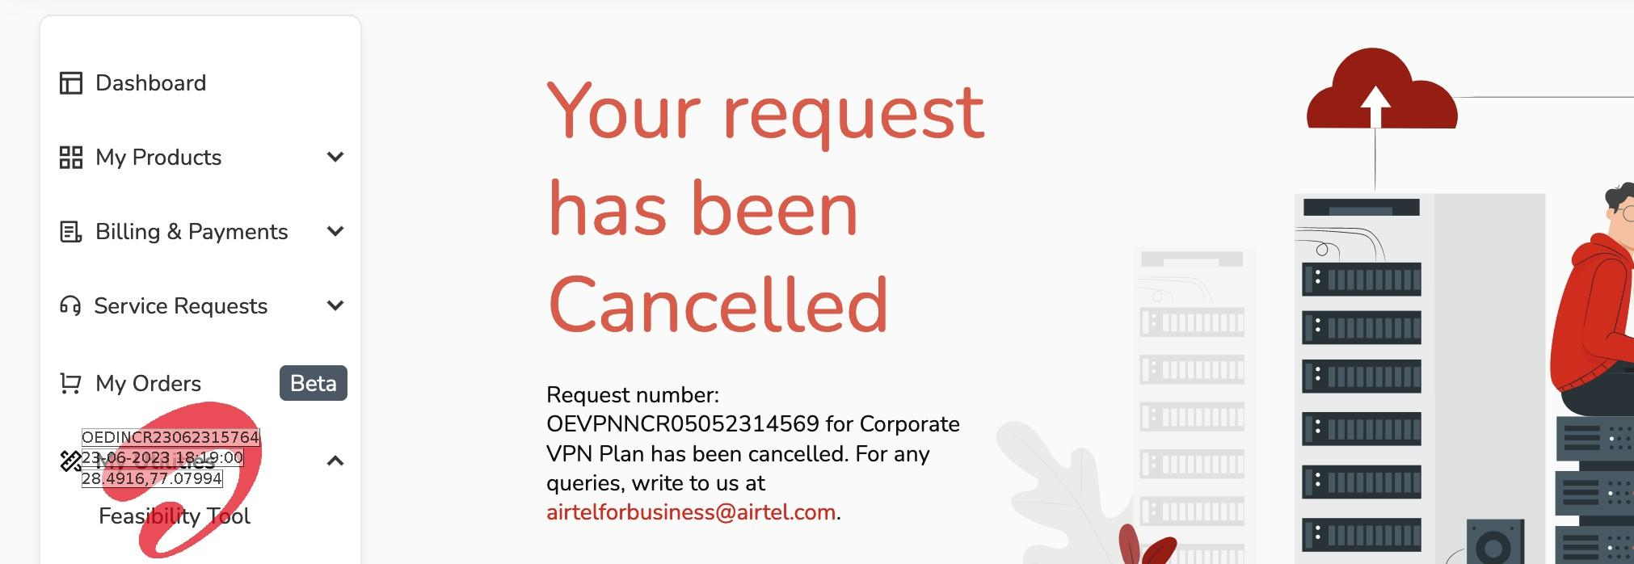

# TERMS & CONDITIONS



1. I/We undertake to comply with all applicable laws and regulations, including without limitation, the provisions of the Indian Telegraph Rules, 1951 made thereunder, Indian Wireless Act 1933, IT Act 2000 and TRAI Act 1997 and any amendments or replacements made thereto from time to time.
2. I/We shall not re-sell the services procured from Airtel to any third party.
3. I/We ensure that objectionable, obscene, unauthorized or any other content, messages or communications infringing copyright, Intellectual property right and international & domestic cyber laws, in any form or inconsistent with the laws of India, are not carried out by us.
4. I/We shall provide necessary facilities to Airtel, TRAI, DOT or any other Government Agencies to counteract any unlawful activity.
5. I/We shall undertake that services from Airtel will not be used for any call center or other OSP-related service unless I/we hold a valid OSP registration certificate issued by the concerned Govt. of India authority.
6. I/We agree and undertake not use the services for any of the following activities:
   1. Voice communication by means of dialling a telephone number (PSTN/ISDN/PLMN) until and unless I/We hold appropriate licenses and approvals and the same is informed to Airtel.
   2. Originating/terminating the voice communication from/at a telephone in India.
   3. Establishing connection to any Public switched network in India and/or establishing gateway between Internet & PSTN/ISDN/PLMN in India, until and unless I/We hold appropriate licenses and approvals and the same is informed to Airtel.
   4. Use of dial up lines with outward dialling facility from nodes.
   5. Routing public Internet traffic between links of two or more Internet Services Providers (ISPs)
7. Price: All prices are exclusive of tax which will be payable extra at applicable rates. Any Change in Tariffs/Regulation from Telecom Regulatory Authority of India (TRAI) would be applicable with immediate effect.
8. Bharti Airtel Limited shall not be responsible for any installation, commissioning or maintenance of any equipment or hardware unless supplied by Bharti Airtel Limited or otherwise agreed by us.
9. Contract Period: Rates set forth under each service order shall be fixed for the duration of the service order term unless otherwise agreed between the parties. Service order term will be either 12 months (minimum) or agreed service term whichever is higher.
10. "No Termination for convenience: Customer cannot exit from the contract for convenience or Business reason during the service order term. In all such cases, Exit penalty of the amount equal to remaining term of the order will be payable in case of early exit.
11. No Termination for convenience right for deals involving investment/HW recovery on opex"
12. "Payment terms: Payment terms will be quarterly in advance for recurring charges and the one-time charges.
13. Network Acceptance would be link wise as per the following criteria - Network Acceptance Test Criteria would be Ping test from CE modem/Mux towards Bharti Service Equipment & payment to be released on link wise basis
14. Site wise acceptance shall be provided and site wise payment will be released accordingly
15. Validity: Price given in this quote is valid for 15 days
16. Any site which requires additional tower height, anything above than 6mtr, shall be chargeable at 4000 Rs per Mtr
17. For any hardware/ CPE on rental: Any intentional damage / mishandling / theft of equipment(s) deployed at end customer points will be the responsibility of the customer and replacement would be charged additionally at actual cost
18. The given rates are applicable only for this particular scope of work. In case bandwidth upgrade/new links are required, the same will be treated as a separate request and pricing shall be proposed accordingly
19. Given prices are based on L1 feasibility. During implementation if any sites needs an additional capital expenditure or the site becomes completely non feasible even after best effort to establish the link, customer shall be informed/ charged accordingly for additional expense
20. Cross connect charges: if any will be charged back extra to the customer.
21. Any client request for travel & manpower support shall be charged at actual
22. Shifting charges will be additional, charged as per actuals.
23. User to comply with all applicable laws and regulations including, the provisions of the Telegraph Act 1885, TRAI Act 1997, etc.
24. Airtel shall not be liable for any cost to the customer in any manner whatsoever for any loss of profits, goodwill, consequential losses (including any actions brought by a third party), whether direct or indirect.
25. Site readiness & site availability (Space, rack, power earthing, internal cabling, LAN work, conduiting, access) will be in customer's scope. Delay in installation due to site not ready shall not be considered under any penalties.
26. Roof rights will be provided by customer
27. Service level agreement: Airtel provides SLA as per the media (Fiber: 99.5%, Radio: 98%, Copper: 98.5%). Customers shall allow Bharti to carryout maintenance activities as and when required. On 4G Last mile,Bandwidth : Up to 4 Mbps(Bandwidth is on Best Effort Basis, actual b/w availability will depend on utilization level of the 4G cell site at that time). 4G Last mile will be provided as backup wherever it will be feasible as per the product construct with agreed commercials.
28. Last mile can be on wireless (RF) in case not feasible on wire line subject to feasibility
29. Service Order Term will start from the date of commissioning or from the date of renewal of such Service Order (hereinafter referred to as the "Service Effective Date") . In case a Service Order provides for multiple locations, Airtel shall invoice the Customer basis each individual locations from the Effective Date and the Service Order Term shall be twelve (12) months from the Effective Date of each such link/circuits.
30. Contract will be automatically renewed annually in a cycle unless revoked at time of completion of the cycle. All rate revisions will be applicable from the next quarter with no back dated revisions.
31. In the event of termination of a link(s) or partial termination of the Data Services during the Service Order Term for the respective link(s)/Data Services by the Customer, Airtel reserves the right to charge for the residual term at the rates as mentioned in the SAF ("Termination Charges") and Customer agrees to pay such Termination Charges along with charges for Data Services rendered up to the effective date of termination within thirty (30) days of the date of the invoice.
32. Any change in the applicable taxes, duties, fees, government levies including but not limited to the license fees shall be borne by Customer.
33. Any delay in the payment of any undisputed amount beyond the due date as printed on the invoice shall attract overdue interest of 2% per month, where the minimum unit of time shall be computed as one(1) month and shall be considered in multiple thereof, if applicable.
34. Customer may raise any dispute within thirty (30) days of raising the invoices, beyond this time the customer agrees to waive off its right to raise any dispute related to the invoice.
35. In case of conflicting terms between various documents, unless specifically mentioned, following will be the priority of the document for interpretation of the term, in descending order 1) CAF/SAF 2)MSA 3)PO
36. User Acceptance Test of links shall be done site wise and LOCs to be signed by customer site wise. Accordingly billing shall start as soon as the LOC for respective site has been signed and payments shall become due accordingly. If customer does not sign LOC within 2 days from date of offer by Airtel for User Acceptance Test, Airtel reserves the right to treat the site as Deemed Accepted from end of such 2nd day and billing shall start from 3rd day. Where payment is linked with delivery of hardware, such delivery of hardware and payment shall apply site wise. At later date when customer is signing the LOC, LOC shall be signed with effective date as the original date of offer of UAT by Airtel.
37. The Services from Airtel will not be used by the Customer for any Call Center or Other OSP related Services
38. The Services from Airtel will not be used by the Internet Service Providers (ISP) with or without License holder for ISP Related Services or/and bandwidth reselling.
39. We also hereby acknowledge that in case we have not provided Regular GST Registration number for mentioned states/union territories to BAL, we will become disqualified for claiming Input Tax Credit of GST (CGST, SGST/UTGST, IGST) charged by BAL on the supplies made by BAL in mentioned states / union territories to us. Further, we also hereby declare that while making Invoice payment we will neither hold nor make any deductions of any kind on account of non-availment of input tax credit by us in captioned states/union territories
40. The customer shall not re-sell the services procured from Airtel to any of its affiliates or group companies and any other third party, unless having the required authorization from the concerned authorities to do so.
41. Declaration: Customer's signatory and/or the person submitting this SAF to Airtel confirms that he/she has read and agrees to the SAF and is authorized to sign this SAF and/or submit it on behalf of his/her company.
42. We, at Airtel do not ask our Customers to make any payment (recurring or non- recurring) for our services to any third party vendor's bank account. All payments must be paid to Airtel directly in the bank account mentioned in valid invoices raised by Airtel.