Mobile Cranes’ Safety System At Construction Sites

Nur Shafiqah Binti Abdullah

*Faculty of Electrical Engineering*

*Universiti Teknologi Malaysia*

*Johor Bahru, Malaysia.*

*nurshafiqah.abdullah8@gmail.com*

PM Zamani Mohd Zain

*Department of / Centre of*

*Faculty of Electrical Engineering*

*Universiti Teknologi Malaysia*

*Johor Bahru, Malaysia.*

*zamani@fke.utm.my*

*Abstract*— Safety issue involving mobile cranes at construction sites has become serious matter due to its working environment and the complexity of working practices. This project proposed a low cost automated monitoring system kit to help monitoring the hazard on the operation of mobile crane at construction site. The prototype system is an integrated electronic alert system for the crane operator when lifting a load using mobile crane. Sensor was used to obtained boom length and angle which then processed by the controller module installed in the driver’s operating room using Arduino Mega as the processor. The data obtained will then being send to the Ground Monitoring Terminal (GMT) which is at ground worksite were done for supervision purposes. At the end of this project, an anti-accident algorithm was executed and the real-time data was recorded using MATLAB to ensure the safety of mobile crane during construction.

Keywords— mobile cranes; Arduino Mega; monitoring system

# Introduction

The field of construction today have become significant part of industrial culture, safety issue on construction site is highly concerns especially regarding mobile crane. Mobile crane is one of the heavy-duty equipment for moving heavy structure and materials on construction sites. The effectiveness and safety of the mobile crane is degrading due to the flexible nature of crane physical structures. Based on the figure from Department of Occupational Safety and Health, Ministry of Human Resources Malaysia, in 2014, the rate for an accident to happen in construction sites is 3.10 per 1000 workers while rate of fatality is 4.21 per 100000 workers. In 2015, the accident rate per 1000 workers in 2015 is 2.81 while fatality rate per 100000 workers is 4.84. Even though there is slightly decline of the accident rates between 2014 and 2015, the rates are still considered as big figures of numbers for construction field. Safety measure should be implemented by respective company in order to prevent the rate to increase from year to year. However, these studies only focusing on how to tackle armature crane operator handling crane which according to the load chart of a mobile crane and real-time data supervise problem. Fig.1 shows the mobiles crane parts.

# Literature Review

## Construction and Crane Security System Kit

This thesis that was published in 2016 focusing on an integrated electronic alert system for stress and strain movement on construction structure. The sensor module that was attached to the construction structure in order to detect any vibration or displacement events which will then send to Arduino Uno Board to compute the data and trigger the alert system for the user.

1. *A Proactive System for Real-Time Safety Management in Construction Sites*

This paper reports the development of a first prototype for the proactive safety management and real-time signaling of potential overhead hazards. It is expected to enhance standard safety policies and assist inspectors and coordinators in executing their tasks. The system performs real-time tracking using ultra wide band technology and implements proactive virtual fencing logics. The development of the system, its laboratory test results, the algorithm optimization, and the final field test results are reported herein. The results achieved demonstrate the capability of proactive logics to reinforce safety management policies and assist personnel in coping with unpredictable hazardous events.

1. *Dynamic Responses of Hydraulic Mobile Crane with Consideration of The Drive System*

This paper focusing on improvement of dynamic calculation of mobiles cranes. using the new method, the flexible multibody model of the structure will be couples with the model of the drive system. In that way the elastic deformation, the rigid body motion of structures and the dynamic behavior of the drive system can be determined in an integrated model. The calculation method has been realized for a hydraulic mobile crane. In addition to the structural elements, the mathematical modelling for hydraulic drive- and control system is described. The crane rotating simulation for arbitrary working conditions has been carried out. As a result, a more exact representation of dynamic behavior, not only for the crane structure, but also for the drive system is achieved.

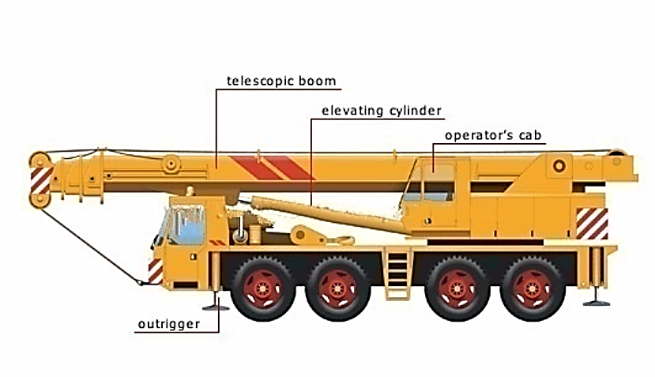

1. Mobiles Cranes Parts

# Methodology

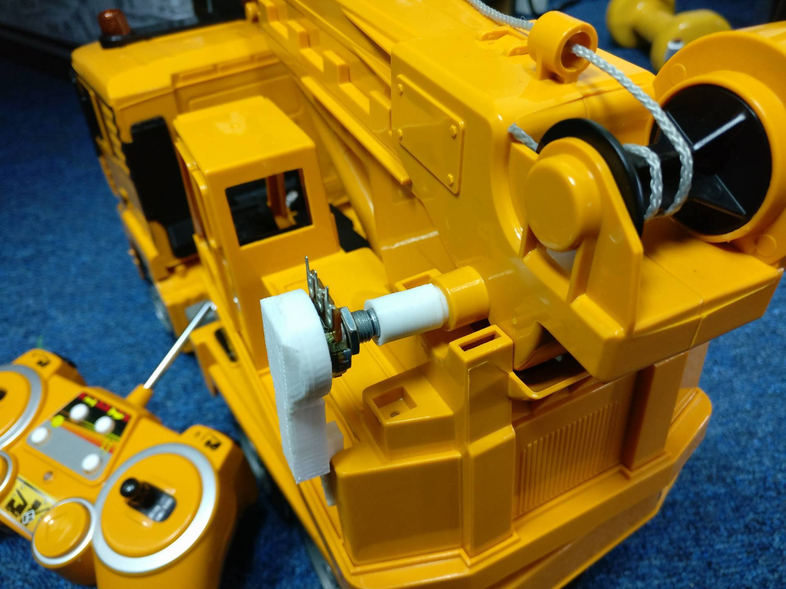

The method conducted in this project was divided into software simulation and hardware development. In order, to compare the functionality of data logging concept in industrial mobile crane, simulation really important before transfer simulation circuit into hardware. Fig. 2 shows the block diagram of overall system. At the early stage of operation, the crane operator will insert the weight of the load and the crane working radius. Potentiometer that act as sensing module in the system was used to detect parameter when the crane is in operation. In the controller module, Arduino Mega board processed the data according to the load chart which give output to the Alert Kit and MATLAB.

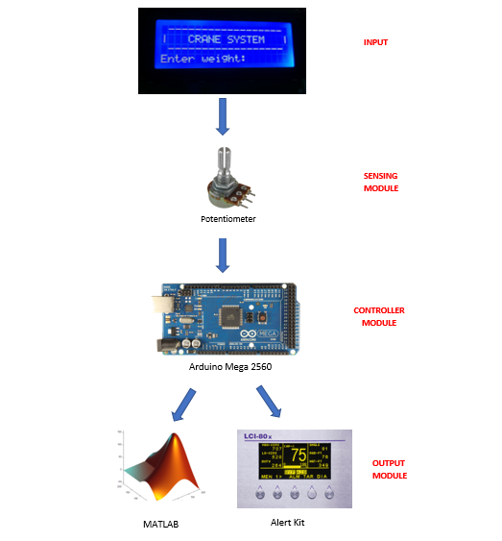

Fig. 4 Potentiometer to measure boom lenght

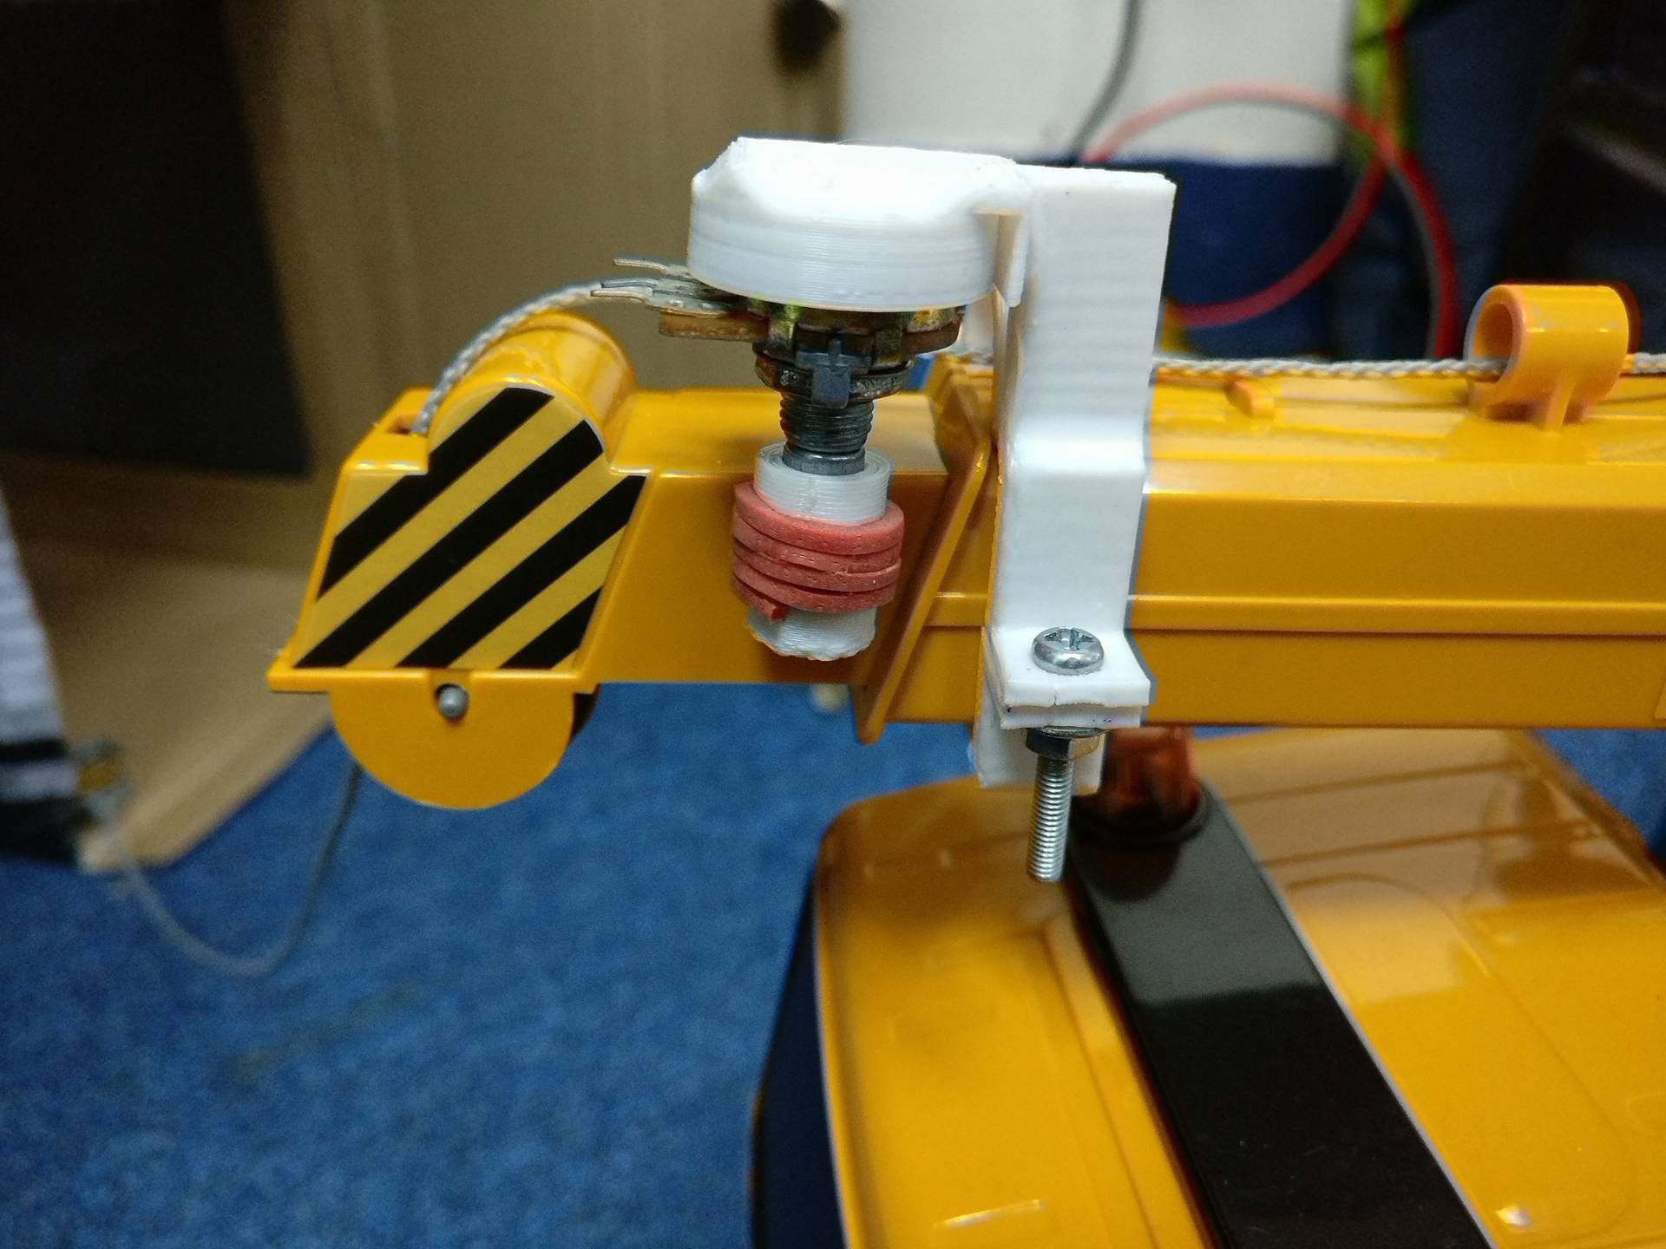

Fig.3. Potentiometer to measure boom angle

## Hardware Developement

## Sensing Module

Fig.5. Alert Kit

Various of sensor can be used in order to get the parameter needed to be measured. In this project, potentiometer was used to measure two values:

1. Angle of the telescopic boom.
2. Length of the telescopic boom.

The variation of voltages 0-5V of potentiometer was map to the minimum and maximum value of boom length and boom angle so that it will produce the value needed. The implementation of the potentiometer is as shown in Fig.3 and Fig. 4.

1. *Alert Kit*

The alert kit function like data loggers, it consists of LCD 16x4, a keypad membrane, 4 LEDs and one buzzer. This kit will be stored in the operator’s cab for the operator reference when lifting a load. In case, the operator exceeds the maximum length or angle fixed according to the load chart, red LED will be light up and buzzer will be triggered. If the potentiometer gives out the exact value according to the load chart, yellow LED will light up. The Alert Kit is as shown in Fig.5

Fig.2 Flowchart of Overall System

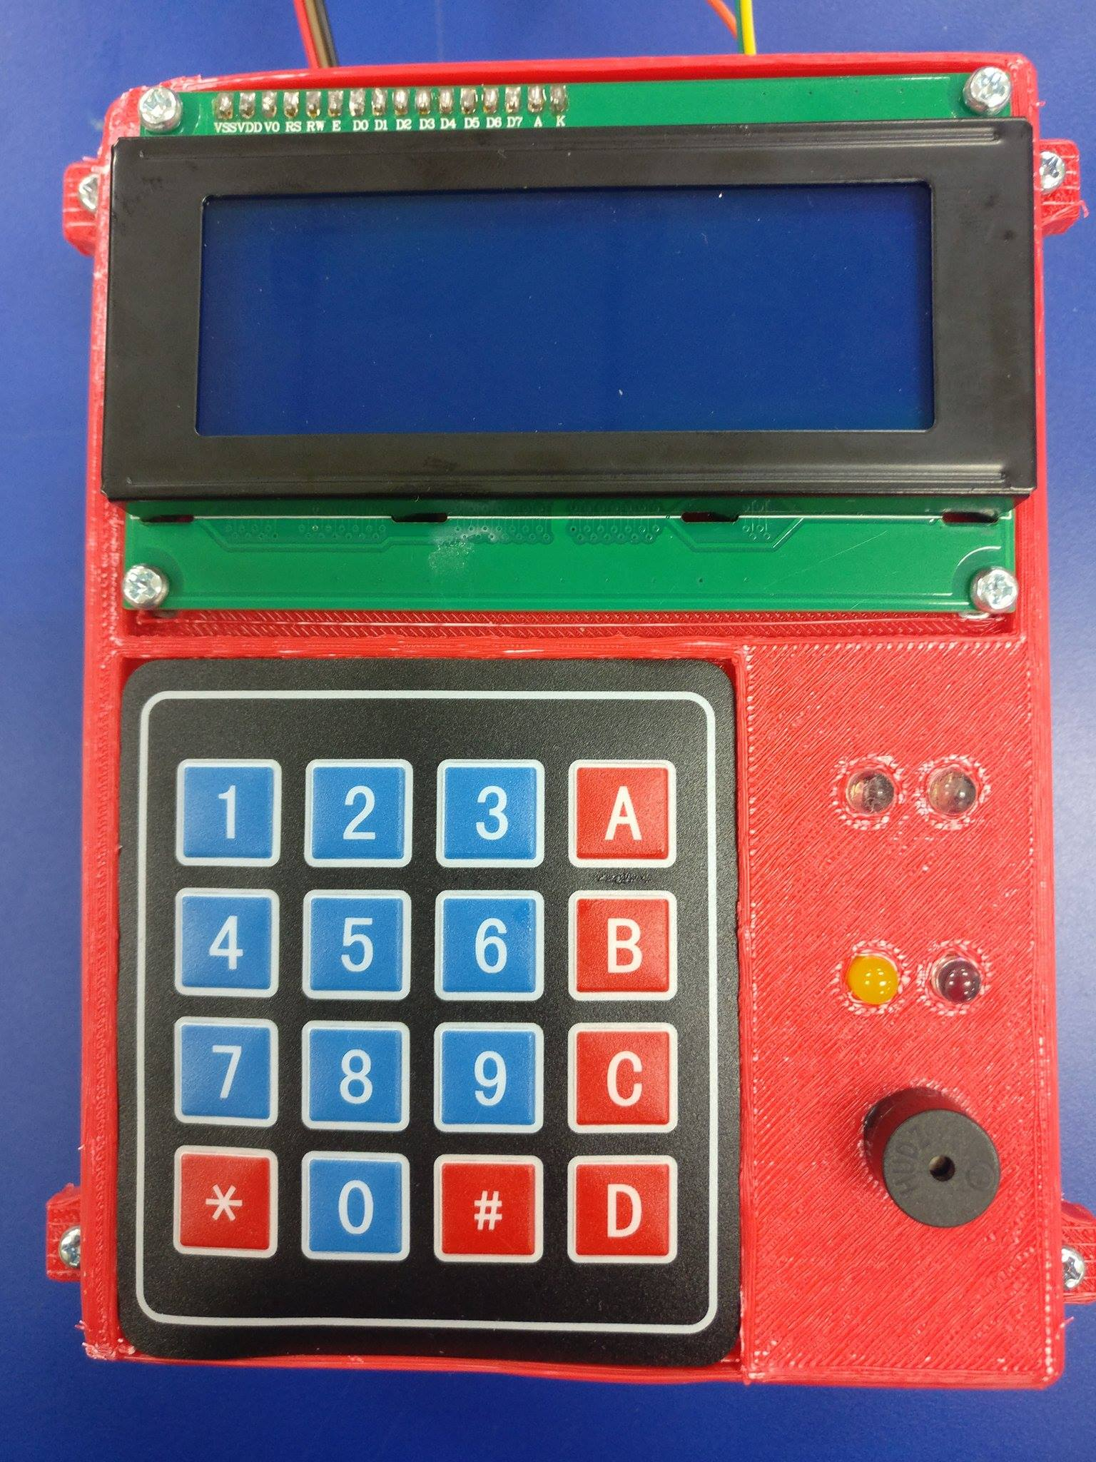

## Software Simulation and Designation

## Arduino Mega 2560

The Arduino Mega is the addition to the Arduino family. This board is physically larger than all the other boards and offers significantly more digital and analog pins. The MEGA uses a different processor allowing greater program size and more. The Mega2560 differs from all preceding boards in that it does not use the FTDI USB-to-serial driver chip. Instead, it features the ATmega16U2 programmed as a USB-to-serial converter. The Mega has four hardware serial ports, which means maximum speed if you need a second or third (or fourth) port. The Arduino Mega works in the same way the Arduino Uno does but the difference is that it uses ATmega2560 microcontroller and has more number of digital pins, analog pins. In this project, Arduino Mega will process input from potentiometer, maps with the load chart and then gives output to the Alert Kit and MATLAB. Fig.6 shows the circuit diagram of the system.

Fig.6. Circuit Diagram

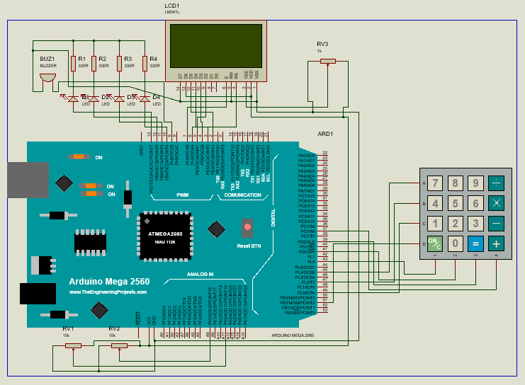

1. *Mobile Crane’s Load Chart*

Each crane has a load chart that, in short, specifies the crane’s capabilities—detailing its features and how its lift capacity varies when considering distance and angle. Before a crane is rented, transported, employed or purchased, the crane chart must be consulted. Everyone, from the crane operator, to the job supervisors, to even the sales guys have to know how to read a load chart. Table 1 shows example of crane performance which will map to the load chart as shown in Fig.7

Fig. 8. Graphical User Interface (GUI)

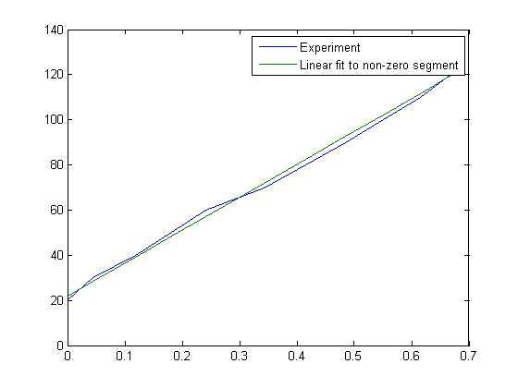

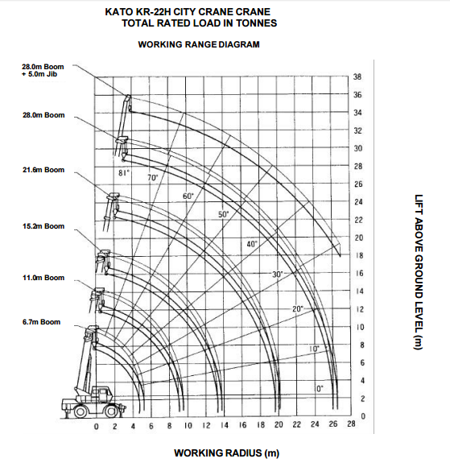

Here, the chart illustrates the total weight able to be picked up at an 81-degree angle while outriggers is extended. The column to the left indicates the radius of the lift, the one to the far right, the maximum boom length each weight can be carried at. and on the x axis, indicates the working radius on how far the boom is extended from the initial position.

1. Crane Performance

| Crane Performance | | |
| --- | --- | --- |
| Maximum Total Rated load | Boom Length | Load Weight |
| 6.70 m boom | 22,000 kg |
| 11.00 m boom | 12,000 kg |
| 21.60 m | 8,000 kg |
| 28.00 m | 6,000 kg |

1. *MATLAB Graphical User Interface (GUI)*

In this project, GUI was used to communicate Arduino with MATLAB to show the output of potentiometer for supervision purposes. The GUI typically contains controls such as menus, toolbars, buttons, and sliders. Many MATLAB products, such as Curve Fitting Toolbox™, Signal Processing Toolbox™, and Control System Toolbox™ include apps with custom user interfaces. Fig.8 shows the GUI used to communicate Arduino Mega to MATLAB.

# Results and Discusions

After entered value of load weight and working distance, Arduino calculate the potentiometer value and maps to the boom length and angle. In this example, 22000 is entered for the load weight and 2m for the working distance. From the load chart suppose the boom length is 6.7m and angle should be 60°, if the boom length is longer then red LED lights up. If not yellow LED lights to indicate it is safe.

Fig. 9. Result 1



Fig. 7. Load chart of a mobile crane

Fig.9 shows that LED from boom is still in red which indicate, it is still below rated length.

Fig. 10. Result 2



Fig. 10 shows that LED from angle is still in red which indicate, it is still below rated angle.



Fig. 11. Result 3

Fig. 11 shows that LED from angle and boom is still in red which indicate, both is still below rated length and angle.

Fig. 12. Result 4



Fig. 12 shows that LED from angle and boom is in yellow which indicate, both is at safe angle and length to operate. While in Fig. 13 shows the result of serial communication between MATLAB and Arduino. The GUI shows the weight load, working distance and graph on the potentiometer when it is operated.

Fig. 13. Result 4

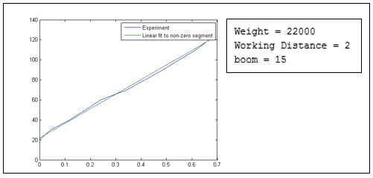

# Conclusions and Recommendations

# Construction sites are always prone to accidents especially when mobiles are involved. The proposed system, through the deployment of an alert kit and supervision system using MATLAB, aims at helping construction or safety personnel in making rapid decisions to avoid or minimize these accidents when in an operation. The results proof of concept– a demonstration that a relatively low-cost system kit can be used to mobile crane operator on harsh and dynamic construction sites.

# In order to improve the performance of the system, a better sensor should be used to get the exact boom length and boom angle under any circumstance. Furthermore, the Internet of Thing (IoT) technologies should be implemented so that the supervision part will not limited to only at the construction site, in fact can be monitor by engineer from far.

# References

1. Muhammad Nasruddin Bin Mohd Shah. “Construction and Crane Security System Kit”, 2016, pp. 1-13.
2. Daichi D. Fujioka, “Tip-Over Stability Analysis For Mobile Boom Cranes With Single- And Double-Pendulum Payloads,” Georgia Institute of Technology, 2010, pp. 23-24.
3. Kevin Tantesevi, Burcu Akinci. “Automated generation of workspace requirements of mobile crane operations to support conflict detection” Carnegie Mellon University, 2010, pp. 1-4.
4. Wolfgang Wilhelm, Ratmgen-Hosel,Kriiger GmbH & Co. KG, Essen, Fed. “Load-Monitoring System For Boom-Type Crane”, Germany, 1985, pp. 8-11.
5. Alessandro Carbonari, Alberto Giretti, Berardo Naticchia, “A proactive system for real-time safety management in construction sites”, Università Politecnica delle Marche, 2011.
6. Teach-ict. (n.d.). “Advantages and Disadvantages.” [Online]. Available:http://www.teach-ict.com/gcse_new/control/ data_logging/ miniweb/pg6.htm, [Accessed October 1, 2016].
7. Mathworks. “Sonar distance graph on Matlab” [Online]. Available: https://www.hackster.io/Luis_R_A/sonar-distance-graph-on-matlab-6d3a1b, [Accessed November 4, 2016].
8. Department of Occupational Safety And Health, Ministry Of Human Resource Malaysia. “National occupational Accident Fatality Rate” [Online]. Available: http://www.dosh.gov.my/index.php/en/national-occupational-accident-fatality-rate, [Accessed September 11, 2016]
9. Ministry of Manpower Singapore, " New mobile cranes to be equipped with data loggers from 1st August 2015," [Online]. Available: http://www.mom.gov.sg/newsroom/press-releases/2015/new-mobile-cranes-to-beequipped-with-data-loggers-from-1-august-2015, [Accessed October 1st, 2016]