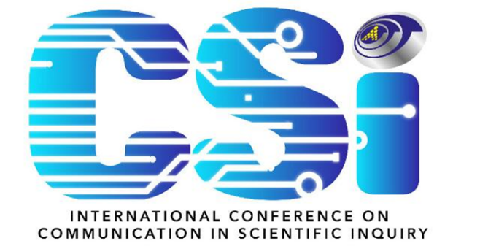

SCHEDULES OF
4th INTERNATIONAL CONFERENCE ON COMMUNICATION IN
SCIENTIFIC INQUIRY (CSI 2024)

Date | : | 03 – 04 December 2024
Time | : | 9:00am – 5:00pm
Venue | : | Borneo Cultures Museum, Kuching Sarawak

DAY 1 (03.12.2024)
8:30 am | : | Registration
9:00 am  –  9:30 am | : | Opening Speech  WAWASANKU  UMSU Song  UNIMAS Song  Welcoming speech (VC UniMAP)
Opening Speech (Dato’ Dr. Anderson)
Opening Gimmick & Book Launching
Cultural performance
Keynote Speech I
Keynote Speech II
Exchange of Souvenier
Photoshoot
11:00 am | : | Presentation of papers
1:00 pm | : | Lunch & Prayers
2:30 pm | : | Workshop registration
2:45 pm | : | Workshop (Parallel session)
5:00 pm | : | End of Day 1

DAY 2 (04.12.2024)
9:00 am | : | Registration
9:30 am | : | Presentation of papers
12:30 am | : | Closing ceremony
12:30 pm | : | Lunch & Prayers
2:30 pm | : | Walk-in workshop registration
2:45 pm | : | Workshop (Parallel session)
5:00 pm | : | Tea Break
5:00 pm | : | End of CSI 2024
Dress code | : | Corporate/ Batik
-------------------------------------------------------------------------------------------------------------

