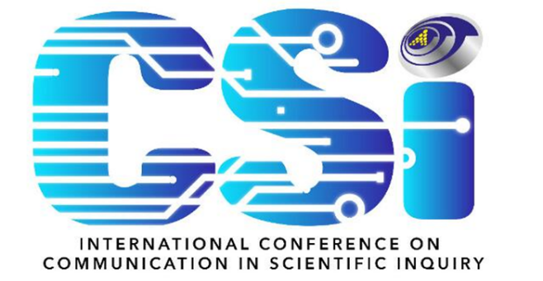

**SCHEDULES OF**

**4th INTERNATIONAL CONFERENCE ON COMMUNICATION IN**

**SCIENTIFIC INQUIRY (CSI 2024)**

|  |  |  |
| --- | --- | --- |
| Date | : | 03 – 04 December 2024 |
| Time | : | 9:00am – 5:00pm |
| Venue | : | Borneo Cultures Museum, Kuching Sarawak |

|  |  |  |
| --- | --- | --- |
| **DAY 1 (03.12.2024)** | | |
| 8:30 am | : | Registration |
|  |  |  |
| 9:00 am  –  9:30 am | : | **Opening Speech**  WAWASANKU  UMSU Song  UNIMAS Song  Welcoming speech (VC UniMAP) |
|  |  | **Opening Speech** (Dato’ Dr. Anderson)  Opening Gimmick & Book Launching  Cultural performance  Keynote Speech I  Keynote Speech II  Exchange of Souvenier  Photoshoot |
| 11:00 am | : | Presentation of papers |
| 1:00 pm | : | Lunch & Prayers |
| 2:30 pm | : | Workshop registration |
| 2:45 pm | : | Workshop (Parallel session) |
| 5:00 pm | : | End of Day 1 |

|  |  |  |
| --- | --- | --- |
| **DAY 2 (04.12.2024)** | | |
| 9:00 am | : | Registration |
| 9:30 am | : | Presentation of papers |
| 12:30 am | : | Closing ceremony |
| 12:30 pm | : | Lunch & Prayers |
| 2:30 pm | : | Walk-in workshop registration |
| 2:45 pm | : | Workshop (Parallel session) |
| 5:00 pm | : | Tea Break |
| 5:00 pm | : | End of CSI 2024 |
|  |  |  |
| Dress code | : | Corporate/ Batik |

-------------------------------------------------------------------------------------------------------------