Overall Patent Analysis Research Report

Generated on: 2025-09-27 02:52:39

# Executive Summary

|  |  |  |
| --- | --- | --- |
| Metric | Value | Description |
| Total Applications | 9515 | Total patent applications analyzed |
| Total Grants | 5341 | Total granted patents |
| Overall Grant Rate | 56.1% | Percentage of applications granted |

# Key Insights

## Overall Patent Grant Efficiency

The overall grant rate for patents is 56.1%, indicating moderate conversion efficiency from application to grant.

## Technology Concentration Analysis

The technology landscape shows moderately concentrated distribution (HHI: 1857), with certain IPC sections dominating the patent landscape.

## Recent Growth Patterns

Recent years show an average annual growth rate of 6.3% in patent applications, indicating increasing innovation activity.

## Industry Concentration Analysis

The industry distribution shows diversified concentration (HHI: 161), with Computer Programming, Consultancy And Related Activities leading in patent activity.

## Geographical Leadership in Patent Grants

IN leads in patent grants with 5,330 granted patents, representing the most active country in successful patent outcomes.

# Visualizations

## Trend Analysis

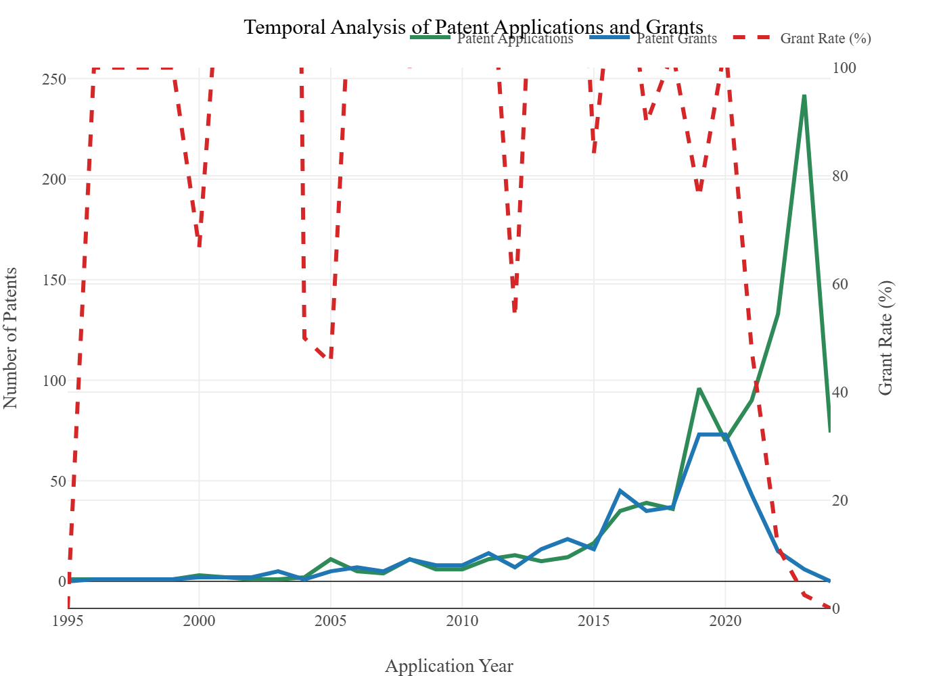

## Technology Landscape

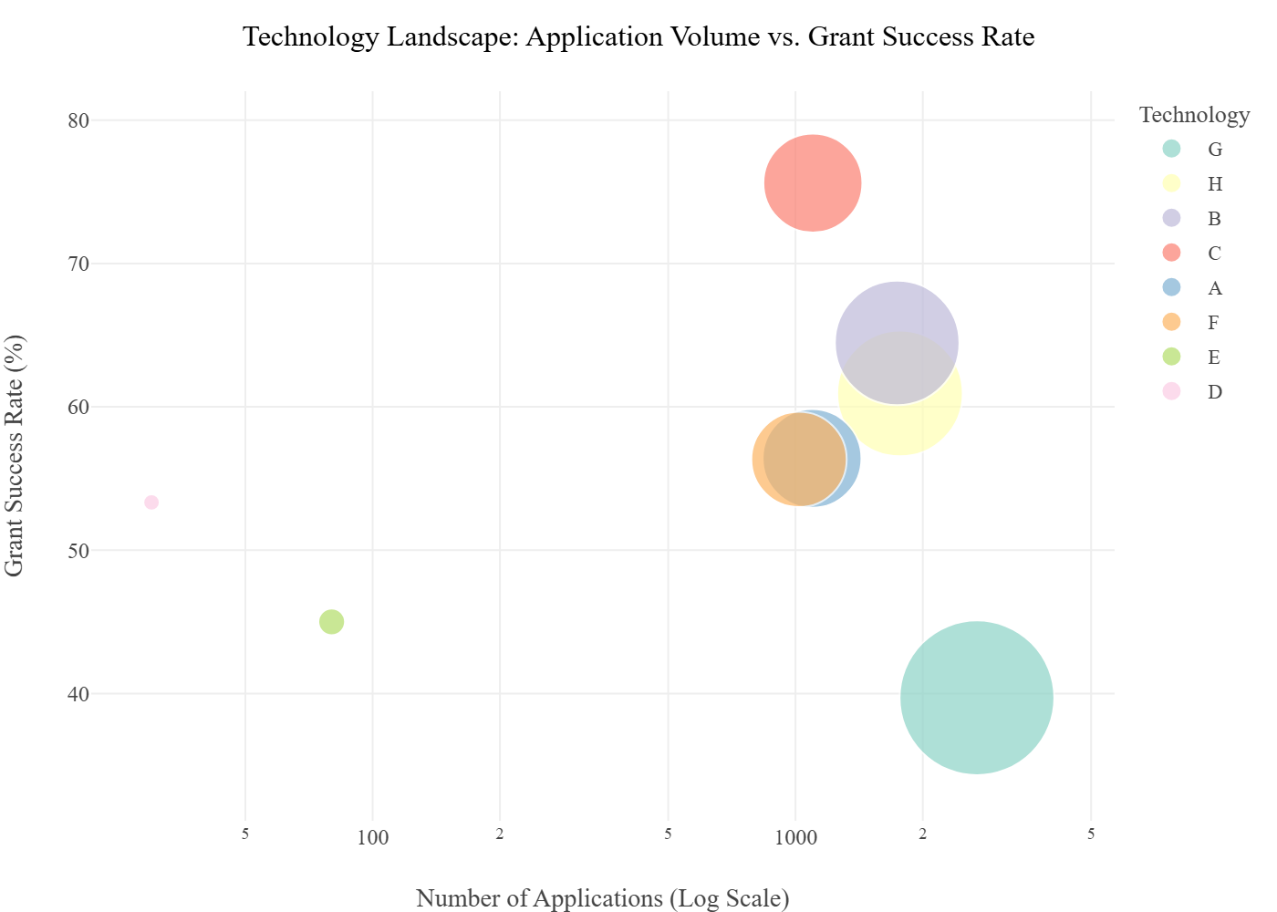

## Ipc Sunburst

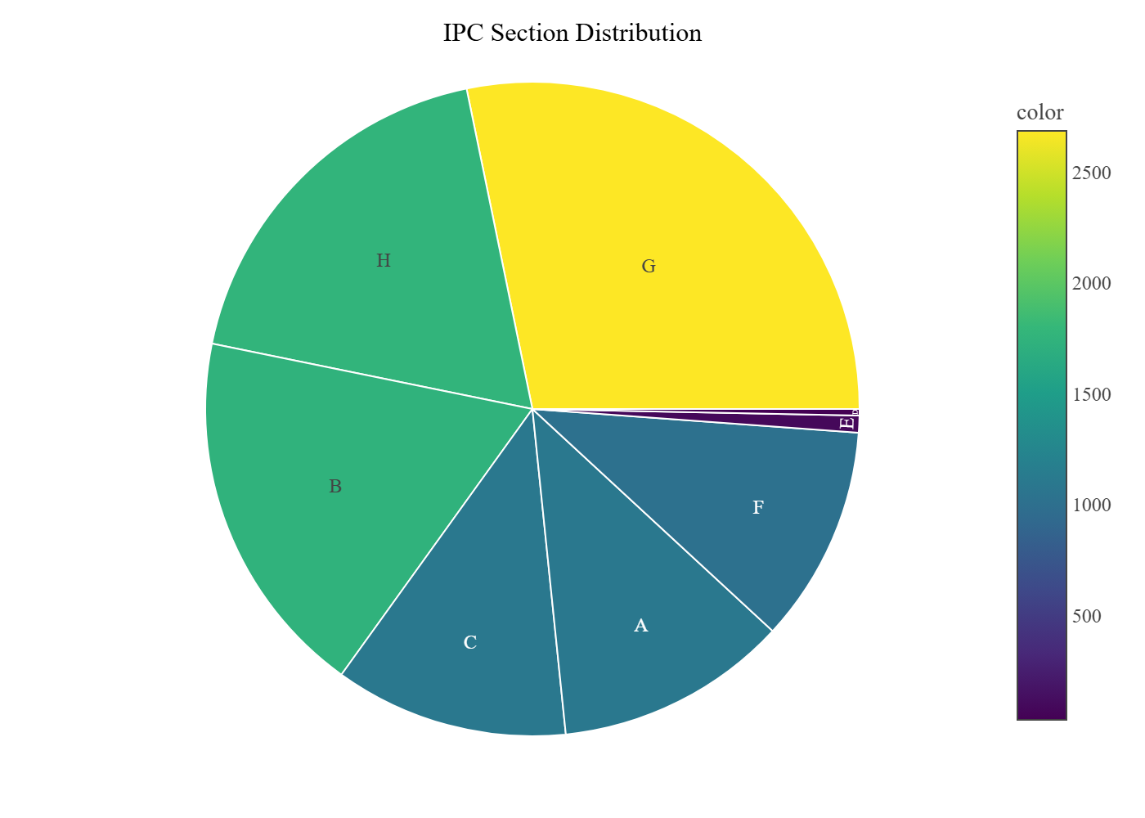

## Ipc Treemap

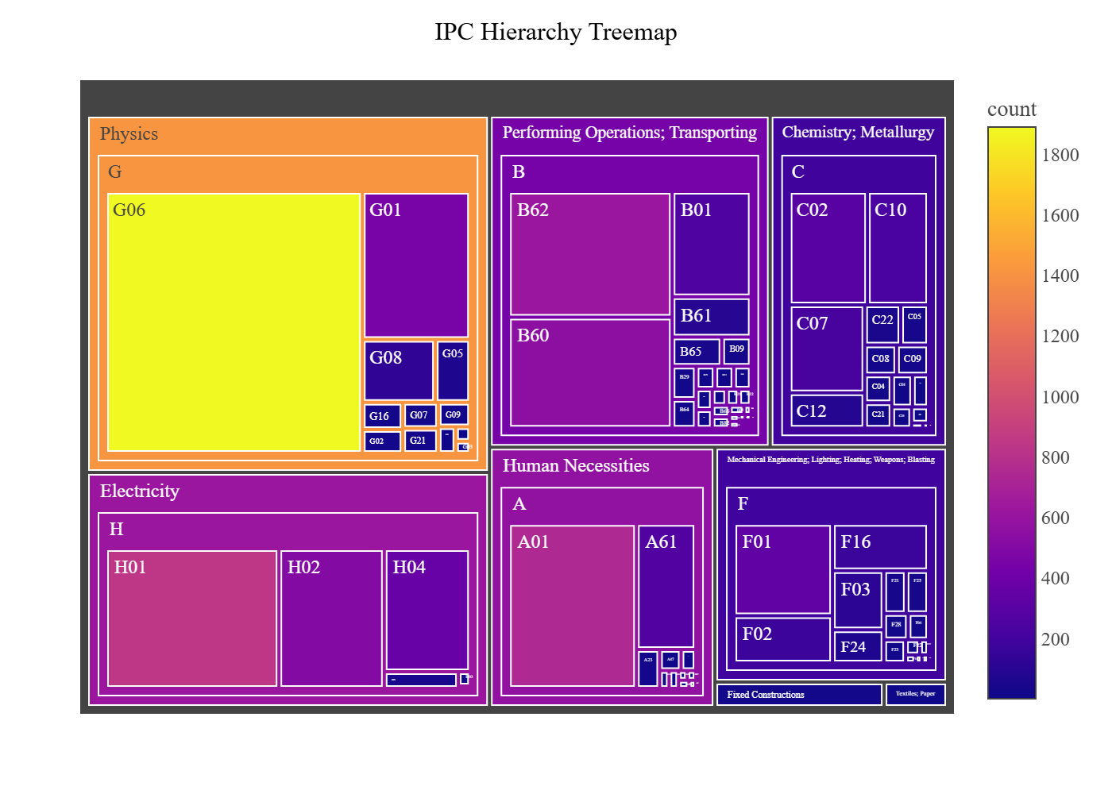

## Sankey Flow

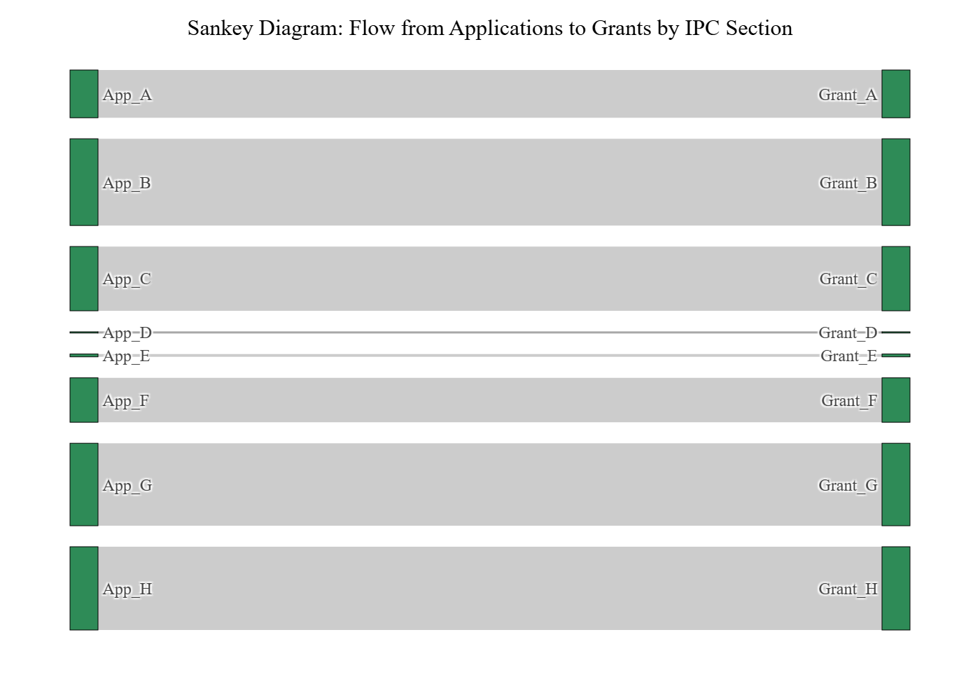

## Radar Comparison

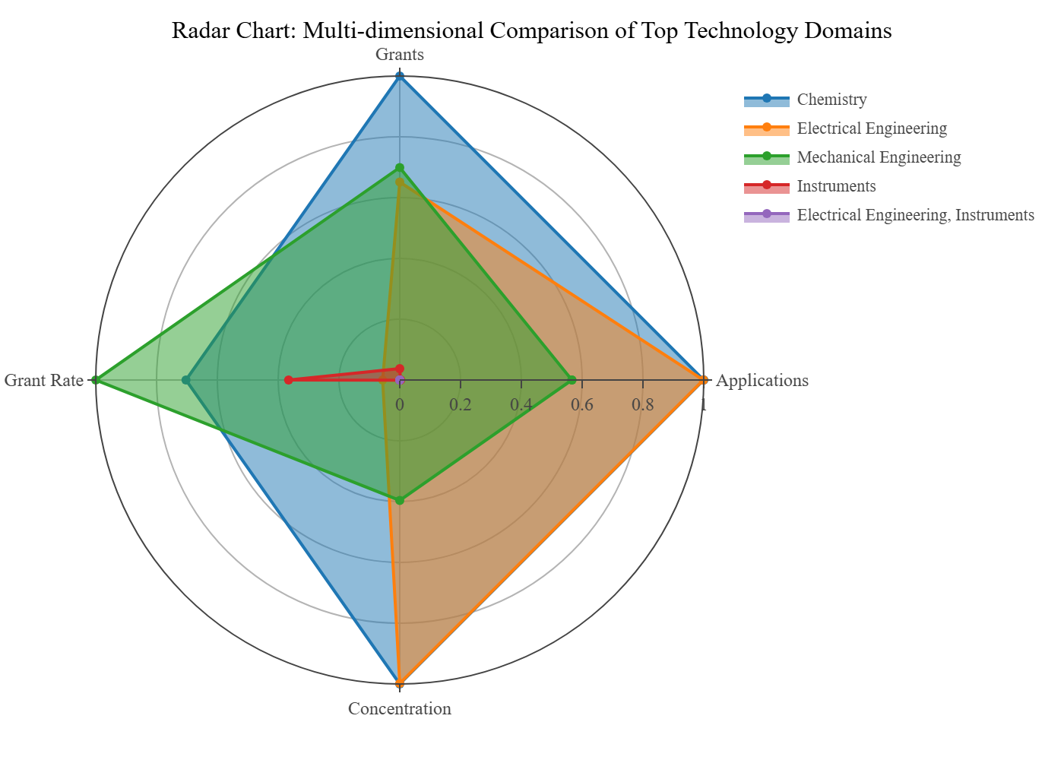

Visualization 'network_graph' not available.

## Tech Hierarchy Sunburst

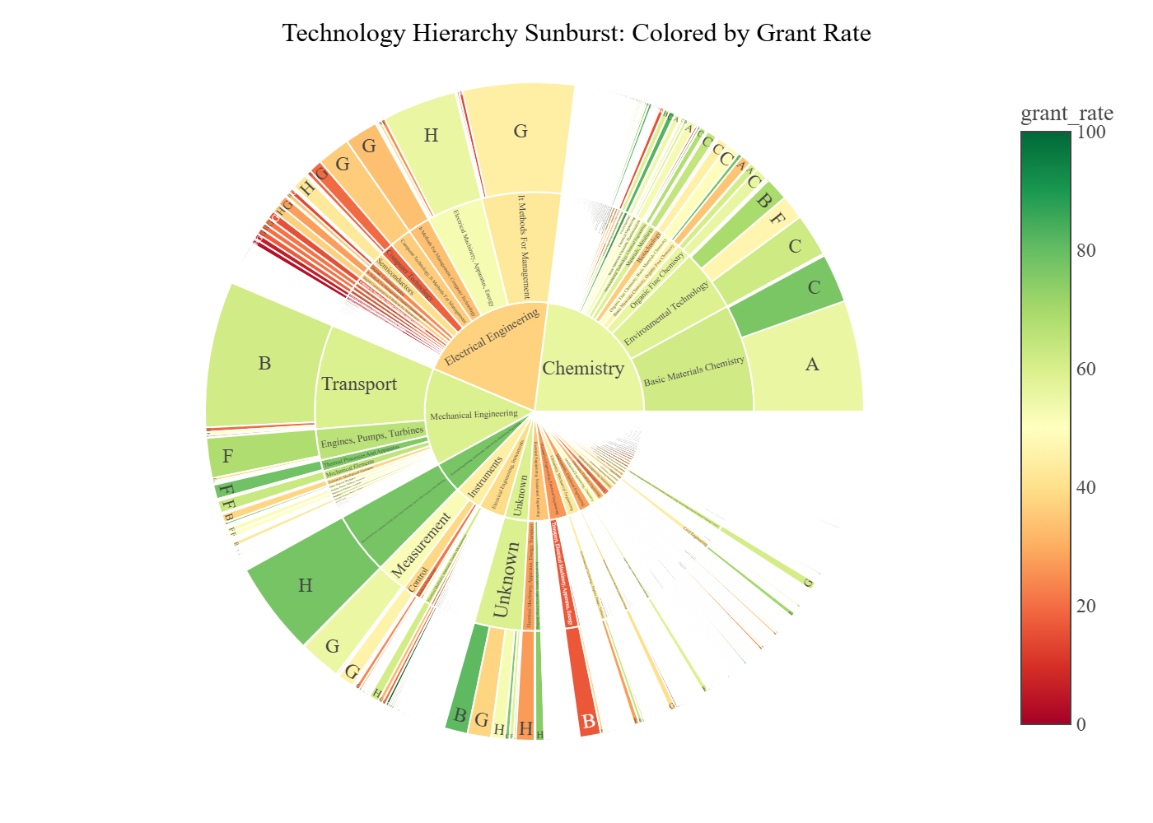

## World Choropleth

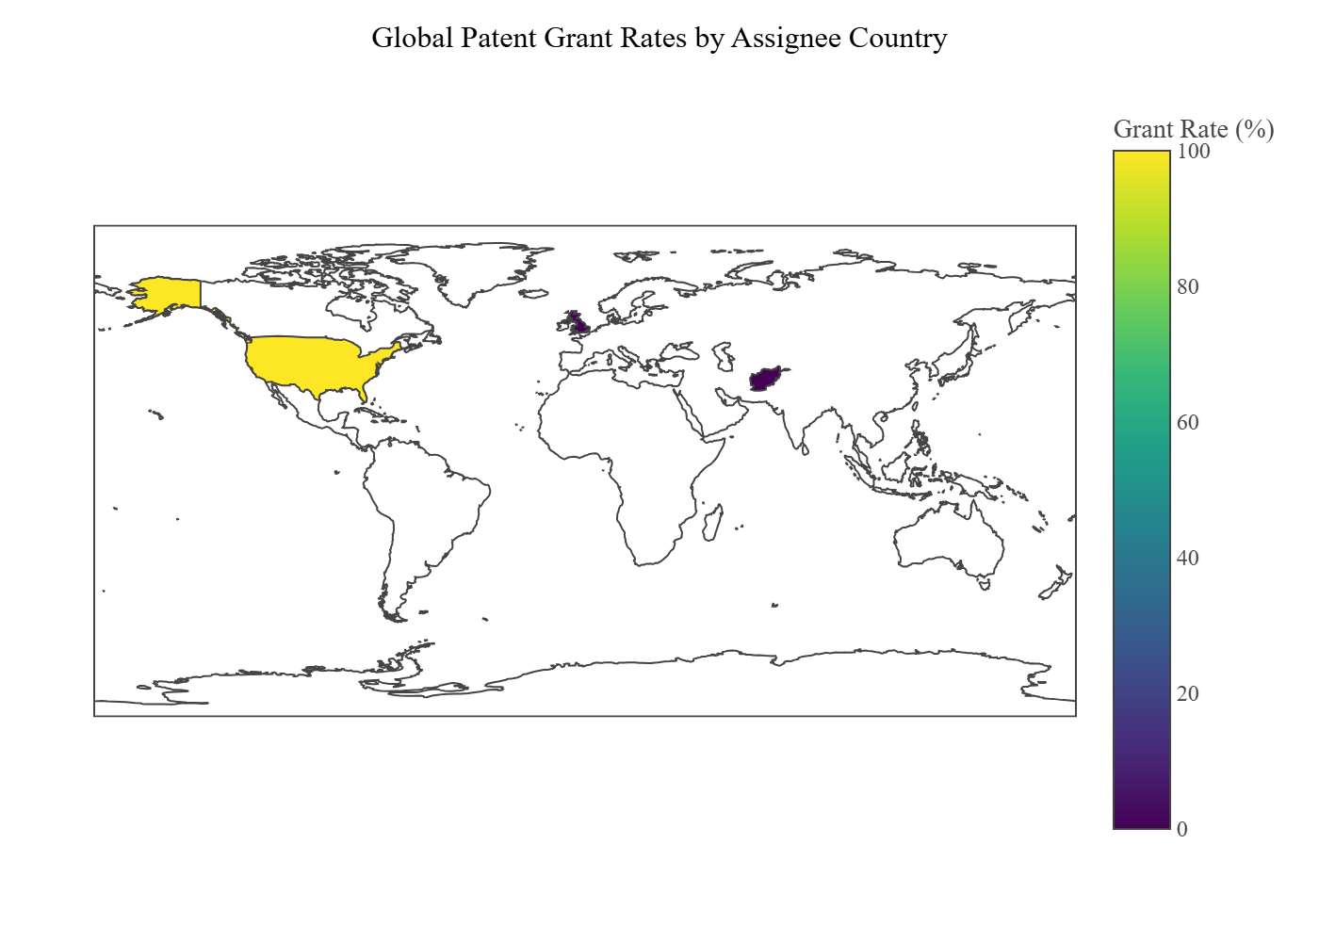

Visualization 'india_choropleth' not available.

Visualization 'india_technology_choropleth' not available.

Visualization 'india_industry_choropleth' not available.

## Industry Treemap

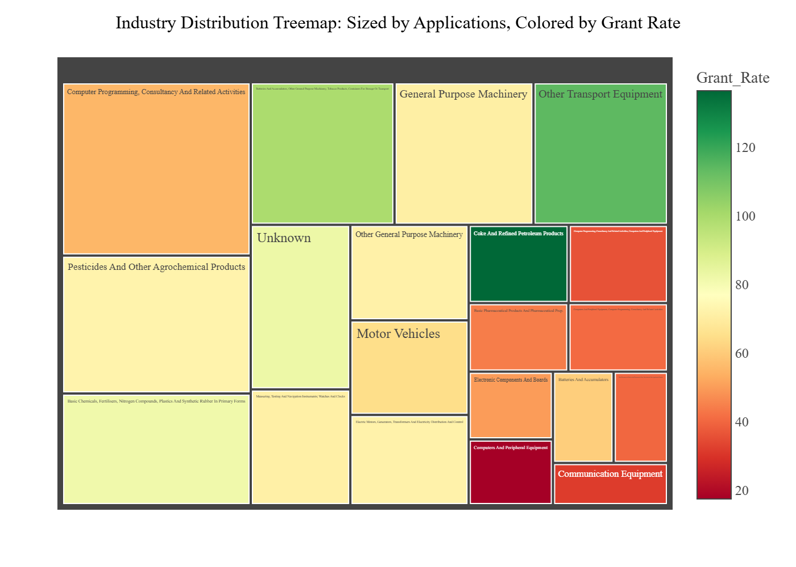

## Industry Sankey

