**VISVESVARAYA TECHNOLOGICAL UNIVERSITY**

**“JnanaSangama”, Belgaum -590014, Karnataka.**



**LAB REPORT**

**on**

**COMPILER DESIGN**

***Submitted by***

**AISHWARYA A G (1BM21CS011)**

***Under the Guidance of***

|  |  |
| --- | --- |
| **Prof. Sunayana S**  **Assistant Professor, BMSCE** |  |

***in partial fulfillment for the award of the degree of***

**BACHELOR OF ENGINEERING**

***in***

**COMPUTER SCIENCE AND ENGINEERING**



**B.M.S. COLLEGE OF ENGINEERING**

**(Autonomous Institution under VTU)**

**BENGALURU-560019**

**November-2023 to March-2024**

**B. M. S. College of Engineering,**

**Bull Temple Road, Bangalore 560019**

(Affiliated To Visvesvaraya Technological University, Belgaum)

**Department of Computer Science and Engineering**



**CERTIFICATE**

This is to certify that the Lab work entitled “**COMPILER DESIGN**” carried out by **AISHWARYA A G (1BM21CS011),** who is bonafide student of **B.M.S. College of Engineering.** It is in partial fulfillment for the award of **Bachelor of Engineering in Computer Science and Engineering** of the Visvesvaraya Technological University, Belgaum during the academic semester November-2023 to March-2024. The Lab report has been approved as it satisfies the academic requirements in respect of a COMPILER DESIGN **(22CS5PCCPD)** work prescribed for the said degree.

Prof. Lohith J J            Dr. Jyothi S Nayak

Assistant Professor Professor and Head

Department of CSE Department of CSE

BMSCE, Bengaluru BMSCE, Bengaluru

**B. M. S. COLLEGE OF ENGINEERING**

**DEPARTMENT OF COMPUTER SCIENCE AND ENGINEERING**



***DECLARATION***

I, AISHWARYA(1BM21CS011), student of 5th Semester, B.E, Department of Computer Science and Engineering, B. M. S. College of Engineering, Bangalore, here by declare that, this lab report entitled " **Compiler Design**" has been carried out by me under the guidance of Prof. Sunayana S, Assistant Professor, Department of CSE, B. M. S. College of Engineering, Bangalore during the academic semester November-2023-February-2024.

I also declare that to the best of my knowledge and belief, the development reported here is not from part of any other report by any other students.

**Index Sheet**

|  |  |  |
| --- | --- | --- |
| **C** | **Program Details** | **Page No.** |
|  | **Part-A: Implementation of Lexical Analyzer, By using C/C++/Java/Python language and using LEX tool.** |  |
| 1 | Write a program to design Lexical Analyzer in C/C++/Java/Python Language (to recognize any five keywords, identifiers, numbers, operators and punctuations) | 6-11 |
| 2 | Write a program in LEX to recognize Floating Point Numbers. | 11-12 |
| 3 | Write a program in LEX to recognize different tokens: Keywords, Identifiers, Constants, Operators and Punctuation symbols. | 12-13 |
| 4 | Write a LEX program that copies a file, replacing each nonempty sequence of white spaces by a single blank. | 14-25 |
| 5 | Write a LEX program to recognize the following tokens over the alphabets {0,1,..,9} a) The set of all string ending in 00. b) The set of all strings with three consecutive 222’s. c) The set of all string such that every block of five consecutive symbols contains at least two 5’s. d) The set of all strings beginning with a 1 which, interpreted as the binary representation of an integer, is congruent to zero modulo 5. e) The set of all strings such that the 10th symbol from the right end is 1. f) The set of all four digits numbers whose sum is 9 g) The set of all four digital numbers, whose individual digits are in ascending order from left to right. | 15-19 |
|  | **Part-B: Part-B: Implementation of Parsers (Syntax Analyzers) Using C/C++/Java/Python language)** |  |
| 1 | Write a program to implement (a) Recursive Descent Parsing with back tracking (Brute Force Method). S→ cAd , A →ab /a | 19-23 |
|  | **Part-C: Syntax Directed Translation using YACC tool** |  |
| 1 | Design a suitable grammar for evaluation of arithmetic expression having + and – operators. + has least priority and it is left associative - has higher priority and is right associative | 23-25 |
| 2 | Use YACC to implement, evaluator for arithmetic expressions (Desktop calculator). | 25-28 |
| 3 | Use YACC to generate Syntax tree for a given expression. | 29-32 |
| 4 | Use YACC to convert: Infix expression to Postfix expression. | 32-34 |
| 5 | Use YACC to generate 3-Address code for a given expression | 34-37 |

**Course Outcome**

|  |  |
| --- | --- |
| CO1 | Apply the fundamental concepts for the various phases of compiler design. |
| CO2 | Analyze the syntax and semantic concepts of a compiler. |
| CO3 | Design various types of parsers and Address code generation |
| CO4 | Implement compiler principles, methodologies using lex, yacc tools |

**Part-A: Implementation of Lexical Analyzer, By using C/C++/Java/Python language and using LEX tool.**

**Q1) Write a program to design Lexical Analyzer in C/C++/Java/Python Language (to recognize any five keywords, identifiers, numbers, operators and punctuations)**

CODE :

#include <stdbool.h>

#include <stdio.h>

#include <string.h>

#include <stdlib.h>

bool isDelimiter(char ch)

{

if (ch == ' ' || ch == '+' || ch == '-' || ch == '*' ||

ch == '/' || ch == ',' || ch == ';' || ch == '>' ||

ch == '<' || ch == '=' || ch == '(' || ch == ')' ||

ch == '[' || ch == ']' || ch == '{' || ch == '}')

return (true);

return (false);

}

bool isOperator(char ch)

{

if (ch == '+' || ch == '-' || ch == '*' ||

ch == '/' || ch == '>' || ch == '<' ||

ch == '=')

return (true);

return (false);

}

bool validIdentifier(char* str)

{

if (str[0] == '0' || str[0] == '1' || str[0] == '2' ||

str[0] == '3' || str[0] == '4' || str[0] == '5' ||

str[0] == '6' || str[0] == '7' || str[0] == '8' ||

str[0] == '9' || isDelimiter(str[0]) == true)

return (false);

return (true);

}

bool isKeyword(char* str)

{

if (!strcmp(str, "if") || !strcmp(str, "else") ||

!strcmp(str, "while") || !strcmp(str, "do") ||

!strcmp(str, "break") ||

!strcmp(str, "continue") || !strcmp(str, "int")

|| !strcmp(str, "double") || !strcmp(str, "float")

|| !strcmp(str, "return") || !strcmp(str, "char")

|| !strcmp(str, "case") || !strcmp(str, "char")

|| !strcmp(str, "sizeof") || !strcmp(str, "long")

|| !strcmp(str, "short") || !strcmp(str, "typedef")

|| !strcmp(str, "switch") || !strcmp(str, "unsigned")

|| !strcmp(str, "void") || !strcmp(str, "static")

|| !strcmp(str, "struct") || !strcmp(str, "goto"))

return (true);

return (false);

}

bool isInteger(char* str)

{

int i, len = strlen(str);

if (len == 0)

return (false);

for (i = 0; i < len; i++) {

if (str[i] != '0' && str[i] != '1' && str[i] != '2'

&& str[i] != '3' && str[i] != '4' && str[i] != '5'

&& str[i] != '6' && str[i] != '7' && str[i] != '8'

&& str[i] != '9' || (str[i] == '-' && i > 0))

return (false);

}

return (true);

}

bool isRealNumber(char* str)

{

int i, len = strlen(str);

bool hasDecimal = false;

if (len == 0)

return (false);

for (i = 0; i < len; i++) {

if (str[i] != '0' && str[i] != '1' && str[i] != '2'

&& str[i] != '3' && str[i] != '4' && str[i] != '5'

&& str[i] != '6' && str[i] != '7' && str[i] != '8'

&& str[i] != '9' && str[i] != '.' ||

(str[i] == '-' && i > 0))

return (false);

if (str[i] == '.')

hasDecimal = true;

}

return (hasDecimal);

}

char* subString(char* str, int left, int right)

{

int i;

char* subStr = (char*)malloc(

sizeof(char) * (right - left + 2));

for (i = left; i <= right; i++)

subStr[i - left] = str[i];

subStr[right - left + 1] = '\0';

return (subStr);

}

void parse(char* str)

{

int left = 0, right = 0;

int len = strlen(str);

while (right <= len && left <= right) {

if (isDelimiter(str[right]) == false)

right++;

if (isDelimiter(str[right]) == true && left == right) {

if (isOperator(str[right]) == true)

printf("'%c' IS AN OPERATOR\n", str[right]);

right++;

left = right;

} else if (isDelimiter(str[right]) == true && left != right

|| (right == len && left != right)) {

char* subStr = subString(str, left, right - 1);

if (isKeyword(subStr) == true)

printf("'%s' IS A KEYWORD\n", subStr);

else if (isInteger(subStr) == true)

printf("'%s' IS AN INTEGER\n", subStr);

//else if (isRealNumber(subStr) == true)

//printf("'%s' IS A REAL NUMBER\n", subStr);

else if (validIdentifier(subStr) == true

&& isDelimiter(str[right - 1]) == false)

printf("'%s' IS A VALID IDENTIFIER\n", subStr);

else if (validIdentifier(subStr) == false

&& isDelimiter(str[right - 1]) == false)

printf("'%s' IS NOT A VALID IDENTIFIER\n", subStr);

left = right;

}

}

return;

}

int main()

{

// maximum length of string is 100 here

char str[100] = "int a = b + 1c; ";

parse(str); // calling the parse function

return (0);

}

OUTPUT:

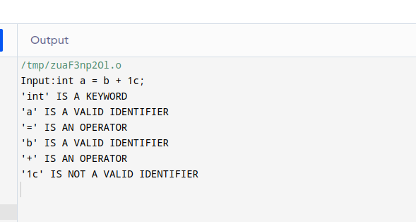

**Q2)Write a program in LEX to recognize Floating Point Numbers.**

CODE:

%{

#include<stdio.h>

%}

%%

[+|-]?[0-9]*[.][0-9]* {printf("%s is a floating-point number\n",yytext);}

.* {printf("%s is not a floating-point number\n",yytext);}

%%

int yywrap()

{

}

int main()

{

printf("Enter the string : ");

yylex();

return 0;

}

OUTPUT:

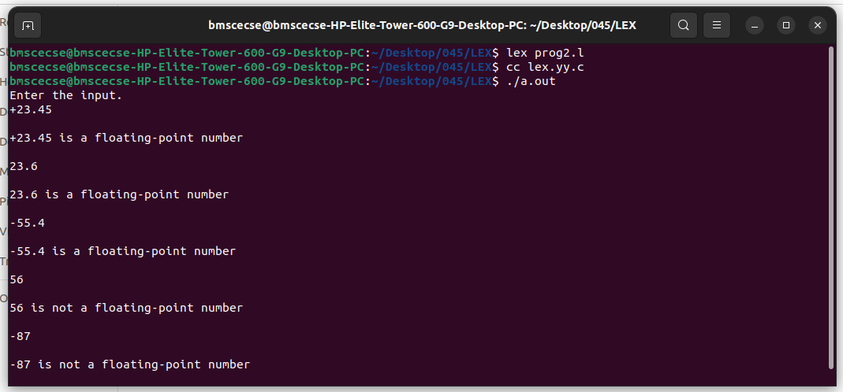

**Q3) Write a program in LEX to recognize different tokens: Keywords, Identifiers, Constants, Operators and Punctuation symbols.**

CODE:

%{

#include<stdio.h>

%}

%%

int|char|float|else|for|void|mainz\while {printf("%s is keyword\n",yytext);}

[a-zA-Z_][a-zA-Z0-9_]* {printf("%s is identifier\n",yytext);}

[0-9]* {printf("%s is a constant\n",yytext);}

[+*^%/<>&=()|]* {printf("%s is operator\n",yytext);}

[?|,.'";:]* {printf("%s is punctuation\n",yytext);}

%%

int yywrap()

{

}

int main()

{

printf("Enter input\n");

yylex();

return 0;

}

OUTPUT:

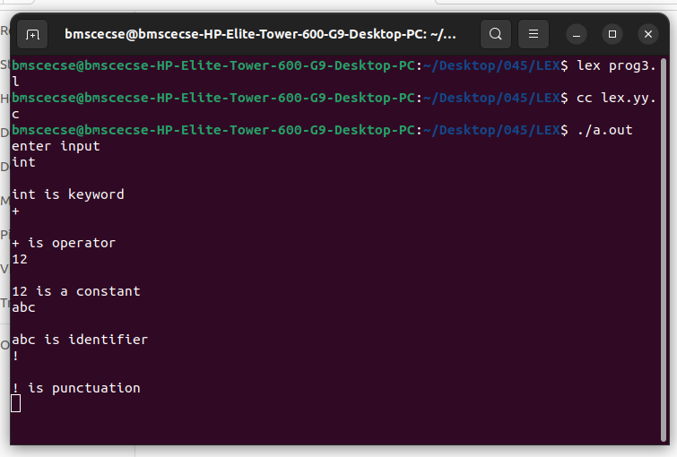

**Q4) Write a LEX program that copies a file, replacing each nonempty sequence of white spaces by a single blank.**

CODE:

/*Definition Section*/

%{

#include<stdio.h>

%}

%%

[\t" "]+ fprintf(yyout," ");

.|\n fprintf(yyout,"%s",yytext);

%%

int yywrap()

{

return 1;

}

int main(void)

{

yyin=fopen("input.txt","r");

yyout=fopen("output.txt","w");

yylex();

return 0;

}

OUTPUT:

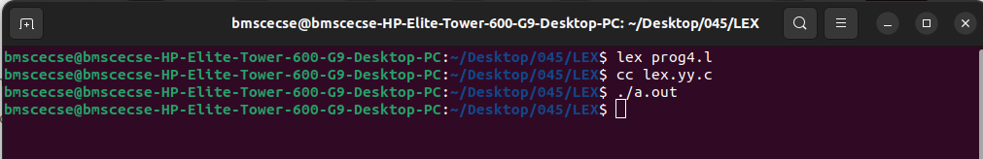

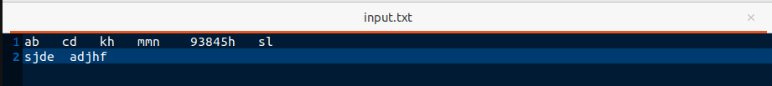

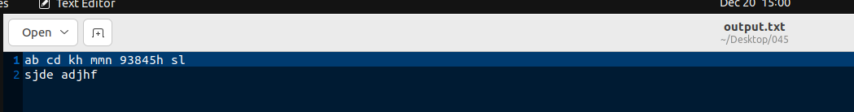

**Q5) Write a LEX program to recognize the following tokens over the alphabets {0,1,..,9}**

**a) The set of all string ending in 00.**

**b) The set of all strings with three consecutive 222’s.**

**c) The set of all string such that every block of five consecutive symbols contains at least two 5’s.**

**d) The set of all strings beginning with a 1 which, interpreted as the binary representation of an integer, is congruent to zero modulo 5.**

**e) The set of all strings such that the 10th symbol from the right end is 1.**

**f) The set of all four digits numbers whose sum is 9**

**g) The set of all four digital numbers, whose individual digits are in ascending order from left to right.**

CODE:

{

int c1=0,c2=0,c3=0,c4=0,c5=0,c6=0,c7=0;

%}

d[0-9]

%%

({d})*00 {

c1++; printf("%s rule A\n",yytext);

}

({d})*222({d})* {

c2++;

printf("%s rule B \n",yytext);

}

(1(0)*(11|01)(01*01|00*10(0)*(11|1))*0)(1|10(0)*(11|01)(01*01|00*10(0)*(11|1))*10)* {

c4++;

printf("%s rule D \n",yytext);

}

({d})*1{d}{9} {

c5++;

printf("%s rule E \n",yytext);

}

{d}{4} {

int sum=0,i;

for(i=0;i<4;i++) {

sum=sum+yytext[i]-48; }

if(sum==9) { c6++; printf("%s rule F \n",yytext);

}

else

{

sum=1;

for(i=0;i<3;i++){

if(yytext[i]>yytext[i+1]) { sum=0;

break;

}

}

if(sum==1) {

c7++;

printf("%s rule G\n",yytext);

}

else { printf("%s doesn't match any rule\n",yytext); }

}

}

({d})* {

int i,c=0;

if(yyleng<5) { printf("%s doesn't match any rule\n",yytext); }

else

{

for(i=0;i<5;i++) { if(yytext[i]=='5') {

c++; } }

if(c>=2)

{

for(;i<yyleng;i++)

{

if(yytext[i-5]=='5') { c--; }

if(yytext[i]=='5') { c++;

}

if(c<2) { printf("%s doesn't match any rule\n",yytext); break; }

}

if(yyleng==i) { printf("%s rule C\n",yytext); c3++; }

}

else

{

printf("%s doesn't match any rule\n",yytext);

}

}

}

\n {

printf("Total number of tokens matching rules are : \n");

printf("Rule A : %d \n",c1);

printf("Rule B : %d \n",c2);

printf("Rule C : %d \n",c3);

printf("Rule D : %d \n",c4);

printf("Rule E : %d \n",c5);

printf("Rule F : %d \n",c6);

printf("Rule G : %d \n",c7);

}

%%

int yywrap()

{

}

int main()

{

printf("Enter text\n");

yylex();

return 0;

}

OUTPUT:

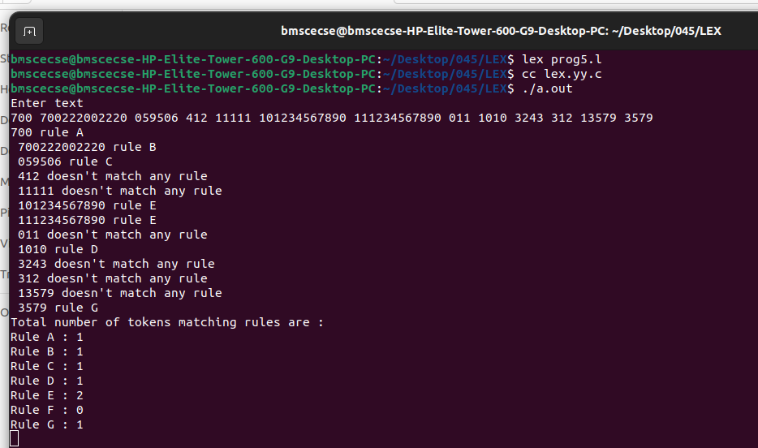

**Part-B: Part-B: Implementation of Parsers (Syntax Analyzers) Using C/C++/Java/Python language)**

**Q1) Write a program to implement (a) Recursive Descent Parsing with back tracking (Brute Force Method). S→ cAd , A →ab /a**

**CODE:**

#include<stdio.h>

#include<string.h>

int A();

void parse();

char str[15];

int isave,curr_ptr=0;

int c=1;

int main(void)

{

printf("1.S->cAd\n2.A->ab/a\n");

printf("Enter any string:");

scanf("%s",str);

while(curr_ptr<strlen(str))

{

if (str[curr_ptr]=='c')

{

curr_ptr++;

if (A())

{

curr_ptr++;

if (str[curr_ptr]=='d' && str[curr_ptr+1]=='\0')

{

printf("String is accepted by the grammar\n");

parse();

return 1;

}

else break;

}

else break;

}

else break;

}

printf("String is not accepted by the grammar");

return 0;

}

int A()

{

isave=curr_ptr;

if (str[curr_ptr]=='a')

{

curr_ptr++;

if(str[curr_ptr]=='b')

{

c=1;

return 1;

}

}

curr_ptr=isave; //return to start

if(str[curr_ptr]=='a')

{

c=2;

return 1;

}

else

return 0;

}

void parse(){

printf("The productions used are \n");

printf("S -> cAd\n");

if(c==1)

printf("A -> ab\n");

else

printf("A -> a\n");

}

OUTPUT:

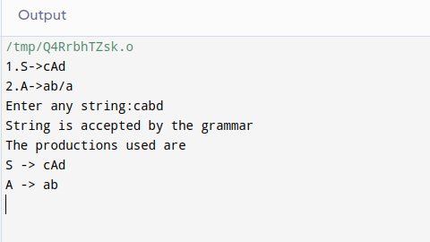

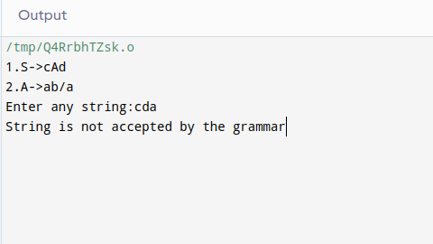

**PART-C :Syntax Directed Translation using YACC tool**

**Q1) Design a suitable grammar for evaluation of arithmetic expression having + and – operators. + has least priority and it is left associative - has higher priority and is right associative**

prog.l

%{

#include "y.tab.h"

%}

%%

[0-9]+ {yylval = atoi(yytext);

return NUM;}

[\t] ;

\n return 0;

. return yytext[0];

%%

int yywrap()

{

}

prog.y

%{

/* Definition section */

#include <stdio.h>

%}

%token NUM

%left '+'

%right '-'

/* Rule Section */

%%

expr:e {printf("Valid expression\n");

printf("Result : %d\n",$$);

return 0;}

e: e'+'e {$$=$1+$3;}

| e'-'e {$$=$1-$3;}

| NUM {$$=$1;}

;

%%

int main(){

printf("\nEnter an arithmetic expression\n");

yyparse();

return 0;

}

int yyerror(){

printf("\nInvalid expression\n");

return 0;

}

OUTPUT:

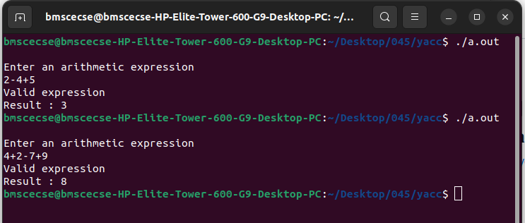

**Q2) Use YACC to implement, evaluator for arithmetic expressions (Desktop calculator) .**

prog.l

%{

/* Definition section */

#include<stdio.h>

#include "y.tab.h"

extern int yylval;

%}

/* Rule Section */

%%

[0-9]+ {

yylval=atoi(yytext);

return NUMBER;

}

[\t] ;

[\n] return 0;

. return yytext[0];

%%

int yywrap()

{

return 1;

}

prog.y

%{

/* Definition section */

#include<stdio.h>

int flag=0;

%}

%token NUMBER

%right '^'

%left '+' '-'

%left '*' '/' '%'

%left '(' ')'

/* Rule Section */

%%

expr:E {printf("Valid expression\n");

printf("Result : %d\n",$$);

return 0;}

E:E'+'E {$$=$1+$3;}

|E'-'E {$$=$1-$3;}

|E'*'E {$$=$1*$3;}

|E'/'E {$$=$1/$3;}

|E'%'E {$$=$1%$3;}

|E'^'E {$$=$1^$3;}

|'('E')' {$$=$2;}

| NUMBER {$$=$1;}

;

%%

//driver code

void main()

{

printf("\nEnter Any Arithmetic Expression:\n");

yyparse();

if(flag==0)

printf("\nEntered arithmetic expression is Valid\n\n");

}

void yyerror()

{

printf("\nEntered arithmetic expression is Invalid\n\n");

flag=1;

}

OUTPUT:

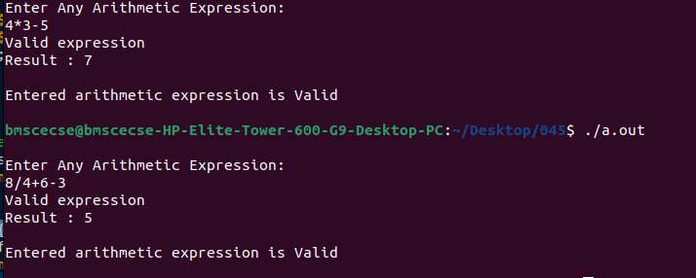

**Q3) Use YACC to generate Syntax tree for a given expression.**

prog.l

%{

#include "y.tab.h"

extern int yylval;

%}

%%

[0-9]+ { yylval = atoi(yytext);

return digit; }

[\t] ;

[\n] return 0;

. return yytext[0];

%%

int yywrap(){

}

prog.y

%{

#include <math.h>

#include<ctype.h>

#include<stdio.h>

#include<stdlib.h>

#include<string.h>

struct tree_node

{

char val[10];

int lc;

int rc;

};

int ind;

struct tree_node syn_tree[100];

void my_print_tree(int cur_ind);

int mknode(int lc,int rc,char val[10]);

%}

%token digit

%right '^'

%left '+' '-'

%left '*' '/' '%'

%%

S:E { my_print_tree($1); }

;

E:E'+'T { $$= mknode($1,$3,"+"); ; }

|T { $$=$1; }

;

E:E'-'T { $$= mknode($1,$3,"-"); ; }

|T { $$=$1; }

;

T:T'*'F { $$= mknode($1,$3,"*"); ; }

|F {$$=$1 ; }

;

T:T'/'F { $$= mknode($1,$3,"/"); ; }

|F {$$=$1 ; }

;

F:'('E')' { $$=$2; }

|digit {char buf[10]; printf(buf,"%d", yylval); $$ = mknode(-1,-1,buf);}

%%

int main()

{

ind=0;

printf("Enter an expression\n");

yyparse();

return 0;

}

int yyerror()

{

printf("NITW Error\n");

}

int mknode(int lc,int rc,char val[10])

{

strcpy(syn_tree[ind].val,val);

syn_tree[ind].lc = lc;

syn_tree[ind].rc = rc;

ind++;

return ind-1;

}

/*my_print_tree function to print the syntax tree in DLR fashion*/

void my_print_tree(int cur_ind)

{

if(cur_ind==-1) return;

if(syn_tree[cur_ind].lc==-1 && syn_tree[cur_ind].rc==-1)

printf("Digit Node -> Index : %d, Value : %s\n",cur_ind,syn_tree[cur_ind].val);

else

printf("Operator Node -> Index : %d, Value : %s, Left Child Index : %d,Right Child Index : %d\n",cur_ind,syn_tree[cur_ind].val, syn_tree[cur_ind].lc,syn_tree[cur_ind].rc);

my_print_tree(syn_tree[cur_ind].lc);

my_print_tree(syn_tree[cur_ind].rc);

}

OUTPUT:

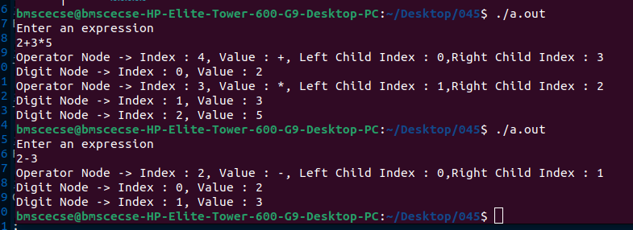

**Q4) Use YACC to convert: Infix expression to Postfix expression.**

prog.l

%{

#include "y.tab.h"

extern int yylval;

%}

%%

[0-9]+ { yylval=atoi(yytext); return digit;}

[\t] ;

[\n] return 0;

. return yytext[0];

%%

int yywrap()

{

}

prog.y

%{

#include <ctype.h>

#include<stdio.h>

#include<stdlib.h>

%}

%token digit

%right '^'

%left '+' '-'

%left '*' '/'

%%

S: E {printf("\n\n");}

;

E: E '+' T { printf ("+");}

| T

;

E: E '-' T { printf ("-");}

| T

;

T: T '*' F { printf("*");}

| F

;

T: T '/' F { printf("/");}

| F

;

F: F '^' G { printf("^");}

| G

;

G: '(' E ')'

| digit {printf("%d", $1);}

;

%%

int main()

{

printf("Enter infix expression: ");

yyparse();

}

yyerror()

{

printf("Error");

}

OUTPUT:

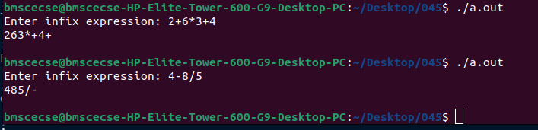

**Q5) Use YACC to generate 3-Address code for a given expression.**

prog.l

d [0-9]+

a [a-zA-Z]+

%{

#include<stdio.h>

#include<stdlib.h>

#include"y.tab.h"

extern int yylval;

extern char iden[20];

%}

%%

{d} { yylval=atoi(yytext); return digit; }

{a} { strcpy(iden,yytext); yylval=1; return id;}

[ \t] {;}

\n return 0;

. return yytext[0];

%%

int yywrap()

{

}

prog.y

%{

#include <math.h>

#include<ctype.h>

#include<stdio.h>

int var_cnt=0;

char iden[20];

%}

%token id

%token digit

%%

S:id '=' E { printf("%s=t%d\n",iden,var_cnt-1); }

E:E '+' T { $$=var_cnt; var_cnt++; printf("t%d = t%d + t%d;\n", $$, $1, $3 );

}

|E '-' T { $$=var_cnt; var_cnt++; printf("t%d = t%d - t%d;\n", $$, $1, $3 );

}

|T { $$=$1; }

;

T:T '*' F { $$=var_cnt; var_cnt++; printf("t%d = t%d * t%d;\n", $$, $1, $3 ); }

|T '/' F { $$=var_cnt; var_cnt++; printf("t%d = t%d / t%d;\n", $$, $1, $3 ); }

|F {$$=$1 ; }

F:P '^' F { $$=var_cnt; var_cnt++; printf("t%d = t%d ^ t%d;\n", $$, $1, $3 );}

| P { $$ = $1;}

;

P: '(' E ')' { $$=$2; }

|digit { $$=var_cnt; var_cnt++; printf("t%d = %d;\n",$$,$1); }

;

%%

int main()

{

var_cnt=0;

printf("Enter an expression : \n");

yyparse();

return 0;

}

yyerror()

{

printf("error");

}

OUTPUT:

