INTEGRATION TESTING

- Able to read 2 or more configuration file names as command line parameters:

AIU/IT – 01, REQ1.1

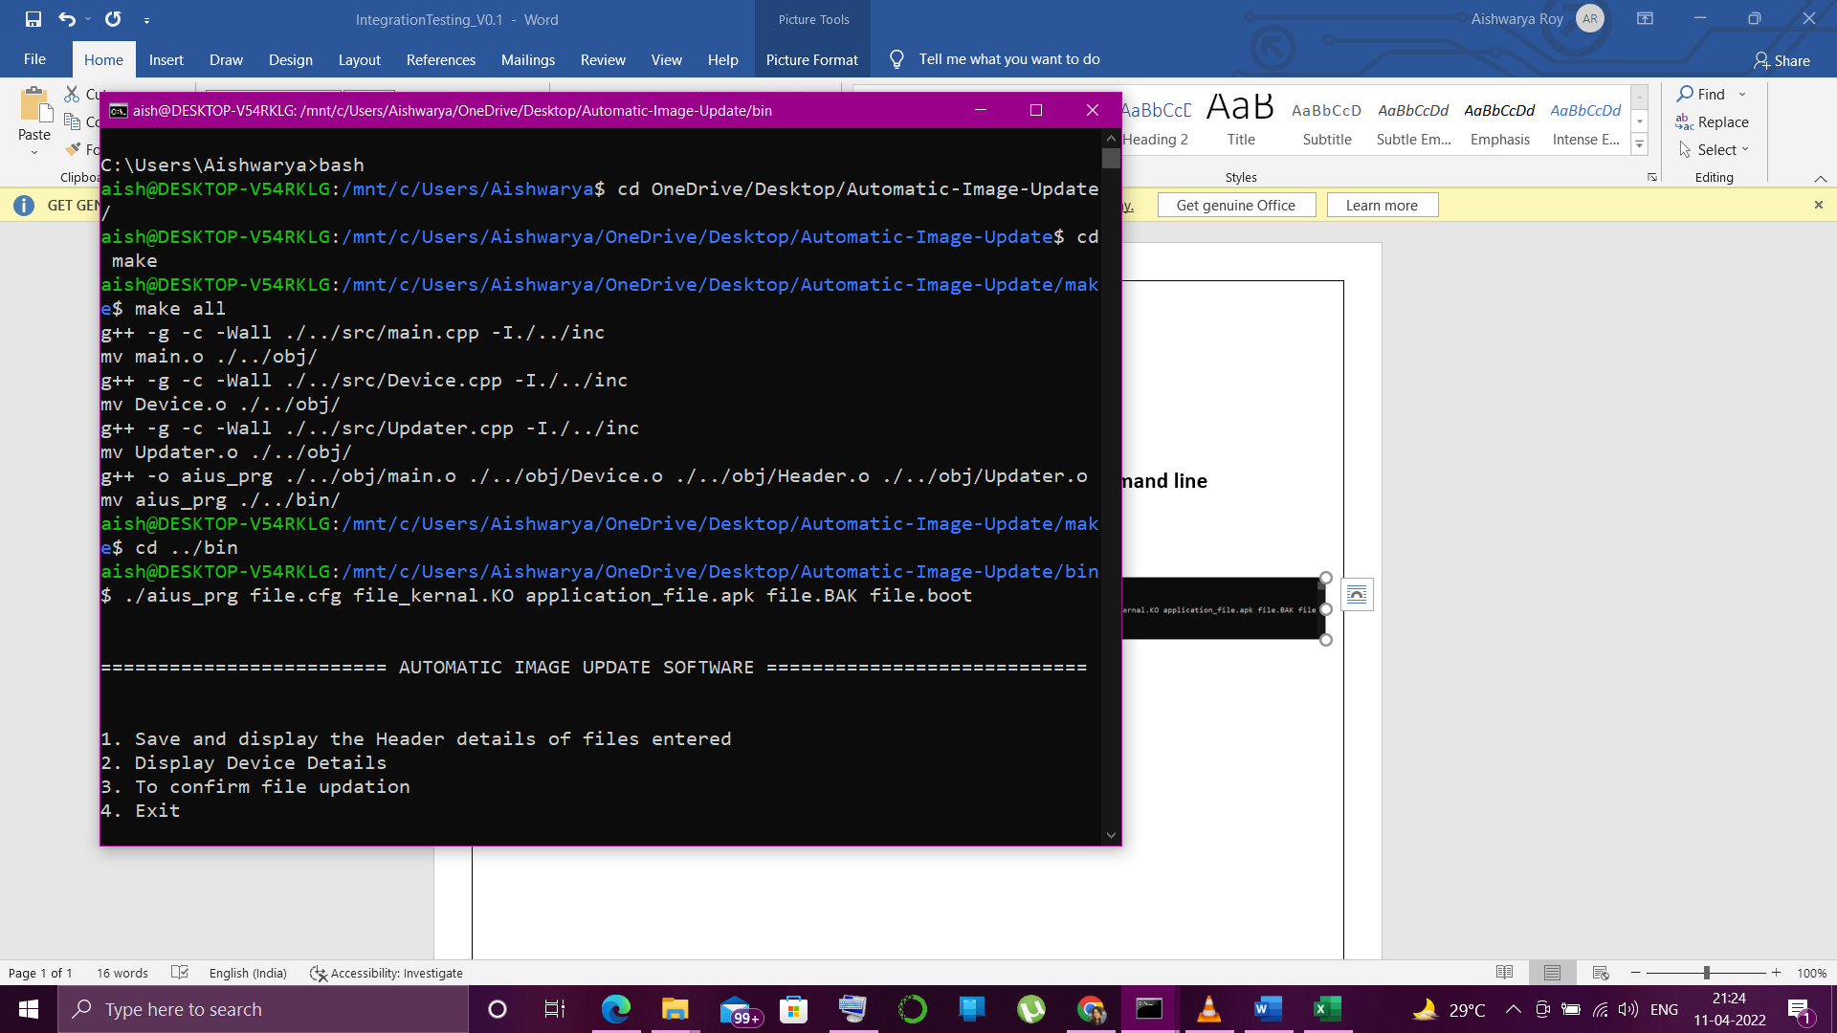

If less than 2 file names are passed it throws invalid_arguments exception and prints the message on the screen –
AIU/IT – 02, REQ 1.2
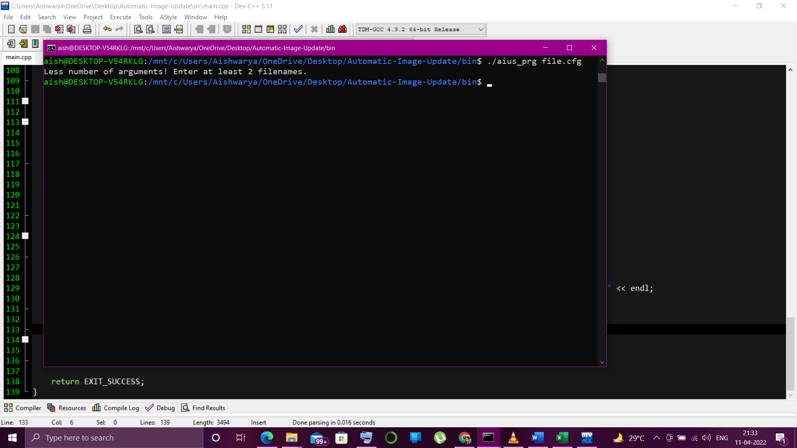
3) Source files should get picked from default path -- REQ2
Source files are present in the bin folder where the .exe file is present
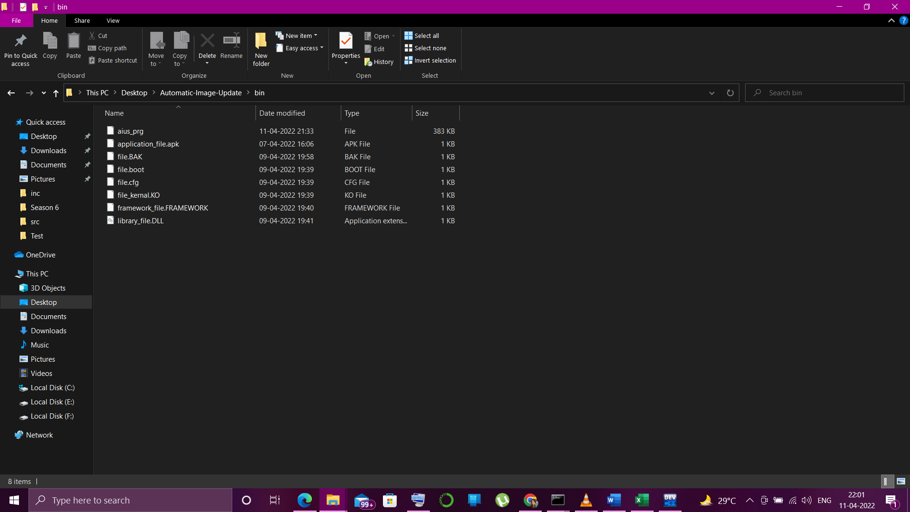
2) Each configuration file will consists of header and data.
Header:
Device Id: <Unique 6 Digit alphanumeric Id>
Magic No:<Unique Device specific 16 Digit number>
Device Name: <255 char device name>
Checksum:Checksum of suitable length to ensure data integrity
Base Address:
BOOT IMAGE:start_addr=<32 bit/64 w.r.t start address>, size=<size>, ver=<version string> ---- AIU/IT-03, REQ3
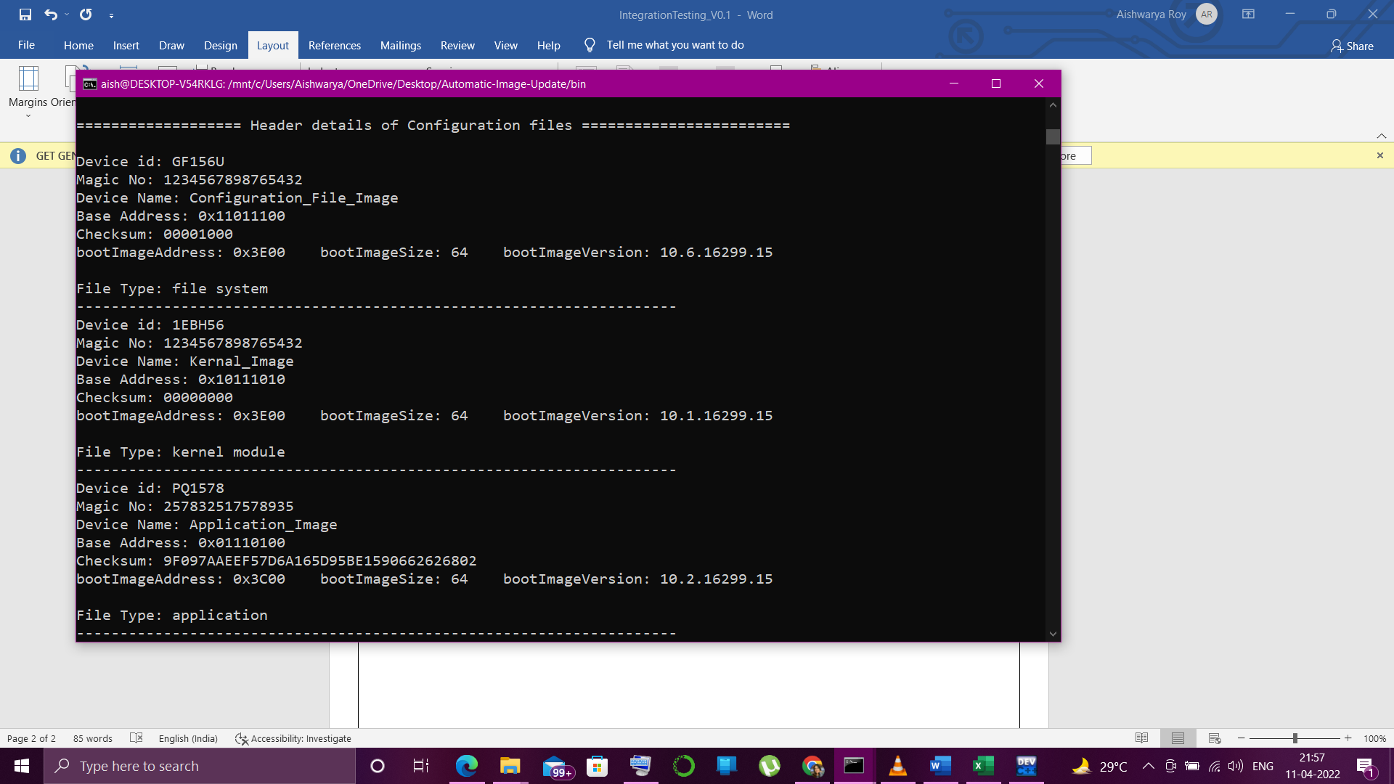

4) A memory mapped region to simulate Target device --- AIU/IT-04 , REQ4

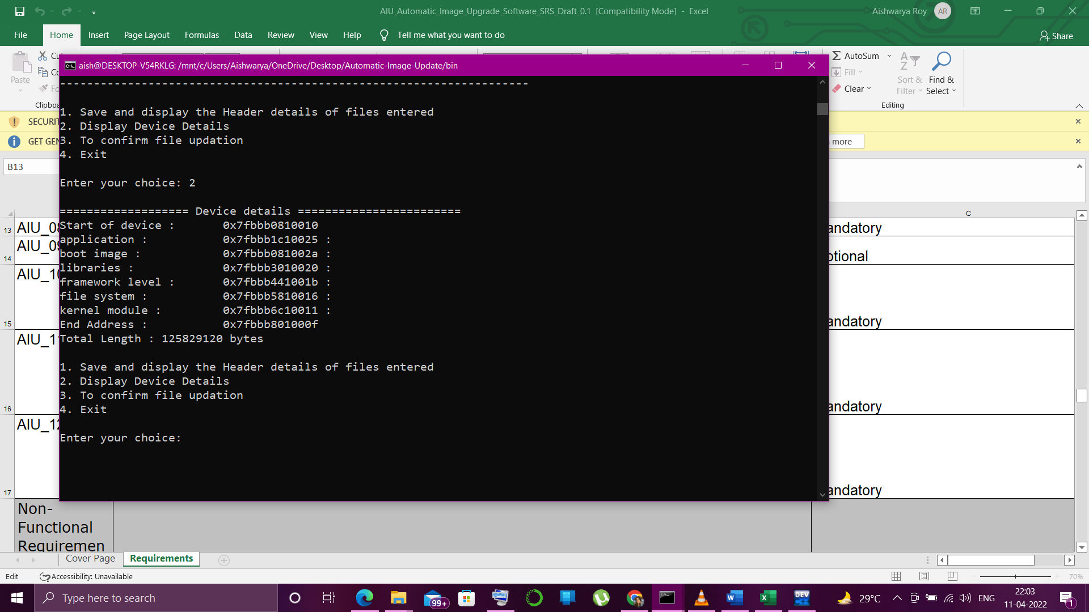

5) Should be able to query and get the current device information including details about all images
- Option to get the Header details of all configuration files -- -- AIU/IT-05, REQ5.1
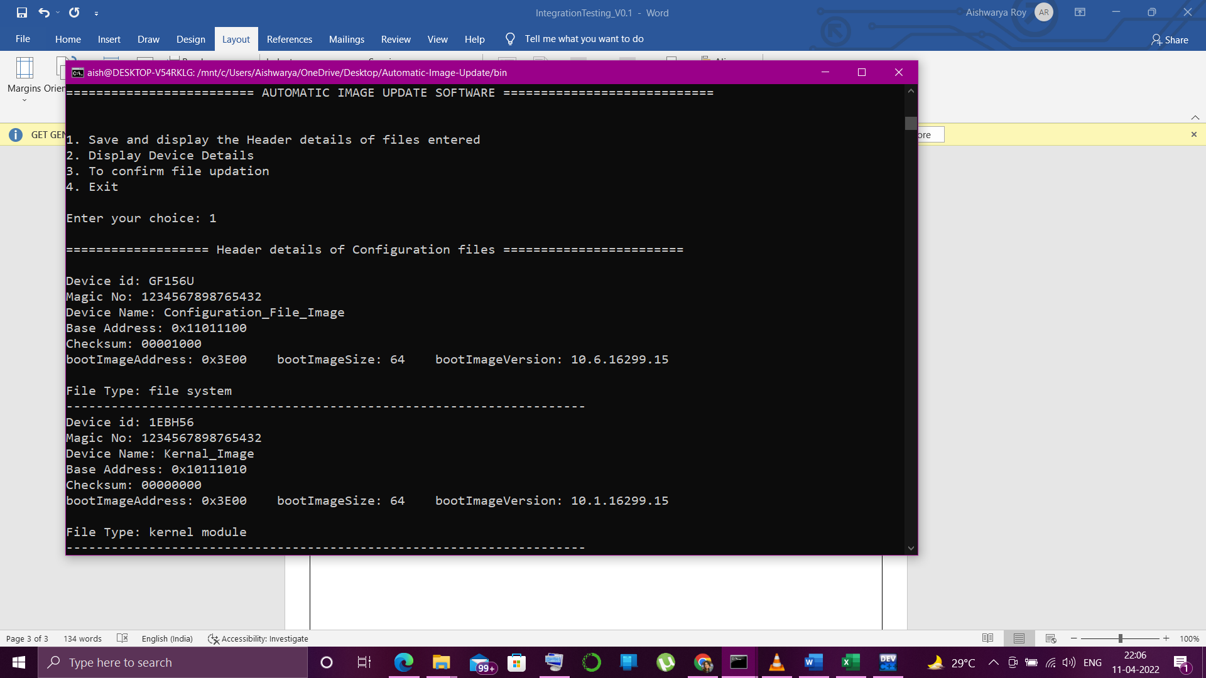
- Option to display Device details and its partition -- AIU/IT-06, REQ5.2


- Option to update the files --- REQ5.3

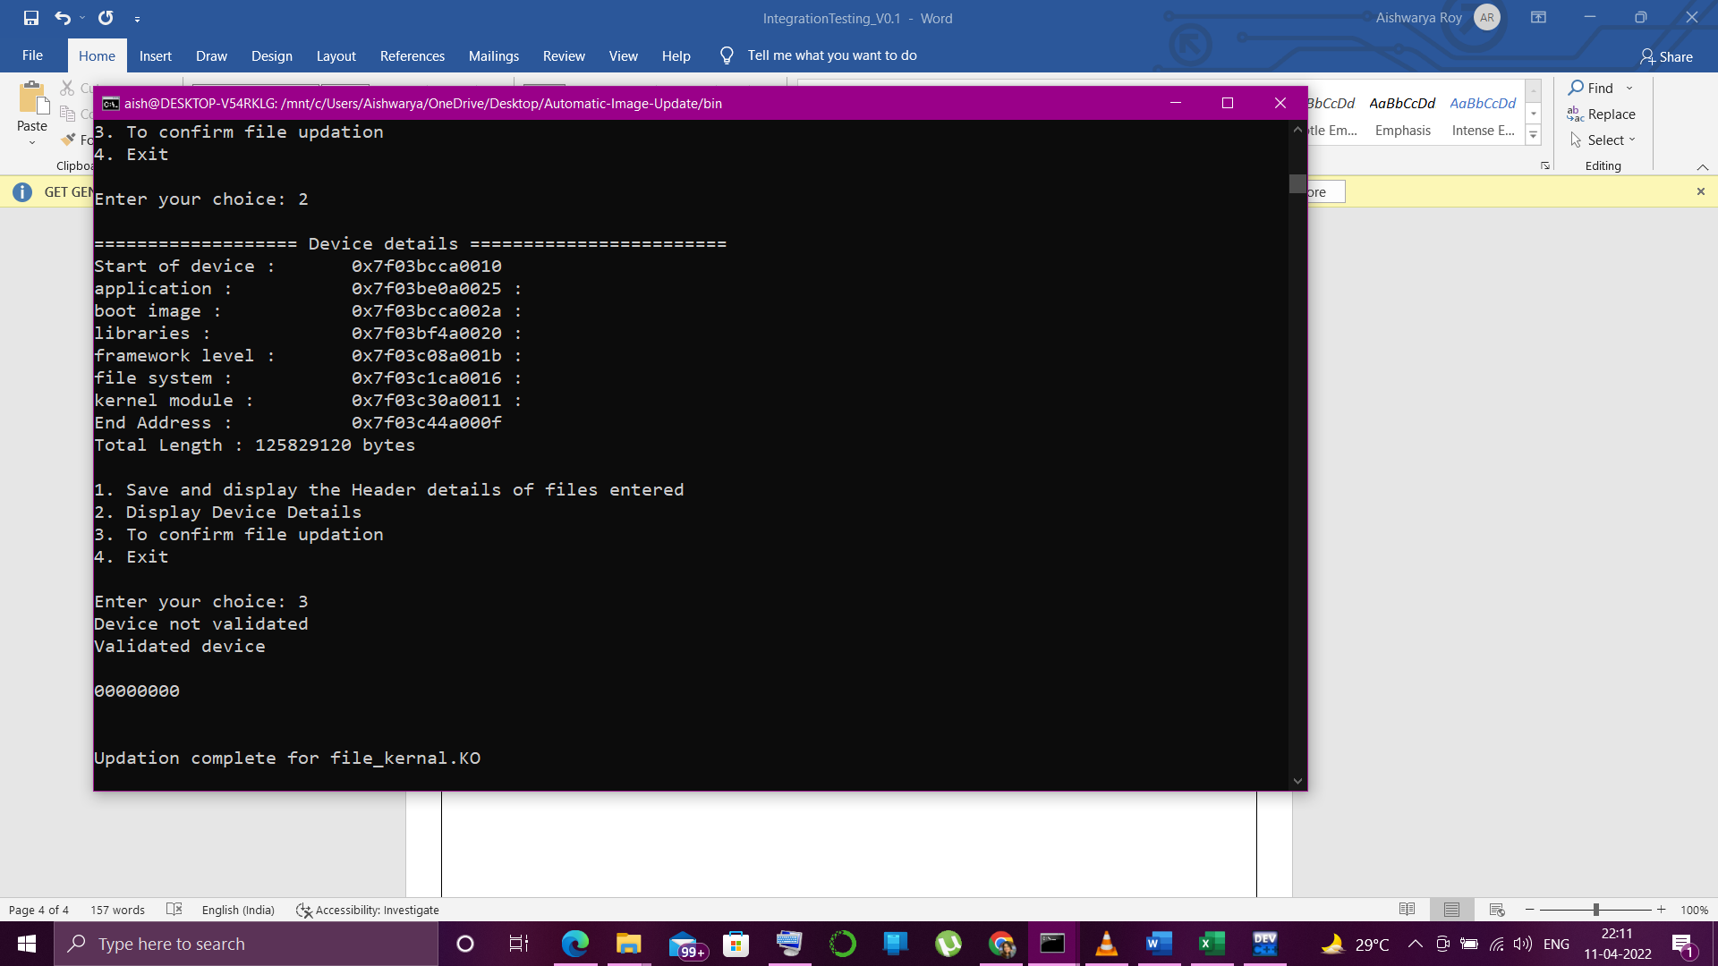

6) In case of failure to upload all the image files, it should revert to original state. --- AIU/IT-07, REQ6.1

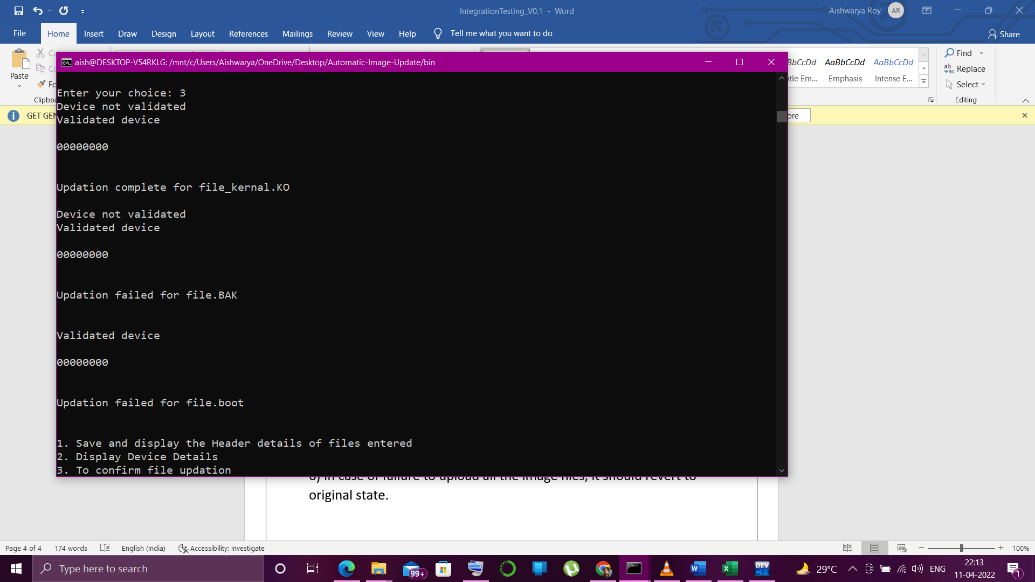
Updation failed due to invalid header details or in valid checksum
Updation failed due to invalid header details or in valid checksum

Device details reverted back to it’s original state :
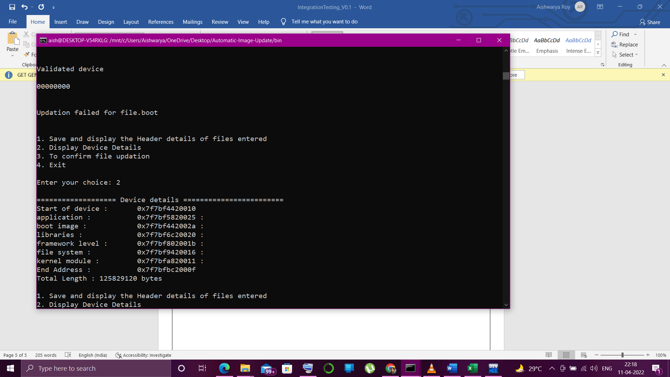
When all the configuration files are validated: --- AIU/IT – 08, REQ6.2
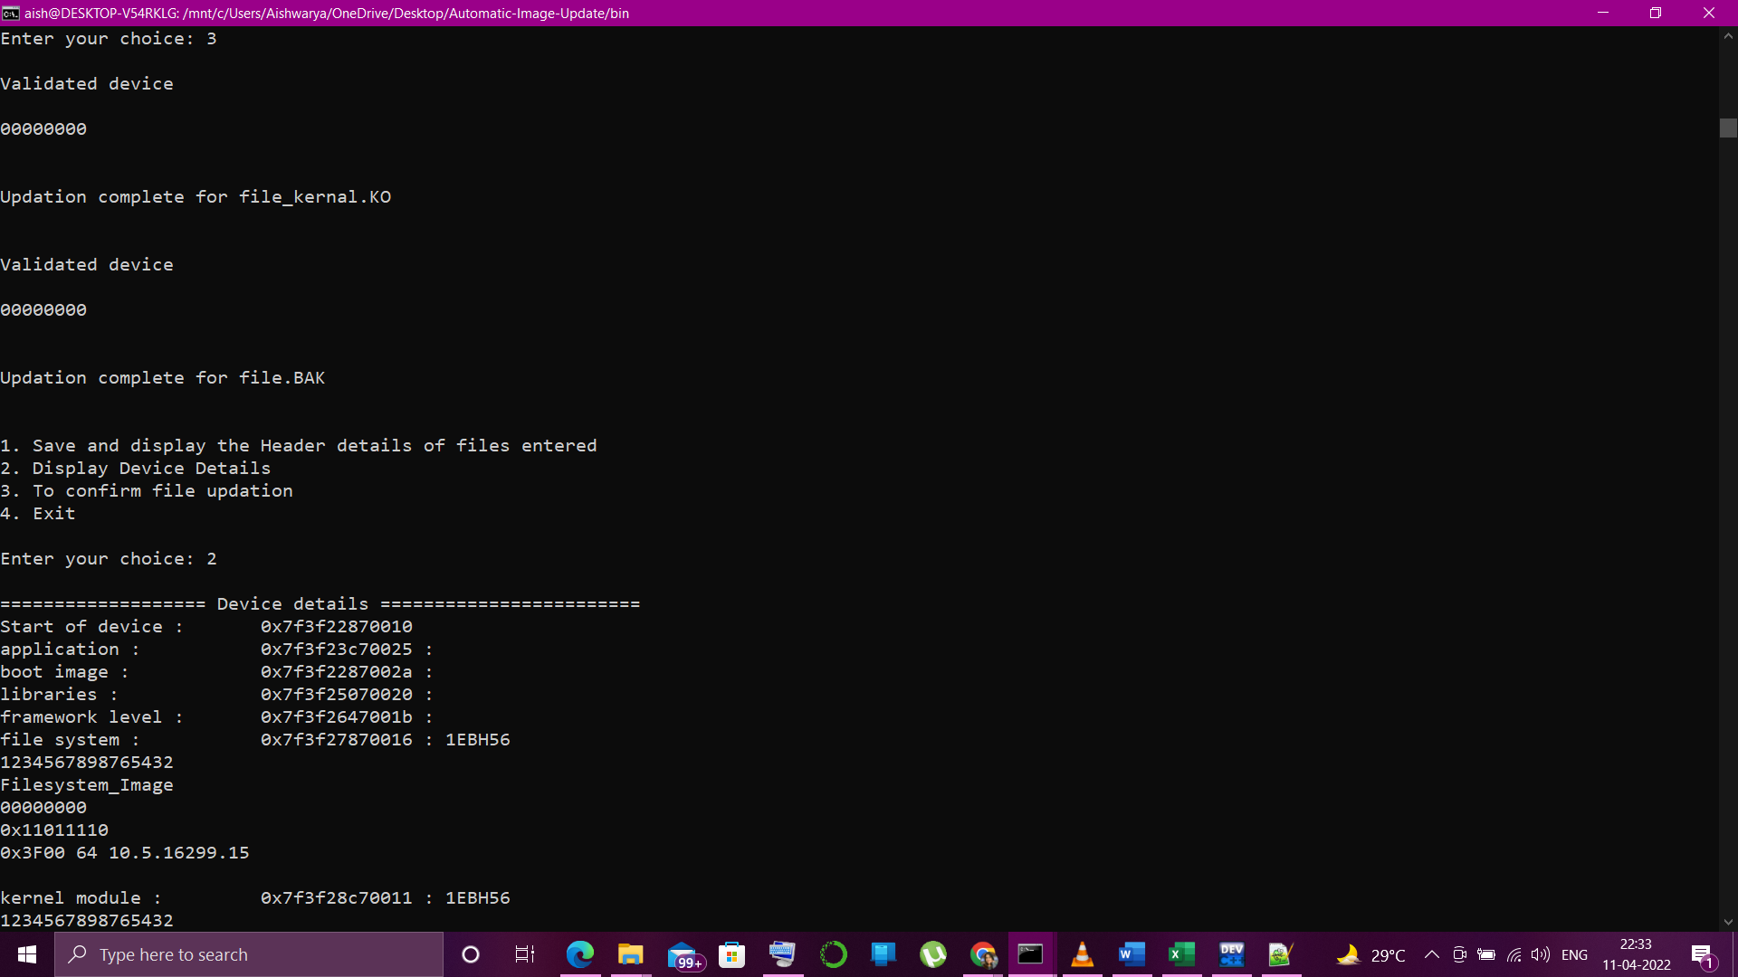

Device details are updated here in the heap memory
