Q.2

* To create new directory with specified name:

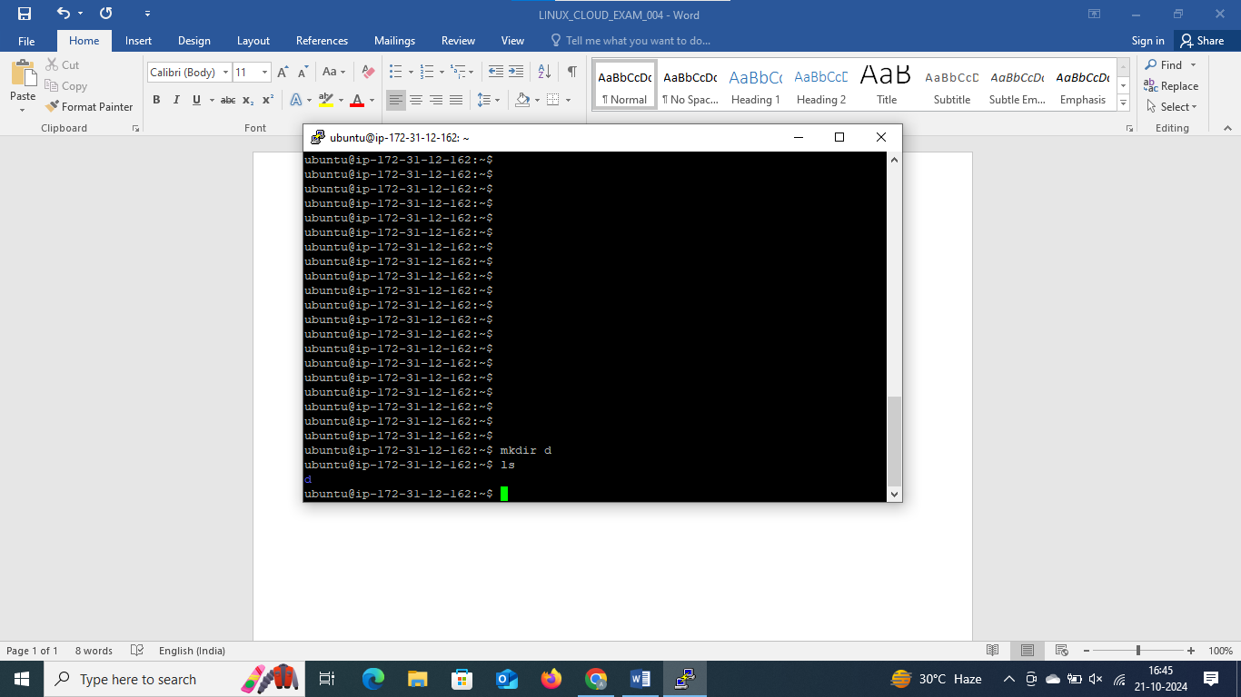

🡪Created a directory with name ‘d’ using command ‘mkdir’

🡪 with command ls we can see the directory ‘d’ which successfully created

* To rename existing directory with a new name­­­

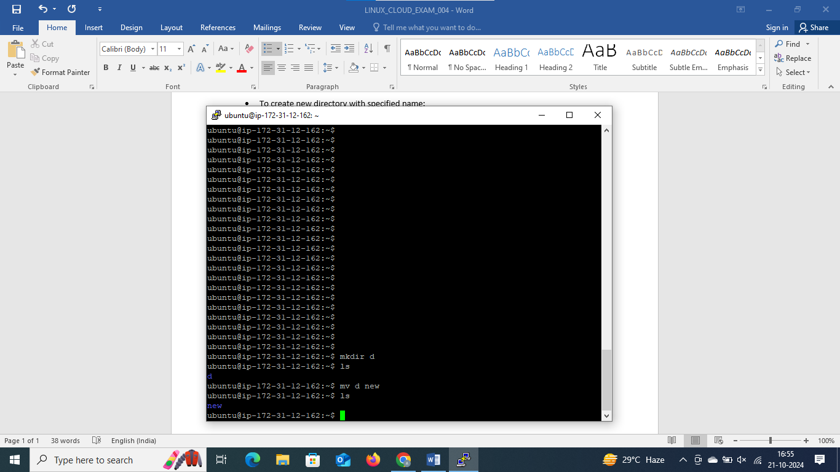

🡪Used command ‘mv’ to rename the file from ‘d’ to ‘new’

* Moving existing directory to a new location

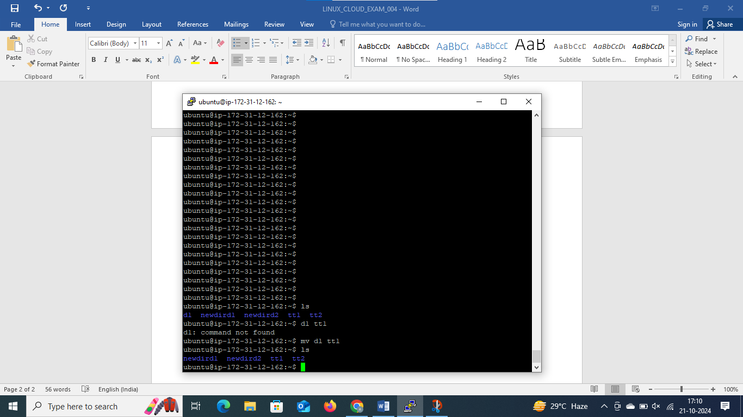

From existing directories moved directory d1 to newdird1

* Deleting the existing directory

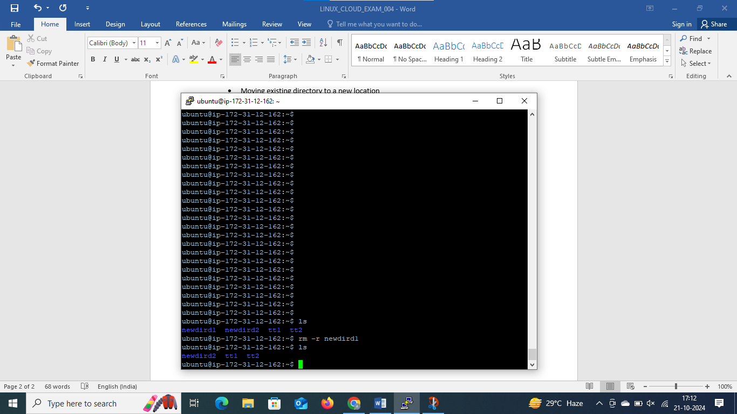

* Directory name ‘newdird1’ deleted with command ‘rm –r newdird1’
* Creating file with name and creating a hardlink

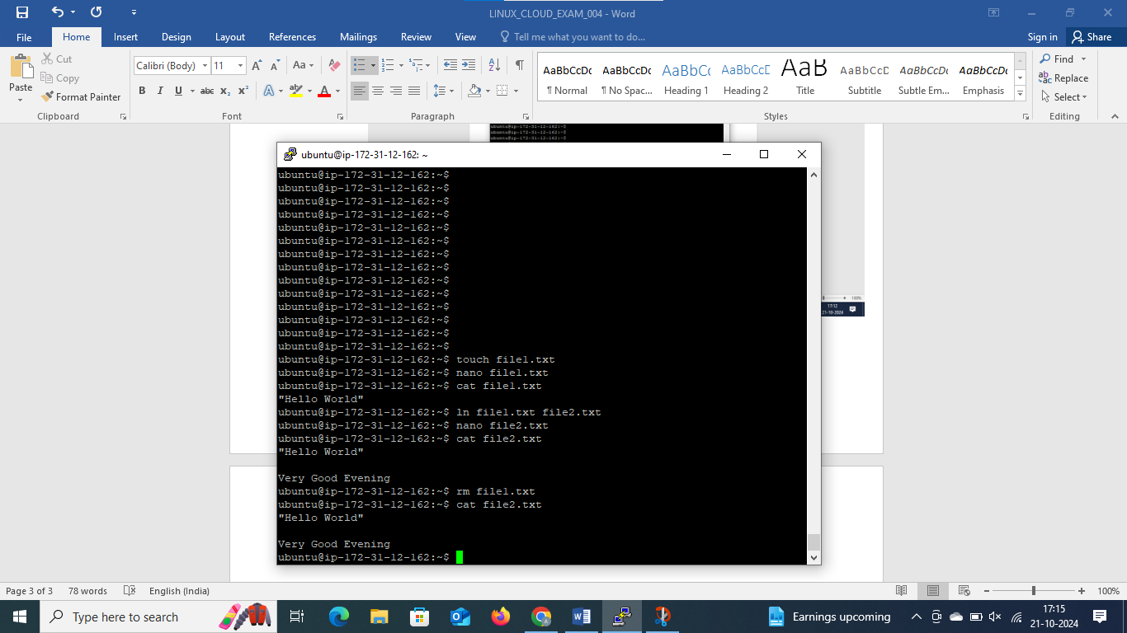

* Created a file-> file1.txt
* Which contains Hello World
* Created hardlink with new file file2.txt
* New file has added- Good evening
* Now even after deleting previous file , new file still has all the data because of the hardlink

**CLOUD**

* **Created a user**

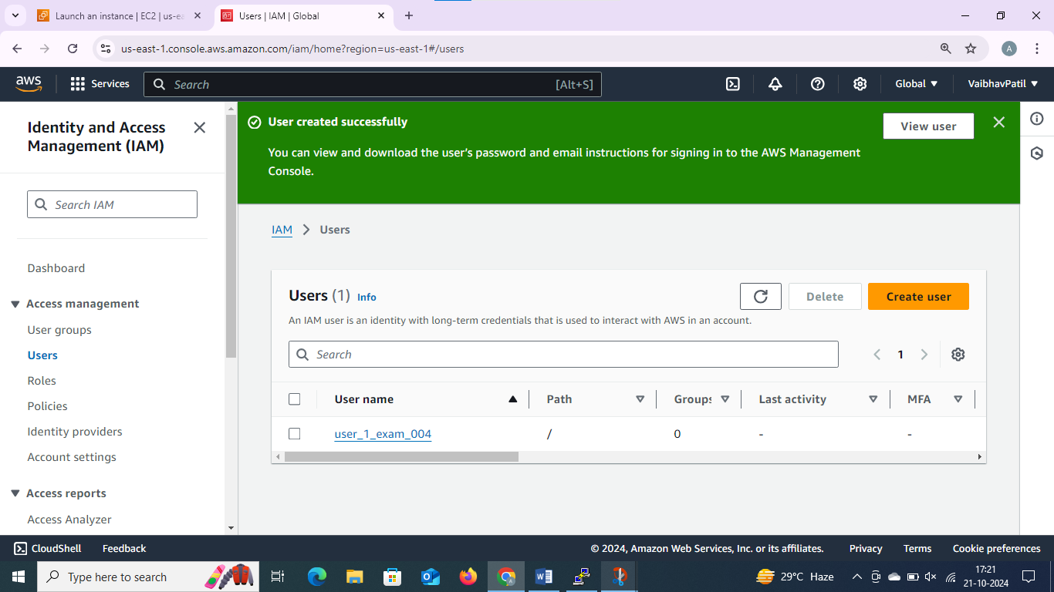

* User is assigned with EC2 and S3 permissions of full access

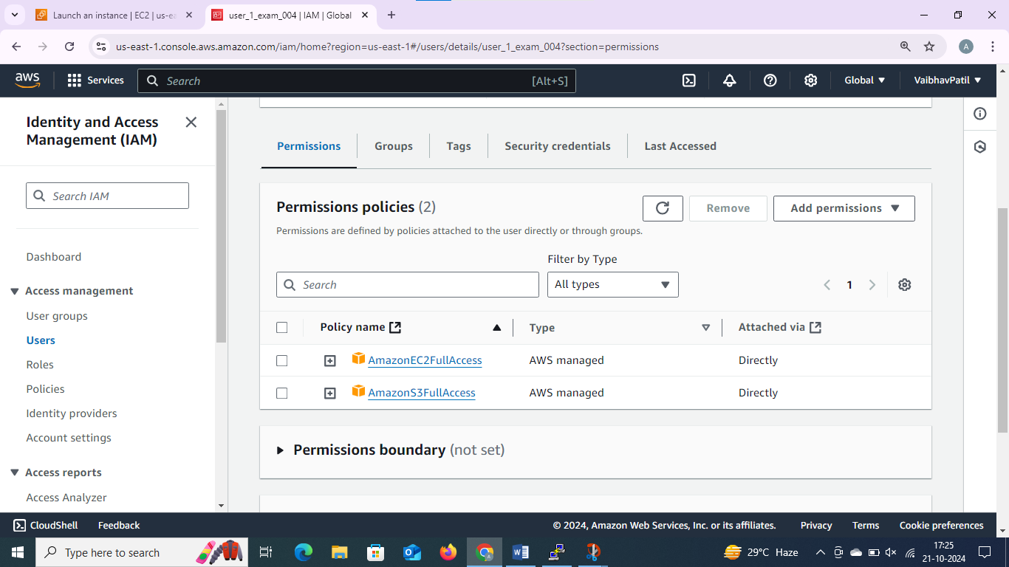

🡪 created access key, downloaded .csv for the same

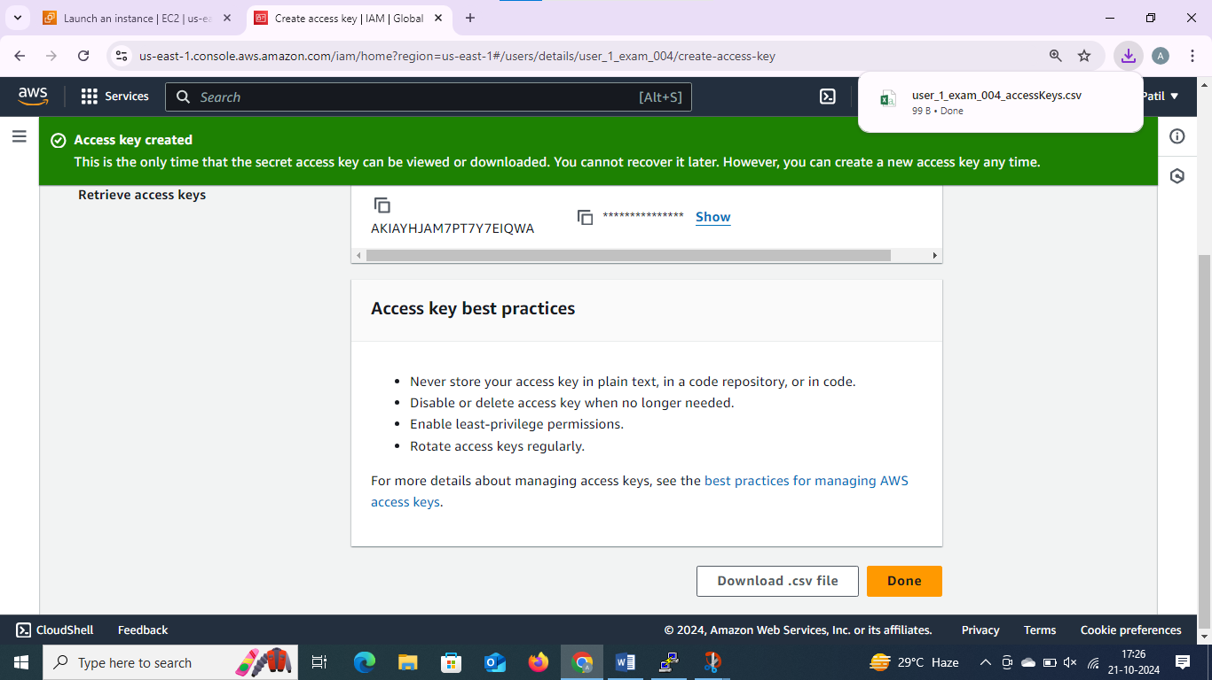

🡪created login and password for login, downloaded .csv file for the same

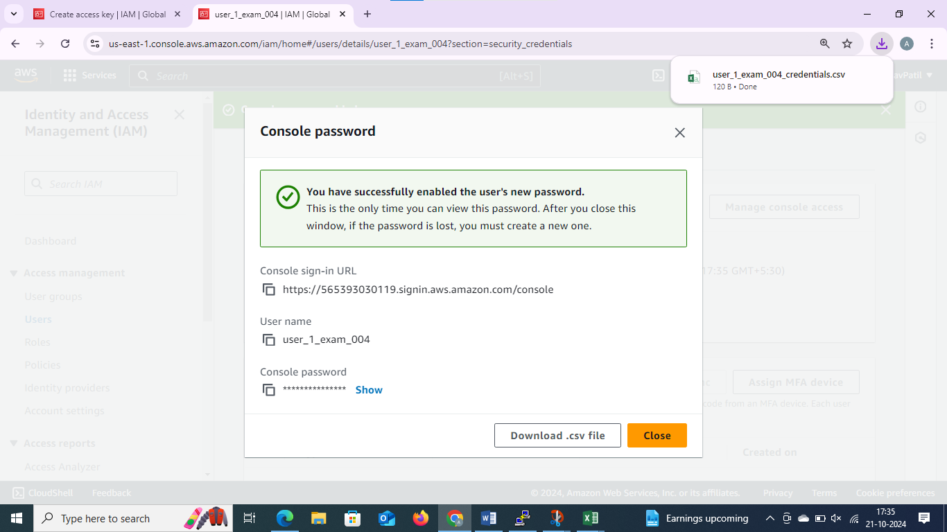

🡪logged with ec2 user in different browser, launched EC2 instance

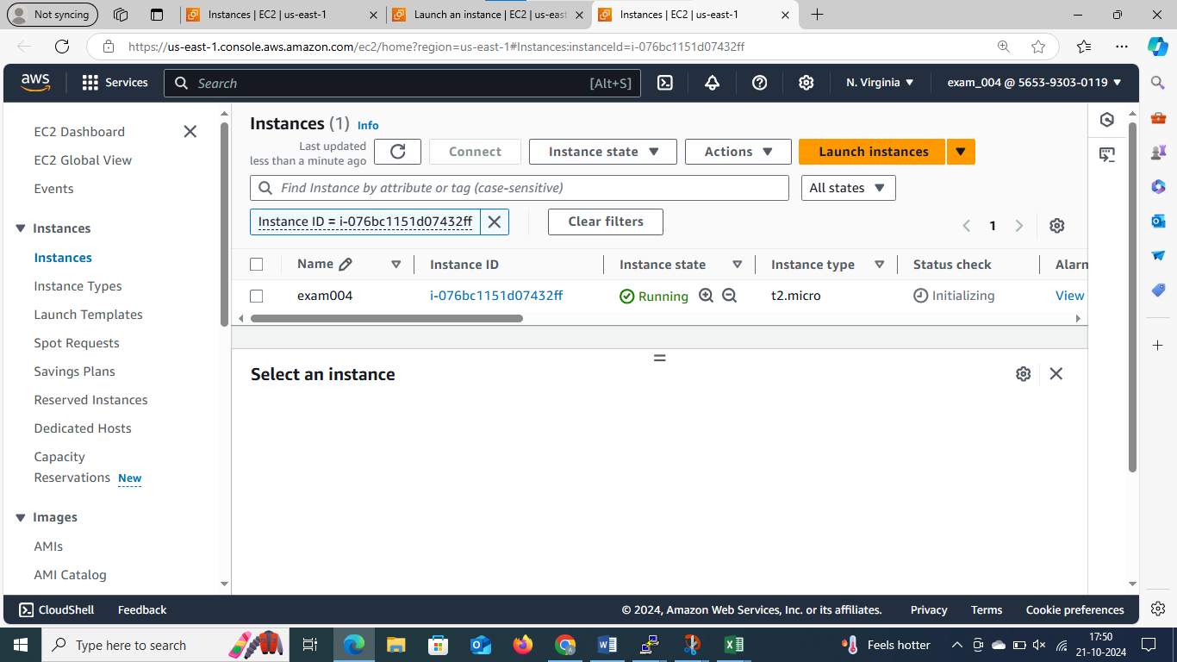

* Created a bucket with name bucketexam004

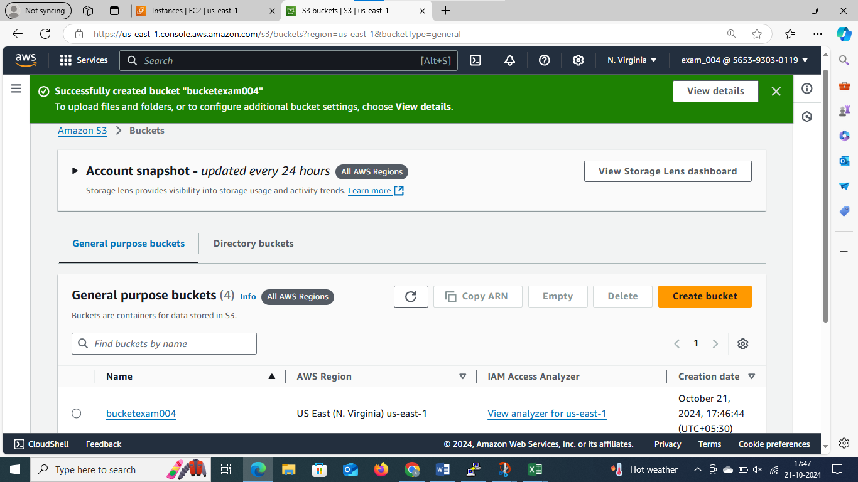

* Logging into putty

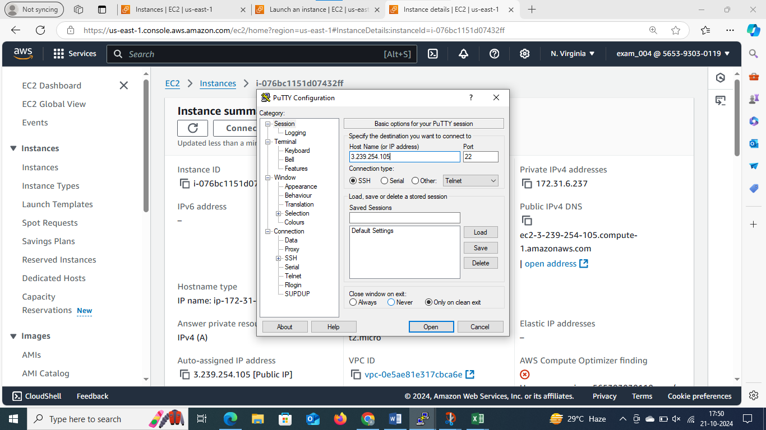

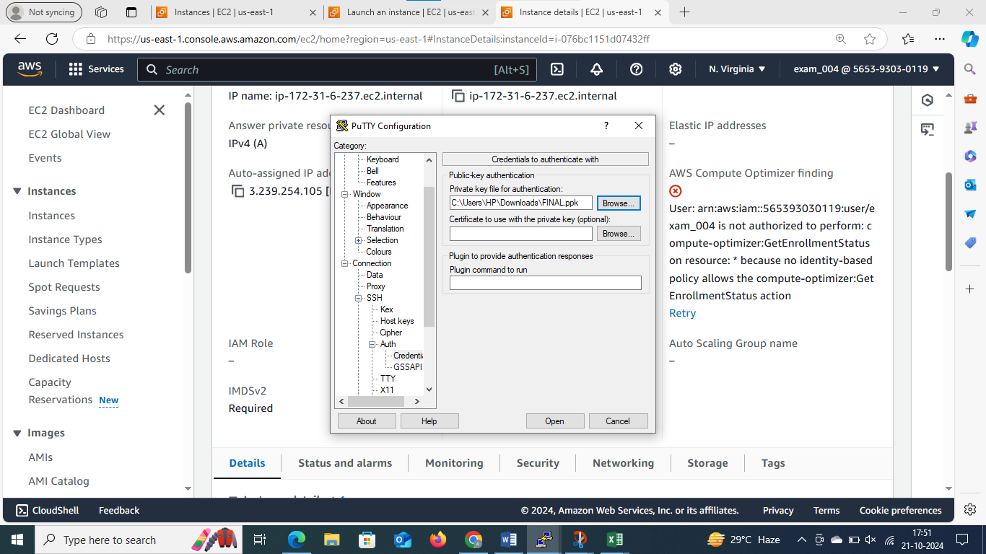

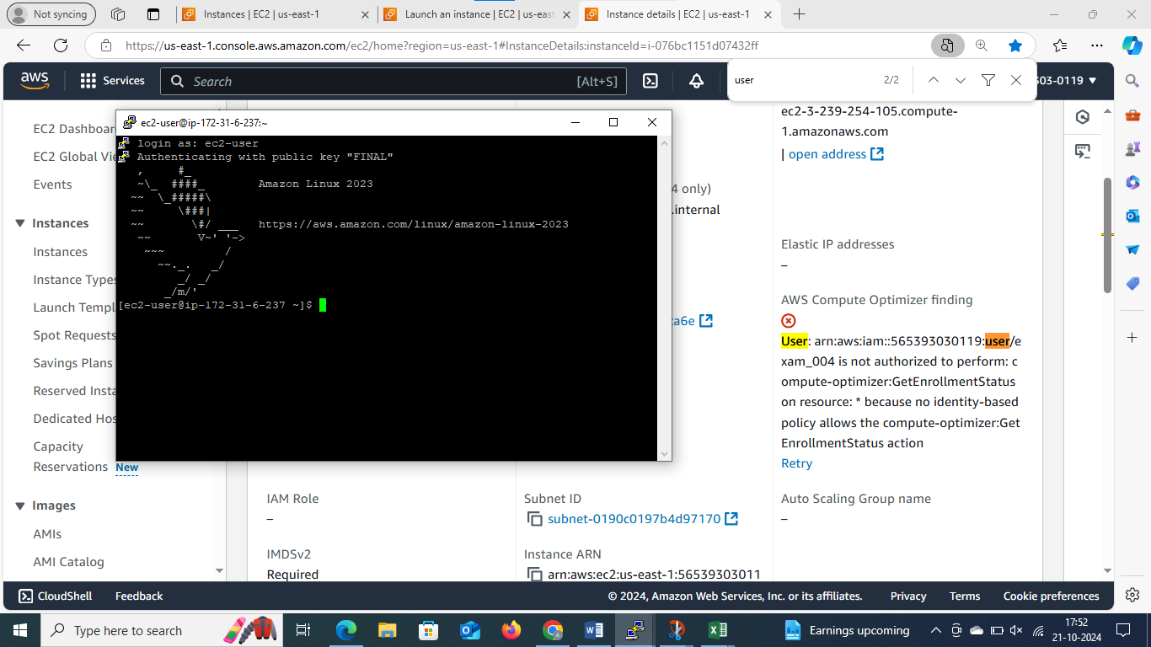

* Created file index.html successfully with given message”Hello,Welcome to my page”,using commands-
* nano index.html
* cat index.html
* aws configure
* successfully uploaded to bucket with below command
* aws s3 cp index.html s3://bucketexam004/

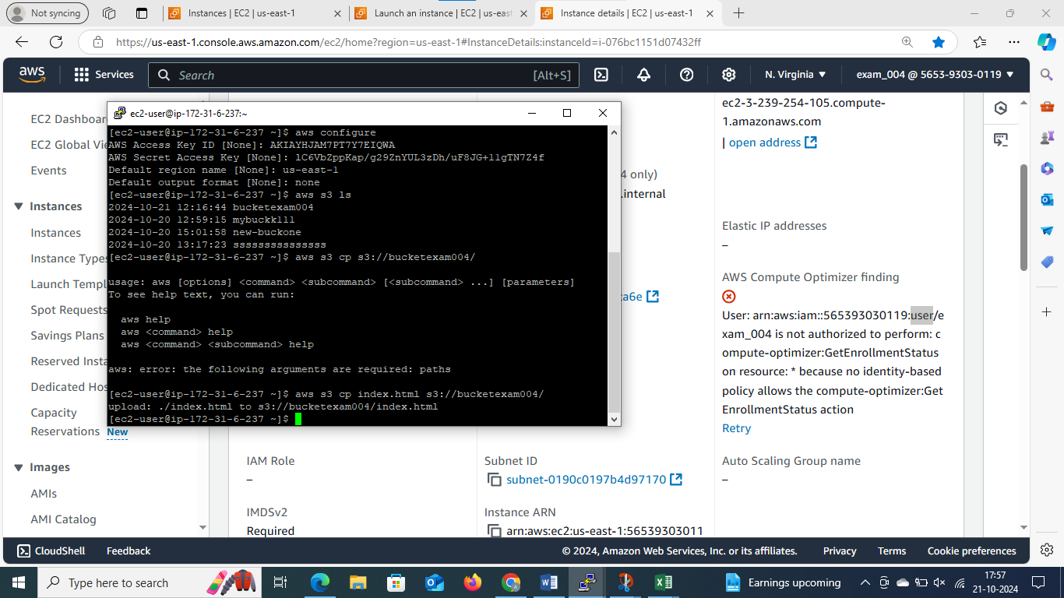

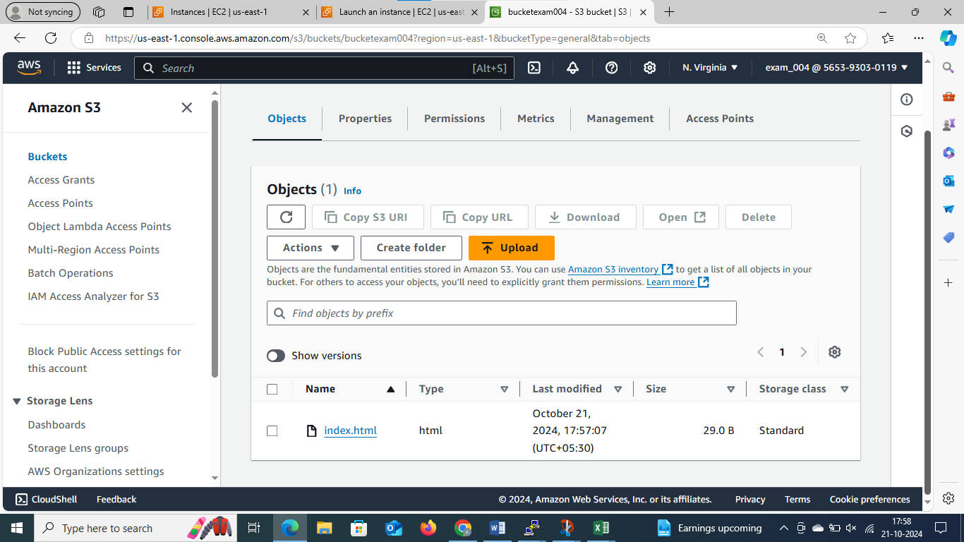

* Successfully reflected in bucket

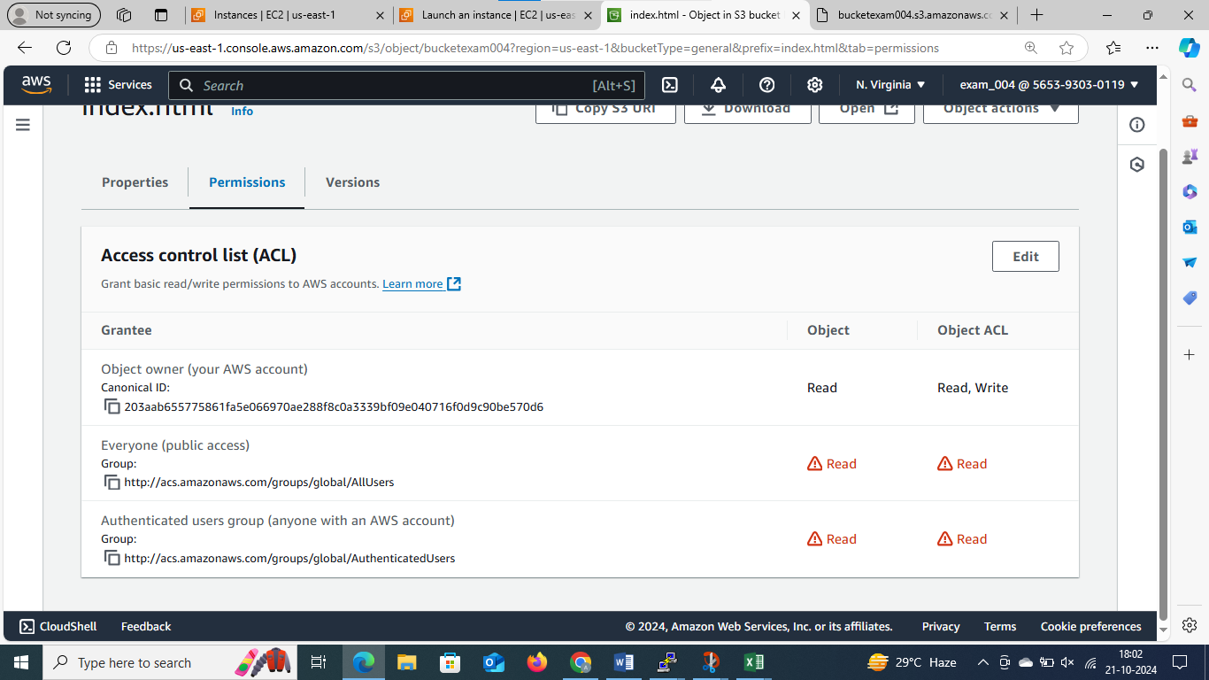

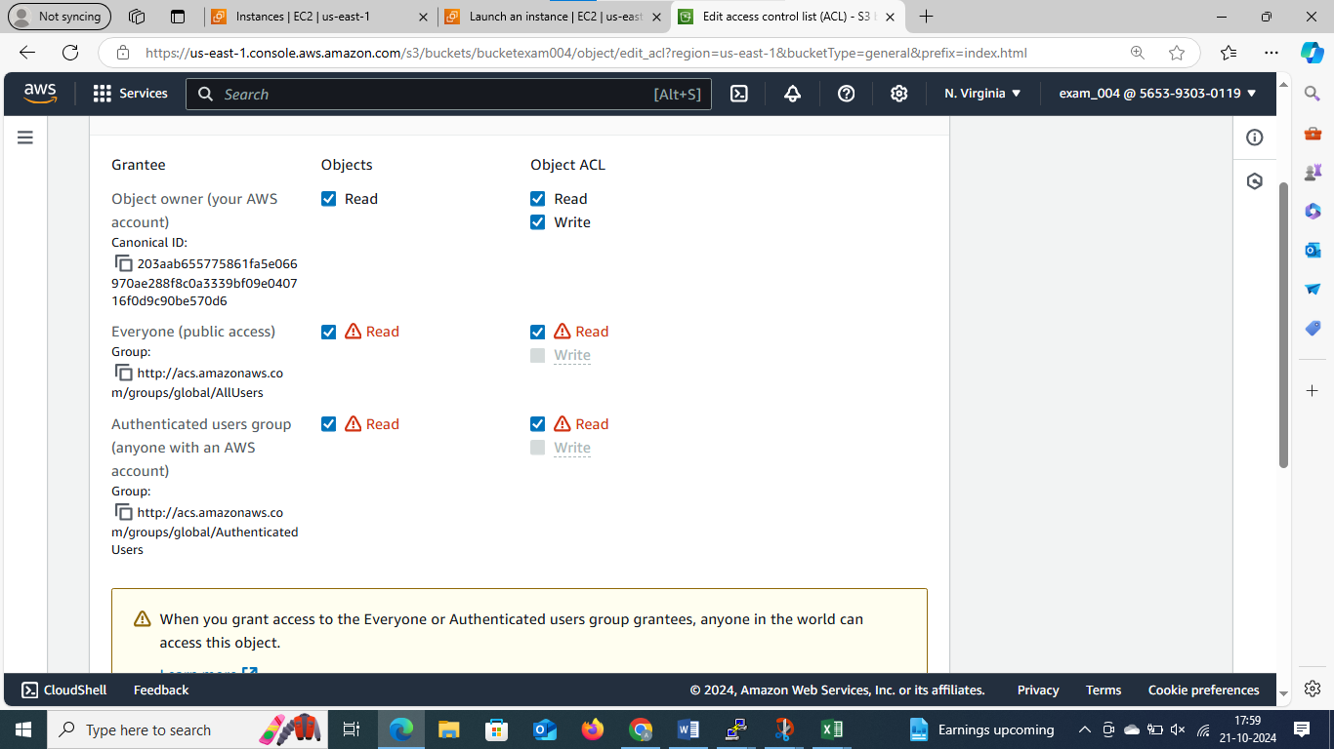

Gave permissions to object and bucket both

* HTML FILE IS PUCBLICALLY ACCESSIBLE BY VISING OBJECT URL IN WEB BROWSER
* LINK - [bucketexam004.s3.amazonaws.com/index.html](https://bucketexam004.s3.amazonaws.com/index.html)

