

**Ayesha Zahid**

**BS Computer science**

**Batch Session**: - BCS-6E

**Roll No**. 21F-9136

**Course: -** web

**Course instructor: -** Mam Sumaira

**Submission Date:**  10/2/24

Question # 1

Code

<!DOCTYPE html>

<html lang="en">

<head>

    <meta charset="UTF-8">

    <meta name="viewport" content="width=device-width, initial-scale=1.0">

    <title>Calculator</title>

    <link rel="icon" type="image/x-icon" href="cal.j.png">

</head>

<body>

    <table border="" style="height: 300px;width: 250px;">

        <caption>Calculator</caption>

        <tr>

            <td colspan="3" style="background-color: rgb(180, 233, 200);"></td>

            <th style="background-color: rgb(238, 41, 41);color:white;">C</th>

        </tr>

        <tr>

            <td style="text-align: center;background-color:rgb(70, 179, 70) ;color: azure;">1</td>

            <td style="text-align: center;background-color:rgb(70, 179, 70) ;color: azure;">2</td>

            <td style="text-align: center;background-color:rgb(70, 179, 70) ;color: azure;">3</td>

            <td style="text-align: center;background-color:yellow ;color: black">/</td>

        </tr>

        <tr>

            <td style="text-align: center;background-color:rgb(70, 179, 70) ;color: azure;">4</td>

            <td style="text-align: center;background-color:rgb(70, 179, 70) ;color: azure;">5</td>

            <td style="text-align: center;background-color:rgb(70, 179, 70) ;color: azure;">6</td>

            <td style="text-align: center;background-color:yellow ;color: black">*</td>

        </tr>

        <tr>

            <td style="text-align: center;background-color:rgb(70, 179, 70) ;color: azure;">7</td>

            <td style="text-align: center;background-color:rgb(70, 179, 70) ;color: azure;">8</td>

            <td style="text-align: center;background-color:rgb(70, 179, 70) ;color: azure;">9</td>

            <td style="text-align: center;background-color:yellow ;color: black">-</td>

        </tr>

        <tr>

            <td style="text-align: center;background-color:rgb(70, 179, 70) ;color: azure;">0</td>

            <td style="text-align: center;background-color:rgb(70, 179, 70) ;color: azure;">.</td>

            <td style="text-align: center;background-color:rgb(70, 179, 70) ;color: azure;">=</td>

            <td style="text-align: center;background-color:yellow ;color: black">+</td>

        </tr>

    </table>

</body>

</html>

Output

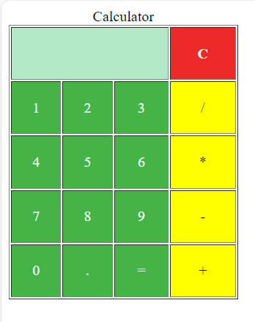

Question # 2

Code

<!DOCTYPE html>

<html lang="en">

<head>

    <meta charset="UTF-8">

    <meta name="viewport" content="width=device-width, initial-scale=1.0">

    <title>Time-Table</title>

    <link rel="icon" type="image/x-icon" href="tt.jpg">

</head>

<body>

    <table border="solid" style="background-color:gainsboro">

        <caption><b><u>Department Of Computer Science</u></b></caption>

        <caption>BCS-6E</caption>

        <!--&nbsp; &nbsp; &nbsp; &nbsp; &nbsp; &nbsp; &nbsp; -->

        <tr >

            <th><img src="tt.jpg" height="100px" alt=""></th>

            <th style="background-color: darkkhaki;">8:45-9:15</th>

            <th style="background-color: #A28089;">9:15-9:45</th>

            <th style="background-color: darkkhaki;">9:45-10:10</th>

            <th style="background-color: #A28089;">10:15-10:45</th>

            <th style="background-color: darkkhaki;">10:45-11:15</th>

            <th style="background-color: #A28089;">11:15-11:40</th>

            <th style="background-color: darkkhaki;">11:45-12:15</th>

            <th style="background-color: #A28089;">12:15-12:45</th>

            <th style="background-color: darkkhaki;">12:45-1:10</th>

            <th style="background-color: #A28089;">1:10-1:45</th>

            <th style="background-color: darkkhaki;">1:45-2:15</th>

            <th style="background-color: #A28089;">2:15-2:45</th>

            <th style="background-color: darkkhaki;">2:45-3:10</th>

            <th style="background-color: #A28089;">3:15-3:45</th>

            <th style="background-color: darkkhaki;">3:45-4:15</th>

            <th style="background-color: #A28089;">4:15-4:40</th>

        </tr>

        <tr>

            <th style="background-color: darkkhaki;">MO</th>

            <td></td>

            <td></td>

            <td></td>

            <td colspan="3" style="text-align: center;"><sub></sub>Web Programming <br><sub>R-8&nbsp;&nbsp;&nbsp;&nbsp;&nbsp;&nbsp;&nbsp;Mam Sumaira</sub></td>

            <td colspan="3" style="text-align: center;"><sub></sub>PDC <br><sub>R-7&nbsp;&nbsp;&nbsp;&nbsp;&nbsp;&nbsp;&nbsp;Sir Haseeb </sub></td>

            <td colspan="1" style="background-color:rgb(170, 218, 233);text-align: center;">Recess</td>

            <td colspan="3" style="text-align: center;"><sub></sub>Artificial Intelligence <br><sub>R-13&nbsp;&nbsp;&nbsp;&nbsp;&nbsp;&nbsp;&nbsp;Sir A.Raza</sub></td>

            <td></td>

            <td></td>

            <td></td>

        </tr>

        <tr>

            <th style="background-color: #A28089;">TU</th>

            <td colspan="3" style="text-align: center;"><sub></sub>Computer Networks<br><sub>R-19&nbsp;&nbsp;&nbsp;&nbsp;&nbsp;&nbsp;&nbsp;Dr.Umar</sub></td>

            <td colspan="3" style="text-align: center;"><sub></sub>Artificial Intelligence<br><sub>R-10&nbsp;&nbsp;&nbsp;&nbsp;&nbsp;&nbsp;&nbsp;Sir A.Raza</sub></td>

            <td></td>

            <td></td>

            <td></td>

            <td colspan="1" style="background-color:rgb(170, 218, 233);text-align: center;">Recess</td>

            <td colspan="6" style="text-align: center;"><sub></sub>Artificial Intelligence Lab<br><sub>Lab-1&nbsp;&nbsp;&nbsp;&nbsp;&nbsp;&nbsp;&nbsp;Sir A.Tabassum</sub></td>

        </tr>

        <tr>

            <th style="background-color: darkkhaki;">WED</th>

            <td></td>

            <td></td>

            <td></td>

            <td></td>

            <td></td>

            <td></td>

            <td></td>

            <td></td>

            <td></td>

            <td colspan="1" style="background-color:rgb(170, 218, 233);text-align: center;">Recess</td>

            <td colspan="6" style="text-align: center;"><sub></sub>Computer Networks Lab<br><sub>Lab-1&nbsp;&nbsp;&nbsp;&nbsp;&nbsp;&nbsp;&nbsp;Sir A.Hamza</sub></td>

        </tr>

        <tr>

            <th style="background-color: #A28089;">THU</th>

            <td></td>

            <td></td>

            <td></td>

            <td colspan="3" style="text-align: center;"><sub></sub>Computer Networks<br><sub>R-15&nbsp;&nbsp;&nbsp;&nbsp;&nbsp;&nbsp;&nbsp;Dr.Umar</sub></td>

            <td colspan="3" style="text-align: center;"><sub></sub>Software Design & Analysis<br><sub>R-10&nbsp;&nbsp;&nbsp;&nbsp;&nbsp;&nbsp;&nbsp;Sir A.Azam</sub></td>

            <td colspan="1" style="background-color:rgb(170, 218, 233);text-align: center;">Recess</td>

            <td colspan="3" style="text-align: center;"><sub></sub>Web Programming <br><sub>Lab-1&nbsp;&nbsp;&nbsp;&nbsp;&nbsp;&nbsp;&nbsp;Mam Sumaira</sub></td>

            <td colspan="3" style="text-align: center;"><sub></sub>PDC<br><sub>R-19&nbsp;&nbsp;&nbsp;&nbsp;&nbsp;&nbsp;&nbsp;Sir Haseeb </sub></td>

        </tr>

        <tr>

            <th style="background-color: darkkhaki;">FRI</th>

            <td></td>

            <td></td>

            <td></td>

            <td colspan="3" style="text-align: center;"><sub></sub>Software Design & Analysis<br><sub>R-10&nbsp;&nbsp;&nbsp;&nbsp;&nbsp;&nbsp;&nbsp;Sir A.Azam</sub></td>

            <td></td>

            <td></td>

            <td></td>

            <td colspan="1" style="background-color:rgb(170, 218, 233);text-align: center;">Recess</td>

            <td></td>

            <td></td>

            <td></td>

            <td></td>

            <td></td>

            <td></td>

        </tr>

        <tr>

            <th style="background-color: #A28089;">SAT</th>

            <td colspan="16" style=" background-color:silver;text-align: center;color: rgb(254, 15, 15);"><B>HOLIDAY</B></td>

        </tr>

        <tr>

            <th style="background-color: darkkhaki;">SUN</th>

            <td colspan="16" style=" background-color:silver;text-align: center;color: rgb(254, 15, 15);"><b>HOLIDAY</b></td>

        </tr>

    </table>

    <style favicon></style>

</body>

</html>

Output

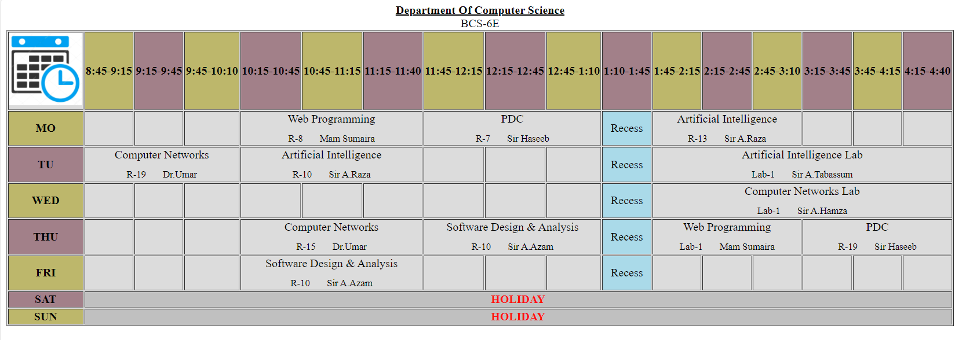

Question # 3

Code

<!DOCTYPE html>

<html lang="en">

<head>

    <meta charset="UTF-8">

    <meta name="viewport" content="width=device-width, initial-scale=1.0">

    <title>CV</title>

    <link rel="icon" type="image/x-icon" href="cv.png">

    <style>

        * {

            margin: 0;

            padding: 0;

        }

        body {

            width: 100%;

            height: 100vh;

            background-image: linear-gradient(90deg, rgb(145, 145, 222) 30%, rgb(204, 193, 193) 30%, white 100%);

            position: relative;

        }

        .rectangle {

            width: 400px;

            height: 150px;

            background-color: rgb(148, 180, 219);

            margin-top: 70px;

            position: absolute;

            top: 0.1%;

            left: 1%;

            display: flex;

            align-items: center;

        }

        .rectangle img {

            width: 150px;

            height: 150px;

            border-radius: 50%;

            margin-right: 10px;

            display: inline-block;

            vertical-align: middle;

        }

        .rectangle p {

            display: inline-block;

            vertical-align: middle;

            font-size: 24px;

            color: white;

        }

        .contact-info {

            margin-left: 20px;

            color: aliceblue;

        }

        .right-section {

            position: absolute;

            top: 0;

            left: 31%;

            width: 50%;

            padding: 20px;

            color: black; /* Change text color for better readability */

        }

    </style>

</head>

<body>

    <div class="rectangle">

        <img src="img.jpeg" alt="">

        <p><b>AYESHA ZAHID</b></p>

    </div>

    <br>

    <br>

    <br><br><br><br><br><br><br><br><br><br><br>

    <div class="contact-info">

        <h2><u>Contact</u></h2>

        <br>

        <p><b>Mobile no. 0300-1234567</b></p>

        <br>

        <p><b>Email id :</b> <a href="mailto:ayeshazahid036@gmail.com" style="color: rgb(1, 50, 1)">ayeshazahid036@gmail.com</a></p>

        <br>

        <h2><u>Skills</u></h2>

        <p><u>Programming Languages : </u></p>

            <li> C++ </li>

            <LI> Python</LI>

            <LI> Swift</LI>

            </li>

            <p><u>Front-end : </u></p>

            <li> HTML5</li>

            <li>CSS</li>

            <li>JavaScript</li>

        <br>

        <h2><u>Hobbies</u></h2>

        <li>Reading Books</li>

        <li>Painting</li>

        <li>Cricket</li>

        <br>

    </div>

    <div class="right-section">

        <h2>Web Developer</h2> <br>

        <p style="font-style:oblique;">Ayesha Zahid is a dedicated and driven individual with a passion for tech With a background in GOOGLE, she brings a wealth of knowledge and expertise to any team she joins.

            Ayesha's strengths lie in her strong communication skills, attention to detail, and ability to adapt to new challenges with ease. She is known for her analytical mindset and problem-solving abilities, which allow her to approach tasks with a strategic perspective.

            As a suitable candidate, Ayesha is committed to continuous learning and development, always seeking opportunities to expand her skill set and stay updated with the latest trends and technologies in her field. Her proactive approach and willingness to take on responsibilities make her a valuable asset to any organization.

            Driven by a desire to make a meaningful impact, Ayesha is eager to contribute her talents and expertise to full stack development With her strong work ethic and positive attitude, she is poised to excel in any professional environment and make significant contributions to the success of her team and organization.

        </p><br>

        <h2>Experience</h2> <br>

        <p>Duration: [Jan, 2019] - [Sep, 2024]</p>

        <li>ABC Corporation: Led key projects resulting in technologies</li>

        <li>XYZ Enterprises: Optimized processes, maintained client relationships, and provided expertise.</li>

        <li>LMN Technologies: Implemented innovative solutions and influenced strategic decisions.</p></li>

        <p>

        <br>

        <h2>Education</h2>

        <br>

        <li>Matriculation : Al-Faisal School</li>

        <li>Intermediate : Punjab College</li>

        <li>BS : FAST </li>

        <br>

        <h2>Projects</h2>

        <br>

        <li>CodeCraft: A collaborative coding platform for developers</li>

        <li>TaskMaster: A task management application for teams</li>

        <li>HealthHub: A health tracking app for monitoring fitness and nutrition</li>

        <li>SecureVault: A password manager with end-to-end encryption</li>

        <li>EduEdge: An e-learning platform with interactive courses and quizzes</li>

    </div>

</body>

</html>

Output

