

AI 2002 – Artificial Intelligence
Assignment 1

Group Members

Ayesha Naeem | 21F-9190
Ayesha Zahid | 21F-9136

Question No 01:
Examine the AI literature to discover whether the following tasks can currently be solved by computers. If yes, then list the name of a successful application or otherwise, state a reason why a specific task is not possible yet.

- Drive safely on a highway.

Yes, computers can currently drive safely on highways.

Successful applications:

Tesla and Waymo.

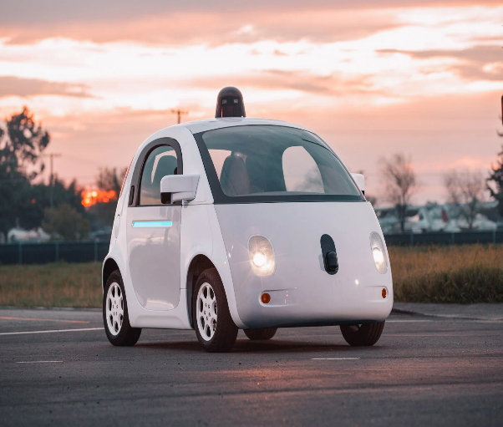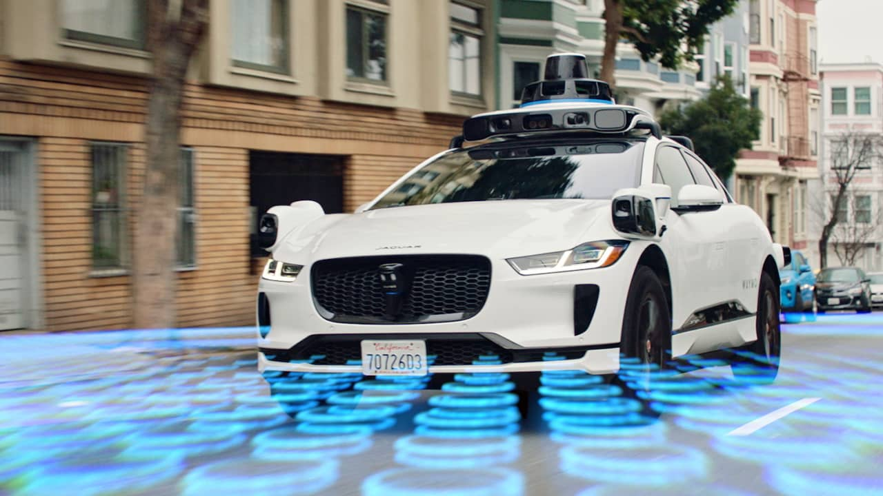
Figure 1.1 Figure 1.2

- Drive safely in a busy city with other traffic and pedestrians.

Yes, computers can currently drive safely in busy cities with other traffic and pedestrians.

Successful applications:
1. Waymo
2. Tesla
3. Uber
4. Apple (Project Titan)

- Buying a week’s worth of groceries online.

Yes, buying a week's worth of groceries online can currently be done by computers.
Successful applications:
- Amazon Fresh
- Instacart, etc

- Buying a week’s worth of groceries at a superstore.

Yes, buying a week's worth of groceries at a superstore can be facilitated by computers.
Successful applications:
- Walmart
- Target, etc

- Booking a doctor’s appointment online.

Yes, booking a doctor's appointment online is a task that can currently be accomplished through various online platforms and healthcare systems.
Successful applications:
- Zocdoc
- Healthgrades
- MyChart
- Doctolib
- Practo

- Win a soccer game against human(s).

No, computers and AI are not able to win a soccer game against human players.
Reason:
The main reason AI hasn't won soccer games against humans is because the real-world soccer is too complicated for AI. The game involves physical moves, changes in the environment, and the need to adapt quickly. AI is not good at these things yet. It lacks the physical abilities, quick adjustments, and complex coordination required to beat humans in a real soccer game.

- Win an art competition.

AI has not won any art competitions.
Reason:
AI struggles with replicating the depth of human creativity, emotional expression, and cultural nuances crucial for success in subjective domains like art competitions.

- Win a chess game against human(s).

Yes, AI has won a chess against humans.
Successful applications:
- Stockfish
- AlphaZero

- Discovering and proving new mathematical theorems.

No, Discovering and proving new mathematical theorems is a
task that is currently not solved by computers.
Reason:
While AI can assist in mathematical research and problem-solving, discovering and proving new mathematical theorems typically relies on human insight, creativity, and intuition, which current AI lacks.
The reasoning and abstract thinking involved in mathematical discovery often go beyond the capabilities of existing AI systems.

- Giving competent legal advice in a specialized area of law.

No, AI systems can only assist in legal research and provide information.
Reason:
AI lacks the experience, ethical judgment, and comprehensive understanding needed to provide competent legal advice in highly specialized areas of law. Giving competent legal advice in a specialized area of law requires a deep understanding of complex legal principles, ethical considerations, and contextual variation.

- Translating spoken Urdu into spoken English in real time.

Yes, AI can translate spoken Urdu into spoken English in real time.
Successful applications:
- Google Translate
- Microsoft Translator

- Writing an intentionally funny story.

Yes. AI can generate intentionally funny stories by processing and understanding patterns in humor from vast amounts of training data. It can produce narratives with jokes, wordplay, and comedic elements.

Successful applications:
- ChatGPT
- Jukebox.

- Writing a publishable research article.

No. AI cannot write a publishable research article.
Reason:
AI cannot create a truly publishable and scientifically rigorous research article because it involves original research, domain expertise, critical analysis, and validation by human researchers. AI lacks the capacity for independent research and the variation understanding necessary for academic contributions.

Question No 2:
For each of the following assertions, say whether it is true or false and support your answer with examples or counterexamples where appropriate.
- An agent that senses only partial information about the state cannot be perfectly rational.
- There exist task environments in which no pure reflex agent can behave rationally.
- There exists a task environment in which every agent is rational.
- Every agent function is implementable by some program/machine combination.
- Suppose an agent selects its action uniformly at random from the set of possible actions. There exists a deterministic task environment in which this agent is rational.
- It is possible for a given agent to be perfectly rational in two distinct task environments.
- Every agent is rational in an unobservable environment.
- A perfectly rational poker-playing agent never loses.

Question No 3:
For each of the following activities, give a PEAS description of the task environment in tubular form.
- Playing soccer
- Exploring the subsurface oceans of Titan
- Playing a tennis match
- Practicing tennis against a wall
- Performing a high jump
- Knitting a sweater
- Bidding on an item at an auction

Question No 4:
For each of the activities listed in the previous question, describe the environment type as:

- Fully or partially observable
- Deterministic or stochastic
- Episodic or sequential
- Static or dynamic
- Discrete or continuous
- Single or multi-agent

Provide your answers in a tubular form.

Question No 5:
Pick a real-world example of your choice (a robot or software agent/bot, except for the examples discussed in detail in the class e.g., taxi & vacuum-cleaner agents) and describe different scenarios in the context of the following agent types that solve the problem.
- Reflex agent
- Model-based.
- Goal-based
- Utility-based
- Learning agent

Question No 6:
A problem can be described as a “search problem” by specifying the following components: (a) initial state, (b) actions, (c) transition model/successor function, (d) goal state, (e) path cost (assume a path cost of 1 per action, if not specified explicitly). For each of the following problems, identify the above components.
- There are six glass boxes in a row, each with a lock. Each of the first five boxes holds a key unlocking the next box in line, the last holds a banana. You have the key to the first box, and you want the banana.
- Consider a 3-coins problem, C1-C2-C3 where each coin has two sides: a head (or H) and a tail (or T). Only one coin can be flipped at a time which will change an H to T or a T to H. Since, we have three coins, the coin position would tell the coin to be flipped, that is, C1 will flip coin 1 and so on. The initial state is H-H-H and the goal is to get at least two tails.
- In the “missionaries and cannibals” problem, three missionaries and three cannibals must cross a river using a boat which can carry at most two people, under the constraint that, for both banks, if there are missionaries present on the bank, they cannot be outnumbered by cannibals (if they were, the cannibals would eat the missionaries). The boat cannot cross the river by itself with no people on board.

Question No 7
For each of the problem in the previous question:

- Construct a state space and clearly show the initial state(s), possible actions, and goal state(s).
- Is the state space a graph or a tree?

