

Ayesha Zahid
BS Computer science
Batch Session: - BCS-6E
Roll No. 21F-9136
Course: - CN Lab 9
Course instructor: - Sir Ali
Submission Date: 28/03/24

Question #1
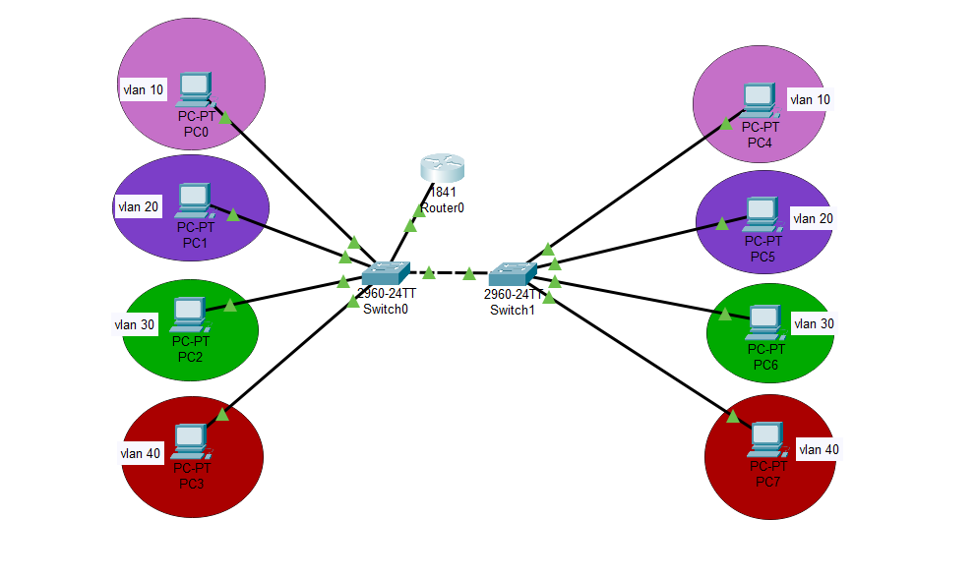
Q1: Use 2 switch and configure both using following instructions:
• Use Telnet concept on both
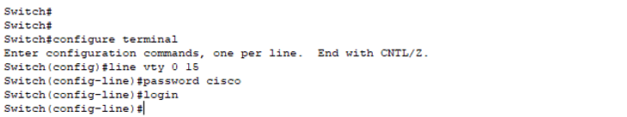
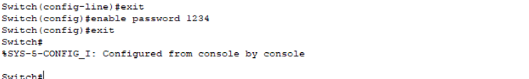
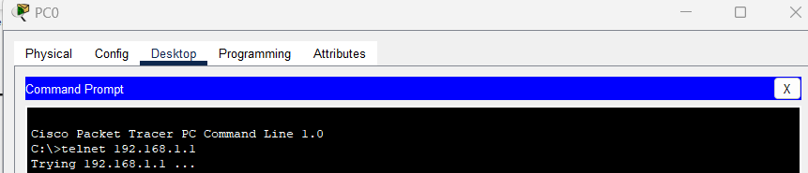
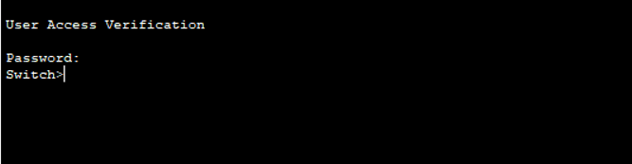
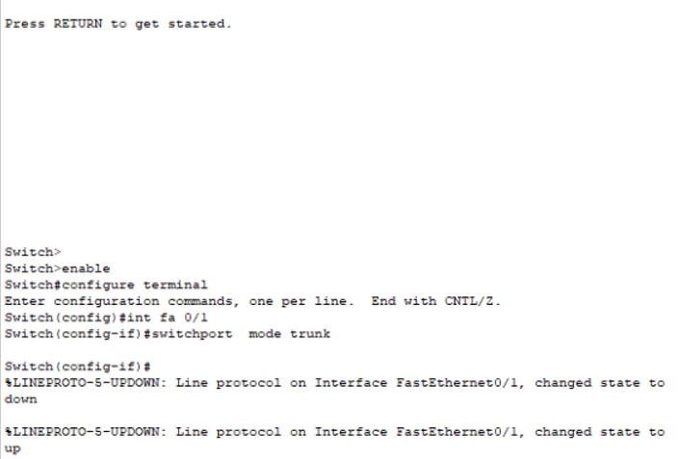•

Create vlan 10, 20, 30 and 40 on both switches
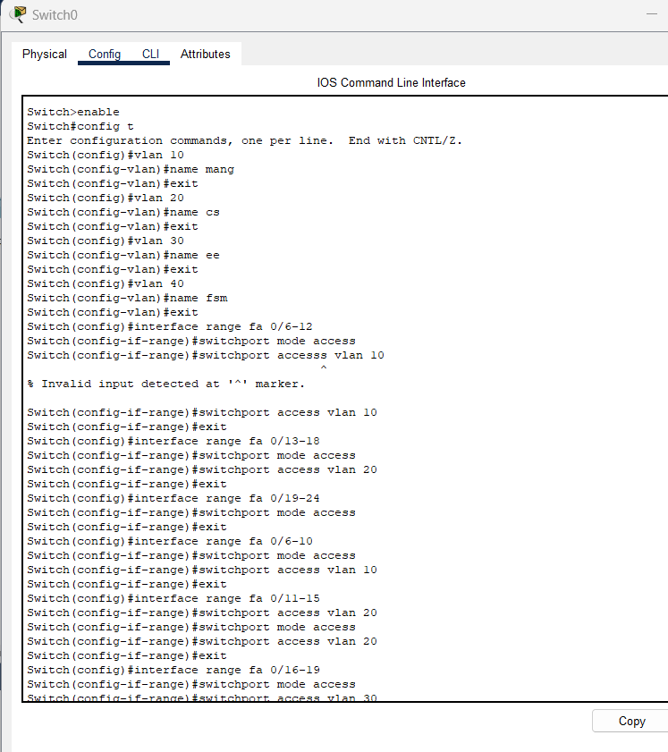

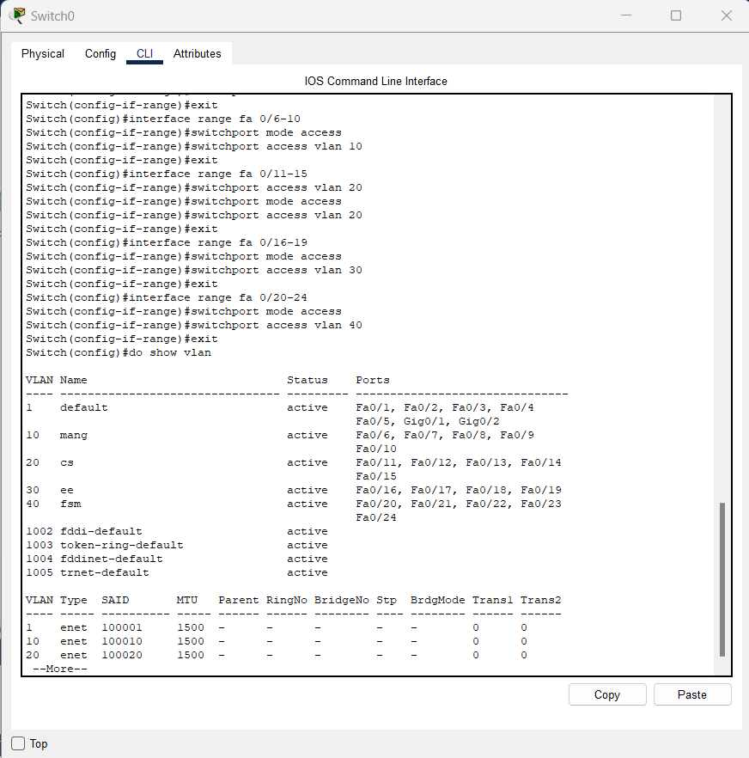
2nd switch
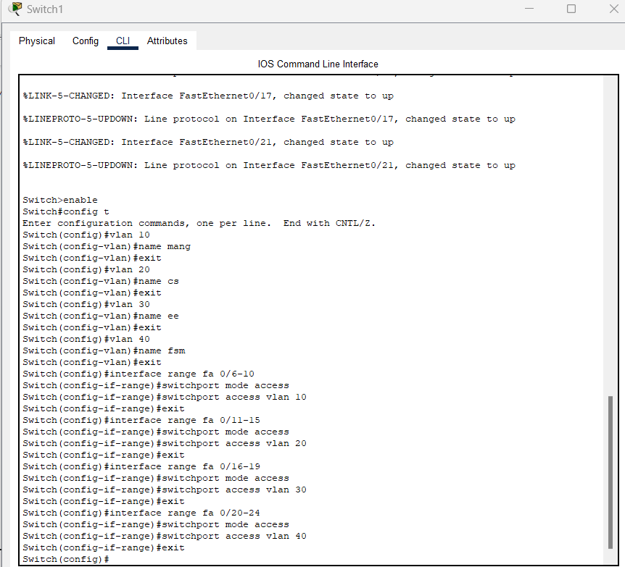
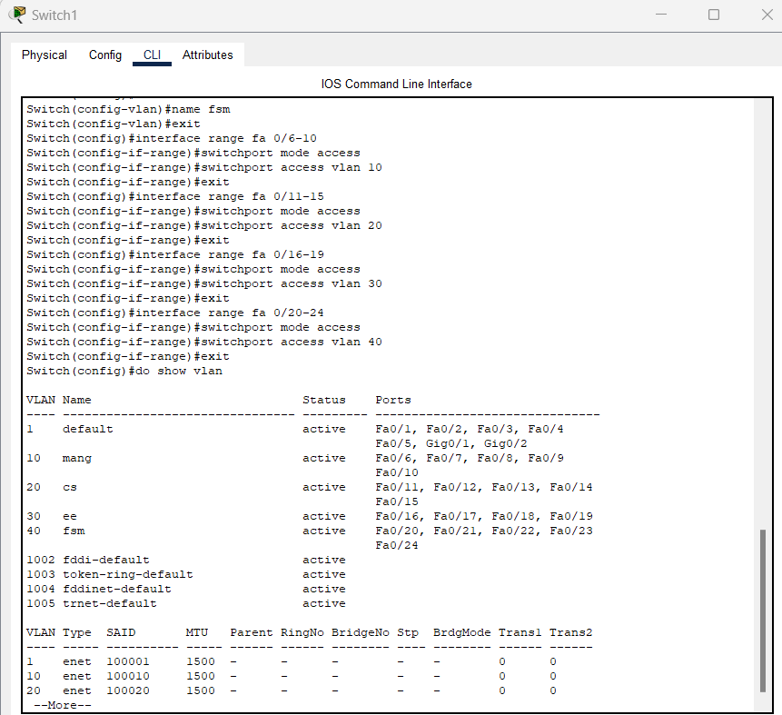
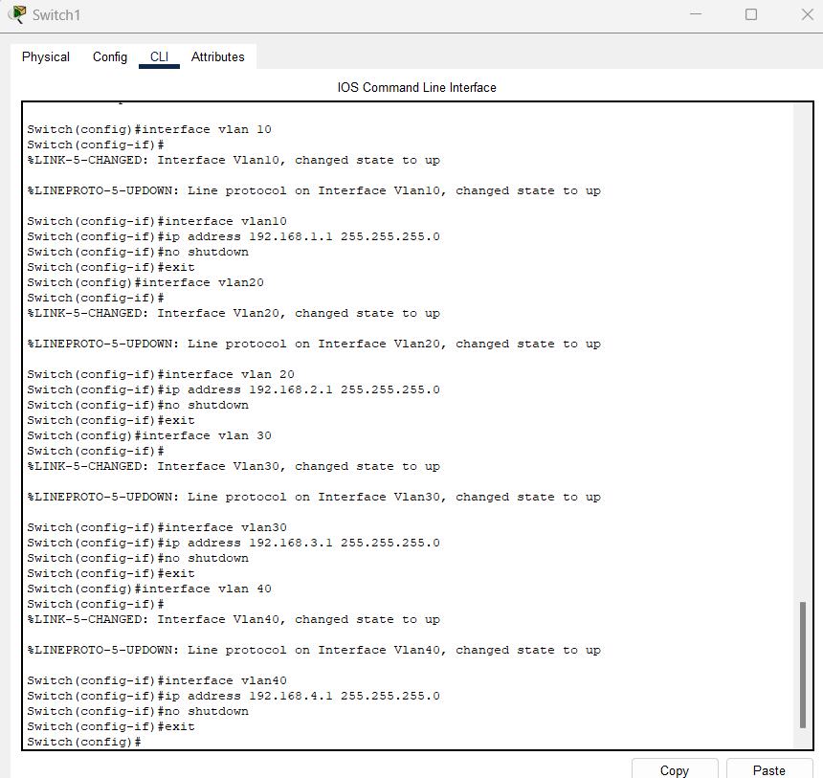
• Change name and password of both switches
1st switch
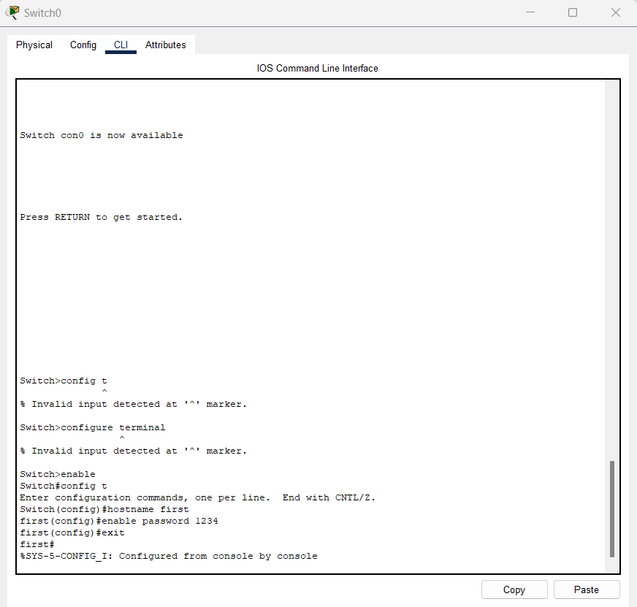
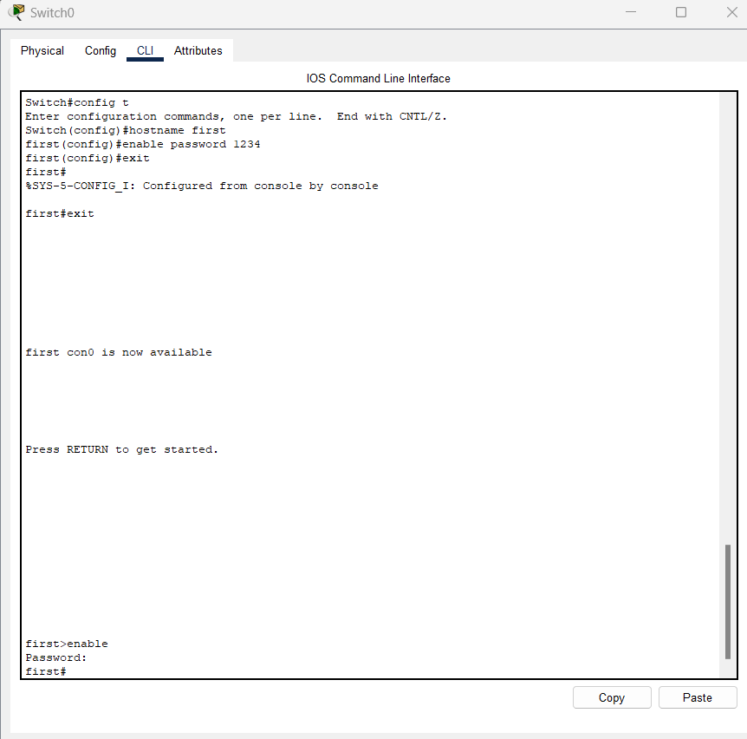

2nd switch
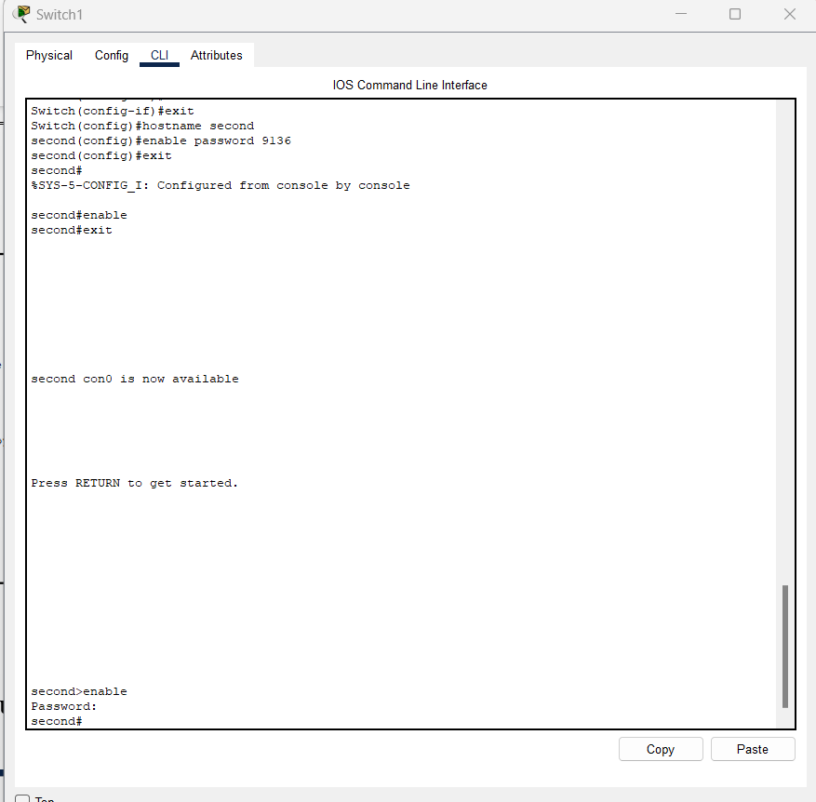

Question#2
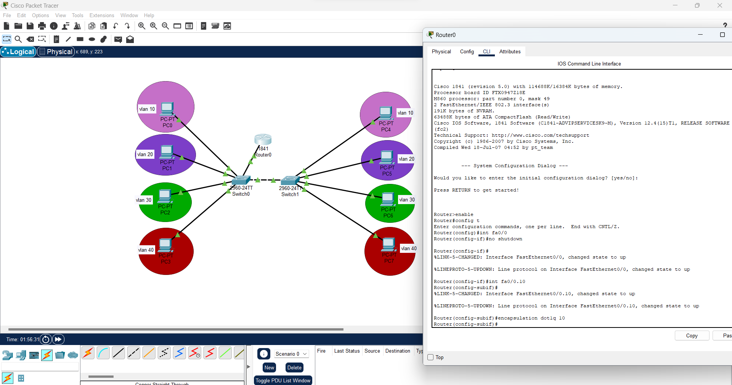
ANS:
Use 2 switch and configure both using following instructions:

• Use Telnet concept on both
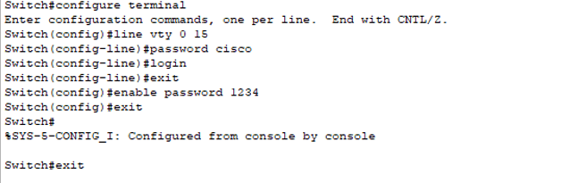
• Create vlan 10, 20, 30 and 40 on both switches A.
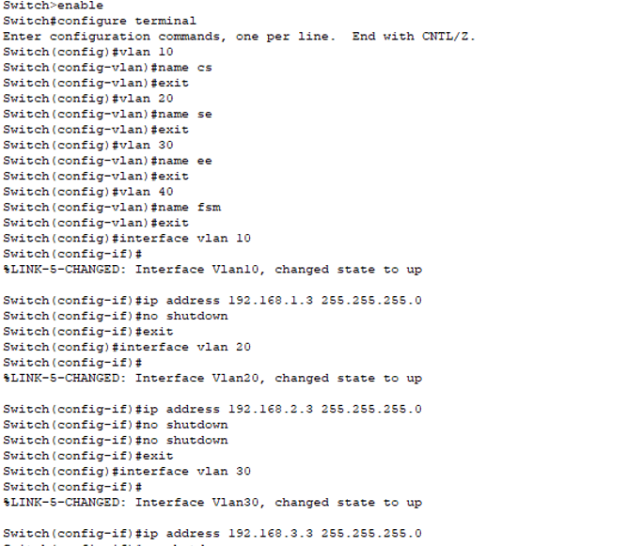
• Create vlan 50, 60, 70 and 80 on both switches B.
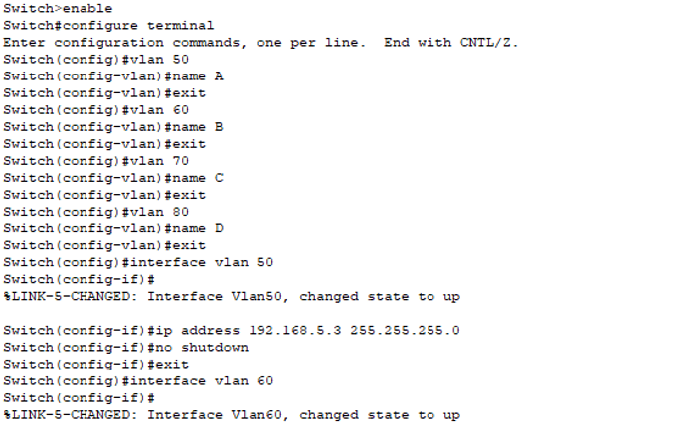
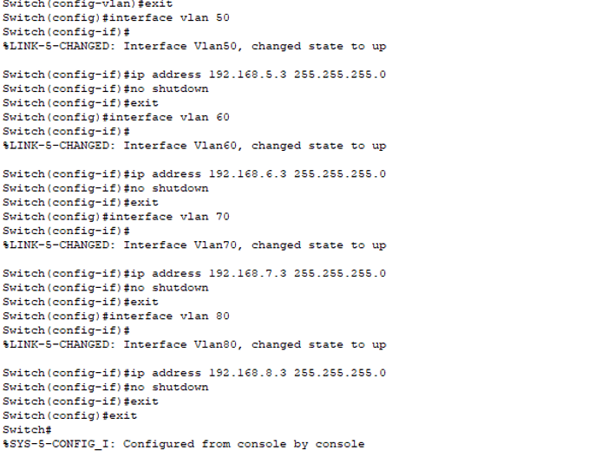

• Change name and password of both switches
1st switch
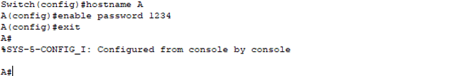
2nd switch
