Ayesha Naeem
21F-9190
Lab 12

Question No 01:
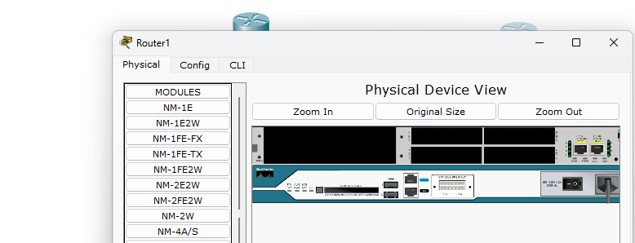
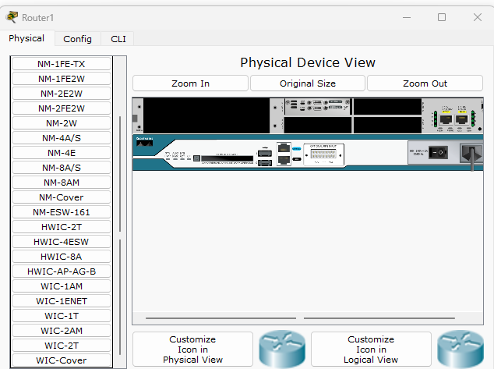

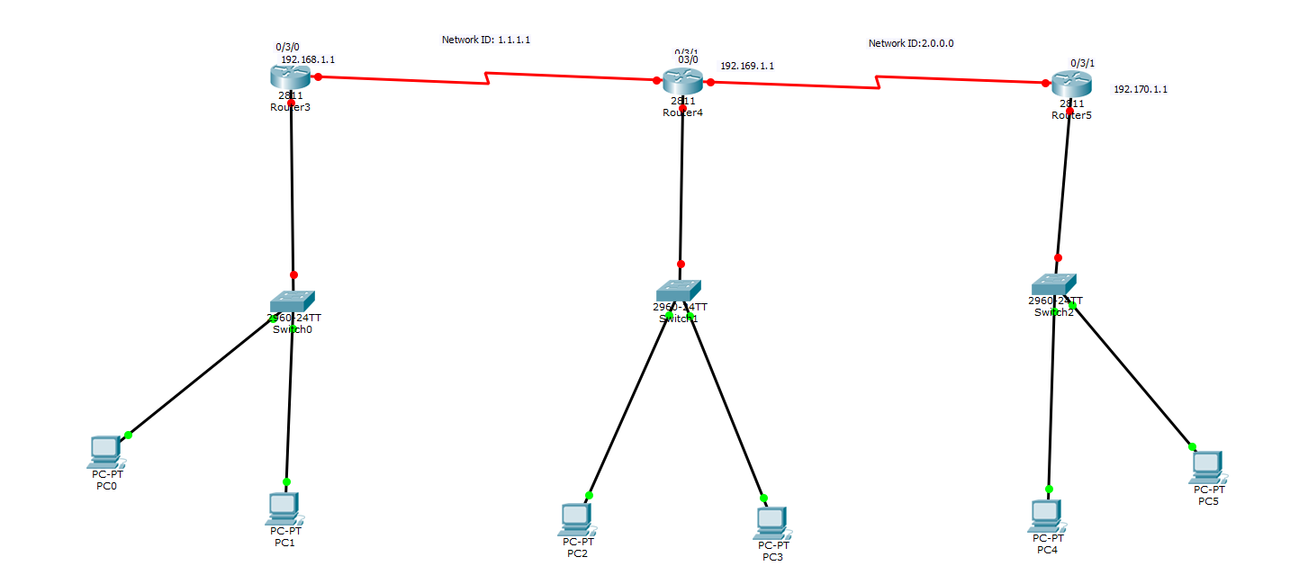
Changing the names of the routers:

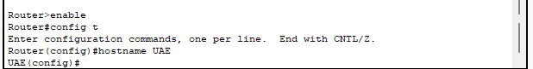
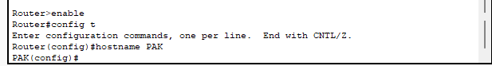
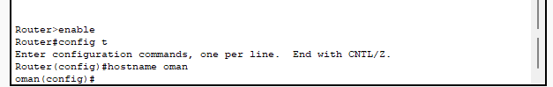

Assigning IP Address:
1st Router:
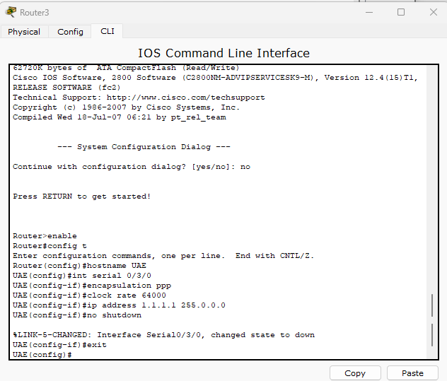
2nd Router:
Assign address 1.1.1.2 :
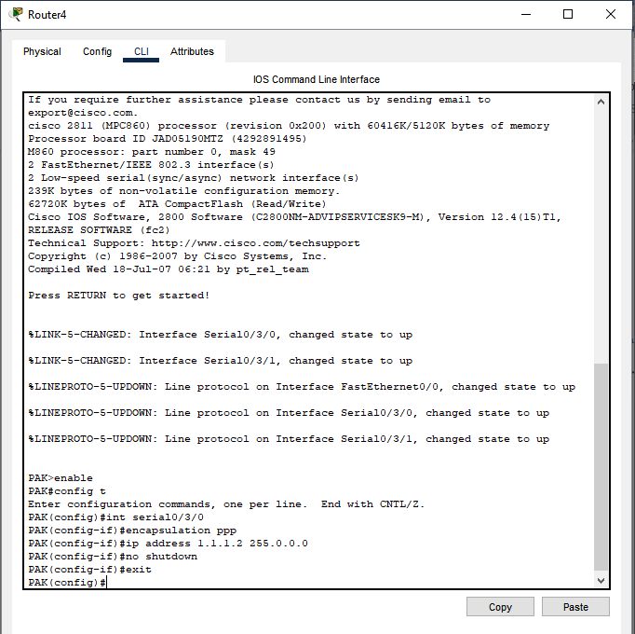

Assign address 2.1.1.2 :
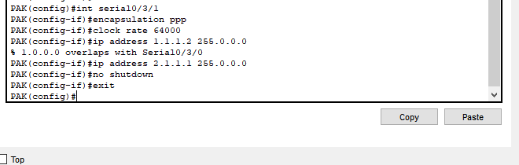
3rd Router:

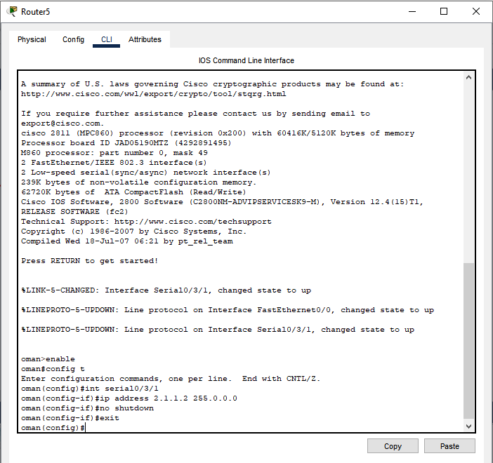
Assigning Router’s their whole Network Id:
1st Router:
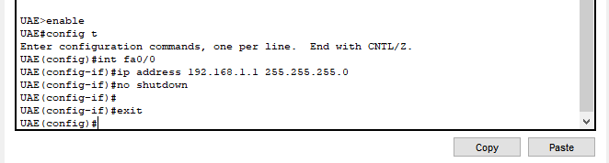
2nd Router:
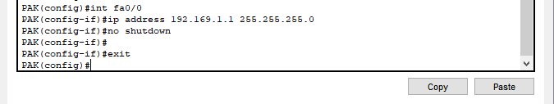
3rd Router:
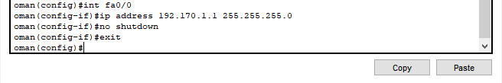

Assigning Router’s other Network Id’s:
1st Router:
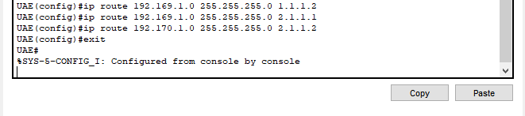
2nd Router:
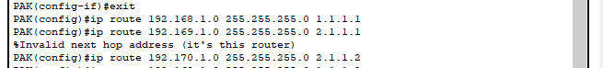
3rd Router:
