

Ayesha Zahid
BS Computer science
Batch Session: - BCS-6E
Roll No. 21F-9136
Course: - CN Lab 7
Course instructor: - Sir Ali
Submission Date: 03/06/24

Question #1
Open command prompt and set color light purple?
ANS:
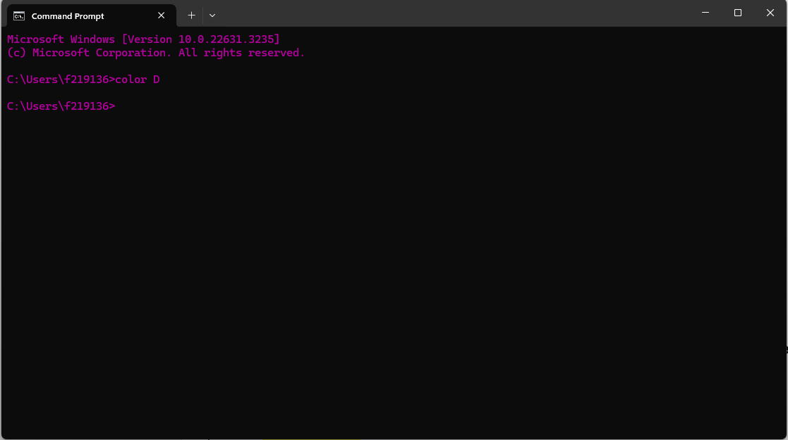
Question#2
What is Default gateway IP?
ANS:
Command: ipconfig
Home
Question#3
Run command “nslookup” and find IP address of website “wwww.facebook.com”?
ANS:
Command: nslookup (then write ) www.facebook.com
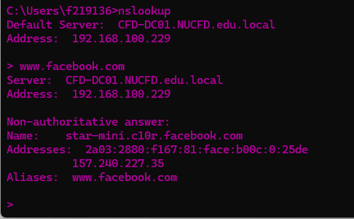
Home:
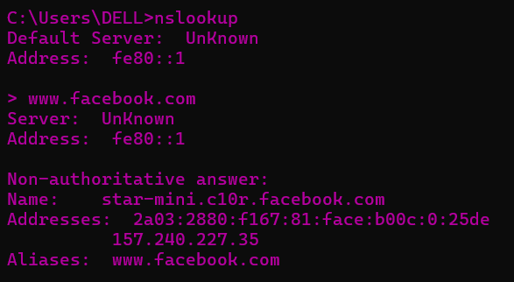
Question#4
Run command “tracert” and tell number of hops count?
ANS:
Command: tracert facebook ka ip
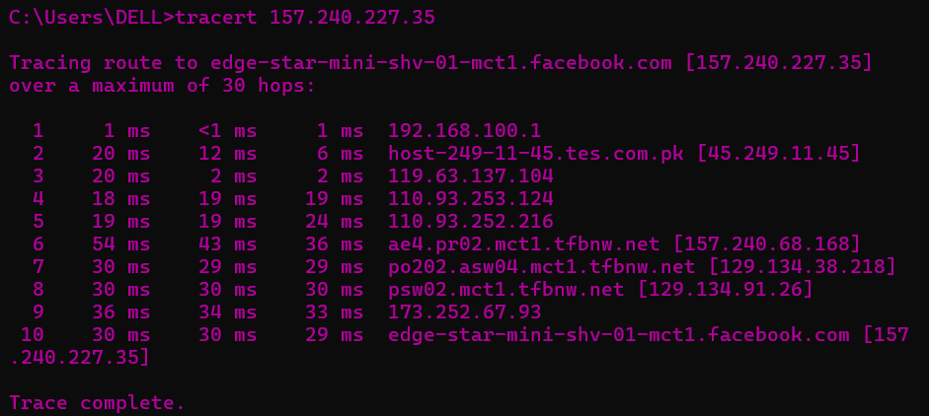
Question#5
What is TTL. Explain with proper example?
ANS:
TTL stands for Time to Live in the context of computer networks. It is a value in an IP packet that sets a limit on the number of hops (routers) the packet can pass through before being discarded.
The TTL field is an 8-bit binary number in the IPv4 header. It is primarily used to prevent packets from circulating indefinitely in the network in case of routing loops or other issues.
The TTL value is decremented by one each time the packet passes through a router. When the TTL reaches 0, the packet is discarded, and an ICMP error message may be sent back to the source host.
For example, let's say a computer sends an IP packet with TTL set to 5 to a destination server. As the packet travels through the network, each router it passes through will decrement the TTL value by one. If the packet passes through 6 routers before reaching the destination, the TTL will reach 0 at the 6th router, and the packet will be dropped.
TTL is a mechanism used in computer networks to prevent packets from circulating endlessly and helps ensure efficient routing and error detection in the network.
Question#6
What is loopback testing and perform it and tell that is loopback testing is successful or not?
ANS:
Loopback testing is a method used to test the functionality of a network adapter or a communication channel by sending data from a device and receiving it back without any external transmission. This test helps in verifying whether the network adapter or connection is working properly and able to send and receive data correctly.

To perform loopback testing, you can follow these steps:

1. Connect a loopback plug or adapter to the network adapter you want to test. A loopback plug is a device that loops the transmit signals to the receive signals on a network interface, simulating the network communication.

2. Send data from the device to the loopback plug or adapter. This data will be transmitted through the network adapter and looped back to the receive side.

3. Receive the looped-back data on the device and verify if it matches the data that was originally sent. If the received data is the same as the transmitted data, the loopback test is successful.

4. Check for any errors or discrepancies in the transmission and reception of data. If the received data is incorrect or missing, it indicates an issue with the network adapter or connection.

By performing loopback testing, you can ensure that the network adapter or communication channel is functioning correctly and is capable of sending and receiving data as expected.
Loopback testing command : ping 127.0.0.1
We specified this command for loopback testing.it also runs even without internet.
We use it to check is our device is capable of communication
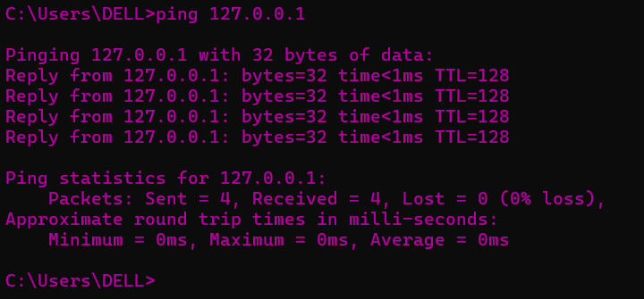
Question#7
Draw table in which explain the classes, ranges, public and private IP of IPv4?
ANS:
Classes | Ranges | Public IP | Private IP
A | 0-127 | N.H.H.H/8 | 10.0.0.0
B | 128-191 | N.N.H.H/16 | 172.16.0.0
C | 192-223 | N.N.N.H/24 | 192.168.0.0
D | 224-239 | / | /
E | 240-255 | / | /

Question#8
Calculate Network ID of 3 IP from classes A, B and C?
ANS:
Class A:
- IP address 15.10.20.30
- Subnet mask 255.0.0.0 ---> >1.0.0.0
- 15.10.20.30 & 1.0.0.0 -- > > 15.0.0.0
- Network ID: 15.0.0.0

Class B:
- IP address 172.31.45.67
- subnet mask 255.255.0.0---> >1.1.0.0
- 172.31.45.67 & 1.1.0.0 ---> >172.31.0.0
- Network ID: 172.31.0.0
Class C:
- IP address 192.168.5.10
- subnet mask 255.255.255.0---> >1.1.1.0
- 192.168.5.10 & 1.1.1.0 ---> >192.168.5.0
- Network ID: 192.168.5.0

Question#9
Design peer-to-peer architecture in which both PC’s ping to each other.
ANS:
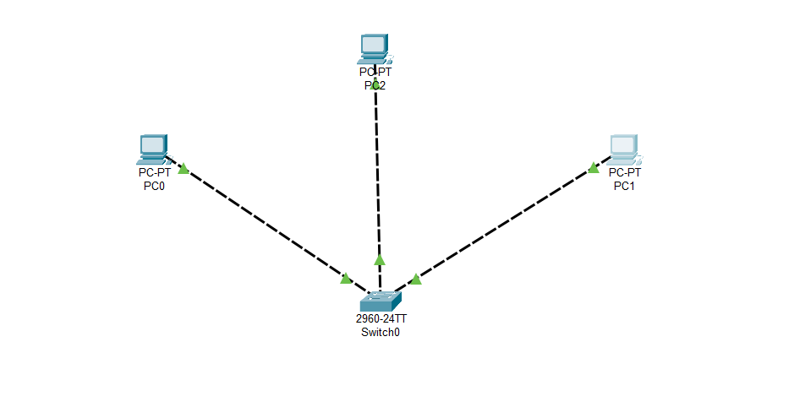
Question#10
Design start topology?
ANS:
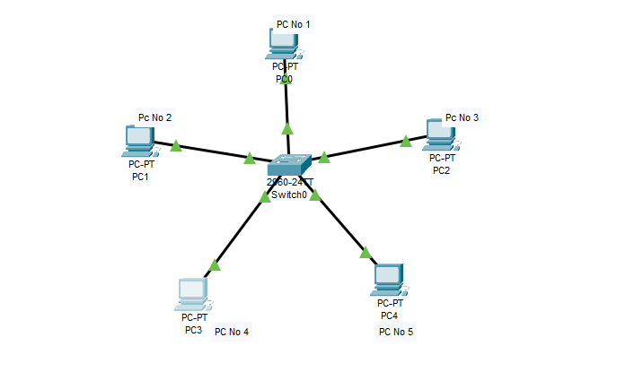
Question#11
Show mac address on switch
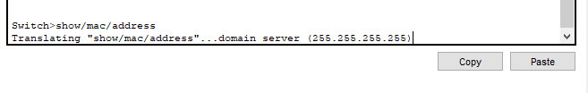
ANS:
Question#12
Design topology with following instructions: (5)
• Take 10 PC’s and connect with switch
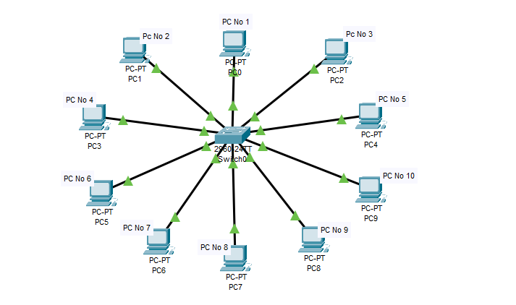
• Assign Ips
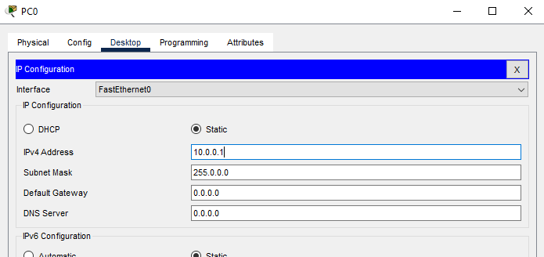
• Perform loopback testing of each computer
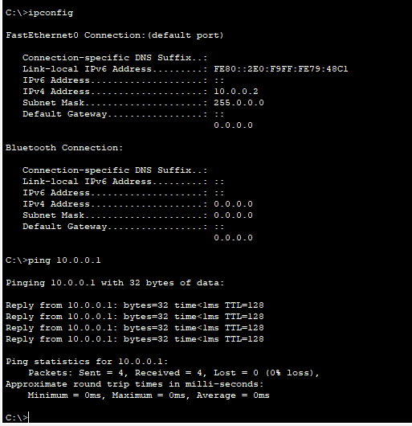
• Ping each computer with others.


