

Ayesha Zahid
BS Computer science
Batch Session: - BCS-6E
Roll No. 21F-9136
Course: - CN Lab 8
Course instructor: - Sir Ali
Submission Date: 21/03/24

Question #1
ANS:
There 15 departments in a university named d1, d2, d3, ……, d15 respectively. The
minimum IP requirements for hosts in departments d1, d2, d3, …….., d15 are 55, 28, 28, 12, 12,
12, 12, 3, 3, 3, 3, 4, 4, 4 and 4 respectively. We have only IP 194.168.99.0, use VLSM concept
and create subnetting for each department using following instructions. (15)
• Write network ID and broadcasting address for each department
• First and last useful IP for each department
• Write subnet mask for each department.
D1=>55
D2=>28
D3=>28
D4=>12
D4=>12
D4=>12
D4=>12
D4=>3
D4=>3
D4=>3
D4=>3
D4=>4
D4=>4
D4=>4
D4=>4
Vlsm
D1=>55
194.168.99.0
Subnet=>255.255.255.0
Network id=> 194.168.99.0
Broadcasting address=>194.168.99.63
Subnet mask=>255.255.255.192
D2=28
194.168.99.-
Subnet=>194.168.99.64/27
Network id=> 194.168.99.64
Broadcasting address=>194.168.99.95
Subnet mask=>255.255.255.244
D4=>d15=>d12
Subnet=>194.168.99.128/28
D4
Network id=> 194.168.99.128
Broadcasting address=>194.168.99.143
D5
Network id=> 194.168.99.144
Broadcasting address=>194.168.99.159
D6
Network id=> 194.168.99.160
Broadcasting address=>194.168.99.175

D7
Network id=> 194.168.99.176
Broadcasting address=>194.168.99.191
D8
Network id=> 194.168.99.192
Broadcasting address=>194.168.99.207
D9
Network id=> 194.168.99.208
Broadcasting address=>194.168.99.223
D10
Network id=> 194.168.99.224
Broadcasting address=>194.168.99.239
D11
Network id=> 194.168.99.240
Broadcasting address=>194.168.99.255
D12
Network id=> 194.168.100.0
Broadcasting address=>194.168.100.15
D13
Network id=> 194.168.100.16
Broadcasting address=>194.168.100.31
D14
Network id=> 194.168.100.32
Broadcasting address=>194.168.100.47

D15
Network id=> 194.168.100.48
Broadcasting address=>194.168.100.63
D1
First Usable IP=>194.168.99.1
Last Usable IP=>194.168.99.62
D2
First Usable IP: 194.168.99.65
Last Usable IP: 194.168.99.94
D3
First Usable IP: 194.168.99.97
Last Usable IP: 194.168.99.126
subnet mask
D1
Subnet: 194.168.99.0/26
D2
Subnet: 194.168.99.64/27
D3
Subnet: 194.168.99.96/27
D4
Subnet: 194.168.99.128/28
D5
Subnet: 194.168.99.144/28
D6
Subnet: 194.168.99.160/28
D7
Subnet: 194.168.99.176/28
D8
Subnet: 194.168.99.192/28
D9
Subnet: 194.168.99.208/28
D10
Subnet: 194.168.99.224/28
D11
Subnet: 194.168.99.240/28
D12
Subnet: 194.168.100.0/28
D13
Subnet: 194.168.100.16/28
D14
Subnet: 194.168.100.32/28
D15
Subnet: 194.168.100.48/28

Question#2
Create 4 virtual LAN with following instructions: (15)
• Change switch name with your name and password with last 4 digit of your roll
Number
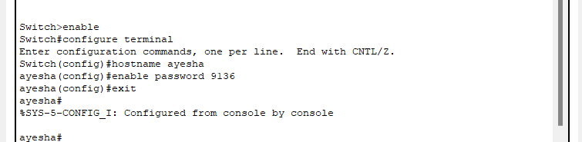
• Create four VLAN with name csdept, sedept, eedept and shdet
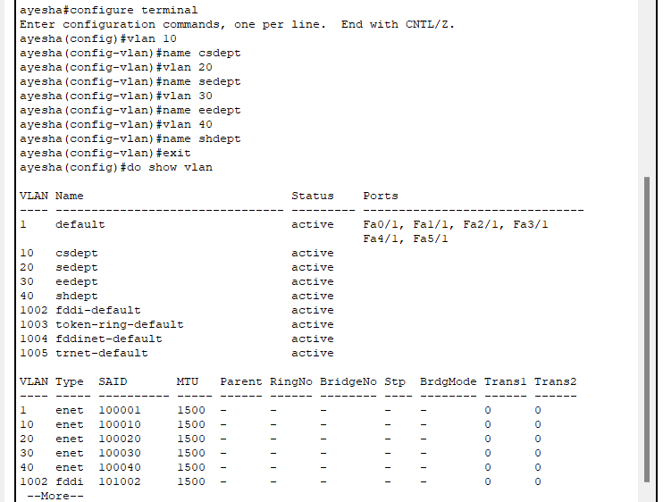
• Put 5, 6, 6 and 6 fastethernet interfaces in VLAN respectively.
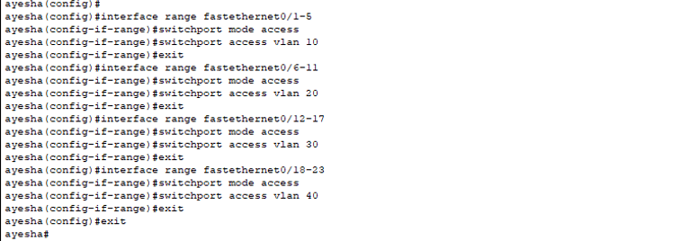

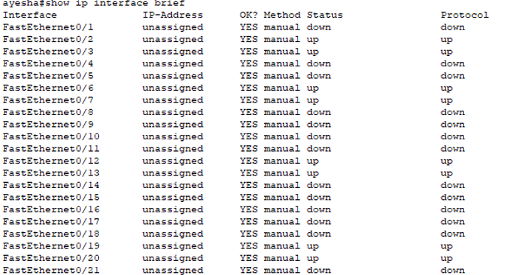

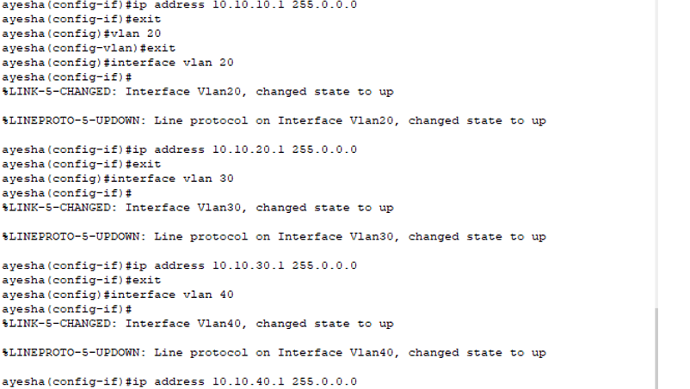

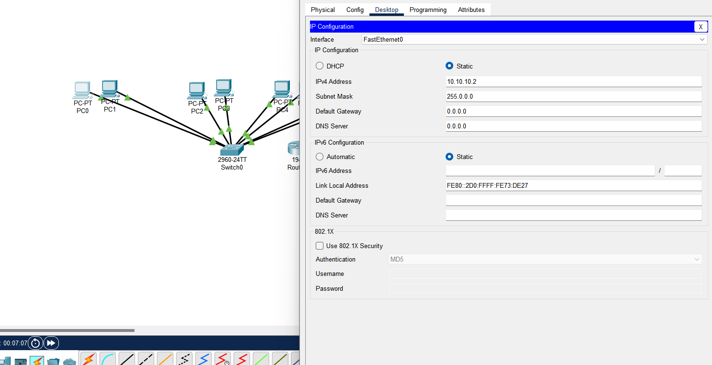
• Attach Router and ping intra VLAN communication
ANS:
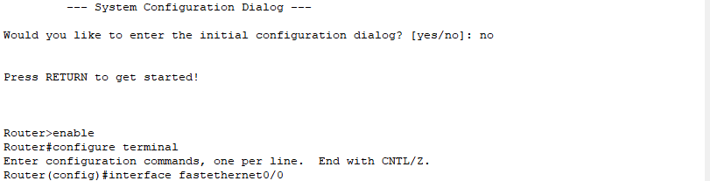
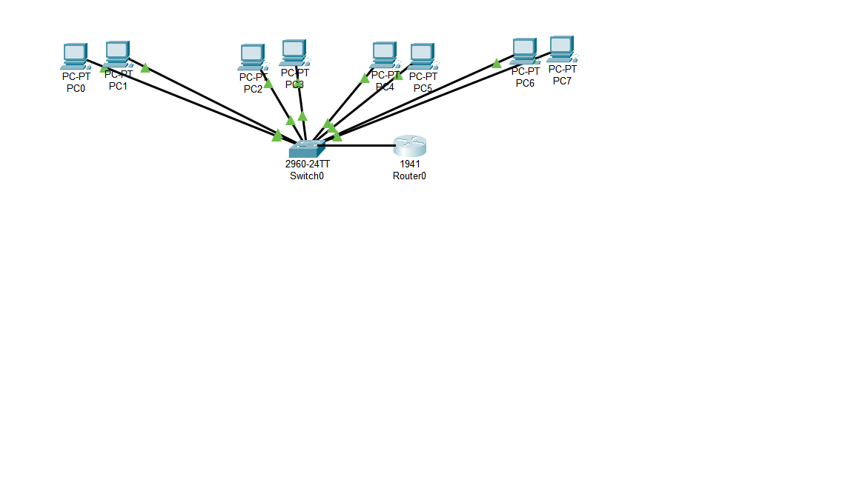
Ping
