

Ayesha Zahid
BS Computer science
Batch Session: - BCS-6E
Roll No. 21F-9136
Course: - web lab 3
Course instructor: - Mam Sumaira
Submission Date: 17/2/24

Question # 1
https://github.com/Aisha-Zahid/Web-programming-course
Question # 2
Code
<!DOCTYPE html>
<html lang="en">
<head>
<meta charset="UTF-8">
<meta http-equiv="X-UA-Compatible" content="IE=edge">
<meta name="viewport" content="width=device-width, initial-scale=1.0">
<link rel="icon" type="image/x-icon" href="form.webp">
<title>Signup Form</title>
<script>
function validateForm()
{
var username = document.getElementById('username').value;
var password = document.getElementById('password').value;
var birthdate = document.getElementById('birthdate').value;
var email = document.getElementById('email').value;
var gender = document.getElementById('gender').value;
var phoneNumber = document.getElementById('phone').value;
var zipCode = document.getElementById('zipcode').value;
var country = document.getElementById('country').value;

if (username === '')
{
alert('Username is required');
return false;
}
if (password === '')
{
alert('Password is required');
return false;
}
if (birthdate === '')
{
alert('BirthDate is required');
return false;
}
if (email === '')
{
alert('Email is required');
return false;
}
if (gender === '')
{
alert('Gender is required');
return false;
}
if (phone === '')
{
alert('Phone is required');
return false;
}
if (zipCode === '')
{
alert('Zipcode is required');
return false;
}
if (country === '')
{
alert('Country is required');
return false;
}
if (submit === submit)
{
alert('Submitted!');
return false;
}

return true;
}
</script>
</head>
<body style="background-color:rgb(193, 110, 127);">
<h1>Signup Form</h1>
<img src="form3.png" alt="" style="height: 150px;">
<form onsubmit="return validateForm()">
<br>
<input type="text" id="username" name="username" placeholder="Username"><br><br>

<input type="password" id="password" name="password" placeholder="Password"><br><br>

<input type="date" id="birthdate" name="birthdate" placeholder="Birthdate"><br><br>

<input type="email" id="email" name="email" placeholder="Email"><br><br>

<select id="gender" name="gender" placeholder="Gender">
<option value="male">Male</option>
<option value="female">Female</option>
<option value="other">Other</option>
</select><br><br>

<input type="text" id="phone" name="phone" placeholder="Phone Number"><br><br>

<input type="text" id="zipcode" name="zipcode" placeholder="Zip Code"><br><br>

<input type="text" id="country" name="country" placeholder="Country"><br><br>

<input style="background-color: rgb(148, 182, 218);" type="submit" value="Submit">
</form>
</body>
</html>

Output
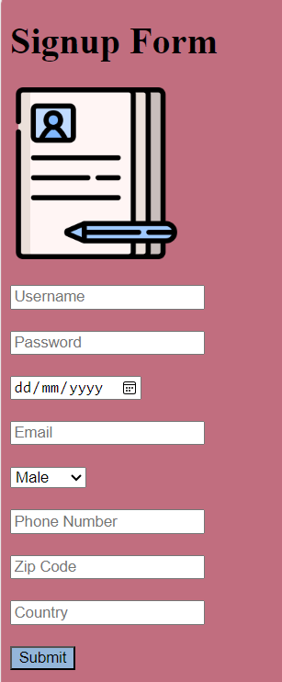
Question # 3
Code
<!DOCTYPE html>
<html>
<head>
<meta charset="UTF-8">
<meta http-equiv="X-UA-Compatible" content="IE=edge">
<meta name="viewport" content="width=device-width, initial-scale=1.0">
<link rel="icon" type="image/x-icon" href="imgg.jpeg">
<link rel="stylesheet" href="https://stackpath.bootstrapcdn.com/bootstrap/4.5.2/css/bootstrap.min.css" integrity="sha384-JcKb8q3iqJ61gNV9KGb8thSsNjpSL0n8PARn9HuZOnIxN0hoP+VmmDGMN5t9UJ0Z" crossorigin="anonymous">
<title>web-page</title>
<style>
body {
padding-top: 4rem;
padding-bottom: 4rem;
background-color: #f5f5f5;
}
.jumbotron {
background-color: white;
padding: 2rem;
margin-bottom: 0;
border-radius: 0;
}
.lead {
font-size: 1.5rem;
}
.picture {
width: 100%;
height: auto;
}
.end{
background-color: rgb(126, 202, 147);
text-align: center;
}
</style>
</head>
<body>
<div class="container">
<div class="jumbotron">
<h1 class="display-4">Welcome to our website!</h1>
<p class="lead">Look at this button! Wow, let's click on it!</p>
<a class="btn btn-primary btn-lg" href="#" role="button">Learn more</a>
</div>

<div class="row">
<div class="col-md-4">
<h2 style="background-color: rgb(203, 201, 205);">&nbsp;&nbsp;&nbsp;&nbsp;&nbsp;Strawberry Fields!</h2>
<img class="picture" src="pic.webp" alt="">
<p>Fuga repellat, quo, qui illum voluptatibus esse corporis aut quia deserunt voluptatem, consequatur. Voluptatum repellendus, recusandae aliquid nemo perspiciatis debitis, beatae minus.</p>
</div>
<div class="col-md-4">
<h2 style="background-color: rgb(203, 201, 205);">&nbsp;&nbsp;&nbsp;&nbsp;&nbsp;&nbsp;&nbsp;&nbsp;&nbsp;&nbsp;&nbsp;&nbsp;Pink Pot!</h2>
<img class="picture" src="flower" alt="">
<p>Fuga repellat, quo, qui illum voluptatibus esse corporis aut quia deserunt voluptatem, consequatur. Voluptatum repellendus, recusandae aliquid nemo perspiciatis debitis, beatae minus.</p>
</div>
<div class="col-md-4">
<h2 style="background-color: rgb(203, 201, 205);">&nbsp;&nbsp;&nbsp;&nbsp;&nbsp;&nbsp;&nbsp;&nbsp;&nbsp;&nbsp;&nbsp;&nbsp;&nbsp;Kawaii!</h2>
<img class="picture" src="imgg.jpeg" alt="">
<p>Fuga repellat, quo, qui illum voluptatibus esse corporis aut quia deserunt voluptatem, consequatur. Voluptatum repellendus, recusandae aliquid nemo perspiciatis debitis, beatae minus.</p>
</div>
</div>

<div class="end">
<a style="color: rgb(245, 243, 241);font-style: italic;"><b>Thanks For Visiting!</b></a>
</div>

</div>
</body>
</html>

Output
