PAPER
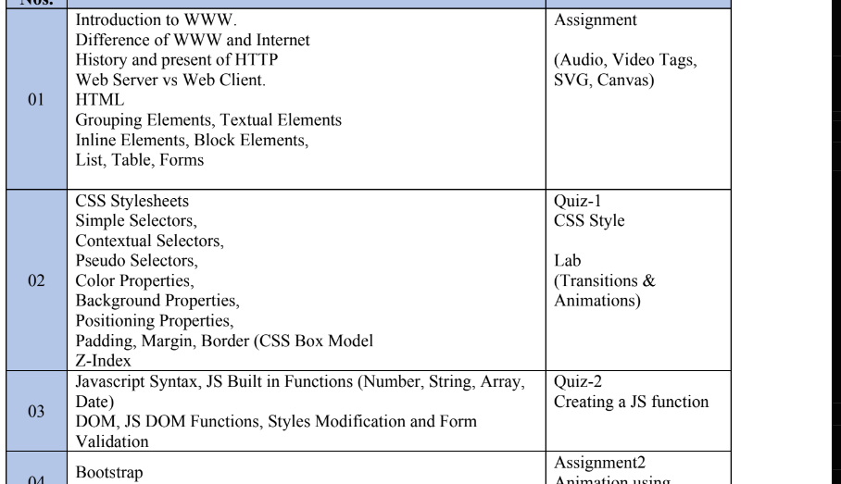

HTML Dom https://www.w3schools.com/whatis/whatis_htmldom.asp
1- A responsive html page in paper
2-header footer also included
3-images moving (slideshow)
4-sections divisions
5-explore hacks of vs code for web
6-sections used in html instead of div to classify things
7-html tags cheat sheet will be provided
8- frameset frame9- ordered unordered list
9- tables in html
10- colspan for collapsing columns in a row
11- rowspan for collapsing rows in a column
12- forms in html --- all things in this
13-flex box
CSS
Internal external
Style=”color:red”

<style>
body {background-color: powderblue;}
h1 {color: blue;}
p {color: red;}
</style>
</head>
<body>

- Z-index
- Selectors
- Universal selection *
- Css grouping selector
- H1{}
- H2{}
- H1,H2{}
- Css class selector
- Id preference > class preference
- Id is unique (can be common but good approach is to use it unique)
- p.center
- url/image can also be written in css rather than in html only
- Margin top right bottom left margin: 10 15 20 60
- Border
- Padding
- Content
- SAAS
- Functions css rotate etc
- 2d transform
- Transform
- Scale() method transform: scale(2,3)
- transform: matrix(2,3)
- css 3d transform
- transitions animations are in it transformations
- @keyframes rule
- Animations in css paper linear ease etc
- Animation duration
- Animation shorthand property all things in one function all in one function

BOOTSTRAP – 5 (it’s a framework)
- Responsive design and in
- Content deliver network CDN
- Complied css and js
- BREAKPOINTS
- Classes name
- Col/sm/6 this is a class name not included in cheat sheet
- Add file by own / no link /
- Customize your page
- Node download sass
- Run disk
- Grid system -> classes
- Container class
- Container fluid
- Do responsiveness by using bootstrap
- Means that page changes itself for mobile/pc/tab

JAVASCRIPT
Event lisners
On mouse
DOM
Tag that does not exist – how to implement in js
Content display on click button
.getid
.style.
Create element
After clicking on button js function trigger
It’s a flexible language even if tags are not defined in html you can still do it on js

Array elements access and display
Button click element show and hide

9092

