

Ayesha Zahid
BS Computer science
Batch Session: - BCS-6E
Roll No. 21F-9136
Course: - web lab 2
Course instructor: - Mam Sumaira
Submission Date: 15/2/24

Question # 1
Code
<!DOCTYPE html>
<html lang="en">
<head>
<style>
.button {
background-color: #04AA6D;
border: none;
color: white;
padding: 15px 10px;
text-align: center;
display: inline-block;
font-size: 16px;
margin: 4px 2px;
cursor: pointer;
}
</style>
<meta charset="UTF-8">
<meta name="viewport" content="width=device-width, initial-scale=1.0">
<title>TASK1</title>
</head>
<body>

<H1>Start CSS Excercise</H1>
<p>Good Luckk!</p>
<button class="button">Start Css Excercises ></button>
</body>
</html>

Output
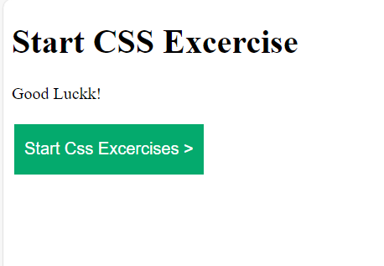

Question # 2
Code
<!DOCTYPE html>
<html lang="en">
<head>

<meta charset="UTF-8">
<meta name="viewport" content="width=device-width, initial-scale=1.0">
<title>TASK2</title>
</head>
<body style="background-color:rgb(176, 189, 230);">
<form >
<label for="fname">First name:</label>
<input type="text" id="fname" name="fname"><br><br>
<label for="lname">Last name:</label>
<input type="text" id="lname" name="lname"><br><br>
<label for="password">Password:</label>
<input type="text" id="password" name="password"><br><br>
<label for="Number">Number:</label>
<input type="text" id="number" name="number"><br><br>
<label for="email-id">Email-id:</label>
<input type="text" id="email-id" name="email-id"><br><br>
<input type="submit" value="Register">
</form>

</body>
</html>

Output
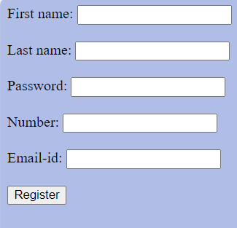
Question # 3
Code
<!DOCTYPE html>
<html>
<head>
<meta name="viewport" content="width=device-width, initial-scale=1">
<style>
.card {
box-shadow: 0 4px 8px 0 rgba(192, 70, 70, 0.2);
transition: 0.3s;
width: 40%;
}
.container {
padding: 2px 16px;
}
</style>
</head>
<body>

<div class="card">
<img src="cinque-terre.jpg" alt="Avatar" style="width:100%">
<div class="container">
<p style="text-align: center;">cinque terre</p>
</div>
</div>

</body>
</html>

Output
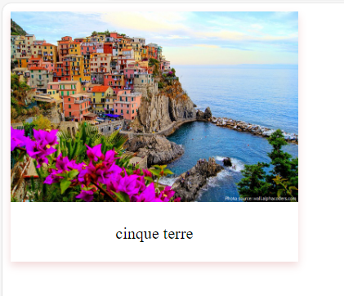
Question # 4
Code
<!DOCTYPE html>
<html>
<head>
<meta name="viewport" content="width=device-width, initial-scale=1">
<style>
@keyframes slidein {
0% {
margin-left: 0%;
}

100% {
margin-left: 50%;
}
}
.card {
box-shadow: 0 4px 8px 0 rgba(192, 70, 70, 0.2);
transition: 0.3s;
width: 30%;
animation-duration: 5s;
animation-name: slidein;

animation-delay: 5s;
}
.container {
padding: 2px 16px;
}
</style>
</head>
<body>

<div class="card">
<img src="cinque-terre.jpg" alt="Avatar" style="width:100%">
<div class="container">
<p style="text-align: center;">cinque terre</p>
</div>
</div>

</body>
</html>

Output
