DevOps Engineer Technical Assignment
Production-like Application on AWS Free Tier
Final Report — Setup, Results, Challenges and Improvements
Aisha — July 2026
github.com/Aisha-gif2003/-devops-assignment

1. Objective and Architecture
Design, deploy, secure, monitor and document a production-like Node.js application on AWS Free Tier, with automated CI/CD, monitoring, log collection and load testing.
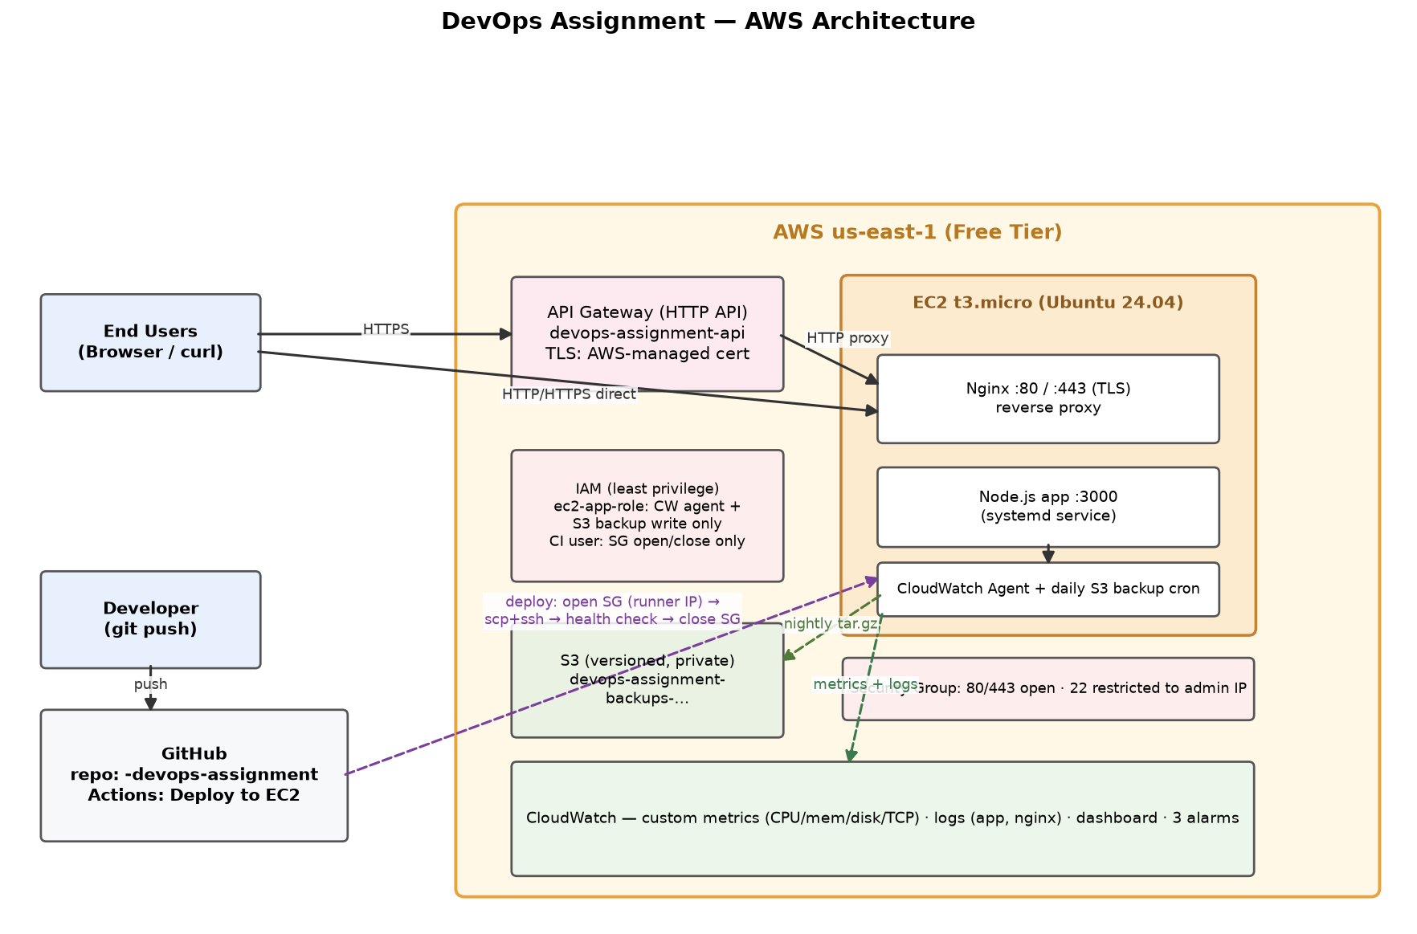
Request path: users reach the app either directly (Nginx on EC2, HTTP/HTTPS) or through an API Gateway HTTP API that provides a fully trusted TLS endpoint. Nginx reverse-proxies to the Node.js service on localhost:3000. The instance ships metrics and logs to CloudWatch and uploads nightly backups to a private S3 bucket.

Live endpoints
Channel | URL
Direct HTTP | http://54.80.171.245/
Direct HTTPS (self-signed) | https://54.80.171.245.nip.io/
API Gateway (trusted TLS) | https://tunjy62f54.execute-api.us-east-1.amazonaws.com/

2. Infrastructure Setup
Resource | Details
EC2 | i-0a9df4800e23576b3 — t3.micro, Ubuntu 24.04, us-east-1
Web tier | Nginx :80/:443 (TLS 1.2/1.3, HSTS) → Node.js :3000 (systemd, auto-restart)
S3 | devops-assignment-backups-333888905061 — versioned, all public access blocked
API Gateway | HTTP API devops-assignment-api, proxy integration to EC2
IAM | 3 least-privilege principals (instance role, CI user, admin CLI user)
Backups | Daily 02:00 UTC cron: app + logs → tar.gz → S3 via instance role

3. CI/CD Pipeline (GitHub Actions)
Trigger: every push to main. Pipeline stages:
- Syntax test: node --check server.js
- Configure AWS credentials for a dedicated github-actions-ci IAM user whose only permission is opening/closing ingress on the deploy security group
- Detect the runner’s public IP and temporarily authorize it on port 22
- Copy files via scp, execute deploy.sh over SSH
- Automated health check: curl must return the app page or the run fails
- Always-run cleanup step revokes the runner’s SSH rule, even when the deploy fails
Result: SSH is never open to the internet, yet deploys are fully automated with zero standing access.

4. Security Summary
- Security group: only 80/443 public; SSH restricted to the administrator’s IP (was found open to 0.0.0.0/0 during audit and remediated)
- App port 3000 is reachable only via localhost — never exposed
- Instance role: CloudWatch agent policy + write access scoped to the single backup bucket
- CI credentials can manage one security group and nothing else — a leaked key has minimal blast radius
- S3 backup bucket: versioning on, public access fully blocked
- HTTPS: TLS on Nginx (self-signed — no owned domain) plus a trusted AWS-managed certificate via API Gateway
- Off-host logging to CloudWatch makes logs tamper-evident
Known gaps and future work: scope down the human admin user from AdministratorAccess, move deploys to SSM to eliminate SSH entirely, add WAF/rate limiting, use a real domain with ACM.

5. Monitoring and Logging
- CloudWatch agent publishes 1-minute CPU, memory, disk and TCP metrics under the DevOpsAssignment namespace
- Log groups: /devops-assignment/app, /devops-assignment/nginx-access, /devops-assignment/nginx-error
- Dashboard DevOpsAssignment-Dashboard: CPU, memory, disk, network, TCP connections, status checks and a live app-log tail
- Alarms: HighCPU (>80% for 5 min), HighMemory (>85%), StatusCheckFailed — all verified in OK state

6. Load Testing and Performance
Tool: Locust 2.44.4, staged profile 25 → 50 → 100 concurrent users over ~5.5 minutes, run from a local machine against the public endpoint (figures therefore include real internet round-trip of ~250 ms).
Metric | Value
Total requests | 11,978
Error rate | 0.00% (zero failures)
Peak throughput | ~65 req/s at 100 users
Median / p95 / p99 response | 270 ms / 320 ms / 490 ms
Peak EC2 CPU | 3.3%
EC2 memory | ~31% steady, no growth
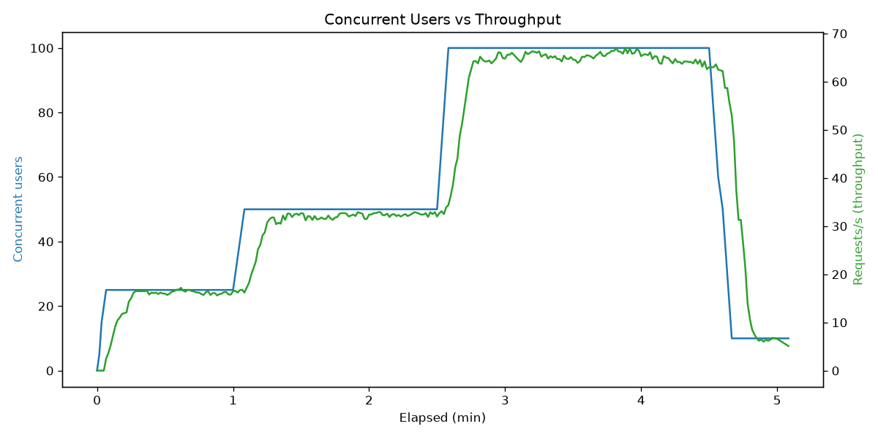
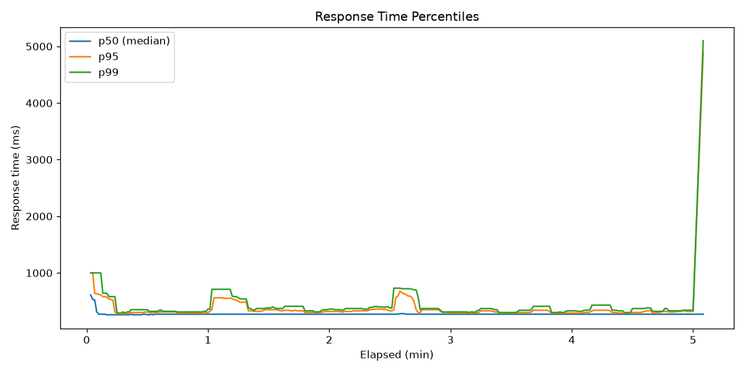
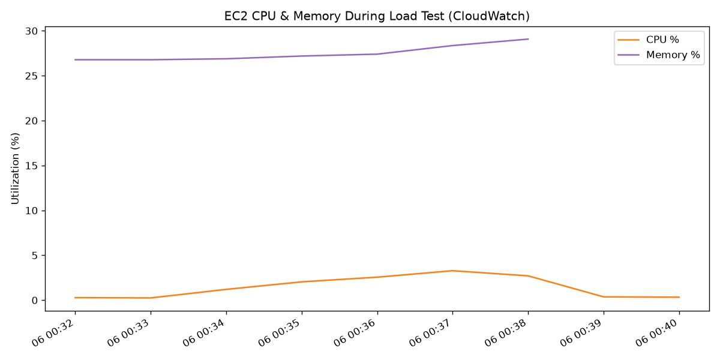

Bottleneck analysis
Throughput scaled linearly with user count and response times stayed flat at the network-RTT floor — the server was never the limiting factor. At 65 req/s the instance used 3.3% CPU, so the first real limits would be Nginx connection defaults, t3.micro CPU burst credits, and the single-process Node event loop.

Optimization recommendations
- Enable Nginx upstream keepalive and raise worker_connections
- Run Node in cluster mode to use both vCPUs
- Add CloudFront (or any CDN) for cacheable payloads to cut latency and origin load
- For horizontal scale: ALB + Auto Scaling Group; health checks already exist
- Alarm on CPUCreditBalance to catch burst-credit exhaustion early

7. Challenges Faced and Fixes
- GitHub Actions SSH failures (“invalid openssh private key format”): the EC2_SSH_KEY secret contained Windows CRLF line endings. Fixed by re-uploading the PEM with LF endings — the repo commits could never fix this because secrets live outside git.
- CloudWatch agent could not read Nginx logs (permission denied): fixed by adding the cwagent user to the adm group.
- HTTPS without a domain: public CAs cannot issue for a bare IP; used a self-signed certificate for the nip.io hostname and API Gateway for a trusted-TLS path, documented as a trade-off.
- Securing CI SSH access without breaking automation: solved with the temporary security-group rule pattern and a purpose-built IAM user.

8. Deliverables Checklist
Deliverable | Location
Git repository | github.com/Aisha-gif2003/-devops-assignment
Deployment guide | docs/DEPLOYMENT_GUIDE.md
Architecture diagram | docs/architecture.png
Pipeline configuration | .github/workflows/deploy.yml
Monitoring screenshots | CloudWatch dashboard/alarms (captured separately)
Load testing report | loadtest/LOAD_TEST_REPORT.md + results/report.html
Security summary | docs/SECURITY_SUMMARY.md
Demo video | recorded separately (5–10 min)
Final report | this document

