Part 2
2.1:
The UNF given in Appendix-B is un-normalized, we normalize it by steps 1NF2NF3NF. Because one student can have multiple loans, causing repeating groups.
- 1NF
We make everything atomic (no repeating groups)
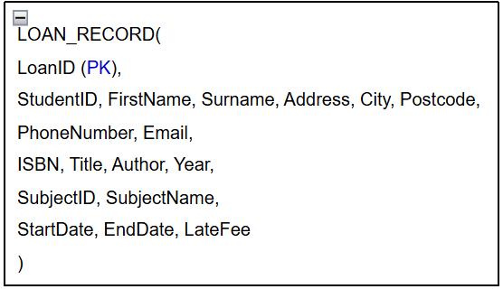
- 3NF
We fix transitive dependency (Subject)
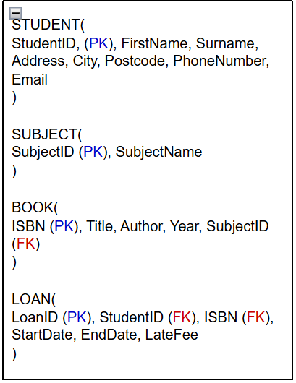
- UNF
Un-normalized form
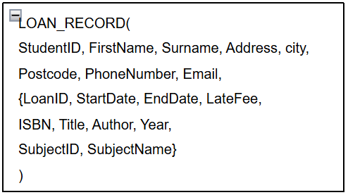

- 2NF
We split into tables
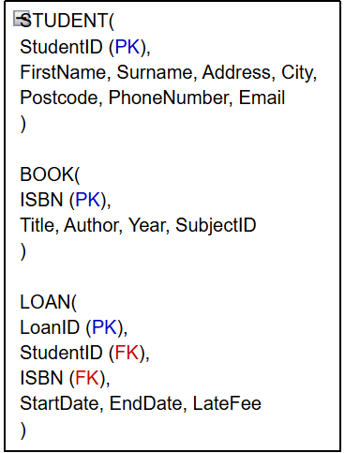

2.2:
Conceptual (ERD) using crow’s foot notation, to sow entities and relationships.
SUBJECT
BOOK
LOAN
STUDENT

- A STUDENT can have 0 or many loans, each LOAN has 1 student.
- Each LOAN has 1 book, a BOOK can be in many loans.
- Each BOOK has 1 subject, a SUBJECT can have many books.

2.3:
SUBJECT
SubjectID (PK), SubjectName
Using the conceptual (ERD), we transform it into a logical (ERD) using crow’s foot notation; which shows entities, attributes, relationships, and primary/foreign keys.
LOAN
LoanID (PK), StudentID (FK), ISBN (FK), StartDate, EneDate, LateFee
STUDENT
StudentID (PK),
FirstName, Surname, Address, City, Postcode, PhoneNumber, Email
BOOK
ISBN (PK), Title, Author, Year, SubjectID (FK)

2.4:
LOAN
Attribute | Data Type | Size | Null | Key
LoanID  StudentID  ISBN  StartDate  EndDate  LateFee | Number  Number  Short Text  Date/Time  Date/Time  Currency | Long Integer  Long Integer  20  -  -  - | No  No  No  No  No  No | PK  FK  FK
STUDENT
Attribute | Data type | Size | Null | Key
StudentID  FirstName  Surname  Address  City  Postcode  PhoneNumber  Email | Number  Short Text  Short Text  Short Text  Short Text  Short Text  Short Text  Short Text | Long integer  50  50  100  50  15  20  100 | No  No  No  No  No  No  Yes  No | PK
Physical (ERD), it is adding implementation details (Data types, Field sizes, Null/ not null, PK/FK) to your logical (ERD).

BOOK
Attribute | Data Type | Size | Null | Key
ISBN  Title  Author  Year  SubjectID | Short Text  Short Text  Short Text  Number  Short Text | 20  150  100  Integer  10 | No  No  No  No  No | PK  FK

SUBJECT
Attribute | Data Type | Size | Null | Key
SubjectID  SubjectName | Short Text  Short Text | 10  50 | No  No | PK

2.5:
Access: The database was implemented in Microsoft Access based on the Physical (ERD). Tables were created with appropriate data types and relationships were established using primary and foreign keys. Referential integrity was enforced to maintain consistency between the tables and no fake connections were allowed.

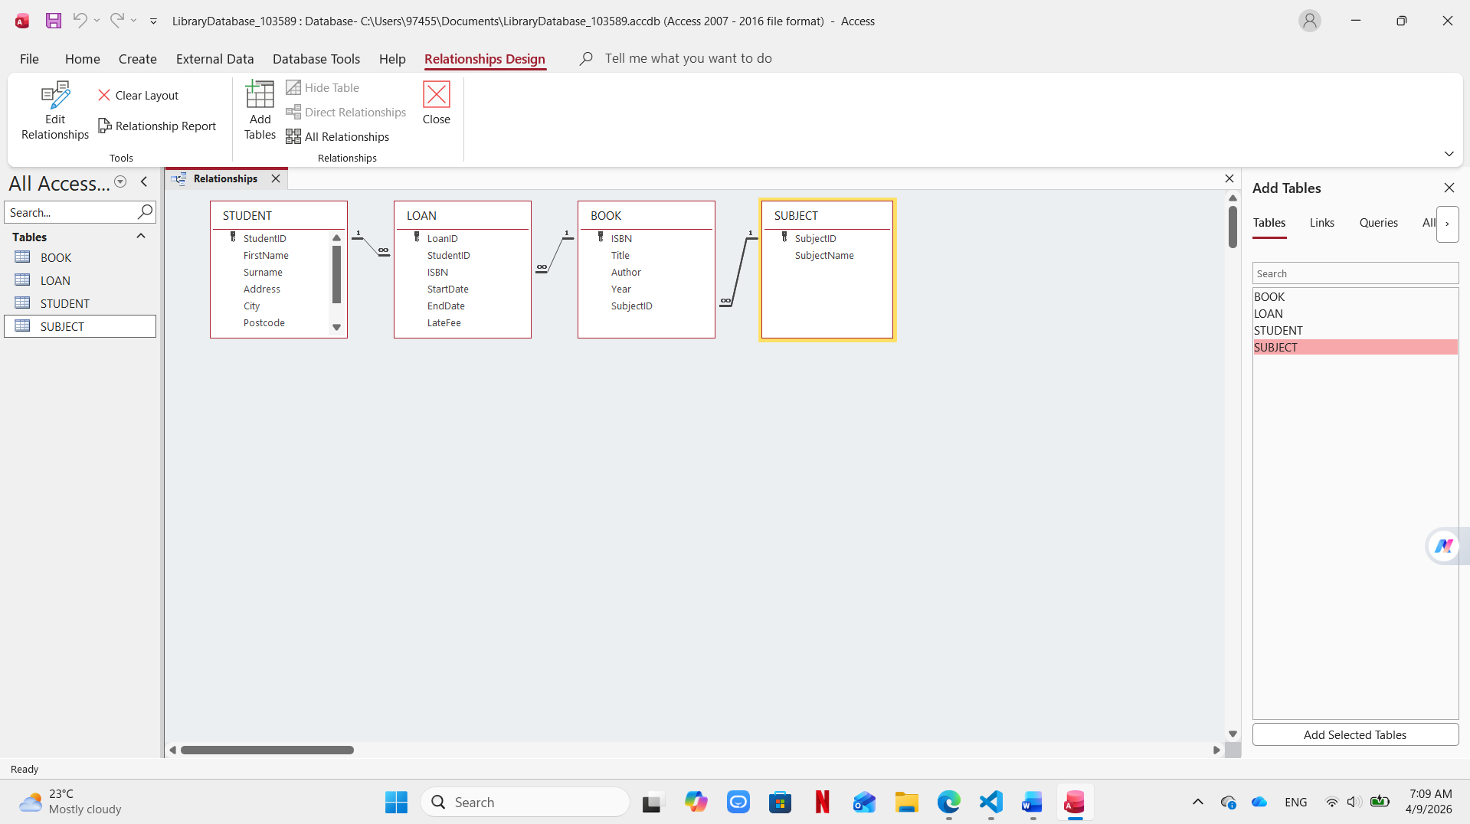

2.6:
The database was extended by applying referential integrity between all related tables to ensure data consistency. Appropriate data types were also used for each field, and relationships were clearly defined between entities. These improvements help maintain accurate data and make the system more reliable.

