Group 10

**Master Clinic/10**

**Project Master Clinic SDS 1.0****CM_Id 04,01,2018**

**Master Clinic** **Statement of Work1.0_mc****_04 01, 2018**

**Master Clinic**

**Software Design Specification (SDS)**

**Team 10 Master Clinic 1.1**

**IdDateVersion: 1.0**

**CM Identifier: Master Clinic1.0_mc_04 01, 2018**

Revision History

|  |  |  |  |  |  |  |
| --- | --- | --- | --- | --- | --- | --- |
| **Sl. No.** | **Prepared/**  **Modified by** | **E-mail** | **Version** | **Date** | **Approved by** | **Descriptions/**  **Remarks** |
| 1.  2. | Abdelrahman Mohamed  Reham Hamdy | [am535150@gmail.com](mailto:am535150@gmail.com)  [rehamhy6@gmail.com](mailto:rehamhy6@gmail.com) | 1.0  1.0 | 4/9/2018  4/9/2018 | Hady Maher  Aisha Mousa | System Architecture/  Design Models/  System Deployment.  Introduction/  Data Models/  Traceability to requirements. |

**Distribution list**

|  |  |  |
| --- | --- | --- |
| **Name** | **E-mail** | **Notes** |
| Dr: Ahmed Hamdy |  |  |
| TA: Ali El-Sedeek | alielseddeek@gmail.com |  |
| TA: Dina El Reedy | dinaelreedy@gmail.com |  |

Table of Contents

**Introduction** **7**

Purpose of this Document 7

Scope 7

Table of Acronyms and Definitions 7

Definition 7

References 8

Overview of Document 8

**System Architecture** **8**

Relation between controllers and models 9

Relation between views and controllers 9

Admin 9

Nurse 9

Patient 9

Guest 9

**Design Models** **10**

Design Patterns Description 10

MVC Architectural design pattern 10

Class Diagrams 10

User 11

properties 11

Methods 11

Admin 11

properties 11

Methods 11

Nurse 12

properties 12

Methods 12

Patient 12

properties 12

Methods 13

Clinic 13

properties 13

Methods 13

Model 13

Methods 13

Interaction Diagrams 15

**Data Models** **31**

**System Deployment** **33**

Client tier 34

Server tier 34

**Traceability to Requirements** **34**

List of Tables

**Table-1: Acronyms and Definitions**  **7**

**Table-2: Traceability to Requirements**   **34**

List of Figures

**Figure-1 : System Architecture**  9

**Figure-2 : Class Diagram**  13

**Figure-3 : SD1**  14

**Figure-4 : SD2**  15

**Figure-5 : SD3**  16

**Figure-6 : SD4**  17

**Figure-7 : SD5**  18

**Figure-8 : SD6**  19

**Figure-9 : SD7**  20

**Figure-10 : SD8**  21

**Figure-11 : SD9**  22

**Figure-12 : SD10** 23

**Figure-13 : SD11**  24

**Figure-14 : SD12** 25

**Figure-15 : SD13** 26

**Figure-16 : SD14** 26

**Figure-17 : SD15** 28

**Figure-18 : SD16** 28

**Figure-19: SD17** 29

**Figure-20: SD18**  29

**Figure-21 : er- entities**  30

**Figure-22 : er- relations**  31

**Figure-23 : er- map**  31

**Figure-24 :Deployment-diagram** 33

# Introduction

Dental care is very important as teeth affects both health and appearance. However lots of people go to the dentist with an average ratio of 64% of a yearly visit for adults. Managing patients’ paper and registering a dentist becomes really an annoying task. That’s why we are creating **MASTER-CLINIC** which is a website that hopefully would help you register a dentist, manage your treatment paper and expenses and also help dentists in managing their patients’ files and easily getting statistics and finding specific patient’s data at any time.

## Purpose of this Document

The purpose of this document is to provide an overview of the design specifications employed to implement the requirements stated in the SRS document .The software design of master-clinic includes the system architecture which describes the different relations between system components e.g. controllers and views. It also includes design models such as design patterns and diagrams illustrating the design elements and their interactions.The design uses a data model (er-diagram) and explains the System deployment plan .

## Scope

The project is mainly concerned with building a centralized database system for a master-clinic business, and building modules that allows three types of users (patients-nurses-doctors) to interact together in a fast and easy way. patients can make reservations with their doctors,check their medical file through a web application. Nurses confirm patients’ reservations,update patients’ information, delete patients ,create invoices and manage clinics. Doctors are concerned with patients’ files , in terms of their creation ,update and deletion , alongside other administrative functions nurses enjoy like accessing patient’s information and clinic management,doctors can also access nurses’ information and perform all sort of data manipulation.

## Table of Acronyms and Definitions

|  |  |
| --- | --- |
| **Term** | *Definition* |
| Worker | anyone working in the clinic and not a doctor or nurse. |
| admin | in this project admin is the dentist himself |
| Super admin | clinic owners |
| Patient file | a file that contains all patient’s prescriptions, photos and any other comments or data dentist noted about the patient like case description and progress. |
| SD | Sequential Diagram |
| SD1 | user login SD |
| SD2 | super admin adds an admin/super admin SD |
| SD3 | admin create a new clinic SD |
| SD4 | admin adds a new nurse SD |
| SD5 | nurse adds a new patient SD |
| SD6 | admin adds a new patient SD |
| SD7 | admin updates his/her profile and super admin update other admins SD |
| SD8 | admin updates information of a clinic SD |
| SD9 | admin updates information of a nurse SD |
| SD10 | admin updates information of a patient SD |
| SD11 | nurse updates information of a patient SD |
| SD12 | nurse updates his/her profile SD |
| SD13 | patient updates his/her profile SD |
| SD14 | super admin removes an admin SD |
| SD15 | admin removes a clinic and its nurses SD |
| SD16 | admin removes a nurse SD |
| SD17 | admin removes a patient SD |
| SD18 | nurse removes a patient SD |

## References

## Overview of Document

* Section 2 : description of the system architecture.
* Section 3 : layout of design models used in the system e.g. design patterns,class diagrams...etc
* Section 4 : data models of the system illustrated by an er-diagram.
* Section 5 : explaining the deployment plan of the system in terms of tiers.
* Section 6 : a table to trace requirements to their corresponding design elements.

# System Architecture

Since the project is website then it would be used be different users at the sametime. This means that a single point of control won’t be suitable. So we use MVC architecture which consists of three separate layers. views layer which is the GUI that takes inputs and actions from users. Controllers layer which are the processing layer in which the application logic is running and have more than one controller that are able to function all together at the same time. Finally the Models layer which is the data layer that contains the application data and connects with the database. MVC architecture makes relation between different layers like the following views are connected to controllers and controllers are connected to models. We start with relation between controllers and models.

### Relation between controllers and models

* Admin Controllers use all the models since admins are allowed to create, update or delete any other entity and themselves given the right permissions (only super admins can create, delete or update any other admins).
* Nurse Controllers use both Nurse model and Patient models since a nurse can update herself and create, update or delete a patient
* Patient Controllers use only Patient model as a patient can only update himself

### Relation between views and controllers

Since the navigation bar contains a link for logging out (If you are logged in if not it’s replaced with a link to the login page) and a link for the home page this makes them every user (admin, nurse, patient or guest) views capable of accessing both the home controller and login controller. That’s why no connections to these 2 controllers from their respective views would mentioned after in the next section.

#### Admin

* login page: can only access forgot password controller
* send reset email page: can only access forgot password controller
* reset password page: can only access reset password controller
* rest of the views: can access patient, nurse, admin and profile controllers due to the links that includes all these views in the side navigation bar. these links would available in every single view as soon admin is logged in to make it easier to perform different functionalities

#### Nurse

* login page: can only access forgot password controller
* send reset email page: can only access forgot password controller
* reset password page: can only access reset password controller
* rest of the views: can access patient and profile controllers due to the links that includes all these views in the side navigation bar. these links would available in every single view as soon nurse is logged in to make it easier to perform different functionalities

#### Patient

* login page: can only access forgot password controller
* send reset email page: can only access forgot password controller
* reset password page: can only access reset password controller
* home page: can access patient controller

#### Guest

* index page: accesses patient’s home and login controllers as a normal guest is a logged out patient

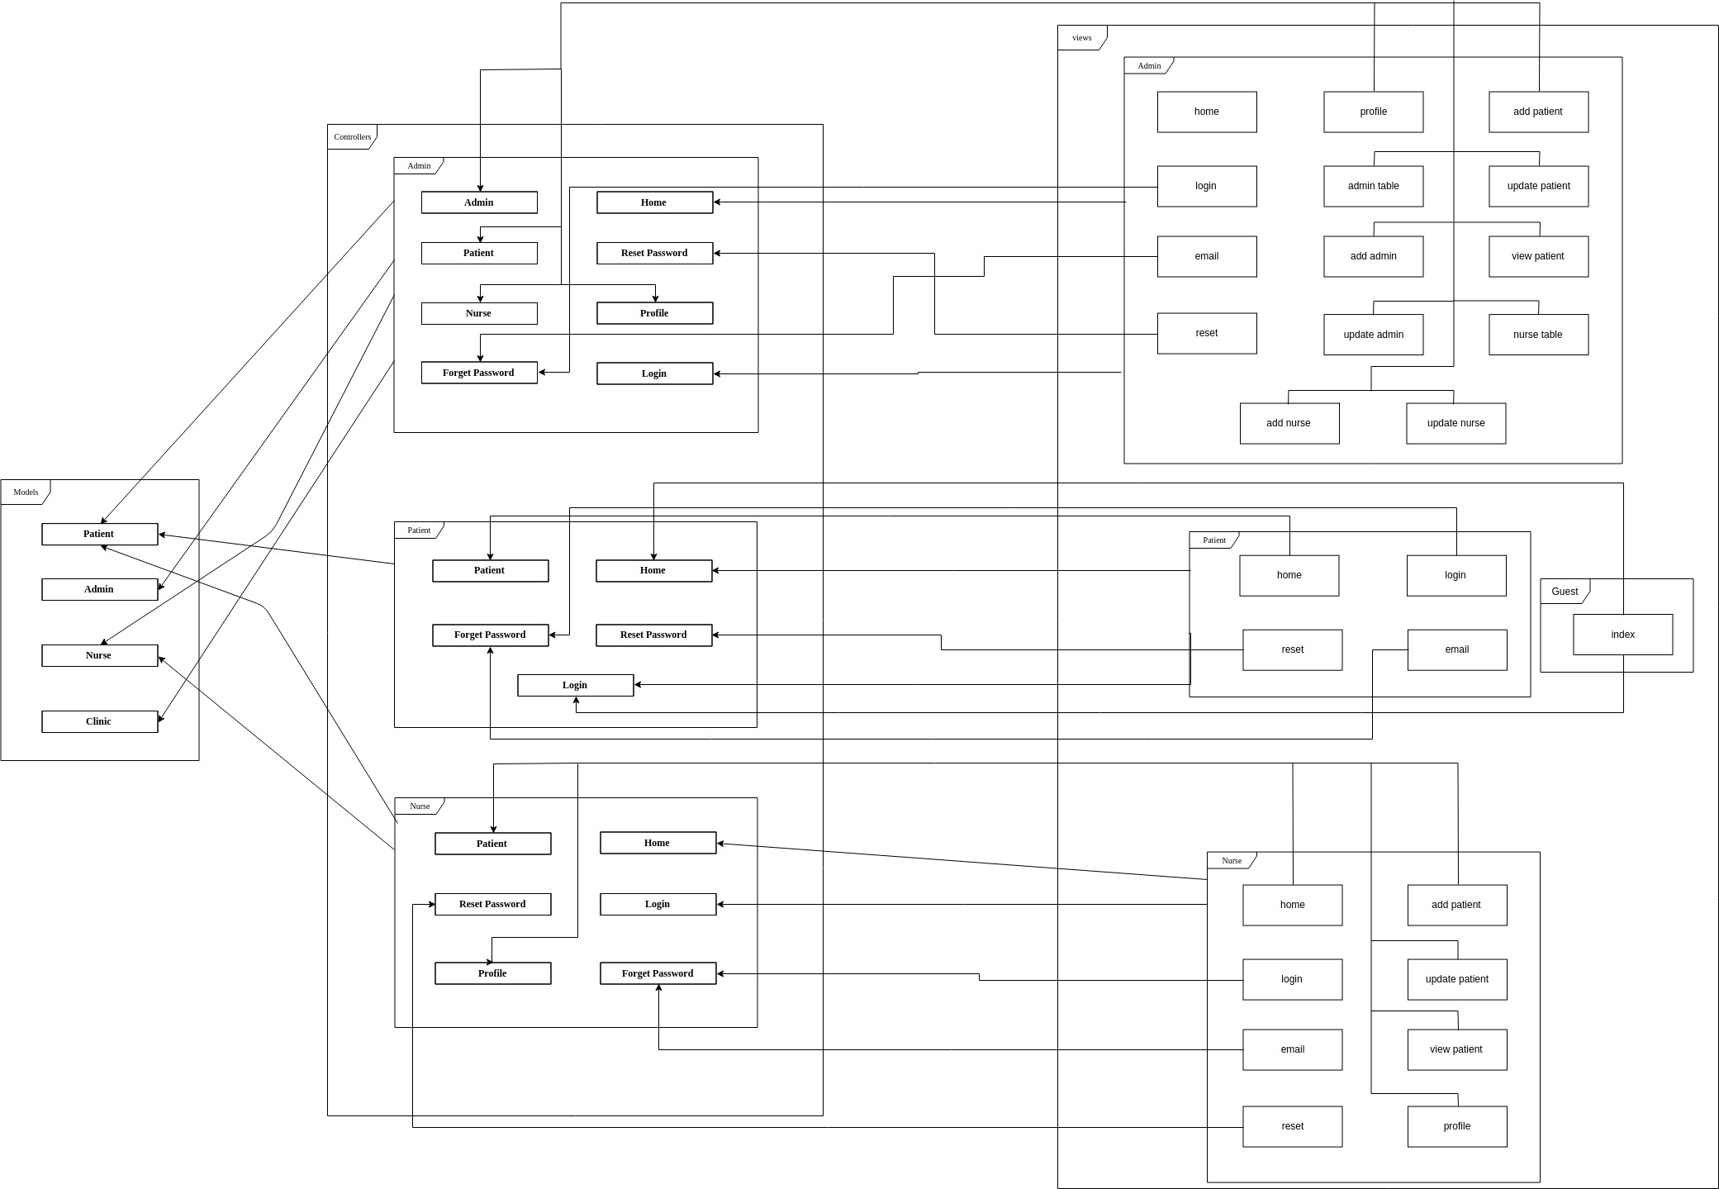

**Figure 1: Architecture diagram**

# Design Models

## Design Patterns Description

### *MVC Architectural design pattern*

MVC architecture which consists of three separate layers. views layer which is the GUI that takes inputs and actions from users. Controllers layer which are the processing layer in which the application logic is running and have more than one controller that are able to function all together at the same time. Finally the Models layer which is the data layer that contains the application data and connects with the database. MVC architecture makes relation between different layers like the following views are connected to controllers and controllers are connected to models.

### *Factory design pattern*

Factory creational design pattern which define an interface for creating an object, but let subclasses decide which class to instantiate. Models layer of MVC architectural design pattern is using factory to create different models for creating different object with the basic models functions and implement its own functions.

## Class Diagrams

Class diagram is meant to show system different classes, their attributes and operation (methods). So we have five classes Patient, Admin, Nurse, User and Clinic. There is also interfaces which are some relevant functions packed together in one structure and we have one interface Model which contains functions to interact with database. We start with class admin

### User

User is an abstract class that handles system users with basic data and functions.

#### properties

User class have not properties as it’s only to handle basic users functions. Every user would implement his own properties

#### Methods

1. login: this methods is for handling user login it takes user’s email and password as arguments to check if the user already exist and authorize his access

### Admin

Admin class is a user class that inherits User class and represents admin user.

#### properties

1. id: integer that represents admin id number which is used to identify the admin thus no two admins would have the same id
2. name: string that represents admin’s name (usually first name)
3. email: string that represents admin’s email address and must be unique as it’s used for logging into the system
4. password: string that represents admin’s password and is used to authorize logging in
5. image: string represents path admin’s profile picture in the storage files
6. mobile: string that represents admin’s mobile number
7. status: boolean variable that indicates account status inactive (false) and active (true)
8. role: string that represents the role of the admin with two valid roles normal and super

#### Methods

1. createPaitent: methods for creating patients which takes an array of patient’s data create the patient if the data is valid and then return the new patient
2. updatePatient: methods for updating patients which takes an array of patient’s data update the patient if the data is valid
3. deletePatient: method for deleting patients that takes the patient argument then delete him
4. listPatients: methods that returns a list of all available patients
5. createNurse: methods for creating nurses which takes an array of nurse’s data create the nurse if the data is valid and then return the new nurse
6. updateNurse: methods for updating nurses which takes an array of nurse’s data update the nurse if the data is valid
7. deleteNurse: method for deleting nurses that takes the nurse as argument then delete her
8. listNurses: methods that returns a list of all available nurses
9. createClinic: methods for creating clinics which takes an array of clinic’s data create the clinic if the data is valid and then return the new clinic
10. updateClinic: methods for updating clinics which takes an array of clinic’s data update the clinic if the data is valid
11. deleteClinic: method for deleting clinics that takes the clinic as argument then delete him
12. listClinics: methods that returns a list of all available clinics
13. createAdmin: methods for creating admins which takes an array of admin’s data and string role (to verify permissions only super admin can create both super and normal admins) create the admin if the data is valid and then return the new admin
14. updateAdmin: methods for updating admins which takes an array of admin’s data and role (only super admin can update other admins) update the patient if the data is valid
15. deleteAdmin: method for deleting admins that takes the admin and role (only super admin can delete other admins) as argument then delete him
16. listAdmins: methods that takes role (only super admin can list all admins) as an argument returns a list of all available admins

### Nurse

Nurse class is a user class that inherits User class and represents nurse user.

#### properties

1. id: integer that represents nurse id number which is used to identify the nurse thus no two nurses would have the same id
2. name: string that represents nurse’s name (usually first name)
3. email: string that represents nurse’s email address and must be unique as it’s used for logging into the system
4. password: string that represents nurse’s password and is used to authorize logging in
5. image: string represents path nurse’s profile picture in the storage files
6. mobile: string that represents nurse’s mobile number
7. status: boolean variable that indicates account status inactive (false) and active (true)
8. gender: nurse gender (male/female)
9. dateOfBirth: nurse date of birth
10. salary: nurse monthly salary
11. clinicId: id of the clinic is working in

#### Methods

1. createPaitent: methods for creating patients which takes an array of patient’s data create the patient if the data is valid and then return the new patient
2. updatePatient: methods for updating patients which takes an array of patient’s data update the patient if the data is valid
3. deletePatient: method for deleting patients that takes the patient argument then delete him
4. listPatients: methods that returns a list of all available patients

### Patient

Patient class is a user class that inherits User class and represents patient user.

#### properties

1. id: integer that represents nurse id number which is used to identify the nurse thus no two nurses would have the same id
2. name: string that represents nurse’s name (usually first name)
3. email: string that represents nurse’s email address and must be unique as it’s used for logging into the system
4. password: string that represents nurse’s password and is used to authorize logging in
5. image: string represents path nurse’s profile picture in the storage files
6. mobile: string that represents nurse’s mobile number
7. status: boolean variable that indicates account status inactive (false) and active (true)
8. gender: patient gender (male/female)
9. dateOfBirth: patient date of birth

#### Methods

Patient class can only update himself, login and logout which are all inherited from class User so there is methods added by this classin

### Clinic

Clinic class represents clinics which unlike previous classes is not a user. That’s why it doesn’t inherit User class

#### properties

1. id: integer that represents clinic id number which is used to identify the clinic thus no two clinics would have the same id
2. name: string that represents clinic’s name
3. email: string that represents clinic’s email address which is used for contacting with patients
4. telephone: string that represents clinic’s telephone number
5. openingTime: the time the clinic opens
6. closingTime: the time the clinic closes

#### Methods

Unlike the previous classes this is not a user clinic class so it doesn’t have any methods at all.

### Model

This is an interface used to interact with database. It provide functions to make secure connections with database and perform different operation on it.

#### Methods

1. find: method that gets row by id from its table
2. update: method that takes an array of data and update a row in database table
3. insert: method that takes an array of data and creates a new row in a database table
4. delete: method that deletes a row by its id

#### 

**Figure 2: Class diagram**

## Interaction Diagrams

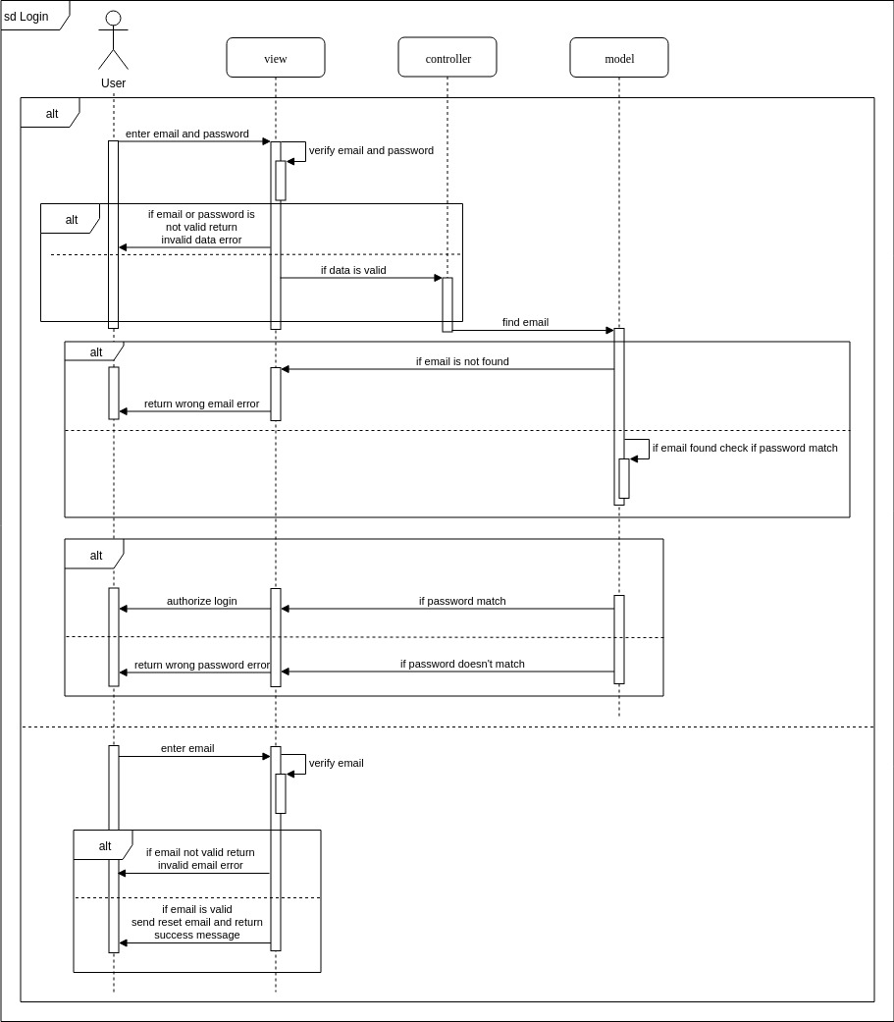

**Figure 3: SD1**

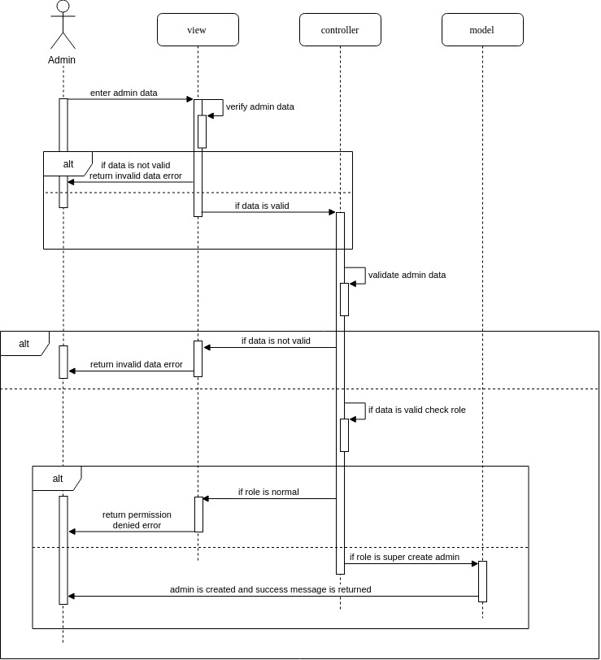

**Figure 4: SD2**

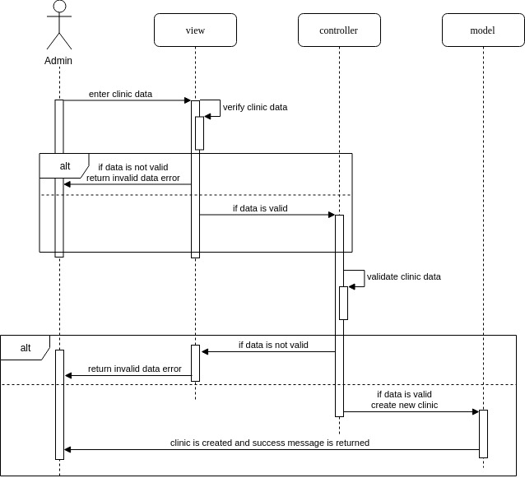

F**igure 5: SD3**

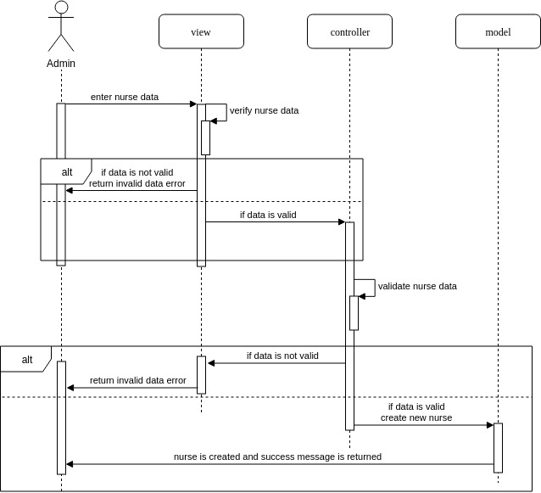

**Figure 6: SD4**

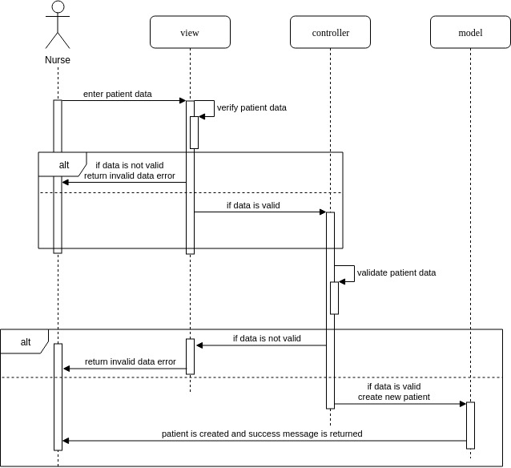

**Figure 7: SD5**

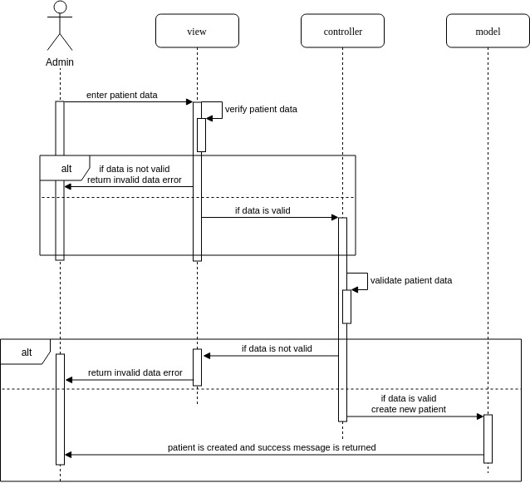

**Figure 8: SD6**

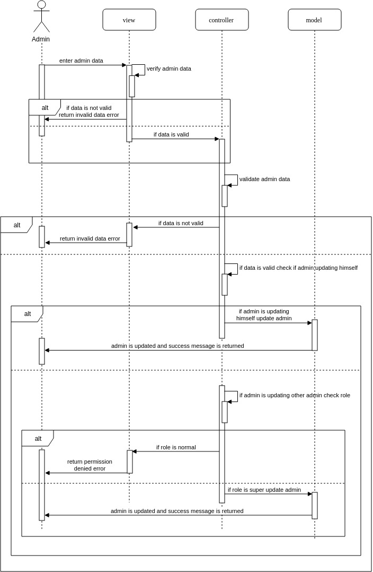

**Figure 9: SD7**

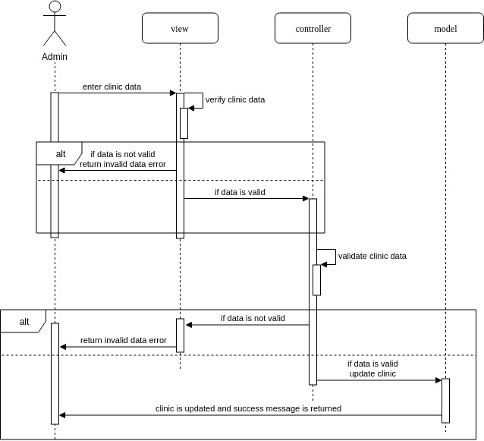

**Figure 10: SD8**

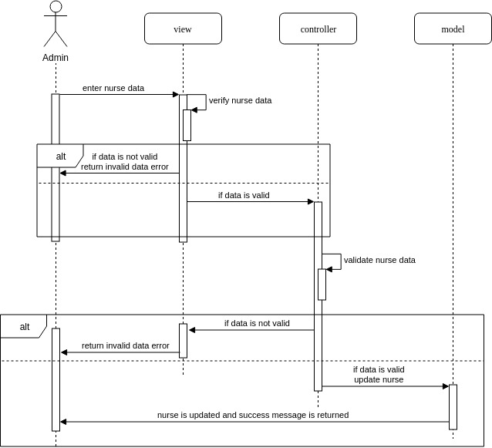

**Figure 11: SD9**

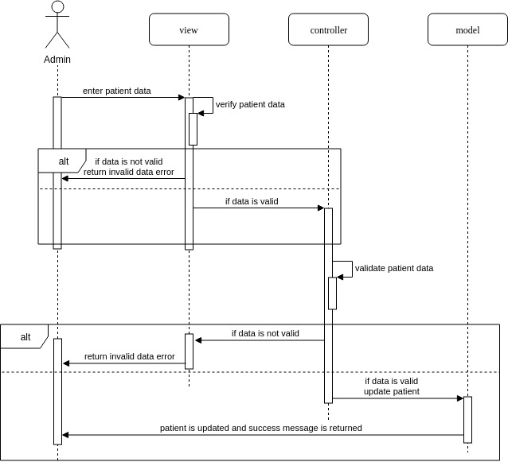

**Figure 12: SD10**

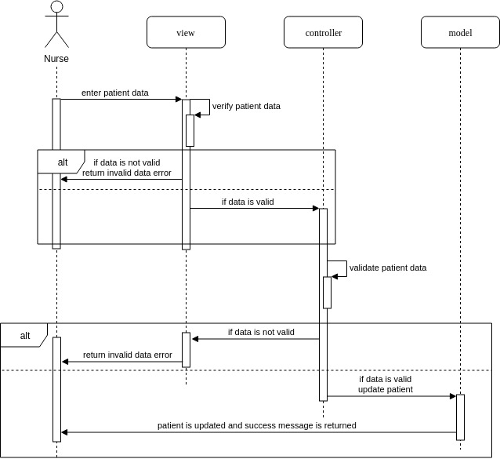

**Figure 13: SD11**

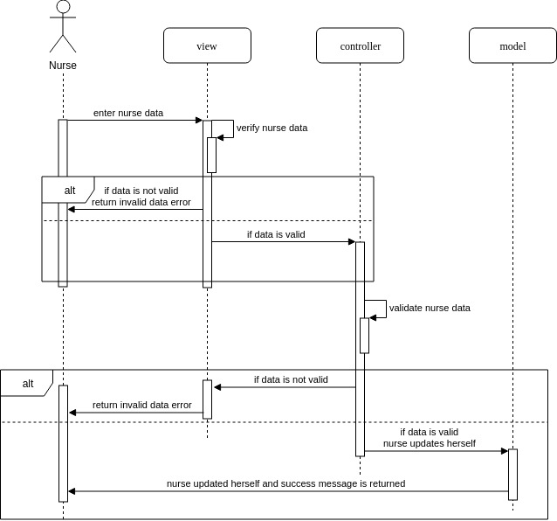

**Figure 14: SD12**

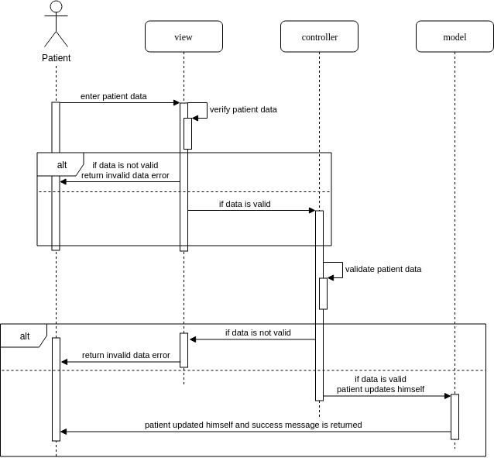

**Figure 15: SD13**

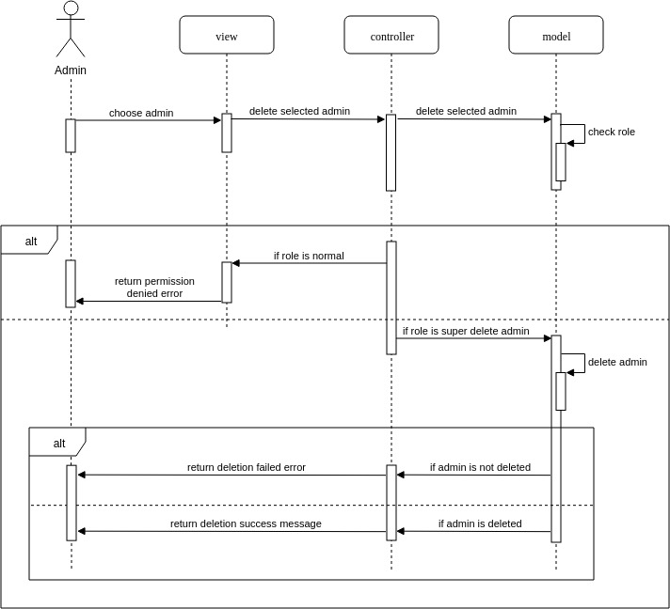

**Figure 16: SD14**

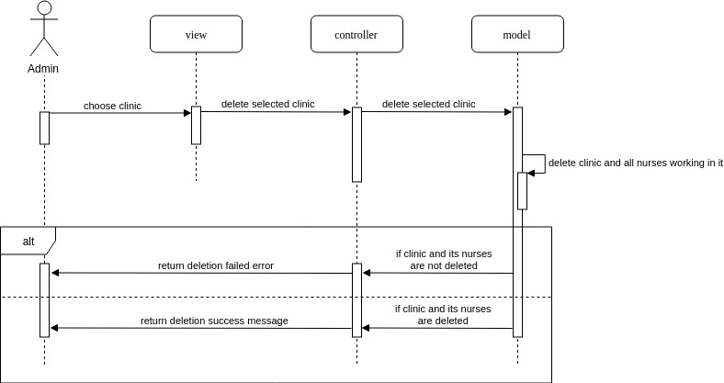

**Figure 17: SD15**

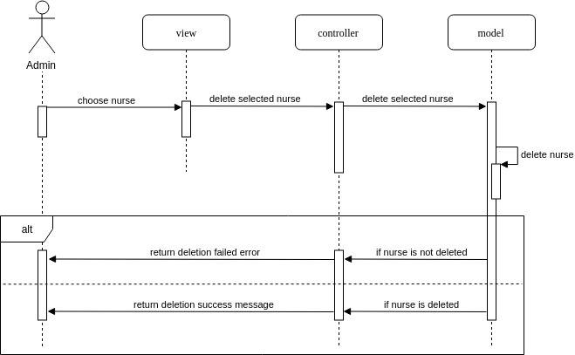

**Figure 18: SD16**

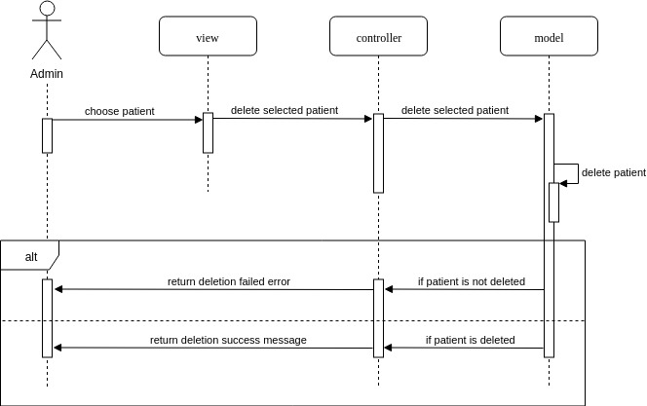

**Figure 19: SD17**

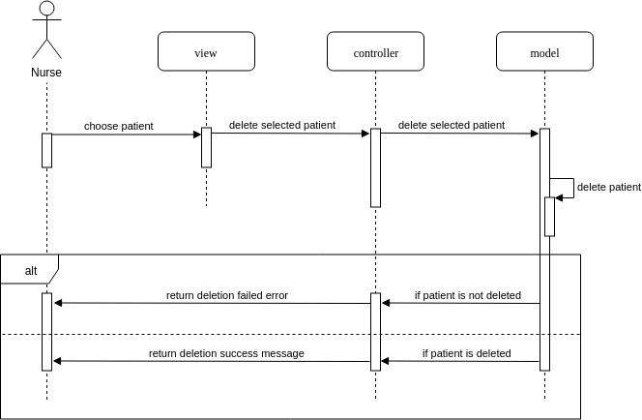

**Figure 20: SD18**

# Data Models

**

**Figure 21 :er-entities** 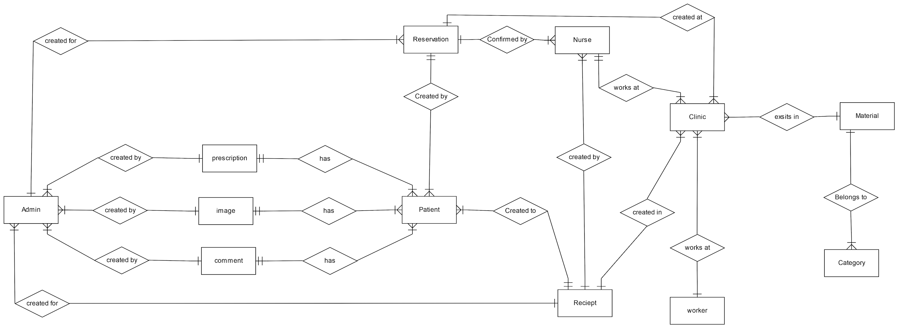

**Figure 22 :er-relations**

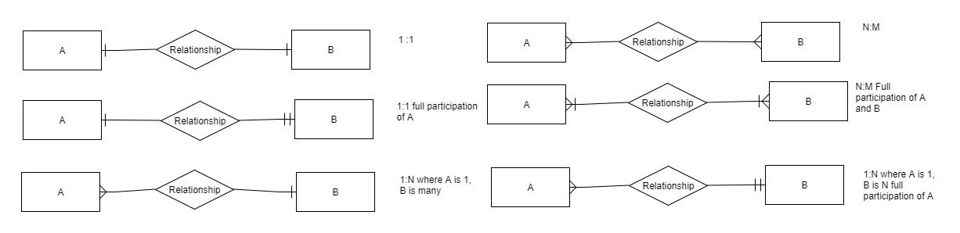

**Figure 23 : er-map**

**Entities**

* **Nurse** : assists doctor in running the clinic .
* **Patient** : the main client the system aims to serve .
* **Admin** : a doctor in the clinic (could be an owner or just an assisting doctor) .
* **Clinic** : the place where admins and nurses work .
* **Receipt** : a written statement acknowledging that patients have paid for their treatment.
* **Prescription** : drug description written by doctors for their patients.
* **Comment** : any observations doctors have of their patient’s medical condition, they are added to patients’ files .
* **Image** : a visual description of a patient’s medical condition which is also added to patents’ files.
* **Material** : medical substances used by doctors in the treatment and are required to be monitored.
* **Reservation** : a request to have an appointment with a doctor made by patients and approved by nurses.
* **Category** : the classification of materials.
* **Worker** : a person who works at a clinic who isn’t a doctor or a nurse but is important to the clinic records.

**Relationships**

* (Reservation-Patient) created by : a list of all reservations made by the patient.
* (Reservation-Nurse ) confirmed by : every reservation made by a patient has to be confirmed by a nurse
* (Reservation-Clinic ) created at : every reservation is assigned a clinic id to specify the location of the appointment .
* (Reservation- Admin) created for : patients can request a certain doctor while reserving an appointment and so a reservation has information on the doctor it is assigned for .
* (Nurse-Clinic) works at : every nurse is assigned to a certain clinic (only one) .
* (Nurse-Receipt ) created by : nurses create receipts for patients after every treatment session to manage the finances of the client and inform their client of their treatment expenses.
* (Receipt-Patient) created to : the receipt holds information about the client it is assigned to.
* (Receipt-Admin) created for : the receipt holds information about the doctor who did the treatment.
* (Receipt-Clinic) created in : every clinic manages its record of receipts independent of other clinics.
* (Clinic-Worker) works at : every clinic employs a number of workers and keeps track of their information.
* (Clinic-Material) exists in : clinics keeps record of their available materials to track their quantity and cost.
* (Material-Category) belongs to : materials that serve a common purpose are classified together under one category to make search and enumeration easy processes.
* (Comment-Patient) has : patients’ files contain comments and observations made by doctors on their medical condition.
* (Image-Patient) has : patients’ files may contain images that visually aids the doctor to understand the issues of their patients.
* (Prescription-Patient) has : drug prescription given to patients which they can check in their files.
* (Comment-Admin) created by : doctors record their remarks on the medical conditions of their patients in their files.
* (Image-Admin) created by : doctors add images essential to the description of their patient’s case to their files.
* (Prescription-Admin) created by : doctors can write drug prescription to their patients for medical purposes.

# System Deployment

The following diagram is the deployment diagram which is shows the hardware deployment and integrity of the system. Following the two tier client server model the system would be divided into two tiers client tier and server tier.

## Client tier

This tier is deployed in the users side. It contains views that interact with controllers on server through a browser. This tier sends data and different requests to controllers on the server side.

## Server tier

This tier is deployed in the server side. It contains controllers, models and database. This tier receives data and requests from the client side. The connection protocol between the two tiers is a normal interprocess communication (**IPC**).

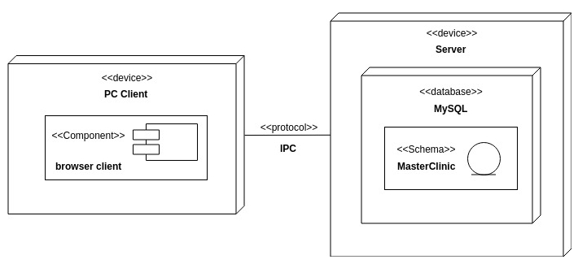

**Figure 24: Deployment diagram**

# Traceability to Requirements

|  |  |  |  |  |  |  |  |  |  |  |  |  |  |  |  |  |  |  |
| --- | --- | --- | --- | --- | --- | --- | --- | --- | --- | --- | --- | --- | --- | --- | --- | --- | --- | --- |
|  | SD1 | SD2 | SD3 | SD4 | SD5 | SD6 | SD7 | SD8 | SD9 | SD10 | SD11 | SD12 | SD13 | SD14 | SD15 | SD16 | SD17 | SD18 |
| US1 | ✓ | ✓ | ✓ | ✓ |  |  |  |  | ✓ |  |  | ✓ |  |  |  | ✓ |  |  |
| US2 | ✓ | ✓ | ✓ |  |  |  |  | ✓ |  |  |  |  |  |  | ✓ | ✓ |  |  |
| US3 | ✓ | ✓ | ✓ | ✓ | ✓ | ✓ |  |  |  | ✓ | ✓ |  | ✓ |  |  |  | ✓ | ✓ |
| US4 | ✓ | ✓ | ✓ |  |  |  | ✓ |  |  |  |  |  |  | ✓ |  |  |  |  |
| US11 | ✓ | ✓ | ✓ | ✓ | ✓ | ✓ |  |  |  |  |  |  |  |  |  |  |  |  |