**Aisha channa**

**Roll no: 20SW122**

**Topic: Power BI Lab**

**TASK 01:**

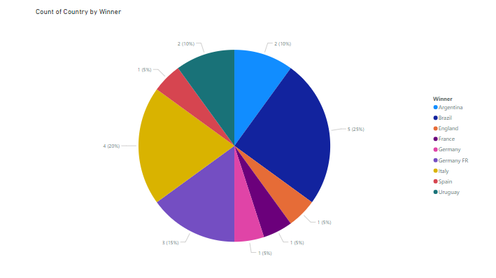

**TASK 02:**

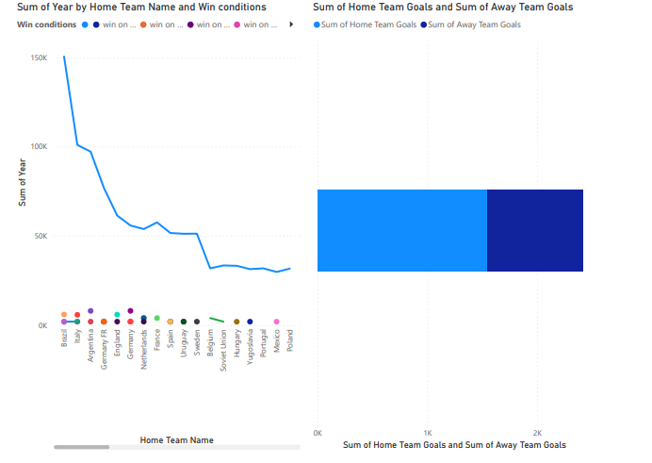

**TASK 03:**

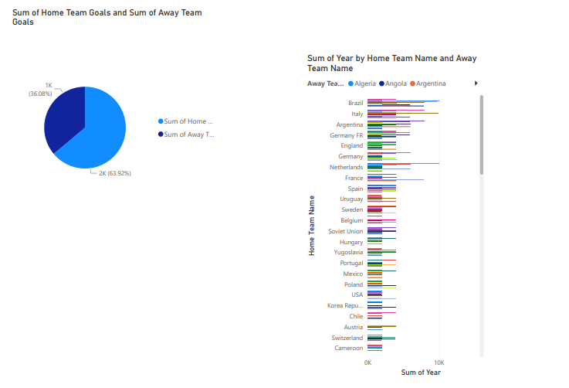

**TASK 04:**

