**Recreate a painting using Bootstrap's grid**

In this project you will practice using the fundamentals of Bootstrap grid by piecing together a famous painting, namely Piet Mondrian’s Composition II in Red, Blue, and Yellow.

In **index.html** is a container with columns that represent various pieces in Composition II. You can tell which piece is what by the element’s id and the comment inside the column and with the labeled painting below:

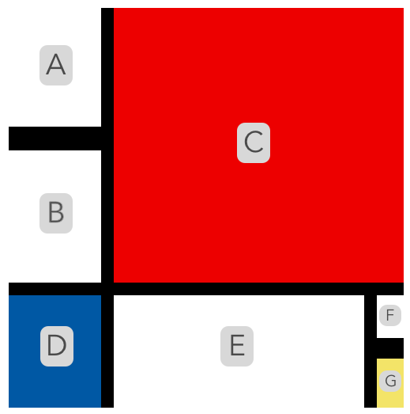

The column’s height and colors, and the container’s height and width, are **already included** in **style.css**. Your goal is to recreate the painting by:

* using the existing container.
* unscrambling the order of the provided columns.
* adjusting the widths of the provided columns.
* adding new rows and additional columns.
* nesting row(s) inside columns.

There will not be step-by-step instructions provided, however, if you get stuck ask for help along the way. Good luck and have fun!

**1.**

What about the ordering?

***Hint***

The initial ordering of the columns is all scrambled!

**2.**

Thinking about the layout?

***Hint***

*You can think of the layout in a few different ways. One way is to separate the painting into two rows.*

**3.**

More complex layouts?

***Hint***

*You can nest rows inside columns. Those nested rows can also have additional columns!*

## Extra Work

**4.**

If you want some additional challenges:

* change up the painting layout entirely.
* render the painting differently based on screen size (use breakpoints).
* add different colors using Bootstrap.
* add some interactivity using Bootstrap.