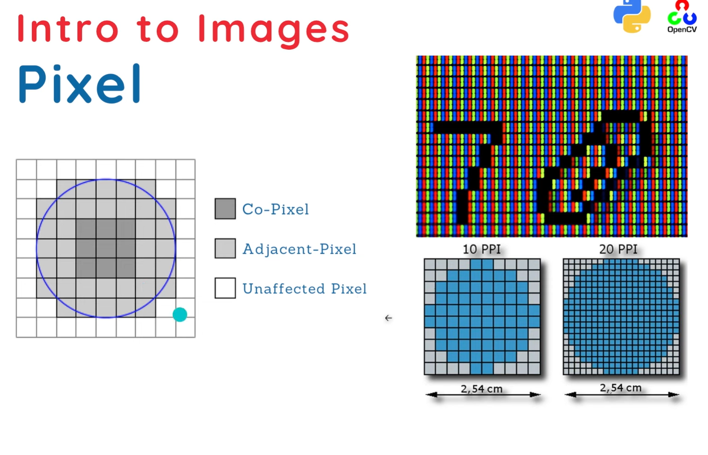

# How Images and Pixels Work

What is an Image?

An image is a grid (matrix) of pixels, where each pixel represents a color or intensity value.

**A grayscale image:**

Each pixel is a single number between 0–255.

* 0 = black
* 255 = white

Example shape: 28×28

**A color image (RGB):**

Each pixel has 3 values (Red, Green, Blue).

Example shape: 28×28×3 (height × width × channels)

So a 256×256 RGB image has:

256 × 256 × 3 = 196,608 pixel values!

# How CNN Works Internally

Let’s see what happens when you feed an image to a CNN:

## Step 1 Convolution Layer

* Uses a small **filter (kernel)**, e.g., 3×3 or 5×5, that slides over the image.
* Each filter detects a **feature** like edges, corners, textures, etc.
* Output: **Feature map**.

## Step 2 ReLU Activation

* ReLU = Rectified Linear Unit = max(0, x)
* Removes negative values → keeps only positive features.

## Step 3 Flatten

* Converts the 2D feature maps into a 1D vector.

## Step 5 Fully Connected (Dense) Layers

* Similar to traditional ANN layers.
* Combine learned features to make final classification.

## Step 6 Output Layer

* For classification → Softmax activation gives probabilities of classes.