Week 1: **Examine TCP/IP and OSI Models in Action**

Report by: Aisha Khalifan, cs-cns04-23014

**Introduction**

This report presents the results of a Packet Tracer simulation activity designed to investigate the TCP/IP and OSI models in action. The simulation focuses on two main areas:

* Examining HTTP web traffic
* Displaying elements of the TCP/IP protocol suite

The first part of the simulation uses Packet Tracer to generate web traffic and examine the HTTP protocol. This allows us to see how HTTP messages are structured and how they are exchanged between a web browser and a web server.

The second part of the simulation uses Packet Tracer to display the elements of the TCP/IP protocol suite. This allows us to see how the different layers of the TCP/IP stack work together to transmit data over a network.

This report will discuss the following aspects of the TCP/IP and OSI models:

* The different layers of the TCP/IP and OSI models
* The protocols that are used at each layer
* The role of each layer in the data transmission process
* Examples of how the different layers of the TCP/IP and OSI models work together in Packet Tracer

The report will also provide a high-level overview of how the TCP/IP and OSI models are used in real-world networks.

**Objectives**

* Part 1: Examine HTTP Web Traffic
* Part 2: Display Elements of the TCP/IP Protocol Suite

**Background**

This simulation activity taught me about the TCP/IP protocol suite and the OSI model by showing how data is broken down and put back together as it travels through the network. I used Packet Tracer to simulate the process of requesting a web page from a web server.

This was a chance to learn how Packet Tracer works and to visualize the encapsulation process, which is essential for data communication over networks.

**Methodology**

**Part 1: Examine HTTP Web Traffic**

**Step1: Switch from Realtime to Simulation mode**

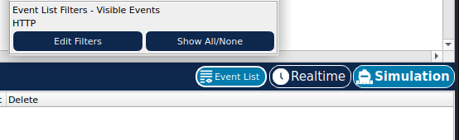

1. In this step, we were required to switch from Realtime mode to simulation mode this is because packet tracer always starts in Realtime mode. Click the Simulation mode icon to switch from Realtime mode to Simulation mode
2. Select HTTP from the Event List Filters.

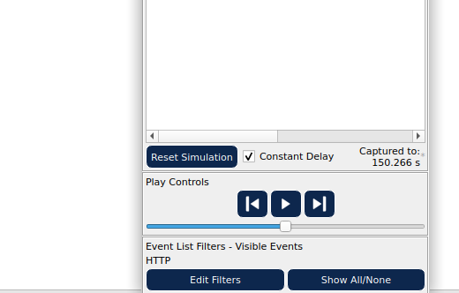

HTTP may already be the only visible event. If necessary, click the Edit Filters button at the bottom

of the simulation panel to display the available visible events. Toggle the Show All/None check box

And notice how the check boxes switch from unchecked to checked or checked to unchecked,

Depending on the current state.

2) Click the Show All/None check box until all boxes are cleared and then select HTTP from the Misc

Tab of the Edit Filters window. Click the X in the upper right hand corner of the window to close the

Edit Filters window. The Visible Events should now only display HTT

HTTP may already be the only visible event. Click Edit Filters to display the available visible events. Toggle the Show All/None check box and notice how the check boxes switch from unchecked to checked or checked to unchecked, depending on the current state.

Click the Show All/None check box until all boxes are cleared and then select HTTP. Click anywhere outside of the Edit Filters box to hide it. The Visible Events should now only display HTTP.

**Step 2: Generate web (HTTP) traffic**.

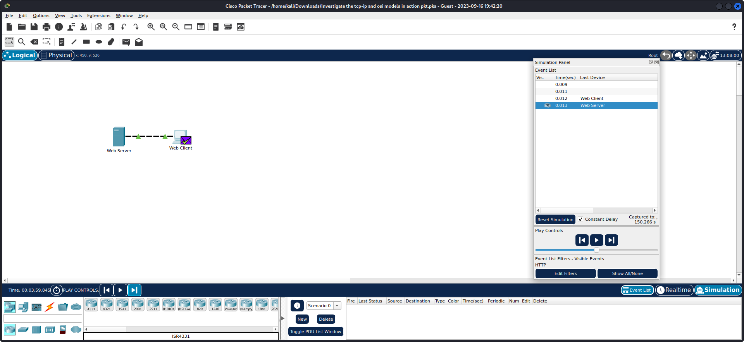

* Checked the empty Simulation Panel with six columns for events.
* Adjusted panel size and accessed Web Client and Web Server.
* Followed the steps: a) Clicked Web Client, b) Opened Web Browser, c) Accessed www.osi.local, d) Clicked Capture/Forward four times, resulting in four events in the Event List.
* Confirmed the web page change after the actions.

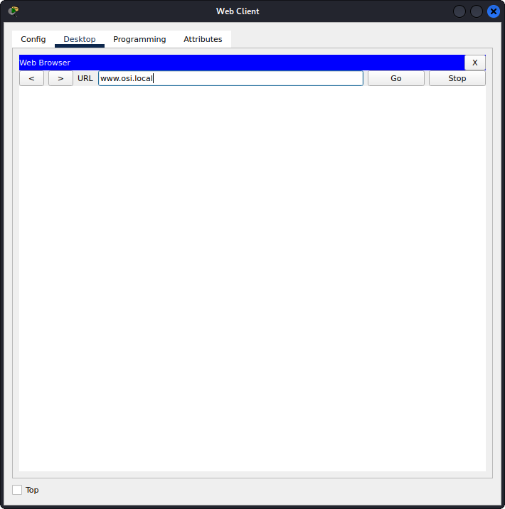

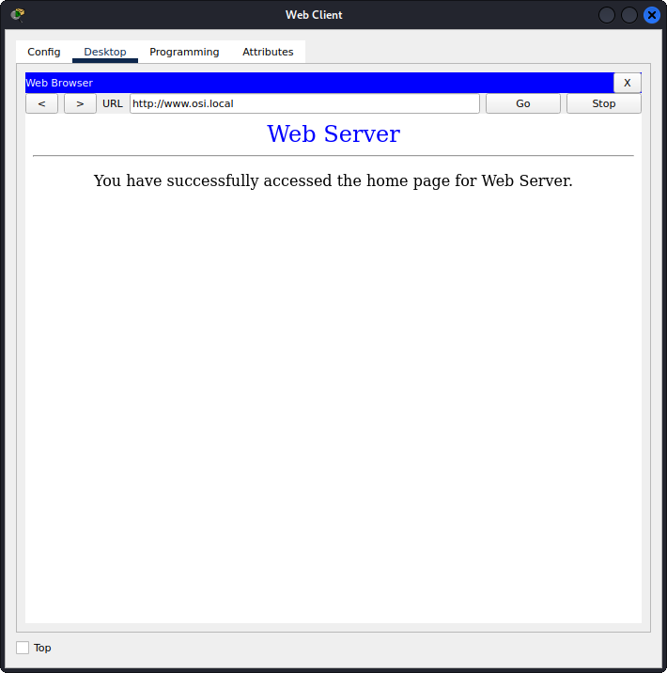

**Step 3: Explore the contents of the HTTP packet.**

* Executed Action: Clicked the first colored square box under the Event List > Info column. Expanded Simulation Panel as necessary to view PDU Information at Device: Web Client window, featuring two tabs (OSI Model and Outbound PDU Details) indicating the start of transmission.

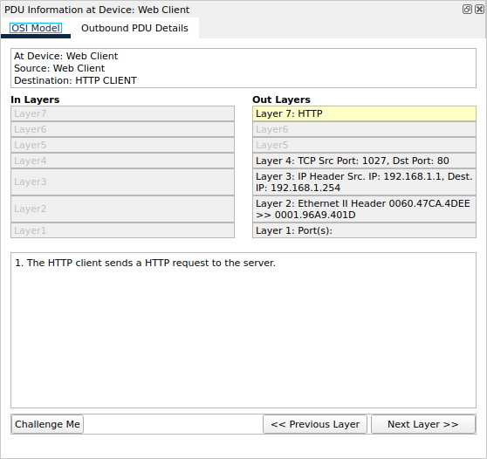

**Step 3b:**

* Verified OSI Model: Ensured OSI Model tab was selected, highlighting Layer 7 box. Noted "HTTP" displayed next to Layer 7 label. Additionally, identified step 1 under In Layers and Out Layers boxes, describing the HTTP request from client to server.
* Layer 4 Analysis: Clicked Next Layer, highlighting Layer 4. Recorded **Dst Port value: 80.**

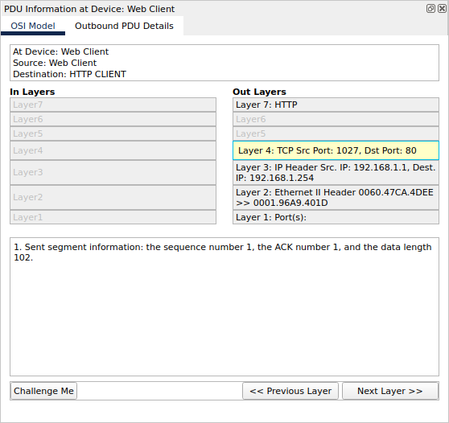

* Layer 3 Analysis: Clicked Next Layer, highlighting Layer 3. Noted **Dest. IP value: 192.168.1.254.**

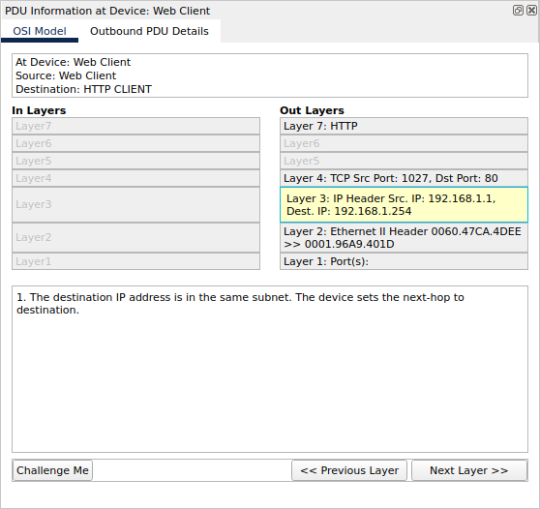

* Layer 2 Analysis: Clicked Next Layer, displaying Layer 2 information including Ethernet II Header and inbound/outbound MAC addresses.

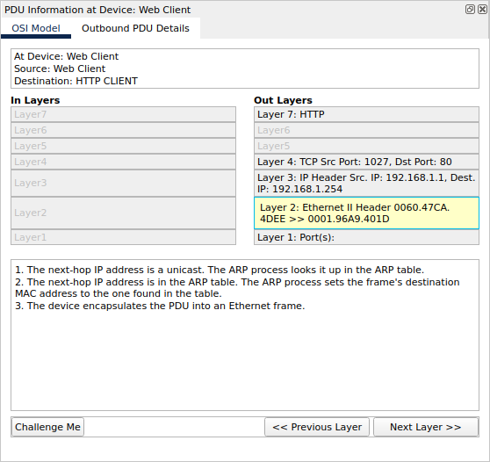

**Step3 c:**

* PDU Details Comparison: Clicked the Outbound PDU Details tab, comparing information with OSI Model tab. Recognized **detailed Ethernet II information and commonalities in SRC/DST MAC at Layer 2.**

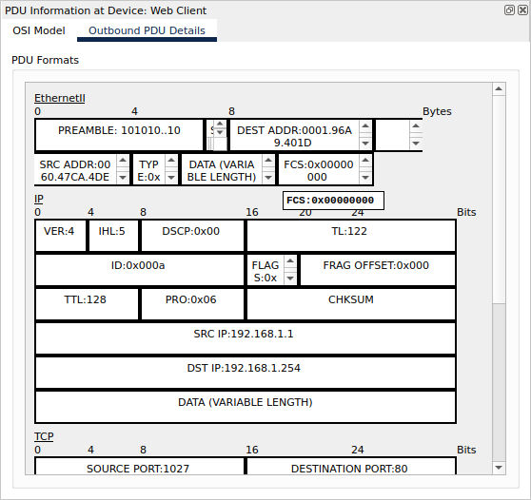

* Layer 1 Observation: Clicked next colored square box, noting Layer 1 activity where the frame is moved from the buffer to the network.
* HTTP Info and Layers: Advanced to the next HTTP Info box, observing directional changes in In Layers and Out Layers columns. Compared differences such as Src/Dst Ports, IPs, and MAC addresses.
* HTTP Message Analysis: Clicked the Outbound PDU Details tab, specifically examining HTTP section and identifying the first line of the HTTP message: "HTTP/1.1 200 OK," indicating a successful request and server response.
* Concluding Event: Clicked the last colored square box, revealing two tabs (OSI Model and Inbound PDU Details) due to this being the receiving device.

Overall, the analysis provided a comprehensive understanding of the network traffic events, encompassing the OSI Model, PDU Details, and layer-specific information. Notable findings include successful HTTP requests, directional data flow, and differences in layers during transmission and reception.

**Step3e:**

|  |  |
| --- | --- |
| In layers | Out Layers |
| Layer 7:HTTP  The server receives a HTTP request. | Layer 7:HTTP  The server sends back a HTTP reply to the client. |
| Layer5 and 6:  Inactive | Layer5 and 6:  Inactive |
| Layer 4:TCP Src Port:1027,Dst Port: 80  1. The device receives a TCP PUSH+ACK segment on the connection to 192.168.1.1 on port 1027.  2. Received segment information: the sequence number 1, the ACK number 1, and the data length 102.  3. The TCP segment has the expected peer sequence number.  4. TCP processes payload data.  5. TCP reassembles all data segments and passes to the upper layer. | Layer 4:TCP Src Port:80,Dst Port: 1027  1. Sent segment information: the sequence number 1, the ACK number 103, and the data length 272. |
| **Layer 3: IP Header Src. IP:192.168.1.1,**  **Dest. IP: 192.168.1.254**  1. The packet's destination IP address matches the device's IP address or the broadcast address. The device de-encapsulates the packet. | **Layer 3: IP Header Src. IP:192.168.1.254,**  **Dest. IP: 192.168.1.1**  1. The destination IP address is in the same subnet. The device sets the next-hop to destination. |
| **Layer 2:Ethernet II Header 006.47CA.4DEE >>**  **0001.96A9.401D**  1. The frame's destination MAC address matches the receiving port's MAC address, the broadcast address, or a multicast address.  2. The device decapsulates the PDU from the Ethernet frame. | **Layer 2:Ethernet II Header 0001.96A9.401D >>**  **006.47CA.4DEE**  1. The next-hop IP address is a unicast. The ARP process looks it up in the ARP table.  2. The next-hop IP address is in the ARP table. The ARP process sets the frame's destination MAC address to the one found in the table.  3. The device encapsulates the PDU into an Ethernet frame. |
| **Layer 1:Port FastEthernet0**  1. FastEthernet0 receives the frame. | **Layer 1:Port(s) FastEthernet0**  1. FastEthernet0 sends out the frame. |

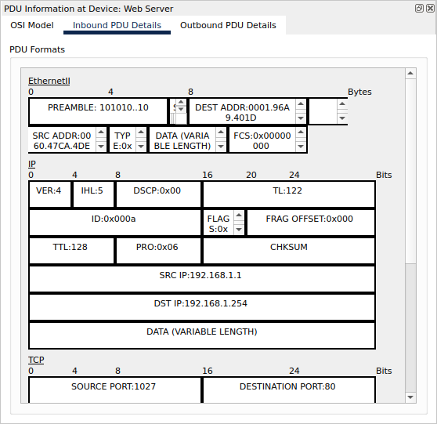

**Step3f: Inbound and Outbound PDU Details**

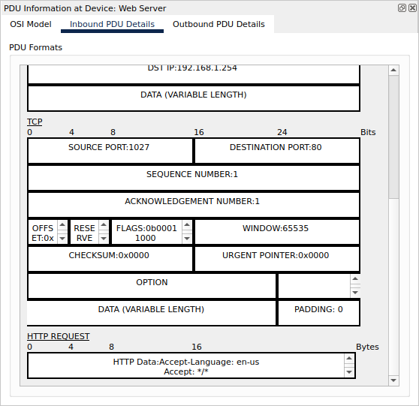

Information listed under the PDU Details is reflective of the layers within the TCP/IP model.

**Step3g:**

Last colored box: It had only 2 tabs displayed with this event:**OSI model and Inbound PDU details**

**In the OSI model**:We had only the Inlayers that was active but Outlayers was active

|  |  |
| --- | --- |
| In layers | Description |
| **Layer 7:HTTP** | 1. The HTTP client receives a HTTP reply from the server. It displays the page in the web browser. |
| Layer5 and 6: |  |
| **Layer 4:TCP Src Port:80,Dst Port: 1027** | 1. The device receives a TCP PUSH+ACK segment on the connection to 192.168.1.254 on port 80.  2. Received segment information: the sequence number 1, the ACK number 103, and the data length 272.  3. The TCP segment has the expected peer sequence number.  4. The TCP segment has the expected ACK number. The device pops the last sent segment from the buffer.  5. TCP processes payload data.  6. TCP reassembles all data segments and passes to the upper layer. |
| **Layer 3: IP Header Src. IP:192.168.1.254,**  **Dest. IP: 192.168.1.1** | 1. The packet's destination IP address matches the device's IP address or the broadcast address. The device de-encapsulates the packet. |
| **Layer 2:Ethernet II Header 0001.96A9.401D >>**  **006.47CA.4DEE** | 1. The frame's destination MAC address matches the receiving port's MAC address, the broadcast address, or a multicast address.  2. The device decapsulates the PDU from the Ethernet frame. |
| **Layer 1:Port FastEthernet0** | 1. FastEthernet0 receives the frame |

**Part 2: Display Elements Of The Tcp/Ip Protocol Suite**

**Step1:View Additional events**

**Step1a:** **Closed any open PDU information windows.**

**Step1b:Additional Event Types displayed**

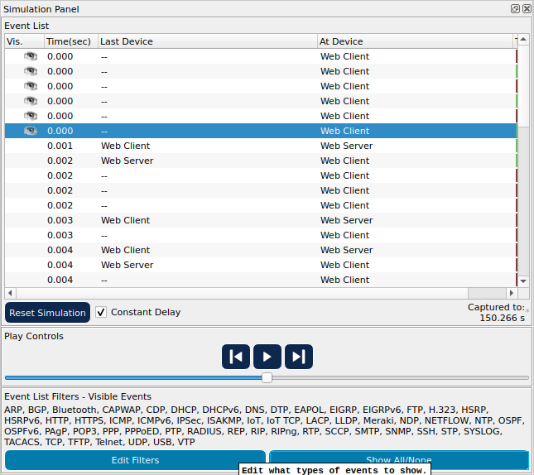

ARP, DNS, TCP and HTTP.

**Step1c: First DNS event type**

Click the first DNS event in the Info column. Explore the OSI Model and PDU Detail tabs and note the encapsulation process. When you look at the OSI Model tab with Layer 7 highlighted, a description of what is occurring is listed directly below the In Layers and Out Layers (“1. The DNS client sends a DNS query to the DNS server.”). This is very useful information to help understand what is occurring during the communication process**.**

OSI Model and PDU Detail

**OSI model** has two tabs: Inlayers which is active and Outlayers which is Inactive

**OSI model:Outlayers**

|  |  |
| --- | --- |
| In layers | Description |
| Layer 7:DNS | The DNS client sends an A DNS query to the DNS server. |
| Layer5 and 6:Inactive |  |
| **Layer 4:UDP Src Port: 1025, Dst Port:53** | The device encapsulates the PDU into an UDP segment. |
| **Layer 3: IP Header Src. IP:192.168.1.1,**  **Dest. IP: 192.168.1.254** | 1. The source IP address is not specified. The device sets it to the port's IP address.  2. The destination IP address is in the same subnet. The device sets the next-hop to destination. |
| **Layer 2:** | 1. The next-hop IP address is a unicast. The ARP process looks it up in the ARP table.  2. The next-hop IP address is not in the ARP table. The ARP process tries to send an ARP request for that IP address and buffers this packet. |
| **Layer 1 Inactive** |  |

**Step 1 d:Outbound PDU Details**

In the DNS Query under the NAME (VARIABLE LENGTH) we get [www.osi.local](http://www.osi.local)

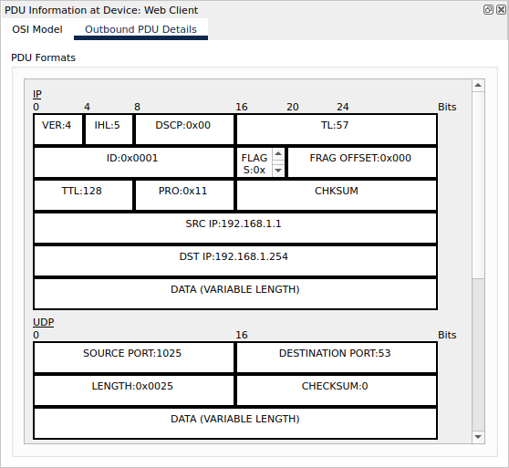 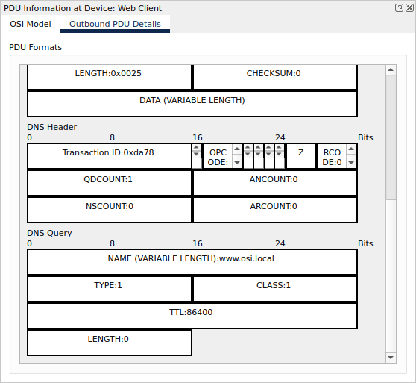

**Step 1 e:**

When you click on the last DNS info colored square box in the event list you get the device at which the the PDU was captured: Web Client(**SRC IP:192.168.1.254** and the Destination IP DST **IP:192.168.1.1** )

The value listed next to the **ADDRESS**: In the **DNS ANSWER** section of the **Inbound PDU** details is: **192.168.1.254 – Address of the Web Server**

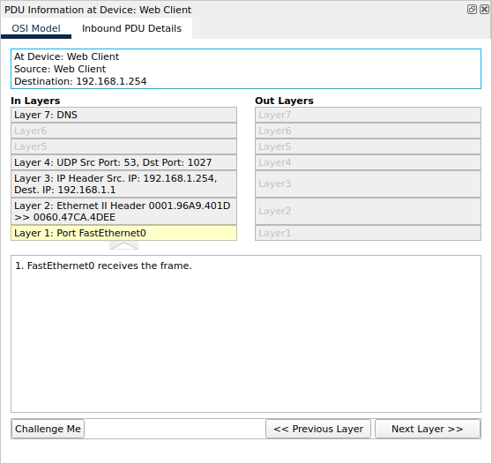

**Step 1 f:Layer 4: inlayers and outlayers**

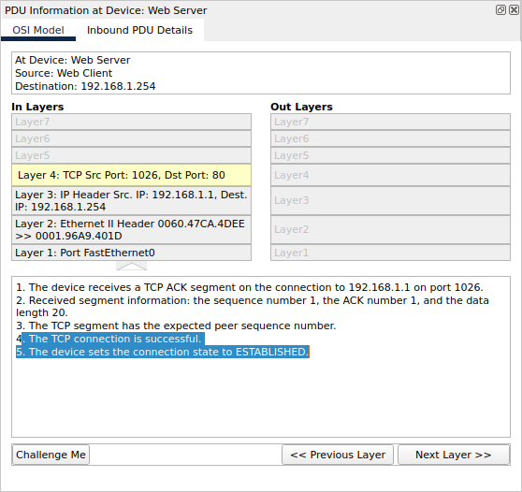

1. The device receives a TCP ACK segment on the connection to 192.168.1.1 on port 1026.

2. Received segment information: the sequence number 1, the ACK number 1, and the data length 20.

3. The TCP segment has the expected peer sequence number.

4. **The TCP connection is successful.**

**5. The device sets the connection state to ESTABLISHED.**

**Step g:** Layer 4: Click the last TCP event. Highlight Layer 4 in the OSI Model tab. Examine the steps listed directly below In Layers and Out Layers. What is the purpose of this event, based on the information provided in the last item in the list (should be item 4)

**Closing the connection(4. The device sets the connection state to CLOSED.)**

Based on the information that was inspected during the Packet Tracer capture, what port number is the Web Server listening on for the web request? **The first HTTP PDU being requested by the Web Client shows port 80 under the layer 4 DST port.**

What port is the Web Server listening on for a DNS request? **The first DNS PDU being requested by the Web Client shows a layer 4 destination of port 53.** DNS requests are handled on port 53 for both TCP and UDP protocols

**Conclusion**

In this assignment, we explored TCP/IP and OSI models in a simulated network. We first examined HTTP traffic, understanding data breakdown into smaller units (PDUs) at each layer. Then, we explored additional protocols like ARP, DNS, and TCP, gaining insights into their roles and encapsulation processes. This exercise laid the foundation for understanding how protocols facilitate communication and data transfer in a network. It's a crucial step toward comprehending networking protocols for further study and application