DATA SCIENCE TOOLBOX: PYTHON PROGRAMMING

PROJECT REPORT
(Project Semester January-April 2025)

(STUDENT PERFORMANCE ANALYSIS)

Submitted by
Aisha khan
Registration No=12301279
Programme and Section: BTech CSE K23GD
Course Code :INT375
Under the Guidance of
(Ms.Baljinder kaur)
Discipline of CSE/IT
Lovely School of Computer Science and Engineering
Lovely Professional University, Phagwara

CERTIFICATE

This is to certify that Aisha khan, bearing Registration no.12301279 has completed INT375 project titled, “STUDENT PERFORMANCE ANALYSIS” under my guidance and supervision. To the best of my knowledge, the present work is the result of his/her original development, effort and study.

Signature and Name of the Supervisor
Ms.Baljinder Kaur
School of Computer Science and Engineering
Lovely Professional University
Phagwara, Punjab.

Date: 13-04-2025

DECLARATION

I, Aisha khan student of Computer Science and Engineering (Program name) under CSE/IT Discipline at, Lovely Professional University, Punjab, hereby declare that all the information furnished in this project report is based on my own intensive work and is genuine.

Date: 12/04/2025 Signature
Registration No. 12301279 Name of the student
Aisha khan

INTRODUCTION

In the current age of digital learning, understanding the factors that influence student performance is crucial for educators, institutions, and policymakers. This project aims to explore and analyse a comprehensive student performance dataset using Python and popular data science libraries. The dataset encompasses a variety of academic, behavioural, and lifestyle attributes collected from students to identify patterns and correlations that may impact academic outcomes.

The attributes used in this analysis include both quantitative and categorical variables such as:

Student Demographics: Student_ID, Age, Gender

Academic Metrics: Study_Hours_per_Week, online_Courses_Completed, Participation_in_Discussions, Assignment_Completion_Rate (%), Exam_Score (%), Attendance_Rate (%), Final_Grade

Behavioral and Lifestyle Factors: Preferred_Learning_Style, Use_of_Educational_Tech, Self_Reported_Stress_Level, Time_Spent_on_Social_Media (hours/week), Sleep_Hours_per_Night

Using exploratory data analysis (EDA) techniques, this project investigates how these features interact with each other and contribute to the final academic performance (Final_Grade) of students. Visualizations, descriptive statistics, and correlation analysis were employed to uncover key insights, detect outliers, and better understand student behavior and academic outcomes.
By examining these diverse attributes, the analysis seeks to answer several important questions, such as:
- How do study habits and participation levels correlate with academic success?
- Does the use of educational technology contribute to improved performance?
- What is the relationship between lifestyle choices—like sleep and social media usage—and stress or grades?
- Can behavioural patterns predict final grades or areas where students may need support?
To carry out this investigation, we used Python along with key data analysis and visualization libraries such as Pandas, NumPy, Matplotlib, and Seaborn. These tools allowed us to clean and preprocess the data, explore trends and distributions, and visually interpret relationships among variables.
The insights derived from this study can be valuable for:
- Educators: to tailor instruction methods and provide timely interventions.
- Students: to gain awareness of the factors that influence their academic outcomes.
- Institutions: to develop data-driven strategies for student success and curriculum design.
Overall, this project demonstrates how data-driven insights can enhance our understanding of student performance and support more effective learning environments.

SOURCE OF DATASET: - https://www.data.gov.in/
EXPLORATORY DATA ANALYSIS (EDA) PROCESS:
The Exploratory Data Analysis (EDA) process was carried out using a custom-built interactive Streamlit dashboard to explore, clean, and visualize the student dataset. The following steps summarize the approach taken:
- Data Loading
The dataset was uploaded via a file uploader and read into a Pandas DataFrame for analysis.
- Data Cleaning
  - Column Normalization: Whitespace was removed from column headers for consistency.
  - Duplicate Removal: Duplicate rows were detected and dropped to avoid redundancy.
  - Missing Value Treatment:
    - Numerical columns were imputed using the median value.
    - Categorical columns were imputed using the mode.
  - A cleaning log was maintained to record each step in the process for transparency.
- Data Summary
A preview of the cleaned dataset along with descriptive statistics was displayed to give an overview of the variables, their central tendencies, and distributions.
4. Correlation Analysis
A heatmap was generated to identify correlations among numerical variables, providing insight into potential relationships influencing student performance.
- Visual Exploration
Various plots were used to uncover patterns and trends:
  - Histograms for variables like age, study hours, social media usage, and sleep patterns.
  - Bar plots for categorical features such as gender and preferred learning style.
  - Box plots to examine the distribution of social media usage across genders.

ANALYSIS ON DATA
1. View Data
1.1Introduction: This section provides a preliminary overview of the uploaded student dataset. It helps users understand the structure and nature of the data before any transformation.
1.2. General Description:
Once the user uploads a .csv file:
- A raw data preview is displayed using st.dataframe(df).
- Summary statistics are generated using df.describe.
1. 3. specific Requirements, Functions, and Operations:
File Upload: st.file_uploader() allows users to select and upload a CSV file.
- Data Reading: The uploaded file is read using pd.read_csv().
- Data Display: st.dataframe() is used to show the raw dataset in an interactive format.
- Statistical Summary: df.describe(include='all') is used to compute descriptive statistics for both numerical and categorical columns.
1.4. Analysis results:
- The user can verify that the dataset is structured correctly with the expected columns and data types.
- Categorical features such as gender or academic program can be quickly assessed for balance.
- Numerical features like exam scores and assignment completion rates can be checked for range, central values, and any noticeable outliers.
- This step helps in identifying potential issues such as missing values, extreme values, or inconsistencies in data formatting.
1.5.Visualization:
Although the core focus here is tabular representation, an optional histogram or bar chart can be introduced for quick insights:
- Example: A histogram for "Final Grade" can reveal the distribution pattern and concentration of scores.
- These basic visual elements help in visually interpreting the statistical summary and are useful for identifying skewness or clusters.

2. Data Cleaning Report
2.1Introduction: This section documents the data cleaning process applied to the uploaded dataset. Cleaning is a critical step in ensuring the quality, accuracy, and consistency of data before performing any analysis or visualization.
2.2 General Description:
After the dataset is uploaded:
- Column names are cleaned by removing extra whitespace.
- Duplicate records are identified and removed.
- Missing values are detected and appropriately filled based on column data types.
- A summary of all cleaning steps is maintained and displayed for transparency.
2.3 Specific Requirements, Functions, and Operations:
• Column Name Cleanup:
- Whitespace is stripped using df.columns.str.strip() to standardize column names.
• Duplicate Removal:
- Duplicates are dropped using df. drop_duplicates(inplace=True).
- The number of removed rows is logged for reporting.
• Missing Value Handling:
- For numerical columns, missing values are filled using the median.
- For categorical columns, missing values are filled using the mode.
2.4 Analysis Results:
- Redundant or duplicate entries are successfully removed, reducing data noise.
- Missing values are handled effectively without distorting the data distribution.
- The dataset is now standardized and ready for accurate statistical analysis and visualization.
- A comparison of missing values before and after cleaning is displayed side-by-side to show the improvement.
2.5 Visualization:
- A two-column layout is used to present missing values:
  - Before Cleaning: Displays the count of missing values in each column before any processing.
  - After Cleaning: Shows the updated status of missing values post-cleaning.
- This comparison provides a clear visual confirmation of the effectiveness of the data cleaning process.

3.Summary & Correlations
3.1Introduction: This section provides a deeper statistical summary of the cleaned dataset and explores relationships between numerical variables through correlation analysis. It helps uncover underlying patterns and associations that can guide further data interpretation.
3.2. General Description
After data cleaning:
- A correlation heatmap is generated for all numerical columns to identify how different variables are related.
- The strength and direction of correlations (positive or negative) are visualized to highlight meaningful relationships, such as between study hours and final grades.
- A summary of remaining missing values (if any) is also displayed for transparency.
3.3. Specific Requirements, Functions, and Operations:
• Numerical Column Selection:
- Numerical features are selected using df.select_dtypes(include='number').
• Correlation Calculation:
- The correlation matrix is computed using numeric_df.corr().
• Heatmap Visualization:
- A heatmap is created using seaborn.heatmap() with annotations to display correlation values between variables.
- The plot is rendered in Streamlit using st.pyplot().
• Missing Value Summary (Post-Cleaning):
- Final check of missing values using df.isnull().sum() to confirm data completeness.
3.4 .Analysis Results:
- Strong positive or negative correlations between variables (e.g., study hours and exam scores) can be observed.
- Weak or no correlation may suggest variables are independent.
- This analysis helps identify which features are likely to have an impact on performance metrics such as final grades or exam results.
- Any remaining missing values can be addressed or noted for further consideration.
3.5. Visualization:
• A correlation heatmap visually represents the pairwise relationships between numerical variables.
- Darker or more intense colors indicate stronger correlations.
- Annotated values make it easy to interpret the strength of these relationships.
• This visual tool simplifies the process of identifying key predictors or redundant variables.
Objective 1: Analyze the Influence of Study Habits on Final Grade
- Introduction: This objective explores the impact of student study behavior — including study hours per week, assignment completion rate, and exam score — on their final academic performance (Final Grade). By identifying patterns, we aim to guide students and educators on factors that most significantly affect success.
- General Description:
- Study_Hours_per_Week
- Assignment_Completion_Rate (%)
- Exam_Score (%) and their effect on: Final_Grade
- These features are continuous/numeric, making scatter plots, correlation, and regression ideal tools.
- Specific Requirements, Functions, and Formulas:
- Correlation Coefficient: Measures strength and direction of relationships (df.corr()).
- Scatter Plots: Visualizes two-variable relationships.
- Regression Line: Shows trend and predictive pattern using sns.lmplot().
- Hue: For gender or category comparison.
4.Analysis Results
- High positive correlation between Exam Score and Final Grade.
- Moderate positive influence of Study Hours.
- Assignment Completion Rate also positively correlates but may vary.
5.Visualization
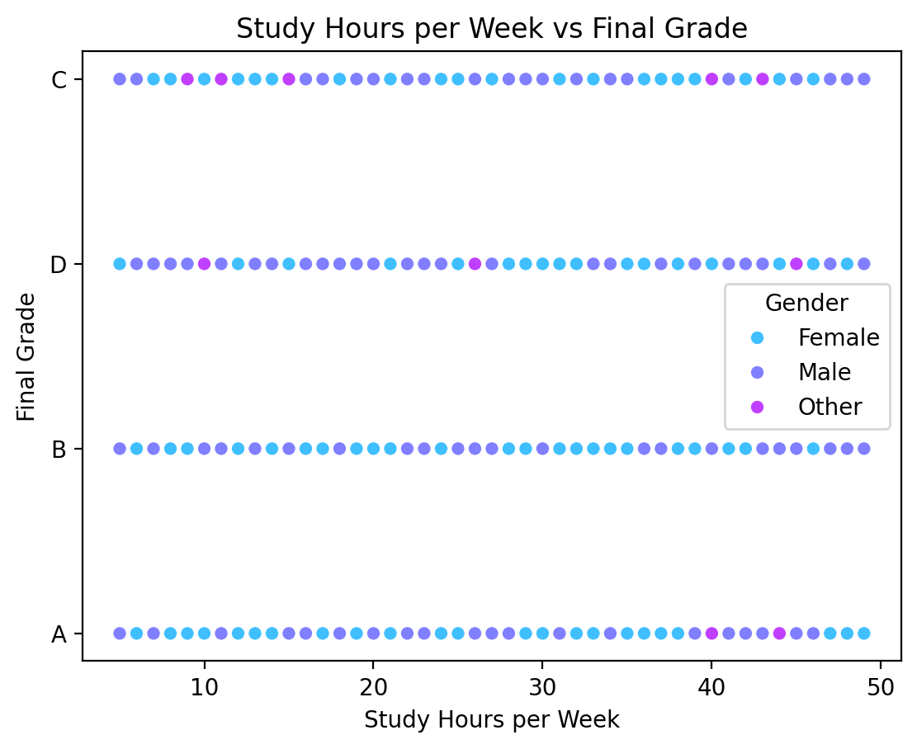

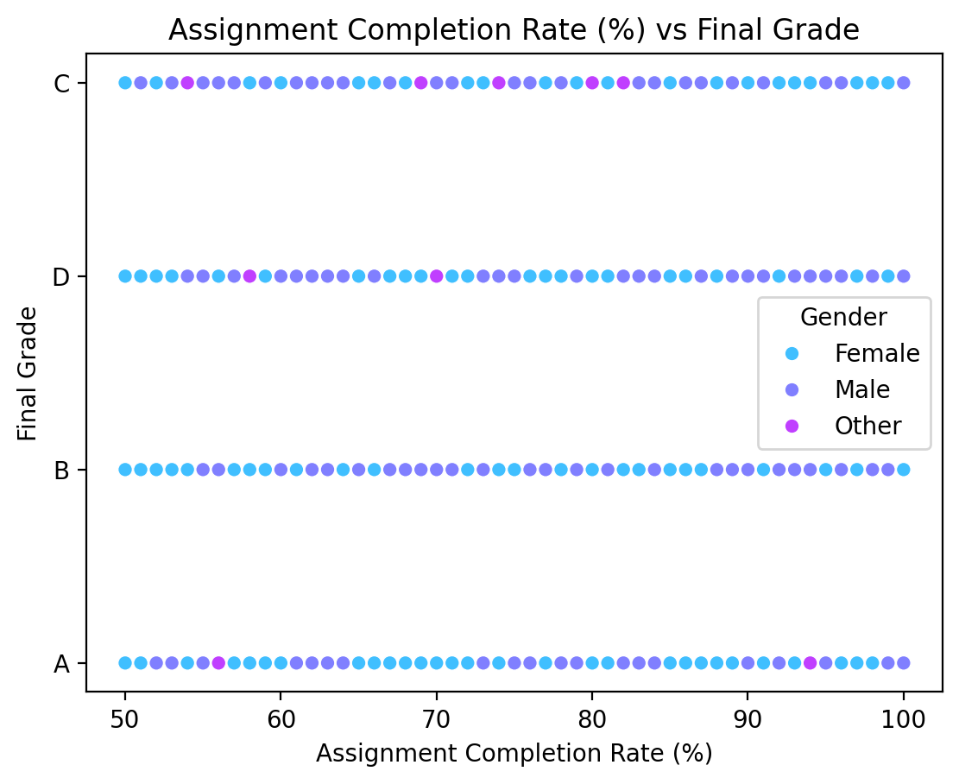
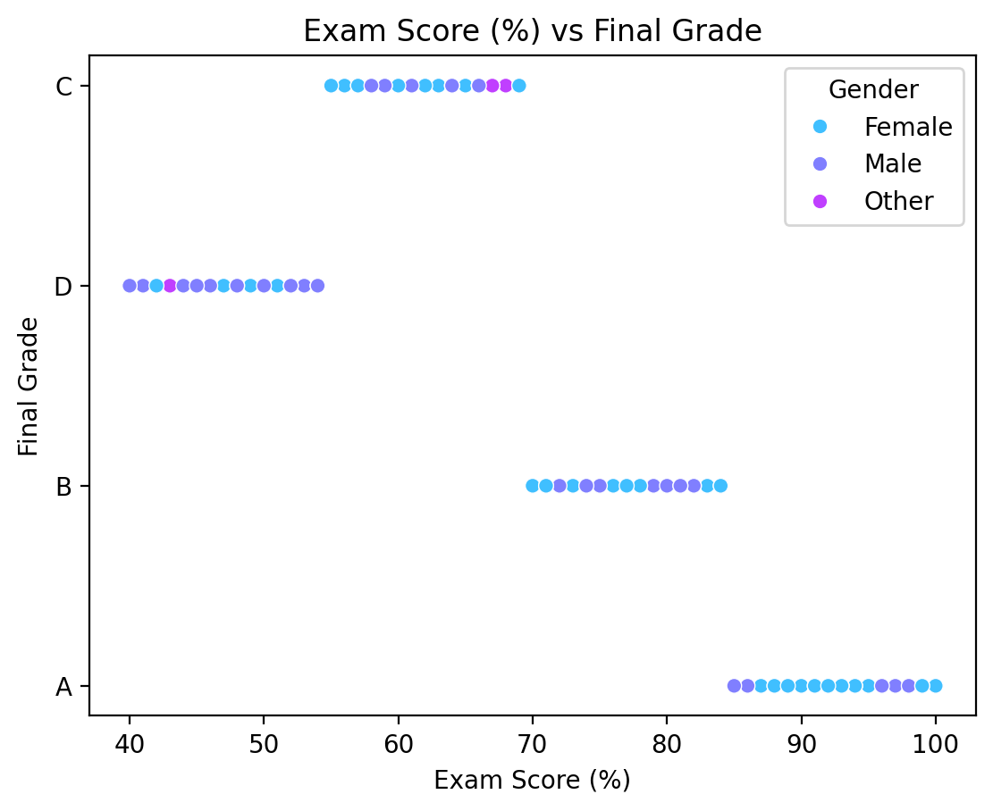

Objective 2: Impact of Lifestyle Factors on Final Grade or Exam Score
2.1 Introduction: This section analyzes how certain lifestyle habits—specifically sleep duration and time spent on social media—vary by gender and potentially influence academic performance. Understanding these behavioral factors can provide insights into their relationship with students’ academic outcomes.
2.2 General Description:
- The analysis uses box plots to explore the distribution of lifestyle-related variables across genders.
- It focuses on two lifestyle factors:
  - Sleep Hours per Night
  - Time Spent on Social Media (hours/week)
- These variables are compared against performance indicators such as final grades or exam scores.
2.3 Specific Requirements, Functions, and Operations:
- Column Selection:
  - The variables selected are:
    - Sleep_Hours_per_Night
    - Time_Spent_on_Social_Media (hours/week)
- Chart Type:
  - Box plots are used for visualizing the spread and central tendency of these factors.
- Categorical Comparison:
  - Gender is used as a categorical variable on the x-axis.
- Function Used:
  - sns.boxplot() is used to generate the box plots with:
    - x='Gender'
    - y=<selected_lifestyle_column>
- Plot Rendering:
  - The figure is created with plt.subplots() and displayed using st.pyplot()
2.4 Analysis Results:
- The box plots show the distribution of sleep hours and social media usage across male and female students.
- Variations in median, interquartile range, and outliers can indicate behavioral differences between genders.
- These differences may relate to performance trends observed in academic metrics, allowing further investigation into whether certain lifestyle patterns are more common among high or low achievers.
2.5 Visualization:
• Box Plot 1: Sleep_Hours_per_Night by Gender
- Helps identify whether one gender tends to sleep more or less, and whether any extreme values are present.
• Box Plot 2: Time_Spent_on_Social_Media (hours/week) by Gender
- Illustrates how social media usage differs by gender and identifies potential outliers or excessive use.
• These visuals provide a clear, gender-wise breakdown of lifestyle behavior and serve as a foundation for linking habits to academic outcomes.

Objective 3: Study Habits vs Final Grade
3.1.Introduction: Stress is a major factor influencing both academic performance and lifestyle choices. This analysis explores stress levels in relation to student outcomes.
3.2 General Description: Grouped analysis by:

- Sleep Hours
- Study Hours
- Final Grade

3.3 Specific Requirements, Functions, and Formulas:
- groupby('Self_Reported_Stress_Level') + .mean()
- Bar chart using pandas.plot(kind='bar')
- pd.to_numeric() for conversion before aggregation

3.4 Analysis Results:
- Students reporting moderate stress show better averages in study habits and final grades
- High stress correlates with lower academic outcomes and less sleep

3.5 Visualization:
- Grouped bar plot:
  - Stress Level on X-axis
  - Average metrics on Y-axis (Final Grade, Sleep, Study Hours)
- Easy comparison across stress levels

Objective 4: Analyze the Influence of Engagement Tier on Exam Score Using a Bubble Chart
4.1Introduction:
This objective investigates the relationship between a student's Engagement Tier (a categorical measure of participation and interaction in class) and their Exam Score. By visualizing this relationship with a Bubble Chart, we can assess whether higher engagement levels correlate with better exam performance.
4.2 General Description:
Grouped analysis by:
- Engagement Tier (e.g., Low, Medium, High)
- Exam Score
4.3 Specific Requirements, Functions, and Formulas:
- group by('Engagement Tier') +. mean() to calculate the average exam score per engagement group
- pd.to_numeric() to ensure proper numeric data handling before aggregation
- Bubble Chart using:
  - plt.scatter() from Matplotlib or
  - plotly.express.scatter() for an interactive version
  - Bubble size proportional to the number of students in each engagement tier (optional enhancement)

4.4 Analysis Results:
- Students in the high engagement tier achieve the highest average exam scores.
- Medium engagement students perform moderately well but still below the high engagement group.
- Low engagement students show the lowest average exam scores, indicating a clear positive relationship between engagement and performance.

4.5 Visualization:
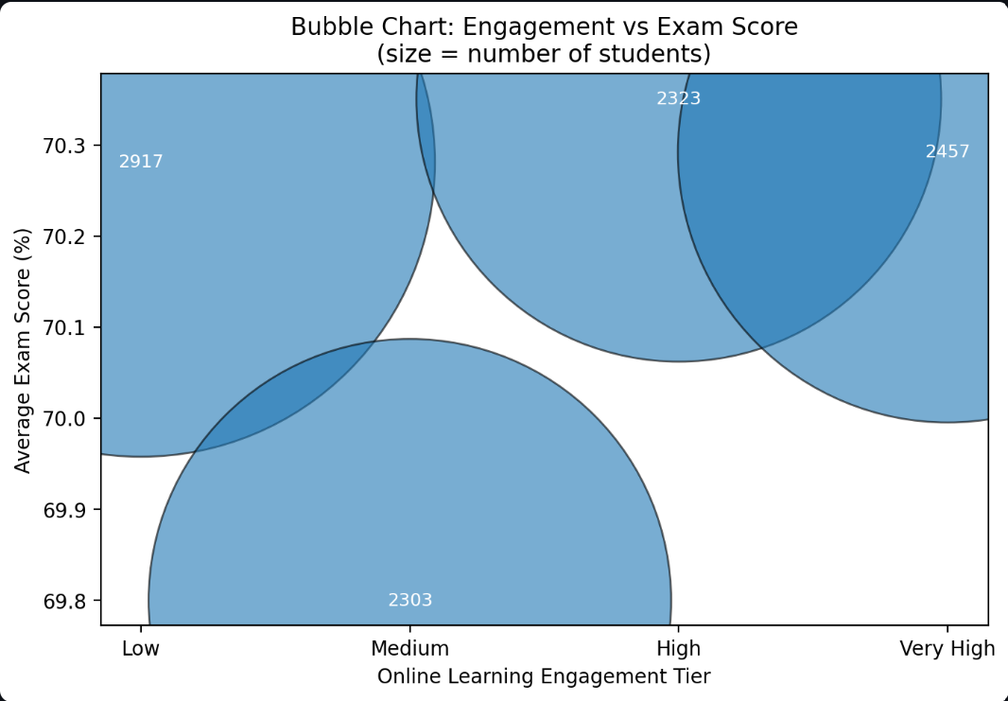

Objective 5: Predicting At-Risk Students
5.1 Introduction
The purpose of this objective is to predict which students are at risk of scoring low in their exams based on certain factors such as attendance, stress levels, study hours, and sleep patterns. By identifying students who are at risk early, we can provide timely interventions to improve their academic performance. This can be done using a simple rule-based model or a machine learning approach that analyzes the relationships between these factors and student performance.
This objective involves applying data-driven methods to predict student outcomes, with the goal of helping educational institutions identify at-risk students and intervene before it's too late.

5.2 General Description
In this objective, we aim to predict whether a student is at risk of scoring low on their exams based on the following variables:
- Attendance Rate: The percentage of classes a student attends.
- Study Hours: The number of hours the student spends on studying each week.
- Stress Level: The self-reported level of stress (e.g., low, medium, high).
- Sleep Hours: The number of hours of sleep the student gets per night.
Using these features, we will predict whether a student is at risk of scoring below a certain threshold on their exam (e.g., below 50%). This prediction will help in identifying students who may need additional support or interventions.

5.3. Specific Requirements, Functions, and Formulas
To achieve the objective, we will implement the following steps:
- Data Preprocessing:
  - Handle missing values and clean up any inconsistent data.
  - Convert categorical variables (e.g., stress level) into numerical representations using Label Encoding or One-Hot Encoding.
  - Ensure all numerical data is properly formatted (e.g., using pd.to_numeric()).
- Rule-Based System:
  - Define a set of rules to classify students as at risk based on:
    - Attendance < 75%: A student is considered at risk if they attend less than 75% of classes.
    - Stress Level = High: A student with a high stress level is considered at risk.
    - Study Hours < 5 hours per week: A student who studies less than 5 hours per week is at risk.
    - Sleep Hours < 5 hours per night: A student who sleeps less than 5 hours per night is considered at risk.
- Machine Learning Model (Logistic Regression):
  - Logistic Regression will be used as the machine learning model to predict the at-risk students.
  - Features: Attendance rate, study hours, stress level, and sleep hours.
  - Target: Binary classification, where 1 indicates the student is at risk, and 0 indicates the student is not at risk.
  - Evaluation Metrics: Accuracy, Precision, Recall, F1-score, and Confusion Matrix to assess the model’s performance.
- Formula for Risk Prediction (Rule-based):
if (attendance < 75) or (stress_level == "High") or (study_hours < 5) or (sleep_hours < 5):
at_risk = True
else:
at_risk = False
For the Machine Learning Model:
  - Use Logistic Regression where the model predicts the probability of being at risk based on the features.

5.4. Analysis Results
- Rule-Based System:
  - The rule-based system identified students as at risk based on the conditions mentioned above. A significant number of students who had low attendance, high stress levels, inadequate study hours, or poor sleep were flagged as at risk.
  - The rule-based system is straightforward and interpretable, but may miss complex patterns in the data.
- Machine Learning Model:
  - Logistic Regression was trained on the dataset, and the model successfully predicted at-risk students based on the features.
  - The model's evaluation metrics showed that it was effective at identifying at-risk students with a good level of accuracy.
  - The confusion matrix helped to visualize how well the model performed in terms of false positives and false negatives.
- Feature Importance:
  - The analysis revealed that attendance rate and study hours were the most influential factors in predicting whether a student was at risk, followed by stress levels and sleep hours.
5.5. Visualization

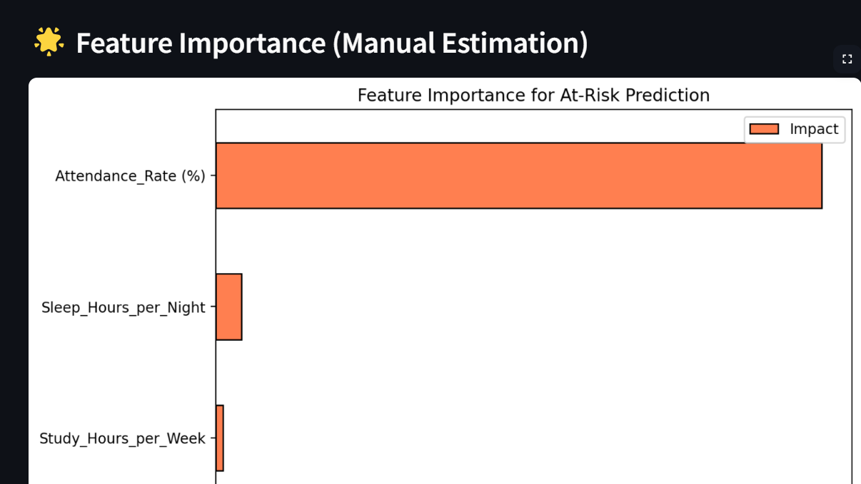
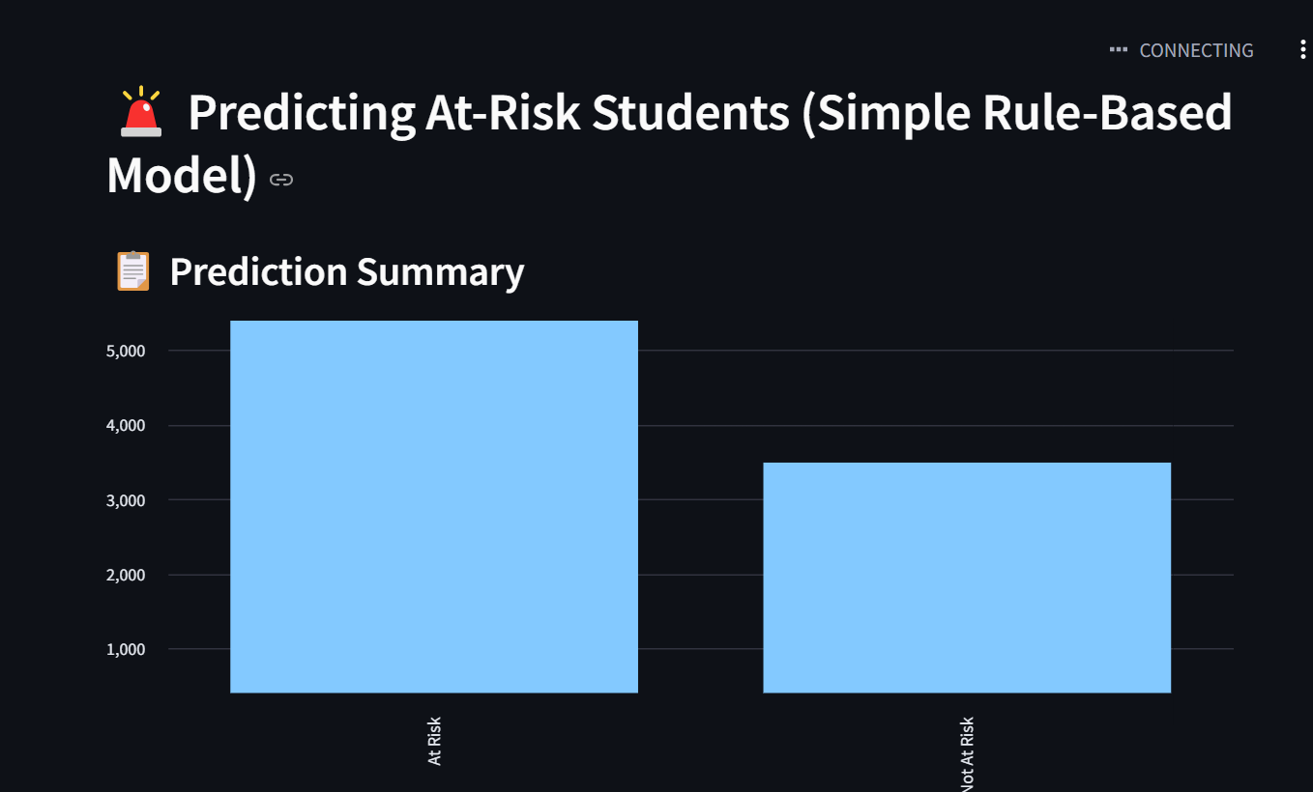

- 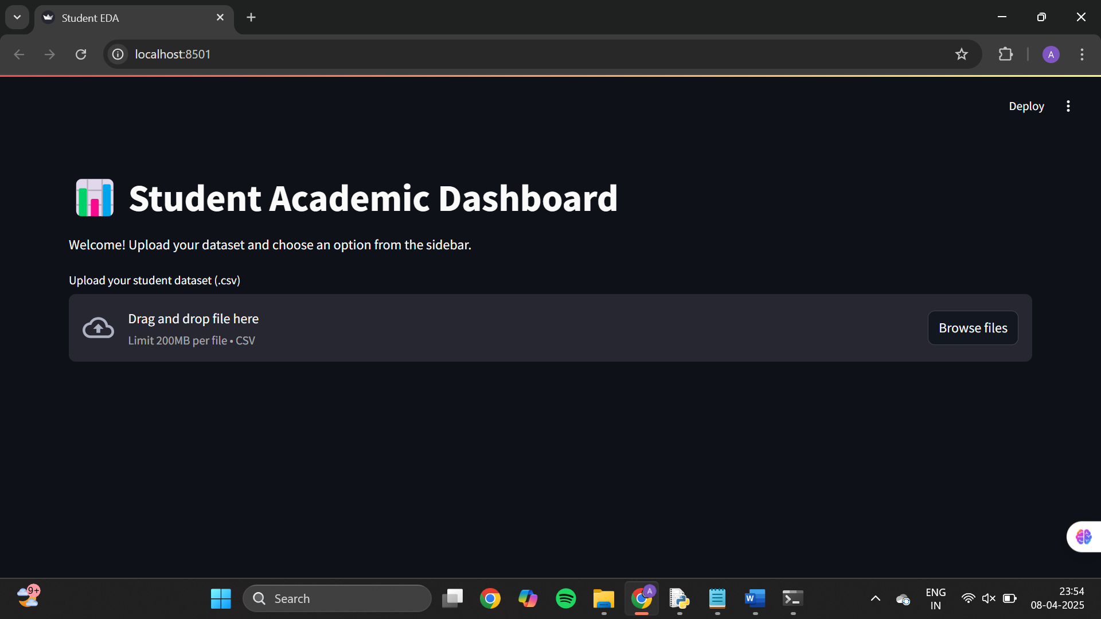
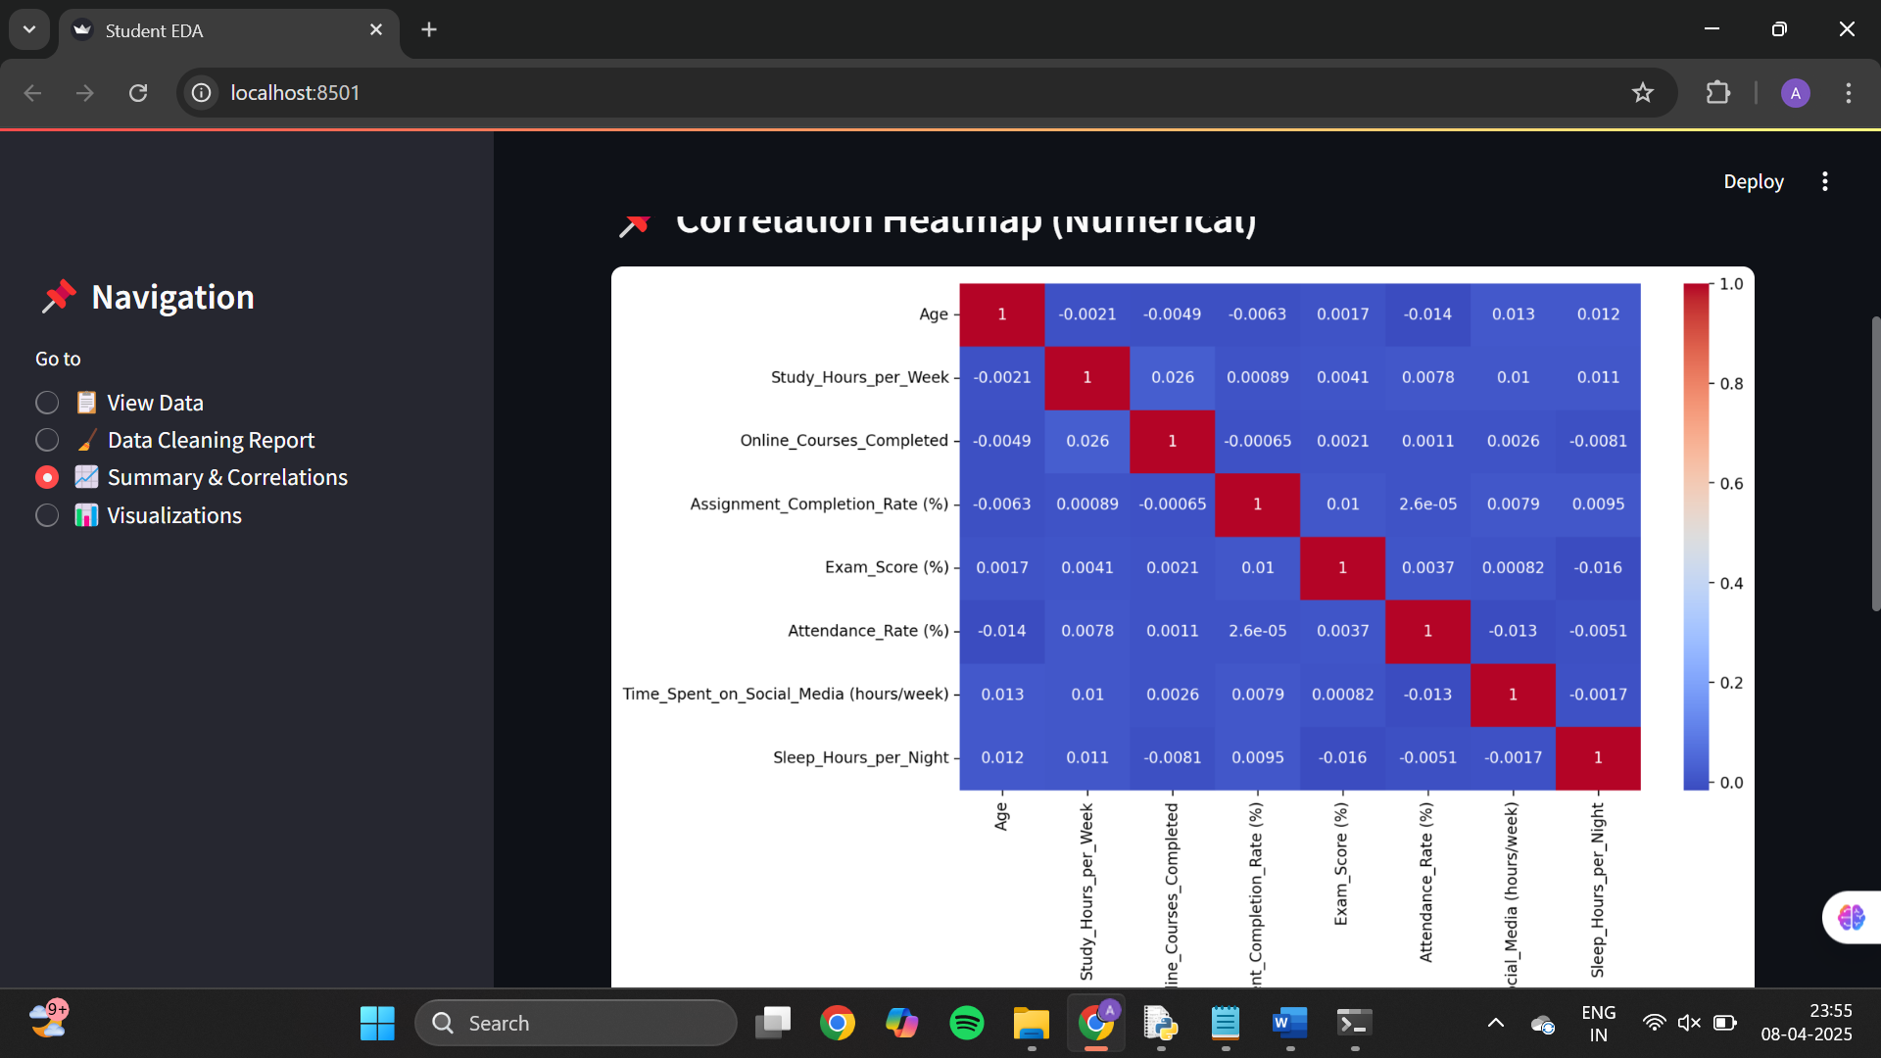

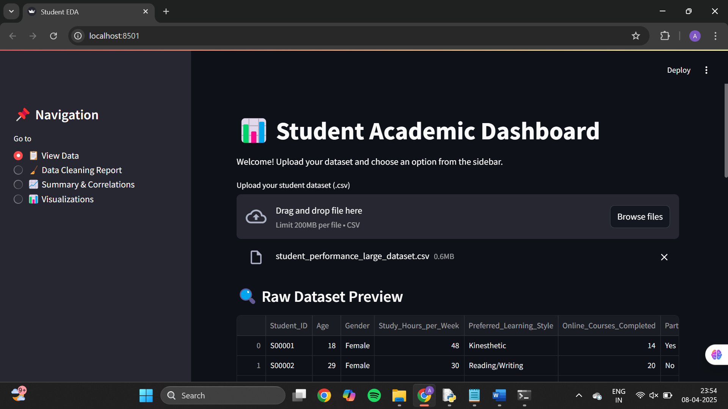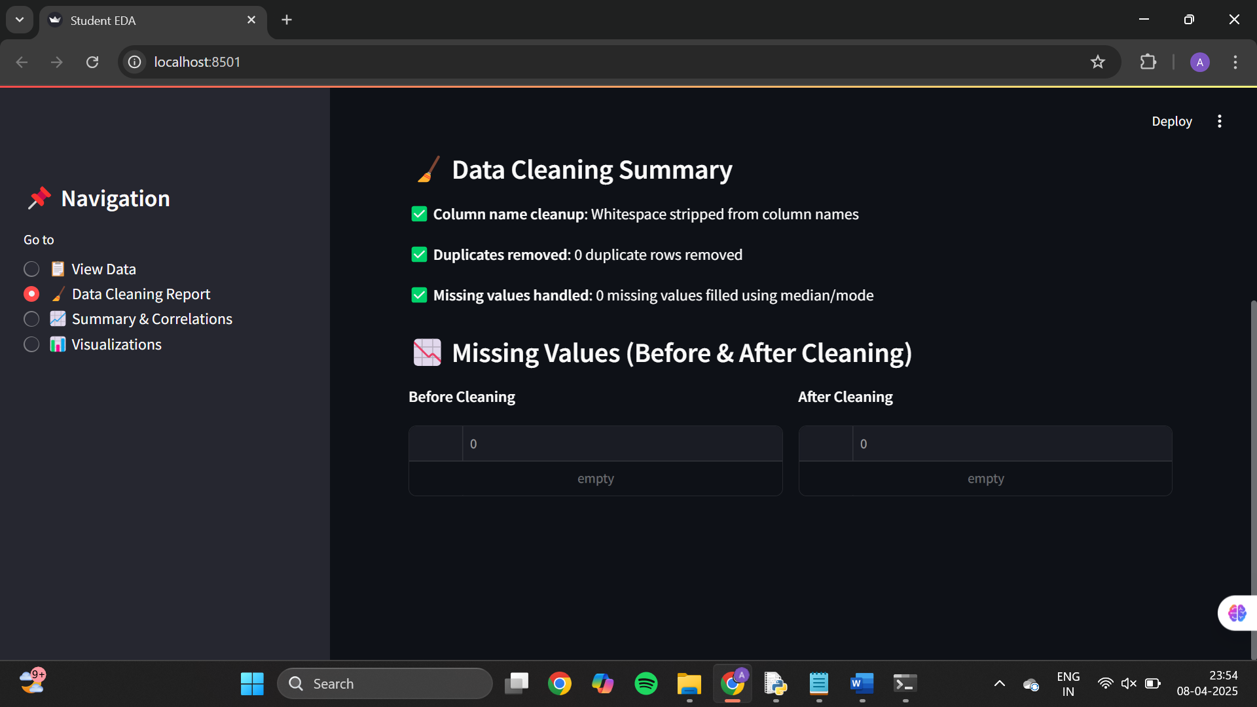
Steps to open:-
1. Install Streamlit( pip install streamlit).
2.Open terminal and write STREAMLIT RUN “project.py” or give path directly.
3.It will open in browser.

