**Git-Assignment 1:**

1. Make account on “https://github.com” and add a new repository named “git_test”.

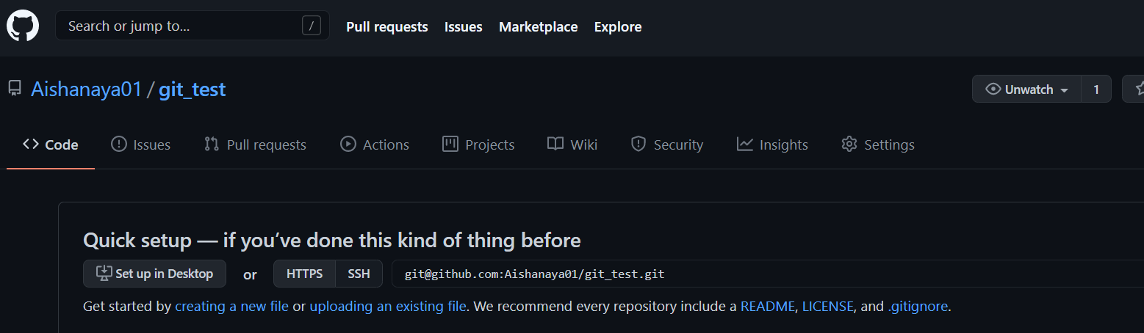

1. Install git bash.
2. Check the version of Git: “git --version”

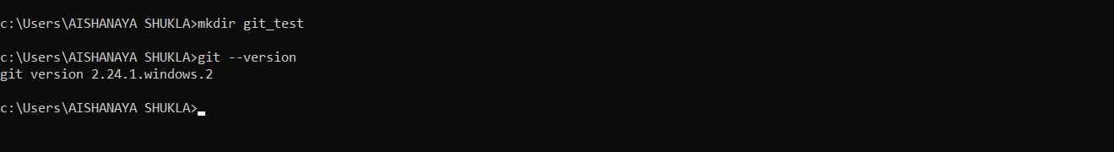

1. Connect the remote repository (made on github) to the local repository

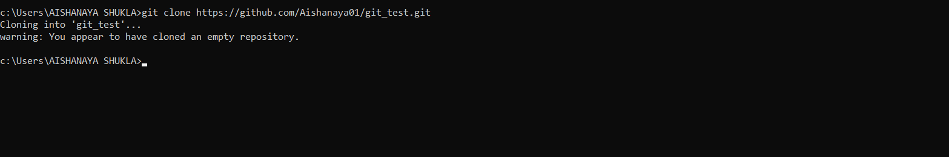

You have successfully cloned the local repository to remote repository.

1. Git remote: to establish the connection local and remote repository.

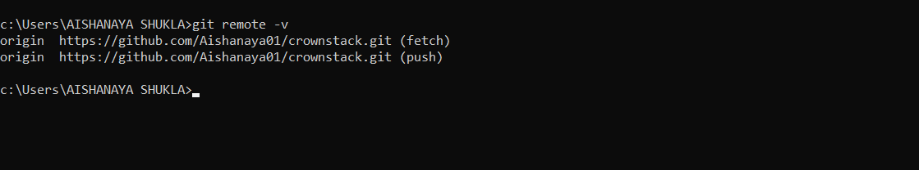

This will display the URL of the repository you created in GitHub, which is the remote for your local copy.

1. Command : README.md : Make a new file named “README.md”



1. Check the status : git status

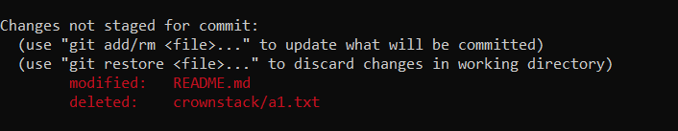

Its red means the file README.md is in unstaging area.

1. Git add command : git add [filename] : will add the given file to tracked file.



Now its green means the file README.md is in staged area of the git.

1. Git commit: git commit –m “a message” will commit you file

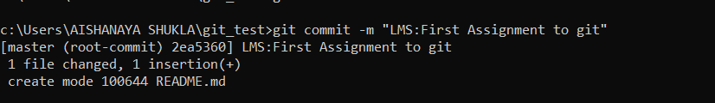

1. View log: git log

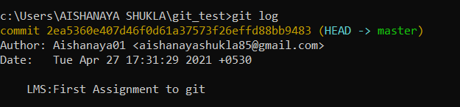

Lets try adding new file then understand the concept of git more clearly.

1. Make a new dummy .txt file. And check the status.

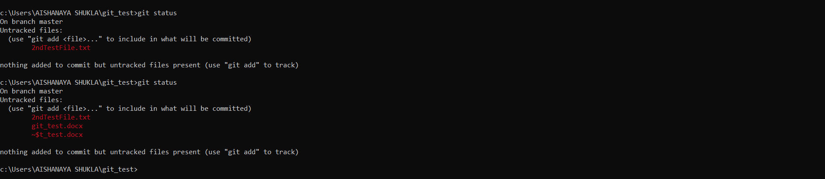

the newly made file is named as untracked file means it is in unstaging area.

1. Push command: to upload the files in git

