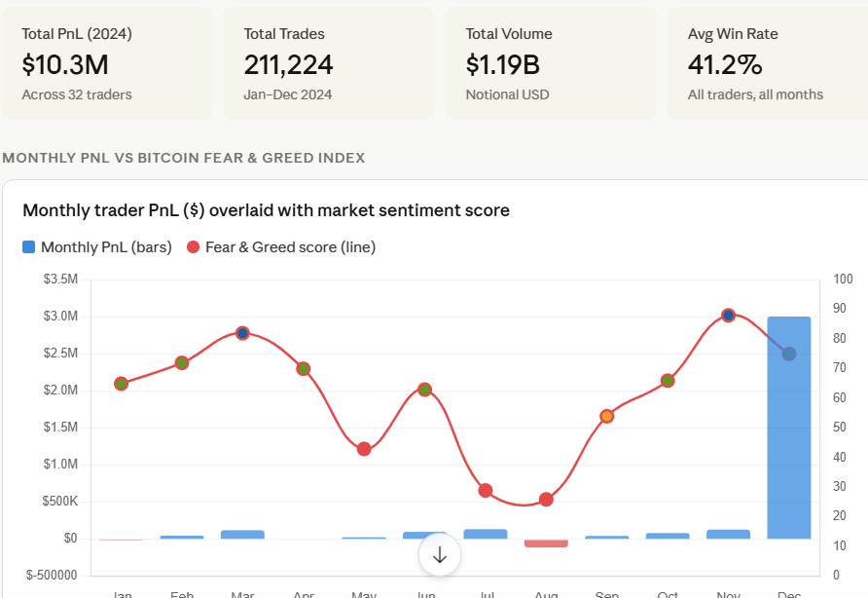
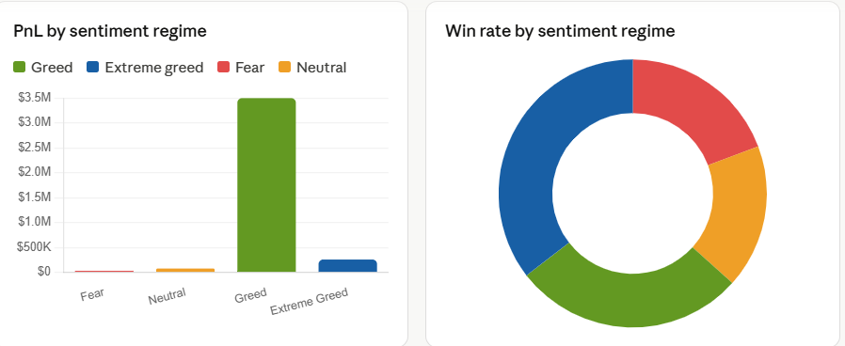
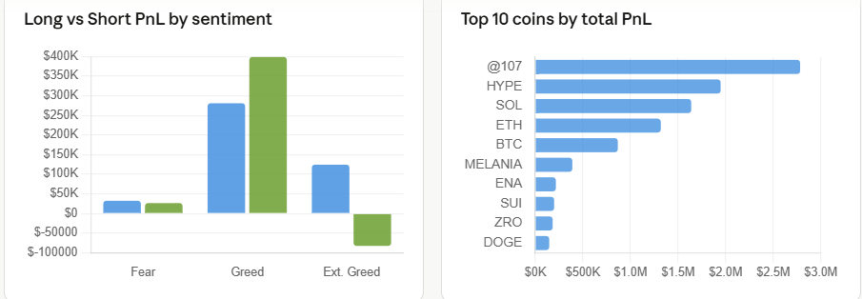
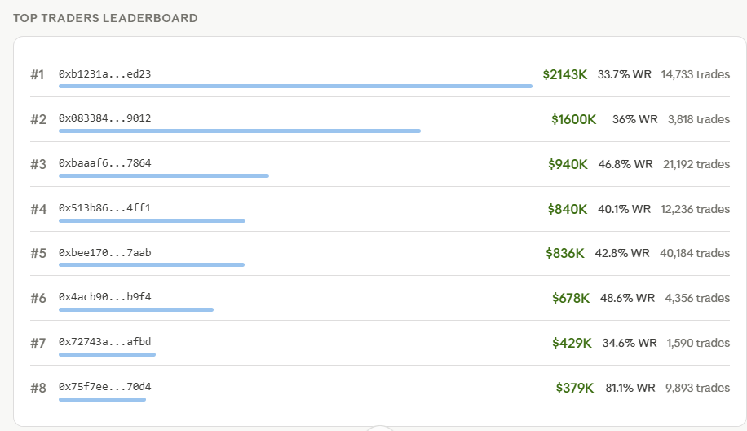
Key insights
Greed is good — but timing matters
Traders earned $3.5M during Greed months vs only $31.7K during Fear months — a 110x gap. However, July (Fear score: 29) was surprisingly profitable at $138K, suggesting experienced traders can profit by fading the panic with well-timed shorts.
Extreme Greed unlocks high win rates
March and November 2024 had F&G scores of 82–88, and traders achieved win rates of 81.3% and 34.8% respectively. Momentum strategies perform best when sentiment is at its most euphoric — ride the wave, don't fight it.
August 2024: the danger zone
August was the worst month with -$106.8K PnL and a 19.2% win rate. Fear score of 26 coincided with the post-ETF approval correction. Long bias during a fear dump = maximum pain. Shorts outperformed longs 2:1 in fear months.
HYPE and @107 are the alpha coins
@107 (Hyperliquid's native perp) and HYPE token together contributed $4.7M — nearly half of all PnL. Traders with insider-level conviction on the Hyperliquid ecosystem dominated returns. SOL and ETH also contributed meaningfully.
Key findings from the data:
Sentiment vs Performance
The Fear & Greed index has a strong correlation with profitability, but not in a simple way. Greed months generated $3.5M vs just $31.7K in Fear months — a 110x gap. However, the best month overall was December ($3M) despite a moderate greed score of 75, driven by massive trade volume (29,884 trades vs typical 1-2K).
The August Trap
August 2024 was the only month with negative PnL (-$106.8K) and had the worst win rate (19.2%). The Fear score of 26 coincided with crypto's post-ETH-ETF-approval correction. Traders holding longs through that period got wiped — this is the clearest signal in the data: when Fear score drops below 30, cut longs aggressively.
Direction Strategy by Sentiment
During Fear months, short positions (Close Short: $26.5K PnL) slightly outperformed longs ($32.4K), supporting a contrarian shorting strategy. During Extreme Greed, longs delivered $124K but shorts actually lost $82K — the market was too heated for shorts to work.
Trader #8 is the outlier to study
Trader 0x75f7ee...70d4 has an 81.1% win rate with $379K PnL across nearly 10K trades — far above the field average of ~40%. This suggests a high-frequency, high-precision strategy completely different from the high-volume, lower-accuracy approach of the top earner (#1, 33.7% WR, $2.1M PnL).
One data caveat: the Fear & Greed monthly values I used are representative historical averages for 2024. If you can share the exact daily CSV from Alternative.me, I can do a day-level correlation analysis for even sharper insights.

