The Products application displays product Images, Titles and Description.

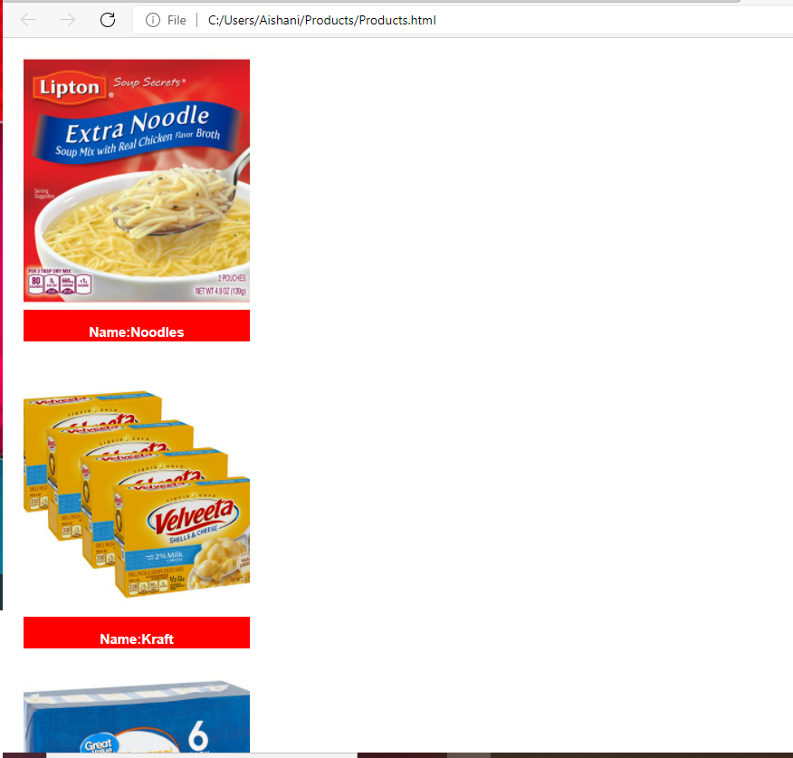

Use Search Box to search Products using the exact title and hit enter.

